What are my symptoms?

This worksheet is designed to help you to provide a detailed description of your symptoms and to help communicate these with your healthcare professional.

Use this worksheet to help you to remember things you want to discuss with the health professional.

What are your Symptoms? Describe them: This could be sore throat, cough, or dizziness.

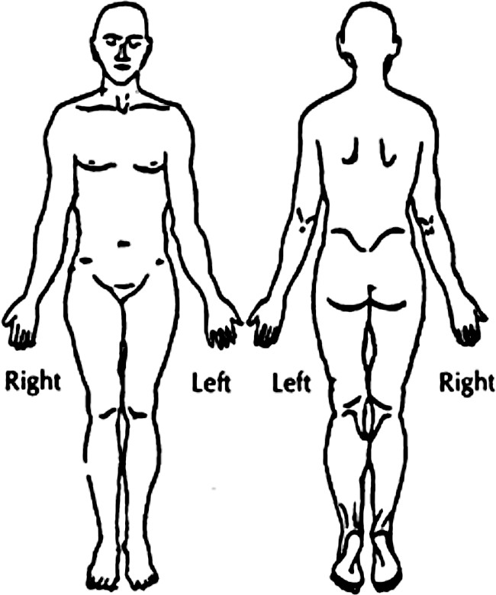
Location – What areas of your body are affected?

Optional: Put an X or shade in the areas of your body where the symptoms are.

Quality - If the symptom is pain, what is the pain like?

Severity - How bad is it? Does it bother you a little bit or a lot?

Optional: You may want to use a pain scale to describe how bad your pain is. Some people like these scales; others don’t. If you are having pain, your provider may ask you to use a pain scale, so it may help to think about it in advance.

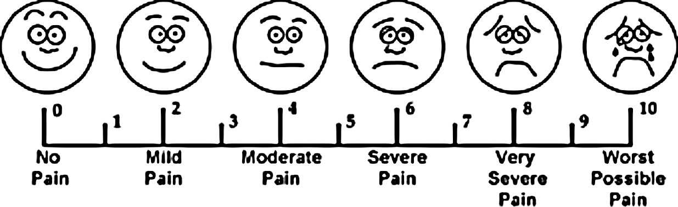

Duration – How long has it been going on? When did you first notice the symptom?

Onset - What were you doing when the symptoms first started?

Frequency and Patterns – Does the symptom come and go or is it there all the time?

Change from Baseline - What is normal for you? How is this problem different from how you usually feel?

What Makes it Worse/Better - What makes the symptoms feel better? What makes them worse?

Related Symptoms – Do you get other symptoms at the same time?

Other People – Do other people around you, like family and friends, have the same symptoms?

Effect On Lifestyle or Activities - How have the symptoms affected your life? Do they keep you from doing things that you normally do?

Treatments – What have you tried doing to treat your symptoms so far? Has it helped? What happened?

