

North West London Single Offer Enhanced Services

Contents
Respiratory Diagnostic Hubs (RDH) - Spirometry and FeNO Service 2
Management of serious mental illness (SMI) and complex common mental health needs (CCMI). 8
Phlebotomy 23
Paediatric Phlebotomy 26
Wound Care 30
Ambulatory Blood Pressure Monitoring 33
Electrocardiogram 37
Multi-Disciplinary Diabetes Team Service Specification (Level 2) 40
Early Onset Type 2 Diabetes Service 61
Anticoagulation Warfarin Service 75
Latent Tuberculosis Testing 83
Ring Pessary 89
Near Patient Testing for Disease-modifying anti-rheumatic drugs (DMARDs) 94
Coil Fitting for Non-Contraception 110
Asylum Seeker Service for Interim Accommodation Centres 114
Asylum Seeker Service for Overnight Initial Accommodation Centres - OIACs 123
Safeguarding Adults and Children 132
Respiratory 136
Applicable Service Standards 148
Medicines Optimisation Enhanced Service 151
Improving Access in General Practice 160
Child Health Hubs……………………………………………………………………….....................................186
Cardio-Renal-Metabolic Conditions…….…………………………………………………………………………195

Service | Respiratory Diagnostic Hubs (RDH) - Spirometry and FeNO Service

- National context and evidence base
The implementation of Out of Hospital (OOH) Strategies changed the way both acute and community services are delivered with a focus on delivering care as close to patients’ homes as possible and ensuring that patients are at the centre of care delivered by quality services in Primary Care. Most of the 8 NWL boroughs had established Spirometry services that were suspended at the beginning of the COVID-19 pandemic.

The NHS Long Term Plan published in 2019 increases the focus of the provision of services based on population health through Primary Care networks (PCNs) and NWL has developed Enhanced Services that are outcome focused and population based.

The aim of the service is to provide timely, quality assured diagnosis for patients with breathlessness and/or cough and/or other respiratory symptoms by improving access to quality assured diagnostic tests at a population level and usually within a community setting. When establishing diagnostic pathways, we encourage collaborative work between commissioners and providers to ensure that access is promoted to reduce health inequities in diagnosis and in turn, respiratory outcomes.
- Aims and objectives of service
This service is intended to commission the service provider to deliver quality assured diagnostic spirometry and FeNO testing (as appropriate) to enable the accurate diagnosis of COPD and asthma. Spirometry is an essential investigation for diagnosis and assessment of severity in people with COPD and other respiratory conditions. Failure to diagnose matters because decline in lung function is faster in the earlier stages of COPD and undiagnosed patients do not receive the treatment that we know makes a big difference to outcomes.

This service must be delivered to all patients registered with practices across a borough ensuring equitable access and quality of service to the entire population group. The location(s) for delivery of the service (number of delivery points) needs to be agreed with NWL ICB. The intent is that most boroughs should have one or two hubs per borough depending on size of borough, appropriate estate and workforce capacity – however larger boroughs may need additional site(s). All sites must ensure that they can meet the operational and workforce requirements including need for sufficient training and provision of consultant oversight.
- Service Description/Care Pathway
The service will be available to all patients registered with GP practices within the primary care network. The service will be delivered by a lead provider for all patients/PCNs and will offer:

- Diagnostic quality assured spirometry and FeNO in breathless patients, for example those with suspected COPD / asthma
- Diagnostic quality assured spirometry in patients whose previous diagnosis of COPD has been made without post-bronchodilator spirometry or where the patient has a diagnosis of COPD with a FEV1/FVC ratio of greater than 0.70
- Diagnostic quality assured spirometry in those patients discharged from hospital with “Suspected COPD”
- Diagnostic spirometry and FeNO to clarify diagnosis in patients with dual COPD and asthma diagnosis in primary care
- Diagnostic reports to general practice with actions / suggestions for action
- The service should ensure non-English speaking patients are included by using interpreters

Lead providers responsible for delivering the services will ensure the following, including preparing for the test:

- Identifying the type of spirometry required (post bronchodilator OR pre and post bronchodilator to test reversibility)
- Suitability for FeNO testing
- Providing patients with all information required ahead of the test
- Ensuring that the patient’s registered GP has prescribed a Salbutamol inhaler and Spacer
- Administering the prescribed drug as per local policy (this can be self-administered by the patient or by a registered healthcare professional).
- Patient appointment should be of sufficient duration to offer all appropriate tests within an appointment
- Record the outcome of spirometry using SNOMED code’ COPD’ 13645005 OR ‘Spirometry reversibility positive’ 314981002 OR ‘Spirometry reversibility negative’ 314980001
- Record the outcome of FeNO testing using appropriate SNOMED code, where not automated through agreed templates.
- Complete the NWL Template : ‘ NWL ICS Respiratory Diagnostic Hublet Service 2025/26’

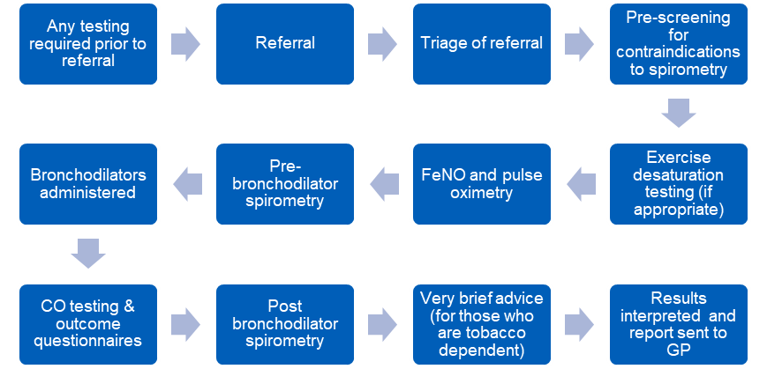

Provider will ensure that adequate consultant led supervision is in place via contracting. The consultant support is to provide oversight and regular MDT by as well as regular checks of testing and reporting accuracy (e.g. checking a proportion of reports for accuracy), supporting virtual reviews and providing specialist input in MDT for patients needing review e.g. uncertain diagnosis.

Guidance for testing:
Suspected asthma
- A blood eosinophil count should be requested at the time of referral for spirometry if there is no historically blood eosinophil count available undertaken in the last 3 years.
- FeNO (should be undertaken before spirometry)
- Spirometry
- Bronchodilator reversibility
  - in patients who demonstrate evidence of airways obstruction and who have not taken a bronchodilator (short or long acting) prior to testing
  - in patients who have normal spirometry and who have not taken a bronchodilator (short or long acting) prior to testing with a clinical history consistent with asthma (to obtain objective evidence of variability)
  - in patients with restrictive spirometry

Suspected COPD
- FeNO (should be undertaken before spirometry)
- Spirometry
- Bronchodilator reversibility
  - in patients who demonstrate evidence of airways obstruction and who have not taken a bronchodilator (short or long acting) prior to testing

Chest x-rays
- A chest x-ray should be requested at the time of referral for spirometry and ideally undertaken before diagnostic testing
- If a chest x-ray is available in the previous 12 months this may not need to be repeated if there has been no change in the patient’s symptoms since it was undertaken

In addition, if reversibility testing is required, the Provider will ensure:

- Salbutamol to be administered via spacer
- Wait 15-20 minutes before performing of post-bronchodilator spirometry
- Recording of post-bronchodilator spirometry results and record the degree of reversibility.

Provider will also ensure that infection control and equipment standards are complied with and will follow procedures in line with required infection control policies:
- Mouthpieces for spirometry must be single use with one-way valve and disposed of after each use in line with infection control policy.
- Mouthpieces for FeNO testing must be single use and disposed of after each use in line with infection control policy.
- Manufacturer’s instructions must be followed for regular cleaning and disinfection of the spirometry transducer.
- Cleaning and disinfection of the transducer is also carried out before use on immuno-suppressed patients and after use on any patients with open sores, bleeding gums or known infection.
- There are systems in place for the regular replacement of spirometer components, such as filters, in accordance with manufacturer’s instructions.
- The external surfaces of the equipment are wiped over between patients with hot water and detergent or detergent wipes

Please note that a SOP for the hubs is available upon request and goes into full detail on operational requirements – this is subject to change as guidance on acceptance criteria, IPC and so on changes.

Reporting Requirements

In addition to the standard monthly reporting requirements, hubs will also be required to report on the following:
- Waiting times (and information on any delays including contingency plans)
- Auditing – regular audits will be required to assess the clinical safety of the service
- A named hub contact will need to be provided to the ICB who will be responsible for submitting monthly reports and responding to queries
- Any Acceptance and exclusion criteria and thresholds
Acceptance
- Patients aged 18 and above:
- Breathlessness query cause and/or cough query cause (to confirm or support a differential diagnosis)
- CXR within the last 12 months or one booked along with this referral
Exclusions at time of spirometry/FeNO appointment:
- Spirometry to monitor the disease progression of patients with a known diagnosis of COPD, including as part of their annual review.
- FeNO to monitor/manage previously established asthma diagnosis
- < 18 years old*
- A chest infection or exacerbation (within last 6 weeks)
- Had a recent eye surgery (12 weeks standard, 6 weeks laser), chest or abdominal surgery (in the last 12 weeks)
- Uncontrolled high or low blood pressure
- Coughed up blood
- Experienced chest pain, had a heart attack or stroke in the last 12 weeks
- Condition which may be aggravated by prolonged expiration i.e. history of panic attacks
- Recent mouth/dental procedures or infection, which may make placement of the mouthpiece distressing or painful

Patients not suitable for Diagnostic Hub:
- Patients requiring specialist review in the chest clinic
- TB or patients with suspected cancer (2 week wait referrals) or any other respiratory “red flags”
- Routine follow up spirometry as part of annual review
- Patients for whom FeNO readings are needed to assess treatment response
- Bed-bound patients or patients who are unable to sit upright
- Patients with cognitive impairment or dementia to a degree that they will not be able to follow instructions
- Training, Skills and Experience
The Provider is responsible for ensuring all clinical staff have the necessary license to practice and qualifications and continuing professional development required to maintain their qualification. As a minimum this should include:

- Staff performing and interpreting spirometry and/or FeNO to be trained and assessed to ARTP or equivalent standards by recognised training bodies in the performance and interpretation of spirometry/FeNO, and that they receive regular updating (e.g., every three years).
- Minimum of 5 diagnostic spirometry tests performed per week (Healthcare Professional responsible for keeping a record of number of tests performed).
- Staff performing and interpreting spirometry and/or FeNO to have adequate regular formal supervision and an agreed number of tests/interpretations reviewed per annum.
- The service will have specialist clinician oversight of patients results and interpretation of test results. This clinician shall be the named contact for the hub and be responsible for ensuring appropriate auditing and reporting takes place and be responsive to queries from the ICB.
- Clinical oversight, support and audit for the hub is required from a respiratory consultant or from an expert adult/paediatric respiratory specialist clinicianClinics are to be supported by an allocated clinical assurance lead (funded by the ICB) who will provide supervision to enable optimal clinical governance, optimal staff training and support for clinicians in general practice & ongoing staff development, and consultant review of difficult diagnoses or cases with multiple related comorbidities (avoiding need for referral to CDC or secondary care). The hub shall be required to engage with this consultant and ensure they allow supervision, auditing and training support from them as well as implementing their recommendations for service improvement.
- An MDT consultant will also be paid for by the ICB. The hub remains responsible for organising the MDT and inviting their relevant consultant to the MDT. The tariff has been top sliced so the funding for the consultant is now paid directly by the ICB so that PCNs no longer need to be pay for the consultant themselves via an SLA, thereby reducing the administrative burden required.
- Staff should be trained in level 1 tobacco dependence support and be able to signpost or refer to local specialist smoking cessation services where they exist. They should be able to assess MRC dyspnoea score, CAT and ACT as required, understand and be able to explain the principles of pulmonary rehabilitation and signpost referring GPs to refer patients to their local PR service where appropriate
- Equipment
Estates
The estates and IPC requirements for the hubs are outlined in the London specification. The NWL estates team supported by the IPC lead have provided the following checklist:

- An ideal room size of approximately 12-16 square meters, with an absolute minimum size being 10 square meters.
- Mechanical ventilation provision offering a minimum of 6 air changes per hour (in accordance with HTM03-01).
- Natural ventilation maybe used in conjunction with mechanical to dilute viruses or singularly if allowing sufficient air into the room where mechanical is not available
- The room is free of soft furnishing to include window dressings to allow for ease of cleaning.
- A wash-hand basin fitted with a thermostatic mixing valve (set to between 39oC and 43oC – in accordance with HTM 04-01)
- Soap dispenser
- Paper towel dispenser
- Apron and glove dispenser
- Pedal-operated sack holder for both clinical and non-clinical waste.
- Supplies trolley
- Workstation
- Operator’s chair - upholstered with a wipeable material
- Consulting chairs - upholstered with a wipeable material
- All wall units will require sloped tops.
- Wash-hand basins to be fitted with level taps and display hand hygiene posters.
- Floors to be hard, sealed and impervious to moisture with upstands.
- Spirometry is not classified as an aerosol generating procedure (AGP). A fluid repellent surgical mask, apron and gloves should be worn for each patient.
- The patients should be offered a fluid repellent face mask to wear when not completing tests if tolerated and used to contain a cough then disposed of during testing.
- Patients should be advised to decontaminate hands prior and post procedure.
- All surfaces and equipment that is not disposable should be cleaned with a detergent and disinfectant between patients. This should include high contact surfaces such as door handles.
- Staff should not consume food and drink in these areas.
- Clinical areas must be clutter free and any display posters must be able to be cleaned.

APPENDIX I - CONTRACTUAL REQUIREMENTS
SPIROMETRY
Unit Price | £80.12 per patient appointment
Service Type | - Episodic | Pop-Up used to Record ‘Enhanced services administration (166221000000105)
Business Rule | Activity is capped 1 per patient per year
Referral Criteria | Patients aged 18 years and above are Mandatory under this contract

CODING NECESSARY FOR PAYMENT
Ref. | Description | SNOMED Code
SP01 | Spirometry Screening | Spirometry Screening (171255006)  AND  Enhanced Service Administration (166221000000105)

PAYMENT/KPI RULES
To Achieve Payment for Spirometry Screening SP01

- Has SNOMED code of Spirometry Screening (171255006) AND
- Has SNOMED code of Enhanced Services Administration (166221000000105) recorded by the provider at the same time as the Spirometry test
- Patient appointment should be of sufficient duration to offer all appropriate tests within an appointment
- Payment for spirometry tests shall be capped at 1 test per patient per year
- Providers will need to submit the necessary reporting requirements including waiting times

Service | Management of serious mental illness (SMI) and complex common mental health needs (CCMI).

- National context and evidence base
North West London ICB is focused on decreasing inequality across the eight constituent boroughs to ensure that patients are at the centre of care, with the Primary Care Network (PCN), managing and coordinating the care received as part of the wider Integrated Care Partnership (ICP). A key part of this approach will be to support the continued development of high quality primary care at both a practice level and network level.

A key approach for decreasing inequality and variation, is the extension of an improved wrap-round offer in primary care for patients who have long term or complex mental health needs. GPs are central to coordinating this care and as such this Enhanced Mental Health Service specification has been developed to provide GPs with appropriate remuneration to deliver care to patients who have complex needs through proactive engagement and support.

This service will support the delivery of an enhanced biopsychosocial care approach which encompasses an extended annual mental health review (hereafter also described as “Annual Review” or “annual review”). This includes a Recovery and Stay Well plan and a patient reported wellbeing measure (e.g. Short Warwick-Edinburgh Wellbeing Scale (SWEMWBS)) and a follow up appointment during the year, to better engage with patients with serious mental illness and complex common mental health needs with primary care services.
- Aims and objectives of service
The ICB is commissioning a service for the Enhanced Case Management of patients on the SMI QOF register and patients with complex mental health needs. This includes patients who are under Secondary Care and those under the sole care of their GP, in order to:

- Provide proactive case management for these patients, supported by a holistic Annual Biopsychosocial ‘Recovery & Staying Well Plan’ and patient contact throughout the year to review progress.
- Ensure that the patient benefits from high quality care, delivered as close to their home as appropriate.
- Prevent or reduce unnecessary referrals and admissions to specialist services and Secondary Care.
- Enable more integrated care of these patients between primary and secondary care so that their care can be provided in the most appropriate setting.
- Promote physical health and wellbeing for these patients including engagement with primary care and community based services.

This service is in addition to those services that GMS, PMS and APMS providers are contracted to provide to their registered patients. The specification of this service is designed to cover the enhanced aspects of clinical care of the patient, which are considered beyond the scope of essential services and additional services within the GMS, PMS and APMS contract.
- Service Description/Care Pathway
Case Finding

The service provider will:

- Update their SMI QOF list and proactively invite the patients on the reviewed list for an Annual Mental Health review.
- Proactively identify, patients with Complex Common Mental Illness, from their registered list, on a case by case basis who are more likely to benefit from a proactive case management approach.
- The completion of targeted searches is not a mandatory requirement for case finding. However, guidance is provided to support the service provider to identify patients who may be likely to benefit from this enhanced service. The criteria are broad to enable GPs to include any patient with common mental illness they feel would benefit from this approach.

Proactive Case Management

The service provider will:
- Carry out an Annual Mental Health Review (recommended at a duration of 30 minutes for each patient) comprising of a biopsychosocial assessment and resulting in a care plan that is given to the patient that includes relevant physical health interventions and applicable screening information.
- Offer a minimum of one follow up appointment (recommended at a duration of 10-20 minutes for each patient), during the financial year (1st April - 31st March), to review progress and make adjustments against the plan where necessary.
- Undertake all required prescribing, monitoring, administration and annual review of medication, particularly for patients taking Lithium. This will include provision of depot antipsychotics in primary care to those patients who are stable on these medications

Appointment Guidance

- All consultations should be recorded on the primary care clinical system using the appropriate Mental Health Enhanced Service template (EMIS or SystmOne).
- Where appropriate and with the consent of the patient, carers may be involved in any appointments in primary care. If carers are involved, they will have the opportunity to have an individual appointment with the patient’s GP to discuss any issues they may have. If the carer has legal responsibility for the patient, they must be involved in all review appointments.
- It is expected that a majority of the Minimum Data Set (MDS) information will be available when carrying out the Annual Review and that the GP will carry out either the annual review or at least one follow-up appointment. The other one of these appointments may be carried out by a suitably trained clinician (such as a clinical pharmacist, a physician’s assistant or an advanced nurse practitioner). This is NOT the role of the mental health ARRS practitioners in NW London as it is not an effective use of their specialist mental health skills. Oversight of the final care plan should always be given by the GP.

The service provider will also:

- Ensure each patient has a named case manager. This should be a registered GP.
- Ensure adequate follow up and engagement of all patients who Did Not Attend (DNA), particularly those on the SMI register. Practices must have a protocol for the follow up and engagement with patients who DNA.
- It is expected that practices will make multiple attempts to contact patients via different methods, including using voluntary sector or Link Worker staff as peer support to promote the importance of this check to patients who struggle with motivation.
- Assess whether patients with CCMI require ongoing proactive case management after 12 months of entry to the service; this can be discussed with the patient as part of the annual review. The expectation is that patients with ongoing SMI will remain with the service long term, unless they meet the ‘in remission’ criteria of five years without antipsychotic medication, secondary care or inpatient treatment.

The Annual Mental Health Review and Minimum Data Set (MDS) Requirements

- Requirements
In one financial year the service provider is required to complete the Annual Mental Health Review described below, and a minimum of one follow up appointment, with the Minimum Dataset having been recorded. Note, however that it is not mandated that these follow up appointments must necessarily sequentially follow an annual review, as we recognise that patient specific circumstances will dictate the most appropriate type of consultation to take place at any one time. There is also no time limit on when these should occur during the year to allow this flexibility. First and follow up appointments must not occur on the same day.

This is a GP delivered service so the GP must carry out either the Annual Review consultation or the follow-up appointment. The other appointment may be carried out by a suitably trained clinician (such as a clinical pharmacist, a physician’s assistant or an advanced nurse practitioner) with the care plan reviewed by the GP. These consultations must include completing the Recovery and Stay Well Plan (RSWP) with the patient as an agreed Care Plan. This should be given to the patient on the same day, or posted where the consultation is undertaken virtually. Other clinicians in the practice team may support the GP in providing lifestyle and physical health information as part of the MDS. It is expected that a majority of the MDS information will be available when carrying out the Annual Review.

GP and practice non face-to-face time for liaison with Psychiatry, PCLNs, CPNs and other staff involved in a patient’s care, telephone calls, DNA follow up and depot injections as appropriate, is included in the tariff price paid for each patient. The ongoing work around transformation of mental health services in NW London requires an integrated approach to ensure that where appropriate, patients can benefit from transfer to primary care so that their recovery journey can be based in their local community. Access to VCSE and social supports can be as important to their recovery as more traditional psychiatric treatments and are a part of their ongoing care needs. This also frees up capacity within secondary care services to enable them to be more responsive to the needs of those patients who are more acutely or severely unwell.

Equally, depot antipsychotic injections can be given in primary care to patients who are stable and who accept the need for them. This reduces the stigma around their treatment and helps to promote their engagement with primary care and community based services. Please see the NW London Transfer of Prescribing of Antipsychotics Guidance (August 2021) for more details. Good communication between primary and secondary care is key to this ease of transfer of patients in and out of secondary care. Rapid access for GPs to secondary care advice can avoid unnecessary and prolonged relapses that are damaging to a patient’s recovery. The new PCN mental health practitioner roles will be a key enabler to this. Read only access between mental health trust and GP records further enables this communication and is now possible between CNWL and GP S1 modules and CNWL S1 and EMIS. Consent is required from each practice to allow this and providers of this Enhanced Service should provide consent for this sharing.

- The Annual Mental Health Review

The Annual Mental Health Review is a comprehensive biopsychosocial consultation that considers the MDS detailed below and results in an agreed, documented, and printed Care Plan that the patient takes away. This will include physical health interventions appropriate to the MDS data collected and applicable screening information. The Annual Review should include all aspects of the MDS within that financial year, and be reviewed by the GP. The Recovery and Stay Well Plan must be completed by the GP OR another suitably trained clinician (such as a clinical pharmacist, a physicians assistant or an advanced nurse practitioner). They must also generate a Care Plan and give this to the patient. Other clinicians in the practice team may support the GP in providing lifestyle and physical health information which informs the MDS.

- The Minimum Data Set (MDS)

For every patient registered, the mandatory 15 MDS items (which include the Recovery and Stay Well Plan (RSWP) should be completed by financial year end.

The mandatory items are shown in the table below and must be completed as these are specified and monitored by NHSE or are essential elements of the check including the RSWP, 2 appointments and the medication review. Failure to complete the 15 mandatory items will result in that patient’s check not counting towards the MDS target.
Ref. | What is required? | Number per year | Mandatory | Carried out by
1. | BMI | 1 | ✓ | GP or HCA or Nurse
2. | BP | 1 | ✓ | GP or HCA or Nurse
3. | Diet assessment | 1 | ✓ | GP or HCA or Nurse
4. | Exercise assessment | 1 | ✓ | GP or HCA or Nurse
5. | Smoking status | 1 | ✓ | GP or HCA or Nurse
6. | Alcohol intake | 1 | ✓ | GP or HCA or Nurse
7. | Substance misuse | 1 | ✓ | GP or Nurse
8. | Cancer screening prompts (breast bowel, cervical) | 1 | ✓ | GP or Nurse
9. | RSWP | 1 | ✓ | GP or Clinical Pharmacist or Physicians' Assistants or Advanced Nurse Practitioners or ARRS MH Practitioners***
10. | Medication review | 1 | ✓ | GP or Clinical Pharmacist or Physicians' Assistants or Advanced Nurse Practitioners
11. | HbA1C or fasting glucose | 1 | ✓ | GP or HCA or Nurse
12. | Lipids or cholesterol | 1 | ✓ | GP or HCA or Nurse
13. | Lithium monitoring | 2 | ✓ | GP or HCA or nurse
14. | First Appointment | 1 | ✓ | GP*/clinical pharmacist/ physician's assistant/ advanced nurse practitioner AND HCA or nurse
15. | Follow up Appointment (must not occur on the same day as First Appointment) | 1 | ✓ | GP*/clinical pharmacist/ physician's assistant/ advanced nurse practitioner AND HCA or nurse

HbA1C or fasting glucose and lipids or cholesterol will NOT be mandatory for SMI and CCMI patients who are NOT on antipsychotic medication AND are under 35 years OR have had these blood tests done within the last 3 years. For all patients, HbA1C is usually offered as this does not require a fasting test. Where this is not suitable, a fasting glucose test may be used instead.

MH13 Lithium monitoring is ONLY required for patients taking Lithium. They must have a 6 monthly check of Lithium levels, renal function and thyroid function. For patients at higher risk this should be done 3 monthly. Please use the Lithium page of
the mental health template to document this.
*Either the First Appointment OR the Follow up appointment must be completed by the GP.
** RSWP must be supervised by the GP where is it not undertaken by the GP
***The aim is to involve the ARRS MH practitioners in this annual physical health check work as part of the primary care team where patients are most in need or are particularly difficult to engage in primary care.

- Overall outcome: Enhanced case management of patients with Serious Mental Illness and Complex Common Mental Illness.

Additional indicators are included in the clinical template as best practice, and while they are not monitored for payment purposes, they are monitored by NHSE, so PCNs should aim to include these areas in delivering the physical health checks to ensure it is recorded and that action is taken on abnormal metrics. Where patients have been referred for interventions previously, or have declined further intervention this does not have to be repeated in subsequent years. Providers should monitor at practice and network level as quality indicators and part of their regular audit cycle.

Interdependence with Other Services/Providers

This service is part of a wider integrated care pathway. The provider will support an integrated approach between services and providers, ensuring that patient records are transferred appropriately to support a seamless patient transfer and service provision.

The service provider will be expected to work in close partnership with a range of health and social care providers, including:

- Local mental health services, which increasingly bring together psychiatric support, case management, health and social care navigators and peer support services.
- Integrated community and primary care mental health teams across North West London (Mental Health Integrated Network Teams (MINT) for West London NHS Trust and Community Mental Health Hubs for CNWL NHS Foundation Trust).
- Local employment, housing, benefits and other community/ voluntary sector based services, which are increasingly accessible to each PCN area.
- Secondary mental health services in the case of crisis/acute exacerbation and for shared care liaison.
- Providers of primary care or secondary care based psychological therapies.
- Local Authority commissioned services supporting wellbeing.
- Other acute providers delivering physical health care.
- Any Acceptance and exclusion criteria and thresholds
Acceptance

- Adult patients (aged 18 years and over) who are on the QOF SMI register.
- The most complex 5% of Adult patients (aged 18 years and over) with the following common mental illnesses whose condition is any of those listed below with recurrent, chronic, severe or treatment resistant conditions and with moderate functional impairment. Diagnoses in this category may include the following diagnoses to ensure patients who would benefit from this service are not excluded on diagnostic grounds:
- ADHD (Attention deficit hyperactivity disorder) or ASD (Autism spectrum disorder) with significant mental health comorbidities.
- Anxiety and/or depression.
- Eating disorders.
- Obsessive compulsive disorder.
- Perinatal mental health needs.
- Personality disorders.
- Post-traumatic stress disorder.
- Sexual and gender identity disorders.
- Sleep disorders.
- Somatization, somatoform or conversion disorders (Somatic Symptom Disorders).
- Substance related disorders with comorbidities.
- Patients prescribed an antipsychotic but not on SMI register.

These would include patients who:
- Are under primary care but have needs above those that would ordinarily be provided for under the GMS core contract, or the Quality Outcomes Framework, and require the additional proactive support.
- Are under secondary mental health care for more than 12 months, are stable and are not inpatients.

To add a CCMI patient to the CCMI register so their check is paid please tick the 'Add CCMI register' box on the NWL template, to add the payment code Mental health administration (713491000000106). If the patient does not need the check the following year, then please tick the 'Remove patient from CCMI register' box to remove this code.

It is key that there is coordination between secondary and primary care to ensure that all eligible patients, especially those with SMI, are enabled to access this service. If a patient is having difficulty attending for a check in a primary care setting, then support to do this may be sought from a VCSE organisation to assist them. Alternatively, they can be offered a check at a community based venue via secondary care if this is preferable for them by coordinating with the relevant Community Mental Health Service if they are under their care.

If patients have comorbid substance misuse needs, ADHD or ASD they will be assessed for their suitability and can be included in this service only if they have dual diagnosis with a mental health comorbidity. With substance misuse, they must be either stable or being actively managed by substance misuse services and again have dual diagnosis with a mental health comorbidity.

It is not expected that GPs will provide specialised management or therapy for specific mental health conditions (For example OCD, eating disorders). This will continue to be provided by secondary care. The focus of this work is the physical health and more general mental and social wellbeing aspects of care.

Exclusions

- Patients with mild to moderate CMI whose conditions respond well to first line treatment specified in NICE guidance.
- Patients under 18 years of age.
- Patients with a severe learning disability.
- Patients with organic illness.
- Training, Skills and Experience
- The service provider must ensure that the staff delivering the service meet appropriate training and competency standards.
- The practice GP service lead must attend a local or online education session on the delivery of the service when commencing the service.
- The GP may deliver the comprehensive biopsychosocial consultation that is part of the Annual Review by any appropriate means (face to face, online or by phone). This is a GP delivered service so the GP must carry out either the Annual Review consultation or the follow-up appointment. The other appointment may be carried out by a suitably trained clinician (such as a clinical pharmacist, a physician’s assistant or an advanced nurse practitioner) with the care plan reviewed by the GP.
- These consultations must include completing the Recovery and Stay Well Plan (RSWP) with the patient as an agreed Care Plan.
- Other clinicians may support the GP in collating lifestyle and physical health data which informs the Annual Review and providing patient follow up information in these areas, as set out in the Minimum Data Set (MDS)

APPENDIX I - CONTRACTUAL REQUIREMENTS
MENTAL HEALTH
Unit Price | The funding for this service is based on disease prevalence. PCN maximum achievement is derived from 70% of the SMI Register excluding patients in remission (of current registered patients) recognising that not all patients on the register will engage with the service and 5% of Depression Prevalence as a proxy measure for the level of complex common mental illness need. This is multiplied by a unit price of £224.47 to give the maximum financial achievement available.  Total budget achievement is subject to meeting Key Performance indicators as listed below.  The tariff will be split as follows based on PCN performance, incorporating:  The SMI and CCMI patient groups are separate in terms of clinical diagnosis, with separate denominators as above and will be monitored and paid separately. However, the CCMI checks will ONLY be paid if 60% of the SMI checks are completed as this group is the priority.  Refer to ‘The Annual Mental Health Review and Minimum Data Set (MDS) Requirements’ under ‘Service Description/Care Pathway’ for details on the Minimum Data Set (MDS) requirements.
  KPI | Target Thresholds | Financial Achievement
  % of QOF SMI Register patients with Mandatory MDS completed | <20% | 0%
  % of QOF SMI Register patients with Mandatory MDS completed | 20-29% | 30%
  % of QOF SMI Register patients with Mandatory MDS completed | 30-39% | 40%
  % of QOF SMI Register patients with Mandatory MDS completed | 40-49% | 50%
  % of QOF SMI Register patients with Mandatory MDS completed | 50-59% | 60%
  % of QOF SMI Register patients with Mandatory MDS completed | 60-64% | 70%
  % of QOF SMI Register patients with Mandatory MDS completed | 65-69% | 80%
  % of QOF SMI Register patients with Mandatory MDS completed | 70-74% | 90%
  % of QOF SMI Register patients with Mandatory MDS completed | 75%+ | 100%
  % of Depression QOF Register (denominator is 5% of the QOF register) Patients with Mandatory MDS completed | <20% | 0%
   | 20-29% | 30%
   | 40-39% | 40%
   | 40-49% | 50%
   | 50-59% | 60%
   | 60-64% | 70%
   | 65-69% | 80%
   | 70-74% | 90%
   | 75%+ | 100%
Service Type | - Package | No Pop-Up
Referral Criteria | Patients aged 18 years and above are Mandatory under this contract

CODING NECESSARY FOR PAYMENT
Ref. | Description | SNOMED Code
 | See Appendix II

TARGET POPULATION
Ref. | Description | SNOMED Code
SMI00 | Register of patients on Serious Mental Illness (SMI) register (not in remission) | QoF Mental Health Register
CC00 | Register of patients on Complex Common Mental Illness (CCMI) register | Mental health administration (713491000000106)

TARGET POPULATION RULE
Target Population for Mental Health SMI Register SMI00
- Patient must be Aged 18 and Over AND
- Is on QoF Mental Health Register WITHOUT a more recent QoF cluster MHREM remission SNOMED code

Target Population for Mental Health CCMI Register CC00
- Patient must be Aged 18 and Over WITHOUT in Target Population SMI00 AND
- Has SNOMED code Mental health administration (713491000000106) WITHOUT a more recent Improvement of status (390771008) recorded by provider in Financial Year

PAYMENT/KPI RULES
To Achieve Payment for Mental Health

- Patient must be Aged 18 and Over AND
- Is in Target Population SMI00 OR CC00 AND
- Has achieved coding for the mandatory Minimum Data Set Items recorded by the Provider: MH01-15
- First Appointment (MH14) and Follow Up (MH15) MUST NOT OCCUR on the same day.

MH16 – MH22 are part of the Clinical Template and are considered best practice. Providers should aim to offer the full review to all patients. This data set will inform your annual audit of the service.

CCMI checks payments will be made independent of SMI checks achieved but ONLY if the minimum of 60% of the SMI checks are completed as this group is the priority

APPENDIX II – MINIMUM DATA SET

CONTRACTUAL REQUIREMENTS 1.0
NW LONDON ENHANCED SERVICES: MENTAL HEALTH
Ref. | Description | Number required per year  (1 April -31 March) | SNOMED CT
MH01 | BMI | 1 | Body mass index – observation (60621009)
MH02 | BP | 1 | Any of below Systolic Blood pressure readings:  - Systolic arterial pressure (72313002)  - Non-invasive systolic arterial pressure (251070002)  - Systolic blood pressure (271649006)  - Minimum systolic blood pressure (314438006)  - Average systolic blood pressure (314440001)  - Minimum day interval systolic blood pressure (314441002)  - Minimum night interval systolic blood pressure (314442009)  - Minimum 24 hour systolic blood pressure (314447003)  - Average night interval systolic blood pressure (314445006)  - Average day interval systolic blood pressure (314446007)  - Average 24 hour systolic blood pressure (314449000)  - 24 hour systolic blood pressure (314464000)  - Average home systolic blood pressure (413606001)  - Self reported systolic blood pressure (1162737008)  - Ambulatory systolic blood pressure (198081000000101)  AND  - Diastolic arterial pressure (1091811000000102)  - Non-invasive diastolic arterial pressure (174255007)  - Diastolic blood pressure (271650006)  - Minimum diastolic blood pressure (314451001)  - Average diastolic blood pressure (314453003)  - Minimum day interval diastolic blood pressure (314454009)  - Minimum night interval diastolic blood pressure (314455005)  - Minimum 24 hour diastolic blood pressure (314456006)  - Average night interval diastolic blood pressure (314460009)  - Average day interval diastolic blood pressure (314461008)  - Average 24 hour diastolic blood pressure (314462001)  - 24 hour diastolic blood pressure (314465004)  - Average home diastolic blood pressure (413605002)  - Self reported diastolic blood pressure (1162735000)  - Ambulatory diastolic blood pressure (198091000000104)
MH03 | Diet assessment | 1 | Diet good ((310500000);  Diet average (310503003);  Diet poor (310502008)
MH04 | Exercise assessment | 1 | Enjoys heavy exercise (160633003)  Enjoys moderate exercise (160632008)  Enjoys light exercise (160631001)  Gets no exercise (228445002)  Exercise physically impossible (160629005)
MH05 | Smoking status | 1 | Smoking status QOF Cluster
MH06 | Alcohol intake | 1 | Alcohol units consumed per week (1082641000000106)  Alcohol intake (160573003)*  *note: this code is no longer recommended for use
MH07 | Substance misuse | 1 | Misuse of prescription only drugs (191939002)  Injecting drug user (226034001)  Has never misused drugs (228368007)  Misused drugs in past (44870007)  Misuses drugs (361055000)
MH08 | Cancer screening prompts (breast bowel, cervical) | 1 | Provision of information about cervical screening programme (851141000000101)  Advice given about breast screening programme  (710871000000104)  Advice given about bowel cancer screening programme (382161000000102)
MH09 | RSWP | 1 | Mental health personal health plan (736058004)  AND complete the 4 fields from the Stay Well template section:  - Signs that patient is becoming unwell 274652004) AND  - Anticipatory care plan if patient unwell 792871000000101) AND  - Agreeing on mental health care plan (867851000000109) AND  - Review of patient goals (775501000000108)
MH10 | Medication review | 1 | Mental health medication review (413143000)
MH11 | Serum lipids or cholesterol | 1 | Plasma total cholesterol level (1017161000000104)  Serum cholesterol level (1005671000000105)  Serum cholesterol normal (166828006)  Serum cholesterol raised (166830008)  Serum cholesterol very high (166831007)  Serum fasting total cholesterol level (1083761000000106)  Serum total cholesterol level (994351000000103)  Total cholesterol measurement (121868005)
MH12 | Serum HbA1c or fasting glucose level | 1 | HBA QOF cluster (16 codes)  OR  GLUC QOF cluster (35 codes)
MH13 | Lithium monitoring | 2 | Which must include the following twice per year for all patients on Lithium:  1. Serum lithium level (1006681000000100)  2. eGFR: either  - eGFR (estimated glomerular filtration rate) using creatinine Chronic Kidney Disease Epidemiology Collaboration equation per 1.73 square metres (1011481000000105) OR  - GFR - glomerular filtration rate (80274001) OR  - GFR (glomerular filtration rate) calculated by abbreviated Modification of Diet in Renal Disease Study Group calculation (1020291000000106) OR  - GFR (glomerular filtration rate) calculated by abbreviated Modification of Diet in Renal Disease Study Group calculation adjusted for African American origin (996231000000108)  3. Serum TSH (thyroid stimulating hormone) level (1022791000000101)
MH14 | Annual mental health review complete | 1 | Mental health review (401061005)
MH15 | Follow-up consultation | 1 | Mental health review follow up (248691000000104)

Please note:

- A follow up appointment must be carried out in the same financial year as the Annual Review. However, it is not mandated that these follow up appointments must necessarily sequentially follow an annual review. We recognise that patient specific circumstances will dictate the most appropriate type of consultation to take place at any one time. There are also no time limits on when these should occur during the year to allow this flexibility
APPENDIX III - Guidance to Practices in targeting the ‘Top 5% of Common Mental Illness Patients’

Background

The previous SMI (Serious Mental Illness) and CCMI (Complex Common Mental Illness) Mental Health Specifications have been extensively reviewed following feedback from practices and commissioners. Greater clarity, specificity and simplicity have been brought to this revised, joint specification with an aim to simplify delivery of the service.

One particular area that greater clarity and guidance was sought was on how practices can target the right patients from all those with common mental illness. Unlike SMI, for which there is a QOF Register, equivalent to ‘known prevalence’, there is no such register for Complex Common Mental Illness. The depression QOF register covers only patients with depression and anxiety, the vast majority of who would not meet the ‘complexity’ test. Common Mental Illness includes a range of conditions including eating disorders, personality disorders, PTSD as well as anxiety and depression. Within these conditions, many patients are often well functioning, or responsive to treatment (talking therapies and medications). Some however are particularly hard to engage with, may not function well, and may be poor responders to treatment. It is for this group that the previous CCMI specification (and this current, joint Mental Health specification) was intended: the top 5% of CMI patients in your practice that are the most complex, that would benefit from the extra time and structure that the Mental Health Enhanced Service specification brings in terms of detailed review, care planning, and follow up throughout the year to improve or maintain their physical, mental health and social wellbeing.

How were the population estimates arrived at?

In the absence of a QOF register, the Clinical Review Group undertook a literature review of the target conditions, to establish evidence based estimates of common mental illness per area. This review determined that across conditions, prevalence of common mental health needs was on average 5.5% of the adult registered population. As described above however, this will include a majority of patients whose level of health and functioning would not merit receipt of the enhanced services. The ‘Top 5%’ of these patients would be the most complex, and this equates therefore to 0.275% of the adult practice population.

This was modelled at borough level using the 18+ population and the target number of CCMI patients is determined as a proxy by the depression prevalence in each borough at the start of each financial year.:
Example: PCN depression prevalence = 1000 patients
CCMI target will be 5% = 50 patients
Minimum expected achievement is 60% = 30 patients to have the check

Each borough will individually determine the number of SMI and CCMI patients eligible for the service and will advise practices on the level of expected associated in-year activity.

How can practices systematically target the most complex 5% of CMI?

GP Mental Health Clinical Leads have collaborated to produce some guidance on ‘markers’ of complexity that GPs and practices can use to systematically search for patients from their lists that may benefit. It should be stressed that this is not an exhaustive or ‘water tight’ search strategy. The value of the Mental Health specification is that it strongly encourages individual clinical decision making. GPs’ knowledge and clinical judgement of their own patients and whether they would benefit from the proactive case management approach of the CCMI specification may be a far more reliable predictor than a list of ‘markers’ or search strategies. The markers set out below may act as a prompt for new ways of considering risk and complexity amongst this group.

The following are raised as potential ‘ways in’ for practices to establish their ‘Top 5%’ of patients with Complex Common Mental Illness for referral in:

(a) Diagnoses: The ‘in scope’ conditions for the specification are:

- ADHD or ASD with significant mental health comorbidities as discussed above
- Anxiety and/or depression.
- Eating disorders.
- Obsessive compulsive disorder.
- Perinatal mental health needs.
- Personality disorders.
- Post-traumatic stress disorder.
- Sexual and gender identity disorders.
- Sleep disorders.
- Somatization, somatoform or conversion disorders (Somatic Symptom Disorders).
- Substance related disorders with comorbidities.

The availability of reliable information on this on the primary care system will depend on the quality and consistency of coding and existence of a pre-existing diagnosis (which for some conditions will be less likely and less accurate than for others that have been included in QOF). In addition, of course, the specification is not intended for universal registration of all patients with such conditions, but only the top 5% most complex (e.g. recurrent and or, chronic, and/or severe, and/or treatment resistant, with poor levels of functioning, poor engagement in mental health and physical health treatments, multiple long term conditions, repeated DNAs).

Nonetheless, we would recommend such ‘global’ searches are carried out as it will foster a better understanding at practice level of the scale and scope of CMI in their population, and use that as a basis for exploring a targeted approach, considering the factors set out in the rest of this section.

(b) Patients being prescribed antipsychotic medication who are not on the SMI QOF

Antipsychotic medication may well have been initiated for some patients who do not have an SMI, but who have a personality disorder or severe depression and anxiety with psychotic symptoms, to control those symptoms, and often at low doses. Whilst patients who experience psychosis related to schizophrenia and bipolar disorder should be registered on then SMI QOF, those outside of those conditions from the list in (a) might well be receiving antipsychotic medication and would benefit from the enhanced biopsychosocial review and care planning involved in the CCMI specification.

Practices could cross match all antipsychotic prescribing against their SMI QOF list and consider whether any of these patients might benefit from the CCMI Enhanced Service specification.

(c) Frequently changing depression/anxiety prescribing

A search could be conducted looking at any patients on the depression QOF who have had frequent changes to the drugs they have been prescribed, which might be an indicator of treatment resistance, risk and hence complexity.

(d) CMI with comorbidities e.g. drug and alcohol, ADHD, ASD Long Term Conditions (LTCs), chronic pain and other mental illnesses

The presence of one or more comorbidity will be a key marker for escalated risk and lower functioning, indicating the need for an enhanced level of care. A search for patients with these illnesses, or individual GP insight into their patients, could quickly identify patients who may benefit from the service.

(e) CMI in patients who are pregnant

Pregnancy greatly escalates the risk factors for those with mental illnesses. Searching for patients with known pregnancy and who have one (or more) of the conditions set out under (a) would identify another at risk group who could be considered for the specification.

(f) Frequency of ED/UCC attendance

Amongst the patients identified under (a), have any attended ED/UCCs at elevated levels and for reasons that would not otherwise necessitate ED/UCC attendance. This might include physical reasons such as self harm, or excess presentation due to their mental ill health. Either could be markers of complexity that would benefit from enhanced support under the specification.

(g) Frequent DNAs

Those who DNA multiple GP or outpatient appointments may be at excess risk, notably if they have LTCs or other comorbidities. Such poor engagement in health care and support is likely a marker of poor levels of functioning and ability to self care. This specification is designed to give practices the extra resource to support them in the additional work that will be required to engage with those patients who are inherently difficult to engage.

(h) Safeguarding Children and/or Adults

Those patients with SNOMED codes related to safeguarding including domestic abuse and with one or more of the conditions under (a) may be a marker for referral in to the specification.

(i) History of childhood or familial mental health difficulties

Whilst this may not be coded, any patients who are known to have had a childhood mental health issue, or have a family history, may be at elevated risk. Consider in children who are reaching age 18 who had had a mental health issue. Consider cross checking notes of parents of children who have a mental health issue.

Please note, CCMI patients may not need the annual physical health check each year if their condition improves in year. Their inclusion the following year is therefore at clinician discretion.

APPENDIX IV - The Short Warwick-Edinburgh Mental Wellbeing Scale (SWEMWBS)

Below are some statements about feelings and thoughts.
Please tick the box that best describes your experience of each over the last 2 weeks

Statements | None of the time | Rarely | Some of the time | Often | All of the time
I’ve been feeling optimistic about the future
I’ve been feeling useful

I’ve been feeling relaxed

I’ve been dealing with problems well

I’ve been thinking clearly

I’ve been feeling close to other people

I’ve been able to make up my own mind about things

“Warwick Edinburgh Mental Wellbeing Scale
© NHS Health Scotland, University of Warwick and University of Edinburgh, 2006,
all rights reserved.”

Exemption is permitted where completion of SWEMWBS is not applicable, such as in cases when:
- No suitable translation or translation services are available.
- Patient has a Learning Disability or Autistic Spectrum Disorder.
- Severe lack of insight into their condition.
- Where completion of the tool would cause significant distress.

In these circumstances, please enter N/A on SystmOne/EMIS. No more than 5% of payment claims per practice can have this code.

Service | Phlebotomy

- National context and evidence base
The main strategic aims for the service are as follows.

- Patients have access to a local, primary care based phlebotomy service away from hospital sites.
- Reduction in secondary care phlebotomy activity;
- Reduced risk of covid19 infection.
- Reduce anxiety to patients.
- Reduced health inequalities by improved access to the service.
- Patients care is informed by prompt diagnostic test results.
- Develop and embed team based and flexible working across primary community and specialist care
- Develop high quality Primary Care services at practice level and within PCNs.
- Aims and objectives of service
- Delivering a timely and safe phlebotomy service
- Provide phlebotomy to patients registered at practices in the PCN who are aged 14+
- Provide a universal, equitable, clinically safe and high quality community phlebotomy service away from acute hospitals to reduce patient risk of covid infection.
- Ensure fast and local access for patients either in their own practice or a practice in the PCN which will offer appointments within 2 days for urgent. For routine tests this can be 7 days or longer according to the clinical indication of the test. Make phlebotomy service available closer to patients’ homes and reduce inequalities.
- Offer continuity of care for patients in familiar surroundings
- Service Description/Care Pathway
Care pathway
- GP/healthcare professional (HCP) will ensure the patient does not fall within the exclusion criteria for the service (excluded patients will be advised of alternative provider locations.)
- HCP will complete the appropriate requisition/blood form on ICE
- Phlebotomists to have access to ICE and clinical systems to ensure digital transfer of patient information and tests requested.
- Patient attends appointment Phlebotomist checks patient details and runs through covid check list questions then draws blood from patient as indicated by the referring HCP.
- Advise the patient regarding the test result follow-up process.
- Sample bottles are clearly and appropriately labelled
- Samples are sealed in appropriate bags and are stored in a safe and appropriate clinical environment prior to transportation to the Pathology Department, in accordance with the specimen handling section of Infection Prevention and Control Guidance for Primary Care
- The phlebotomist logs details of patient contact on appropriate system using codes specified.
- Collection of specimens and transport to secondary care pathology department
- Appointment waiting times should not exceed 7 days for routine bloods (unless clinically appropriate) and 2 days for urgent bloods. Appointments should be flexible for patients with additional needs such as disability /learning difficulties where best practice should be followed.
- Any acceptance and exclusion criteria and thresholds
Acceptance criteria
- Patients 14 years of age and above.
- Provided to housebound patients where clinically appropriate.
- Registered at a practice in a NWL Primary Care Network.
- Patients from whom venepuncture is difficult.

Exclusion criteria
- Infants and children up to 14 years.
- Glucose Tolerance tests, finger prick tests for glucose monitoring or general health screening.
- Patients on a secondary care 2WW/urgent pathway where a blood test is deemed clinically appropriate on the same day
- Secondary care outpatient clinic generated blood test requests
- Patients under the care of Accident & Emergency
- Inpatients
- Training, Skills and Experience
The Service may be provided by a Phlebotomist, GP, nurse, healthcare assistant or staff trained in accordance with the standards of the World Health Organisation’s guidelines on drawing blood: Best practices in phlebotomy (2010). In additon:

- Non-clinical staff such as receptionists or health care support workers should undergo basic training in an appropriate training and competency programme prior to commencing supervised practice;
- All healthcare assistants involved in the provision of the service must be working under the supervision of a qualified RGN or GP
- Staff are trained to treat any vasovagal fainting episodes.
- Staff renew competencies and certification as appropriate.
- Equipment
- The Provider is responsible for ensuring sufficient levels of consumables is maintained to deliver the service including the provision of specimen bottles and holders which will be of the type specified by the receiving laboratory.
- Consumables such as specimen bottles for blood samples (vacutainer), syringes, needles, the specimen bag and forms can be obtained in line with the agreement with your local pahtology provider
- The provider will need to supply the remainder of the equipment.
- All equipment used for taking blood is single use and must be disposed of immediately after use into either a UN-approved sharps container or orange clinical waste bag, in compliance with hazardous waste procedures.

APPENDIX I - CONTRACTUAL REQUIREMENTS

PHLEBOTOMY
Unit Price | £3.91 per blood test  Home visit - £10.34 (capped at one visit per day per patient)
Business Rule | Blood Test | All recorded activity is payable
Business Rule | Home Visit | 1 visit per patient per day across all services
Service Type | - Episodic | Pop-up not required
Referral Criteria | - Patients aged 14 years and above are Mandatory under this contract

CODING NECESSARY FOR PAYMENT
Ref. | Description | SNOMED Code
PHL01 | Number of consultations (payment per sitting) | Blood sample taken (313334002)
PHL02 | Blood sample home visits | Home Visit (439708006)

PAYMENT/KPI RULES
To Achieve Payment for Phlebotomy PHL01
- Has SNOMED code of Blood sample taken (313334002) recorded by the provider

To Achieve Payment for Phlebotomy Home Visits PHL02
- Achieved coding for PHL01 AND
- Has SNOMED code Home Visit (439708006) recorded at the same time as Phlebotomy

Service | Paediatric Phlebotomy

- National context and evidence base
Effective and efﬁcient phlebotomy services are crucial to the delivery of 70% of all clinical interventions since they affect diagnosis, treatment and long term monitoring of care. Phlebotomy services can be provided by a range of healthcare professionals in a wide variety of settings. Wherever an NHS service is provided, it is recommended that patient needs are considered to ensure samples are taken as local to the patient as possible, with ease of access and in a timely manner that allows early decision making

North West London ICB wishes to commission a timely and safe paediatric phlebotomy service that supports its strategic commissioning intentions to ensure that high quality care is delivered as close to the patients home as is appropriate.

All children registered with North West London practices should be able to access Phlebotomy from a local setting.
- Aims and objectives of service
Main strategic aims for the service are as follows.

- Patients under the age of 14 have access to a local, primary care based phlebotomy service away from hospital sites.
- Reduction in secondary care phlebotomy activity;
- Reduce anxiety to patients.
- Reduced health inequalities by improved access to the service.
- Patients care is informed by prompt diagnostic test results.
- Develop and embed team based and flexible working across primary community and specialist care
- Develop high quality Primary Care services at practice level and within PCNs.
- Delivering a timely and safe phlebotomy service
- Provide phlebotomy to patients registered at practices in the PCN who are aged 2-13.
- Provide a universal, equitable, clinically safe and high quality community phlebotomy service away from acute hospitals to reduce patient risk of covid infection.
- Routine tests should be conducted within 7 days or longer according to the clinical indication of the test. Make phlebotomy service available closer to patients’ homes and reduce inequalities.
- Offer continuity of care for patients in familiar surroundings
- Service Description/Care Pathway
The expectation for this services is that it will be delivered at scale across the Primary Care network with practices referring in to a local hub. The Primary care network will confirm with the borough team, the service offering and the sites from which the service will be offered. The Primary Care Network must keep the local borough team updated of any changes to provision so that referring practices have an up to date list of where to refer

Referring Practice

As part of the delivery the referring practice:

- Will provide the patients and/or family, on request, with written information about their blood tests, when to expect the results, and who to contact with any queries
- Order tests via the order comms system.
- Will explain to the patient and the family the reason for the blood tests and clearly communicate any specific instructions such as when the patient is required to fast for the blood test
- The referring GP will ensure prescriptions of EMLA or equivalent (where appropriate) and instructions are provided to the patient and the family, where required. If this is not undertaken the provider may at their discretion return the referral however the interest of the child should be considered paramount. This specification covers children aged between 2 and 13 years old. If a referring clinician is considering blood testing in an under 2-year-old then paediatric advice and guidance must be a requested in the first instance.

The Hub Provider

As part of the delivery the provider will:

- Provide a variety of clinics so patients can have bloods taken at a time convenient to them.
- Offer routine appointments.
- ensure Health Care Professionals and Health Care Assistants maintain their clinical competence for this Standard and:
- Ensure that staff comply with the infection prevention and control procedures and consider any additional measures as a result of COVID i.e. use of PPE, cleaning surfaces after each patient, social distancing in waiting room and triage before patient enters building. Draw blood from patients as indicated by the referring healthcare professional;
- Routine blood tests must be completed within ten working days from receipt of referral
- Ensure that all sample labels are electronically printed, where the service provider has the correct printing equipment to do so;
- Ensure samples are clearly and appropriately labelled i.e. samples should be marked urgent (where undertaken) or routine;
- Ensure that all samples taken are sealed in appropriate bags and are stored in a safe and appropriate clinical environment prior to transportation to the Pathology Department, in accordance with the specimen handling section of Infection Prevention and Control Guidance for Primary Care
- Ensure blood samples are stored in a separate bag from urine samples
- Any Acceptance and exclusion criteria and thresholds
Acceptance criteria
- Patients 13 years of age and younger (Excluding under 2s)
- Provided to housebound patients where clinically appropriate.
- Registered at a practice in a NWL Primary Care Network.
- Patients from whom venepuncture is difficult.

Service is split into three cohorts

- Patients 2-4 years of age
- Patients 5-13 years of age
- Patients 2-13 years of age with a Learning Disability

Exclusion criteria
- Children 14 years of age and older should be seen under the adult pleobotmy specifiaton
- Glucose Tolerance tests, finger prick tests for glucose monitoring or general health screening.
- Patients on a secondary care 2WW/urgent pathway where a blood test is deemed clinically appropriate on the same day
- Secondary care outpatient clinic generated blood test requests
- Patients under the care of Accident & Emergency
- Inpatients
- Training, Skills and Experience
The Service may be provided by a Phlebotomist, GP, nurse, healthcare assistant or staff trained in accordance with the standards of the World Health Organisation’s guidelines on drawing blood: Best practices in phlebotomy (2010). In additon:

- Ensure that the Health Care Professional and Healthcare Assistant undertake appropriate training to be able to deliver Paediatric Phlebotomy
- The Health Care Professional should have 2 years’ experience of taking adult bloods before taking children’s bloods.
- Non-clinical staff such as receptionists or health care support workers should undergo basic training in an appropriate training and competency programme prior to commencing supervised practice;
- All healthcare assistants involved in the provision of the service must be working under the supervision of a qualified RGN or GP
- Staff are trained to treat any vasovagal fainting episodes.
- Staff renew competencies and certification as appropriate.
- Equipment
- The Provider is responsible for ensuring sufficient levels of consumables is maintained to deliver the service including the provision of specimen bottles and holders which will be of the type specified by the receiving laboratory.
- Consumables such as specimen bottles for blood samples (vacutainer), syringes, needles, the specimen bag and forms can be obtained in line with the agreement with your local pahtology provider
- The provider will need to supply the remainder of the equipment.
- All equipment used for taking blood is single use and must be disposed of immediately after use into either a UN-approved sharps container or orange clinical waste bag, in compliance with hazardous waste procedures.

APPENDIX I - CONTRACTUAL REQUIREMENTS
PAEDIATRIC PHLEBOTOMY
Unit Price | Paediatric Phlebotomy (2-4 years) - £31.66 per blood test  Paediatric Phlebotomy (5-13 years) - £15.84 per blood test  Paediatric Phlebotomy (Learning Disability) - £31.66 per blood test  Home visit - £10.34 (capped at one visit per day per patient)
Business Rule | Blood Test | All recorded activity is payable
Business Rule | Home Visit | 1 visit per patient per day across all services
Service Type | - Episodic | Pop-up not required
Referral Criteria | - Patient over 14 years of age and older should be see under the adult phlebotomy contract  - Patients aged under 14 years are Mandatory under this contract  - Patients aged under 2 years are Excluded under this contract

CODING NECESSARY FOR PAYMENT
Ref. | Description | SNOMED Code
PPHL01 | Number of consultations (payment per sitting) | Blood sample taken (313334002)
PPHL02 | Blood sample home visits | Home Visit (439708006)

PAYMENT/KPI RULES
To Achieve Payment for Paediatric Phlebotomy PPHL01a
- Patient must be aged between 2 and 4 years AND
- Has NO SNOMED code in Learning Disability QOF cluster (LD) AND
- Has SNOMED code of Blood sample taken (313334002) recorded by the provider

To Achieve Payment for Paediatric Phlebotomy PPHL01b
- Patient must be aged between 5 and 13 years AND
- Has NO SNOMED code in Learning Disability QOF cluster (LD) AND
- Has SNOMED code of Blood sample taken (313334002) recorded by the provider

To Achieve Payment for Paediatric Phlebotomy Home Visits PPHL02
- Achieved coding for PPHL01 AND
- Has SNOMED code Home Visit (439708006) recorded at the same time as Phlebotomy

To Achieve Payment for Paediatric Phlebotomy (Learning Disability) PPHL03
- Achieved coding for PPHL01 AND
- Has SNOMED code in Learning Disability QOF cluster (LD)

Service | Wound Care

- National context and evidence base
Since 2019 NWL CCG has been implementing The NHS Long Term Plan which increases the focus of the provision of services based on population health through Primary Care networks (PCNs) which has lead towards the development of Enhanced Services that are outcome focused and population based.
- Aims and objectives of service
- To improve the quality of life for people requiring management of their wounds, through the delivery of clinically effective care and advice which reduces the risk of recurrent infection and promotes independence.
- To ensure that high quality care is delivered as close to the patients’ home as is appropriate
- Delivering a timely, effective and personalised wound management and healing service in a safe environment.
- Reducing attendance at A&E/UCCs for wound dressings that should be carried out under this service specification.
- Improving local symptoms such as pain, exudate and odour and healing rate through the use of appropriate treatment in accordance with best practice, published guidance and clinical evidence and reducing unnecessary or inappropriate use of dressings and wound care products.
- Detecting, and where appropriate treating, any infection to prevent deterioration of the wound and systemic involvement.
- Providing appropriate patient education so that patients may make informed choices and fully participate in their care and improve concordance.
- Promoting the use of individualised care management plans for all patients with communication at the point of discharge to patients, carers and healthcare professionals that promotes long term leg care and reduces the risk of recurrence.
- Preventing unnecessary referrals and admissions to specialist services, hospital or nursing homes. But where onward referrals are necessary completing these in clinically appropriate timeframes.
- Service Description/Care Pathway
Process:
- Ensure that patient consent has been obtained to access their record and review the referral, where appropriate.
- Assess the wound, ensuring that it is swabbed where clinical signs and symptoms of infection are indicated and treat as appropriate;
- Ensure that swab results are followed up (by the registered GP or as otherwise agreed by the PCN) and an assessment is made to whether antibiotics are required or need to be changed (antibiotics must be prescribed in line with existing prescribing guidance for primary care).
- The service provider will issue acute necessary prescriptions; the prescribing of repeat medicine as part of ongoing management remains the responsibility of the patient’s registered GP
- Develop a mutually agreed appropriate management and treatment plan to heal the wound and improve the patient’s quality of life
- Record details of the appropriate management and treatment plan in the patient’s record
- Provide clinically appropriate wound care management.
- Accommodate patients for urgent appointments, as clinically required. The maximum patient waiting time for an urgent appointment is one working day. GP Enhanced Access Hubs should be utilised.
- Reassess the wound and the management and treatment plan at appropriate intervals; any changes to the treatment plan should be updated on the patient’s record using the relevant clinical template, where appropriate.
- Update the patient’s registered GP of the management and treatment plan following the first consultation; where possible on the day of the consultation or otherwise within five working days of the first consultation.
- Inform the patient’s registered Practice when the patient is discharged from the service provider.
- Inform the patient’s registered Practice if the patient requires a referral for Compression bandaging or Doppler assessment, to enable an onward referral to be made under locally commissioned arrangements e.g. Community Tissue Viability Services (TVS)
- Inform patient’s registered practice if a patient’s wound has failed to improve after a maximum of six weeks of evidence based management, so that an onward referral to the TVS for expert assessment and advice on management can be made.
- Precribing dressings in line with the NWL Primary Care Wound Care Formulary
- Any acceptance and exclusion criteria and thresholds
Acceptance criteria
- Mandatory for patients aged 16 years of age and above
- Optional for patients under 16 years of age
- Post-operative wound check following surgery, where necessary
- Dressing change/reduction post-surgery
- Re-dressing
- Suture/clip removal
- Wound reviews, including pressure sores
- Minor wound infections
- Simple dressings for wounds from trauma or burns
- Packing for pilonidal sinus and abscesses following incision and drainage
- Wound care management pending review by and post discharge from specialist services, e.g. Diabetic podiatry, Tissue Viability Services, Doppler assessment and Compression bandaging (Venous leg ulcers).
- Home visiting is permissible for temporary housebound patient (note this is a temporary arrangement while we wait for the community contract for district nursing to be updated to include this cohort of patients).

Exclusion criteria
- Patients requiring home visits (including care/nursing home residents)
- Significant wound breakdown where re-suturing is necessary
- Reduction and removal of plaster type orthopaedic dressings after orthopaedic operations/fractures.
- On-going management of wounds under the care of specialist services, including Diabetic podiatry, Tissue Viability Services, Doppler assessment and Compression bandaging (Venous leg ulcers).
- Training, Skills and Experience
- The service provider must ensure all staff delivering the service meet the training and competency requirements outlined in the OOHS Training and Clinical Competencies Guidance document.
- All staff delivering the service should be trained and updated in aseptic technique (ANTT).
- Attendance at wound care training course. Registered nurses who are experienced and competent in the management of wound care need only attend re-fresher training.
- Staff should maintain clinical competencies by attending regular re-fresher update training. It is anticipated this should be every 2-3 years or sooner if changes to clinical guidelines occurs or if competency gaps are identified.
- Healthcare Support Workers, Healthcare Assistants and Nursing Associates with the appropriate training and competency can deliver the service if supervised by a registered nurse.
- Equipment
Dressings
- Dressing packs, gloves, stitch removers and normal saline are included in the price of the service per attendance.
- The service provider must keep a small supply of dressings in stock for the first assessment.
- The provider will be expected to use the FP10 for prescribing dressings in line with the NWL Primary Care Wound Care Formulary.

APPENDIX I - CONTRACTUAL REQUIREMENT

WOUND CARE
Unit Price | £16.21 per wound care appointment  £10.34 per wound care home visit
Business rule | Wound care | All recorded activity is payable
Business rule | Home Visit | 1 visit per patient per day across all services
Service Type | - Episodic | Pop-Up used to Record ‘Enhanced services administration (166221000000105)
Referral Criteria | - Patients aged 16 years and above are Mandatory under this contract  - Patients under 16 years are Optional under this contract

CODING NECESSARY FOR PAYMENT
Ref. | Description | SNOMED Code
W01 | Consultations utilised for Wound Care | Wound Care (225358003)  AND  Enhanced Services Administration (166221000000105)
W02 | Wound care home visits | Home Visit (439708006)

PAYMENT/KPI RULES
To Achieve Payment for Wound Care W01

- Has SNOMED code of Wound care (225358003) recorded by the provider AND
- Has SNOMED code of Enhanced services administration (166221000000105) recorded at the same time as the Wound Care

To Achieve Payment for Wound Care W02

- Achieved coding required for W01 AND
- Has SNOMED code of Home Visit (439708006) recorded at the same time as the Wound Care

Service | Ambulatory Blood Pressure Monitoring

- National context and evidence base
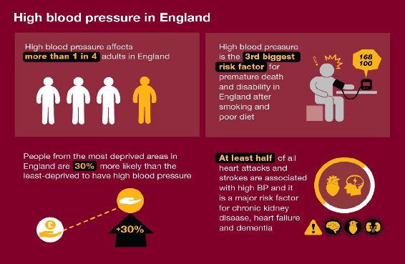
High blood pressure (hypertension) is described by NICE1 as ‘one of the most important treatable causes of premature morbidity and mortality in the world. It is a major risk factor for stroke, myocardial infarction, heart failure, chronic kidney disease, cognitive decline and premature death. Untreated hypertension is associated with a progressive rise in blood pressure’.

Hypertension continues to affect more than 1 in 4 adults in England and is the second largest single risk factor for premature death and disability in the country. A recent Public Health England (PHE) analysis suggests that there is now an opportunity to prevent more than 9,000 heart attacks and at least 14,000 strokes over the next 3 years if we work towards better detection and management of high blood pressure.

Ambulatory blood pressure monitoring (APBM) correlates well with invasive blood pressure measurement and can identify both white-coat and masked hypertension. ABPM remains the gold standard for the accurate measurement of blood pressure in primary care. ABPM has therefore been retained as the preferred method for the diagnosis of hypertension. It is indicated for diagnosing hypertension in patients with a clinic BP reading between 140/90 to 180/120 mmHg. If ABPM is unsuitable or the person is unable to tolerate it, offer home blood pressure monitoring (HBPM).

The plan sets out the requirement to focus on improving hypertensions case finding and diagnosis, where the largest undiagnosed prevalence gap remains and where the greatest reductions in premature mortality can be made.

There are 305,852 people in NWL diagnosed with hypertension; prevalence 10.7%. However, expected prevalence is 26% (745,140) so there are 439,288 people who are undiagnosed [WSIC Hypertension Dashboard; Accessed Jan 2023].

This service should be used alongside the BPM@Home service offered across NWL which aims to improve the BP control of at-risk patients, reduce the time pressures on general practice and prevent avoidable heart attacks and strokes. Blood pressure monitors are being allocated nationally. It is a national programme that emerged as a priority throughout the pandemic. There is now a national recommendation to implement home blood pressure monitoring for patients with a diagnosis of hypertension which is poorly controlled, to allow treatment to be optimised, where it would be of benefit.

In addition, from November 2021, the Community Pharmacy Hypertension Case Finding Advanced Service³ supports PCNs in improving access to blood pressure testing. The service has two stages; the first is identifying people at risk of hypertension, and offering them blood pressure monitoring (a clinic check). The second stage, where clinically indicated, is offering ambulatory blood pressure monitoring (ABPM). Blood pressure test results are shared with the patient’s GP to inform a potential diagnosis of hypertension. PCNs are required to work collaboratively with community pharmacies delivering this service, the work of which will contribute towards the relevant QOF and IIF indicators
- Aims and objectives of service
- To improve access for adult patients (aged 18 and over) requiring 24 hours Ambulatory Blood Pressure Monitoring (ABPM) for diagnosis and management of hypertension.
- To initiate treatment for hypertension before the onset of target organ damage.
- To enable patients with raised blood pressure between 140/90 to 180/120 mmHg in the locality to receive 24hr ABPM via primary care, hence reducing health inequalities.
- To consider 24hr ABPM where the clinician believes clinically appropriate to diagnose or rule out hypertension
- To consider 24hr ABPM, in addition to clinic blood pressure measurements, for people with hypertension identified as having a white-coat effect or masked hypertension
- Service Description/Care Pathway
A primary care-based service that is able to offer ABPM to patients with BP readings between 140/90 to 180/120 mmHg only. Patients with BP at or greater than 180/110 should be considered as having severe hypertension and managed accordingly. Patients with a reading at or below 140/90 should have their BP routinely monitored every 5 years. Patients should be managed in line with NICE Guidance1, using the QRISK tool as appropriate.

Process
- Contact patients to arrange an appointment to fit the device, explain what the patient must and must not do and to answer any questions.
- Provide information to the patient on the service offered
- Ensure the patient returns the equipment the next day.
- Promptly and securely report back the results of the test to the appropriately qualified clinican.
- Record the results of the test into the electronic patient record.
- All patients must be provided with an annual review of care for adults with hypertension to monitor blood pressure, provide people with support, and discuss their lifestyle, symptoms and medication.

Follow-up after 24hr ABPM
- The referring GP or delegated deputy is responsible for ensuring that the results of the test are communicated to the patient, and that further tests and appropriate management is offered to the patient.
- Any acceptance and exclusion criteria and thresholds
Acceptance criteria
- Patients 18 years of age and above.
- Option for patients under 18 years of age where clinically appropriate
- Registered at a practice in a NWL Primary Care Network.
- If clinically appropriate, ABPM monitoring will be made available to housebound patients.
- Diagnosis: Patients who do not have an existing diagnosis of hypertension but are identified as having clinic blood pressure of between 140/90 to 180/120 mmHg.
- Monitoring: In patients who have been identified as having “white coat” effect at diagnosis of hypertension, ABPM can be used as an adjunct to usual blood pressure monitoring to assess response to treatment.
- Monitoring: Patients who have not been identified as having “white coat” syndrome at diagnosis but whose clinic blood pressure is not to target. In this scenario, GP must review lifestyle and check medication compliance with the patient, addressing any modifiable changes which may be contributing to an elevated blood pressure, before 24hrABPM may be offered. If the 24hr ABPM indicates the patient does not have white coat syndrome then the patient can be monitored with clinic blood pressure readings in future and is not eligible for further 24hr ABPMs.

Exclusion criteria
- Patients with BP at or greater than 180/110mmHg should be considered as having severe hypertension and managed accordingly.
- Patients with a reading at or below 140/90mmHg should have their BP routinely monitored every 5 years¹.
- Training, Skills and Experience
The Service will be provided by a GP, Clinical Pharmacist, Nurse or suitably trained staff member who has received training and be confident in the use of the specific device used by the provider, this includes:

- The principles of traditional blood pressure measurement
- Undertaking patient consultations
- Cuff fitting
- Monitoring function and analysis
- Interpreting results
- Reporting results on electronic patient record;
- Equipment
- The Provider must use a device which has been tested according to the revised BHS protocol (1993).
- It is the Providers responsibility to purchase all equipment and consumables (such as replacement cuffs and batteries)
- It is the Providers responsibility to clean, calibrate and arrange for servicing of the device in line with the manufacturer’s guidance, but not less than annually
- It is the Providers responsibility to ensure the ABPM machine is cleaned between uses
- It is the Providers responsibility to monitor the life span of the device and to purchase a new device as required. Again, this cost will be borne by the Provider as a tariff has been set for maintenance/ depreciation etc.
- It is the Provider’s responsibility to replace any lost/ stolen equipment.

APPENDIX I - CONTRACTUAL REQUIREMENTS

AMBULATORY BLOOD PRESSURE MONITORING
Unit Price | £20.87 per completed test  Home visit - £10.34 (capped at one visit per day per patient)
Business rule | 24 hour ABPM | All recorded activity is payable
Business rule | Home Visit | 1 visit per patient per day across all services
Service Type | - Episodic | Pop-Up used to Record ‘Enhanced services administration’ (166221000000105)
Referral Criteria | Patients aged 18 years and above are Mandatory under this contract  Patients under 18 years are Optional under this contract

CODING NECESSARY FOR PAYMENT
Ref. | Description | SNOMED Code
ABPM01 | Consultation utilised for 24 hour blood pressure monitoring | Application of ambulatory blood pressure monitor (448678005)  AND  Enhanced Services Administration (166221000000105)
ABPM02 | Home visit undertaken for ABPM | Home Visit (439708006)

PAYMENT/KPI RULES
To Achieve Payment for ABPM Consultations ABPM01
- Has SNOMED code of Application of ambulatory blood pressure monitor (448678005) recorded by the provider AND
- Has SNOMED code of Enhanced Services Administration (166221000000105) recorded at the same time as the application of the blood pressure monitor

To Achieve Payment for ABPM Home Visits ABPM02
- Achieved coding required for ABPM01 AND
- Has SNOMED code of Home Visit (439708006) recorded at the same time as the application of the blood pressure monitor

Service | Electrocardiogram

- National context and evidence base
This service will provide improved access to electrocardiogram (ECG) recording and interpretation of results for timely diagnosis and management.
- Aims and objectives of service
The aim of the service is to deliver an EGG recording and interpretation service to detect common cardiology conditions such as, but not limited to, arrhythmias and heart block. By delivering this service, commissioners expect to see reduced referrals for ECGs into secondary care and where onward referrals are necessary, completing these in clinically appropriate timeframes.
- Service Description/Care Pathway
The Provider will deliver this service specification in line with the following standards and requirements:

- Review the referral (please refer to Exclusion Criteria)
- Ensure that consent has been obtained and, where appropriate, assess using Fraser guidelines
- Ensure the ECG test is conducted within ten working days of receipt of referral
- Carry out the test by correctly placing 12 adhesive electrode leads on the patient’s chest and limbs and print out the recording for interpretation
- Ensure that an appropriately competent and qualified registered Healthcare Professional carries out a preliminary review of results before the patient leaves the premises to ensure that no urgent action is required and to mitigate any clinical risk
- Ensure that the interpretation of the ECG is completed within three working days of the test;
- Record the results and interpretation of the ECG in the patient’s record
- Inform the patient’s GP of ECG results within one working day of interpretation
- Provide the ECG service to housebound patinets.

The patient’s registered GP is responsible for acting upon test results and recommendations.

The service provider should ensure that they are able to access consultant cardiologist advice as clinically required.
- Any acceptance and exclusion criteria and thresholds
Acceptance criteria
- Patients 16 years of age and above.
- Option for patients under 16 years of age where clinically appropriate
- Registered at a practice in a NWL Primary Care Network.
- If clinically appropriate, ECG monitoring will be made available to housebound patients.

Exclusion criteria
- Patients with suspected acute coronary syndrome (Myocardial infarction or unstable angina)
- Acutely unwell patients; and
- Urgent referrals, patients who are symptomatic should be referred urgently to their hospital to avoid any delay to specialist intervention.
- Training, Skills and Experience
Workforce Requirements
- A minimum number of patients are required to ensure professional competency is maintained. Each GP interpreting results must be able to interpret a minimum number of 100 ECG readings per year. There should be randomised reviews of interpretations to enure a high quality service.
- GPs cannot interpret ECGs on behalf of the service provider until they have attended a cardiology course agreed with the commissioner, unless they can demonstrate that they have been interpreting at least 100 ECGs per year within the last 2 years.

Training Requirements
- All GPs who intend to provide interpretation must attend a cardiology course within a year of commencing with the service provider regardless of previous training and attend an update every 2 years.
- All healthcare professionals should attend appropriate courses either face to face or online
- It is for both the service provider, and contract holder if different, to ensure that staff delivering the service meet the training and competency requirements.
- Equipment
- The Provider must use a device which has been tested and calibrated in line with manufacturer guidelines and this should take place at least annually.
- It is the Providers responsibility to purchase all equipment and consumables
- It is the Providers responsibility to clean, calibrate and arrange for servicing of the device in line with the manufacturer’s guidance, but not less than annually
- It is the Providers responsibility to ensure the ECG machine is cleaned between uses
- It is the Providers responsibility to monitor the life span of the device and to purchase a new device as required. Again, this cost will be borne by the Provider as a tariff has been set for maintenance and depreciation.
- It is the Provider’s responsibility to replace any lost/stolen equipment.

APPENDIX I - CONTRACTUAL REQUIREMENTS

Electrocardiogram
Unit Price | £48.62 per test and interpretation, both are required for payment  Home visit - £10.34 (capped at one visit per day per patient)
Business Rule | ECG Conducted and interpretation | All recorded activity is payable
Business Rule | Home Visit | 1 visit per patient per day across all services
Service Type | - Episodic | Pop-Up used to Record Enhanced services administration (166221000000105)
Referral Criteria | Patients aged 16 years and above are Mandatory under this contract  Patients under 16 years are Optional under this contract

CODING NECESSARY FOR PAYMENT
Ref. | Description | SNOMED Code
E01a | ECG tests conducted | Electrocardiographic monitoring  (46825001) AND  Enhanced Services Administration (166221000000105)
E01 | ECG interpretation | ECG normal (164854000) OR  ECG equivocal (370359005) OR  ECG abnormal (102594003)
E02 | Home visits undertaken for ECG tests | Home Visit (439708006)

PAYMENT/KPI RULES
To Achieve Payment for ECG Test Completed E01
- Has SNOMED code of Electrocardiographic monitoring (46825001) recorded by the provider AND
- Has SNOMED code of Enhanced services administration (166221000000105) recorded at the same time as the ECG AND
- Has SNOMED code of ECG normal (164854000) OR ECG equivocal (370359005) OR ECG abnormal (102594003) recorded by the provider within 7 days of the ECG conducted

To Achieve Payment for Each ECG Home Visits E02
- Has SNOMED code of Electrocardiographic monitoring (46825001) recorded by the provider AND
- Has SNOMED code of Enhanced services administration (166221000000105) recorded at the same time as the ECG AND
- Has SNOMED code for Home Visit (439708006) recorded at the same time as the ECG

Service | Multi-Disciplinary Diabetes Team Service Specification (Level 2)
Delivery Point | Primary Care Networks or Integrated Neighborhood Teams

- National context and evidence base
There are currently over 3.6 million people diagnosed with diabetes in England, with over 171,000 in North West London. There are clear correlations between achievement of key treatment targets and risk of complications, with clear evidence that improving these risk factors can substantially reduce the incidence of adverse outcomes including cardiovascular disease (CVD), renal disease, amputation and death.

Type 2 diabetes in particular is a disease of health inequalities, with substantially more prevalence (and lower achievement of treatment targets) in areas of higher deprivation, BAME ethnicity and amongst those with serious mental health problems. Furthermore, there is an inverse correlation both locally and nationally between age and achievement of targets and thus young people are exposed to very significant lifetime complications risks.
- Aims and objectives of service
The aim of the MDT (Level 2) diabetes service is to improve quality of care and outcomes, reducing morbidity, dependency and mortality, with seamless navigation and better patient experiences across all diabetes services within North West London. This will be achieved through increased integration of services for patients, with shared goals and objectives, shared and proactive workforce planning that aligns with the care pathway and improved communication systems between different parts of the health /social care systems.

The provider/service will embed new ways of working (e.g. new technologies, apps, virtual contacts, remote consultations, remote monitoring or group consultations) in clinics to drive efficiency and avoid duplication and wastage. Providers are required to work alongside partners such as Health Education England - North West London, Public Health, Social Care, Housing, and the Voluntary Sector to meet our shared goals and objectives.

The key elements of the integrated care model are:

- Population health-based approach from wellbeing and prevention through to end of life.
- Population based health outcomes to shift activity towards prevention.
- Holistic approach including lifestyle interventions and mental health integration.
- Using data and digital technology alongside clinician expertise to identify those individuals at most risk.
- Using data and digital technology to identify populations most at risk e.g. WSIC (and target resources where possible)
- A 3-year contract with a view to extend to 10 years’ dependent on achievement of agreed outcomes.
- Evolving criteria and methodologies according to evaluation, new concepts in care and best practice
- Shared governance and accountability via the NWL Integrated Care System, performance measurement and financial framework to underpin integration.

Objectives
Objectives of the service is to provide more intensive and integrated support for high risk groups of patients:
- Young people (18-39) with Early Onset Type 2 DM (note that HbA1c targets should be tighter - ideally 48 or less - for this group)
- Off target and on 3+ (or maximum tolerated) oral medications (e.g. 3 HbA1c > 58 or individualised target – some of these patients will need intensification with insulin or GLP-1 / tirzepatide therapy)
- 2 or more HbA1c values over 75
- Patients with mental health / social factors interfering with ability to self-manage effectively (e.g. SMI, needle phobia, social complexity)
- Frail elderly at risk of hypoglycaemia for de-intensification
- Others nominated by the patient’s GP practice, particularly where there would otherwise be a secondary care referral – e.g. patients with CKD or Heart failure where a specialist opinion about medication would be helpful
- People with Type 1 Diabetes who refuse referral to secondary care or tier 3 services (if a Consultant Diabetologist is providing clinical oversight)

Throughout the service, the team should aim to identify and address wider health needs - including support and referral for weight management, mental health and social issues.

The key objectives of the service will be achieved by:
- Establishing and developing a diabetes multi-disciplinary team (MDT) in each PCN or Integrated Neighbourhood Team (INT) with the following aims:
  - Proactive, systematic identification of people living with diabetes who have significant reversible risk factors for adverse outcomes for MDT review
  - Proactive, systematic identification of people living with diabetes who would benefit from optimisation and where this is seen as potentially feasible but where it has proven difficult to achieve this
  - Conducting of regular MDT meetings (in person or virtual) resulting in a clear management plan for each patient which is communicated back to the patient’s own practice team
  - Ensuring that clinicians involved in injectable initiation and optimization are part of a broader MDT and are maintaining their competency
- Providing additional support to people with Early Onset Type 2 Diabetes (EOT2D) through:
  - MDT review of people with EOT2D (an EOT2D enhanced service for a 30 minute face to face review, ideally performed prior to an MDT, is funded separately by NHSE, but the aim is to ensure that the two enhanced services work as a seamless pathway)
- Insulin / GLP-1 / tirzepatide initiation and optimization where needed in order to achieve glycaemic targets and reduce complications rates.

It is expected that the service will increase the pool of clinicians and support staff who are skilled in supporting people living with complex diabetes-related issues.

- Service Description/Care Pathway
This Level 2 service fits within a wider pathway for people living with diabetes, which operates to allow people to move between levels seamlessly and as their needs dictate and where more experienced clinicians are required to manage their care.

All people with Type 2 diabetes (particularly those with EOT2D) should be offered, where appropriate, the opportunity to participate in a diabetes remission or intensive weight management support programme, whether through a low calorie total diet replacement (TDR) programme, the NHS digital weight management programme, through other education programmes such as X-PERT, or through bariatric surgery.

People with diabetes (seen at any level) should have access to the Know Diabetes Service, structured education, social prescribing and emotional and mental health support according to need, commissioned services available and choice.

Accountability for the incidence of onset of complications and incidence of hard clinical endpoints such as amputation and blindness lies across the health economy, and responsibility will be shared by all providers of diabetes care, therefore both generalist and specialist services will be jointly accountable for clinical outcomes.

Care planning, care delivery, plan review and adjustment and operational improvement should underpin the approach to all service delivery.

The Level 2 (Primary Care Network) Diabetes Service

This service consists of 2 main components. For the initial period from October 23 to end of March 24, these components can be delivered independently of each other.
- Multi-Disciplinary Team (MDT) meetings
- Formation of a Primary Care Network (PCN) or Integrated Neighbourhood Team (INT)-level Diabetes MDT
- Identification of patients suitable for review by a Diabetes Multidisciplinary Team (MDT)
- Preparation, Delivery, and Follow-up of Diabetes Virtual Clinic / MDT sessions
- Initiation and Optimisation of insulin or GLP-1 / tirzepatide therapy for suitable patients

Whilst the expectation is that the MDT Level 2 service will deliver all the components of the service specification, it is understood that insulin and GLP-1 / tirzepatide expertise may take time to develop. PCNs may therefore start with the MDT components of the service whilst training is underway for the insulin/GLP-1/tirzepatide component.

There should be closely integrated with the Level 1 and Early Onset Type 2 Diabetes services as well as with community specialist diabetes services.

See Appendix 1 for examples of patient pathways.

In order to ensure that the NHSE funded service for Early Onset Type 2 Diabetes (EOT2D) launches in October 2023, this has been separated from the MDT Level 2 Specification, but these should be seen as a single pathway from the perspective of patient care, where the MDT Level 2 Specification is also running. Therefore people with EOT2D should receive the 30 minute review specified within the EOT2D specification but many will also benefit from MDT discussion and/or injectable initiation.

Additionally it should be noted that the direction of travel is towards greater integration of other long term conditions such as CVD and renal. Further work will be undertaken in 2024 to bring some of these pathways together more closely.

  - Primary Care Network (PCN) Diabetes MDTs

    - Formation of the MDT
One of the aims of this service is to ensure that PCNs or INTs are enabled to work as a collective of practices and specialists from acute, community, mental health, and voluntary sector organisations. This is especially important for people with diabetes, whose needs are often best met by using an MDT approach.

Within each borough, providers of diabetes services as well as the borough-based team will need to agree local implementation of MDT pathways including but not limited to:
- Specialist support to individual practices and the PCN / INT MDT
- Escalation and referral pathways
- Approaches to minimising health inequalities
- Approaches to minimise the number of professional contacts to deliver very high quality patient care

As the formation of PCN / INT MDTs is in its infancy, especially for this cohort of patients, the borough team will work with the PCNs / INTs to develop and agree local pathways.

The MDT should be jointly led by a lead GP and a diabetes consultant / nurse consultant

Recommended MDT membership includes*:
- DSN with Diabetes Consultant support
- Practice Nurse
- Social Prescriber / Link Worker
- Health and Wellbeing Coach
- District Nurse (where housebound / residential home patients are being discussed)
- Clinical Psychologist / Mental Health Support Worker / Psychiatric Nurse
- Clinical Pharmacist
- Dietitian
- Podiatrist

* This list is not intended to be exhaustive. Not all of these team members will need to be present at every MDT meeting

A Consultant Diabetologist has 3 main roles within the MDT:
1. Quality assurance - having an involvement at the early stages to ensure correct decision making and overseeing audit
2. Regular involvement in complex clinical care - at least quarterly MDTs with consultant and ability to see most complex patients whether in consultant clinics separately at Tier 3 or even better within the Tier 2 MDT
3. Training and importantly research. PCN level hubs should be encouraged to take on clinical trial work as this will deliver T2DM clinical research

Each MDT will need to ensure that the following are agreed and configured:
- Member contact details are shared
- All members have necessary IT configuration and permissions e.g. MS Teams access, access to WSIC
- Clinical Systems (EMIS/SystmOne) are configured to support either a referral in to the PCN team or that MDT appointments are set up and patients are registered on the PCN system
- Smart card configuration
- Staff are trained on use of clinical system templates and tasking

    - Identification of patients suitable for review by a Diabetes Multidisciplinary Team (MDT)

The MDT should adopt a proactive approach to identifying patients for review. Patients will include:
- those identified by their own GP practice who would benefit from MDT input
- patients from high-risk groups identified through systematic, data-driven approaches – these high-risk groups will include:
- Patients with mental health / social factors interfering with ability to self-manage effectively (e.g. SMI, needle phobia, social complexity)
- Young people with T2DM (note that HbA1c targets should be tighter - ideally 48 or less - for this group). This may include exclusion of other diagnoses, signposting and support to engage with dietary interventions and / or initiation of insulin or GLP-1 / tirzepatide therapies
- Off target and on 3+ oral medications (e.g. 3 HbA1c > 58 – some of these patients will need intensification with insulin or GLP-1 / tirzepatide therapy)
- 2 or more HbA1c values over 75
- Frail elderly at risk of hypoglycaemia for de-intensification
- Others nominated by the patient’s GP practice, particularly where there would otherwise be a secondary care referral – e.g. patients with CKD or Heart failure where a specialist opinion about medication would be helpful
- People with Type 1 Diabetes who refuse referral to secondary care or tier 3 services (if a Consultant Diabetologist is present)

Suitable tools for systematic patient cohort identification include:
- Whole Systems Integrated Care (WSIC) Diabetes Radar – WSIC pulls data from GP practices on a daily basis. The WSIC diabetes radar dashboard was developed for proactive identification of diabetes patients with significant risk factors. A number of preset search filters have been developed including:
- Patients aged 18-40 with Type 2 Diabetes
- Latest 2 HbA1c values over 75 (or more than 20 above target)
- 3 diabetes meds and HbA1c >58 – some of these patients will need intensification with insulin or GLP-1 / tirzepatide therapies
- Hypo risk – people over 65 on insulin or sulphonylureas with HbA1c < 48 – need deintensification

Furthermore patients can be ranked by UKPDS risk score (takes into account various factors including ethnicity, duration of diabetes, latest HbA1c, BP, cholesterol/HDL ratio, smoking status, age) or other factors.

In order to gain access to WSIC, each user will need login details. Once logged in, the following link can be used to access the diabetes Radar: Diabetes Radar: Diabetes Radar - Tableau Server (london.nhs.uk)

- Clinical System searches – further detail to be provided - these will be made available on SystmOne and EMIS

It may be helpful to group patients for discussion in a thematic manner in order to maximise the time efficiency of specialist input e.g. discuss all young T2DM patients one week, all housebound patients another week (with district nurse attendance). A thematic approach could be rotated on a monthly basis.

Exclusions:
- Children/adolescents
- Type 1 diabetes patients, unless referral to specialist care or tier 3 services has been refused and a Consultant Diabetologist is present
- Patients who are acutely unwell (including sudden deterioration in renal function)
- Pregnancy
- Acute foot complications (ulceration, infection or swelling)

    - Preparation, Delivery, and Follow-up of Diabetes Virtual Clinic / MDT sessions

It is likely that MDTs will need to run either weekly or fortnightly dependent on the PCN/INT diabetes population.

Preparation
Some preparatory work is required prior to the MDT to ensure that where possible all the information required for the MDT discussion is reviewed and up to date. These tasks will include:
- Carried out by e.g. Clinical Pharmacist or Nurse
- Check 9 key care processes complete where possible
- Mental health screening score
- Medication review
- Check patient adherence
- Check health beliefs e.g. anti-injections
- Check previous interventions:
  - Lifestyle factors including diet and activity
  - Structured education
  - Engagement with REWIND / other weight management programmes
- Ensure that all patients with T2DM (unless unsuitable due to e.g. age or frailty) are encouraged to take up weight management interventions and create a Know Diabetes account
- Factors affecting self-management e.g. shift working, dependencies
- Offer Health and Wellbeing Coach / Psychology support where appropriate

- Administrator
Review all relevant data entries completed and that individuals attending know the time and location/Teams link of the meeting

Delivery
Main elements of the MDT meeting are as follows:
- Screenshare clinical record or patient spreadsheet where needed
- Clinician from patient’s own practice attends for discussion and to action outcomes
- Mental health worker to attend if patient is known to a mental health service
- Enter the outcome of the MDT discussion in the clinical record using Diabetes MDT template (this will require a PCN instance of EMIS/SystmOne and either a referral in or an MDT appointment)

Post MDT activity
Outcomes from the MDT should be communicated back to the patient’s practice either by email or as a clinical system task (agreed between the participating practices)

  - Initiation and Optimisation of insulin / GLP-1 / tirzepatide therapy for suitable patients

Patients may be identified through systematic review processes or referred from their own GP practice to the MDT Level 2 service for insulin/GLP-1 initiation or optimisation. Where a patient is identified by systematic review, the expectation is that the patient’s own clinical team would be consulted as part of the decision making process.
Level 2 teams with sufficient experience in starting insulin/GLP-1 therapies may choose not to review these patients in the MDT prior to initiating therapies.

However, level 2 teams with less experience of insulin/GLP-1 therapies should discuss patients within the MDT prior to initiating therapy.

Service delivery plan for insulin or GLP-1 / tirzepatide therapies
The Provider will ensure that this service specification is delivered by the PCN Tier 2 team in line with the following standards and requirements:
- Ensure that the patient has been offered those services described in the Diabetes Level 1 specification
- Ensure the patient has been reviewed by the PCN/INT diabetes MDT (see. section 3.3) where appropriate. For some PCNs/INTs where there is less experience in initiating injectable therapies, the MDT may need to be more directly involved in reviewing patients at the start of the process while clinicians are upskilling.
- Ensure injectable initiation/optimisation will be provided by accredited clinician(s). These clinicians must be providing regular and frequent injectable initiations throughout the year to maintain standards and competencies
- All patients starting insulin or GLP-1 therapies should receive dietetic support provided by a clinician with Diabetes Specialist Dietician competencies (see Appendix C to this specification). Normally this would be a Diabetes Specialist Dietician from the community provider
- Ensure that the initiation follows the schedule detailed in Appendix A to this specification.
- Ensure that injectables are initiated in line with NWL Diabetes guidelines
- Determine the frequency of follow-up based upon the clinician's assessment of a patient's progress and any complications associated with injectable initiation. In the first 12 weeks, a patient may require weekly follow-up appointments or only two follow-up appointments following initiation. During this period, the clinician can ascertain the patient's ability to use insulin or GLP-1 therapies appropriately, and identify any safety concerns and suitability to continue insulin or GLP-1 therapy. (The requirements detailed in Appendix A to this specification are the minimum requirements for follow up)

Before discharging the patient to their GP, ensure the patient or carer is deemed capable of safely managing their insulin, including being able to undertake home blood glucose monitoring, inject insulin and adjusting their own dose
The provider will also:
  - Prescribe the first week/month’s supply of insulin/GLP-1/ tirzepatide in line with the NWL prescribing policy, if this will reduce delay in treatment
  - Provide patients on insulin with an insulin passport and code in SystmOne/ EMIS

When insulin/GLP-1/ tirzepatide initiation is completed, return to GP care with:
- A personal care plan agreed with the patient (hard copy or email for the patient, electronic copy to the GP)
- A patient management plan for the GP on SystmOne/ EMIS and an electronic copy emailed to the referring practice if it is not on SystmOne/ EMIS.
- Contact details for the practice and patient for further support if required
On discharge, the following information will be collected and where appropriate, entered into the SystmOne/ EMIS clinical system:
- Latest measure of patient’s HbA1c and when next HbA1c test is required
- Patient satisfaction questionnaire completed
- 100% patients should have a self-management care plan on discharge

Other requirements for the GP practice:
- Sign up to managing patients in line with the agreed pathway
- Have systems and processes in place for discharging from secondary care all suitable patients identified in the pathway
- Discuss, as appropriate, referrals to secondary care with the community service (except type 1, acutely unwell including urgent foot complications, gestational diabetes or children)
- Have information available for patients that enables them to understand the care that they will be given
- The practice maintains the list of staff who will be involved in the service, including identified lead clinician
- Offer innovative methods of follow-up consultation/ support to patients that are interested, such as teleconferencing, Know Diabetes, email, texts or YouTube videos
- For insulin or GLP-1/tirzepatide therapy, an accredited clinician(s) will be available to offer same day telephone advice between the hours of 08:00 -18:30, Monday-Friday excluding Bank Holidays.
- Support and encourage engagement with services provided by diabetes mentors, lay educators and champions where these exist.
- The service must be offered between 08:00 and 18:30 Monday to Friday, excluding Bank Holidays, as a minimum requirement.

The service will be delivered at scale to all patients registered with the Practice/Network ensuring equitable access and quality of service to the entire population group. For Network based delivery, the location(s) for delivery of the service (number of delivery points) will need to be agreed with the NWL team.

Outcomes

The level 2 service will demonstrate performance by:

- Engaging in the review of quality metrics (including activity and improvement in key care processes)

- Any Acceptance and exclusion criteria and thresholds
Inclusions:
- Patients on three (or maximum tolerated) oral medications with HbA1c above 58 or above their individualised target (or two oral agents if referral is for insulin initiation)
- Injectable therapy: GLP-1/tirzepatide or insulin initiation
- Optimisation of insulin therapy
- Younger patients with Type 2 diabetes (30-40 years) requiring more aggressive management of their diabetes / earlier initiation of injectable therapy or for
- People with diabetes and complex mental health problems
- Recurrent hypoglycaemia
- Frailty (including nursing home and housebound)
- Type 1 diabetes needing community management (e.g. care home, housebound patients, learning disabilities)
- Community -based flash glucose monitoring and CBG devices
Exclusions:
- Type 1 Diabetes able to be seen in secondary care
- Patients under 18 years of age
- Pregnant or planning to conceive within 12 months – these patients should be referred to acute services for antenatal care or preconception advice
- CKD Stage 5 or CKD Stage 4 requiring nephrology input
- Pancreatic diabetes
- Suspected genetic diabetes e.g. MODY unless for MDT discussion about differential diagnosis
- Training, Skills and Experience
Diabetes Clinician:

- Minimum Grade:
  - Agenda for Change Band 7 or equivalent.
- Education, Qualifications &Training
  - Minimum competencies in line with Training Research and Education for Nurses in Diabetes (TREND) recommendations www.trend-uk.org/documents/TREND_3rd.pdf for “competent nurse” and working towards competencies for “experienced or proficient nurse”.
  - PITSTOP or similar training for insulin and GLP-1 / tirzepatide initiation / optimisation

Dietetics Competencies:
- Minimum Grade:
  - Agenda for Change Band 7 or equivalent.
- Education, Qualifications &Training
  - Minimum competencies for Diabetes Specialist Dietician as indicated in An Integrated Career and Competency Framework for Dieticians and Frontline Staff produced by the Diabetes UK Professional Education Working Group (2011) http://www.dmeg.org.uk/Doccuments/Dietetic%20Competency%20Framework%202011.pdf
  - PITSTOP training

- Equipment
There is no specialist equipment required for the delivery of this service.

APPENDIX 1: EXAMPLE PATHWAYS
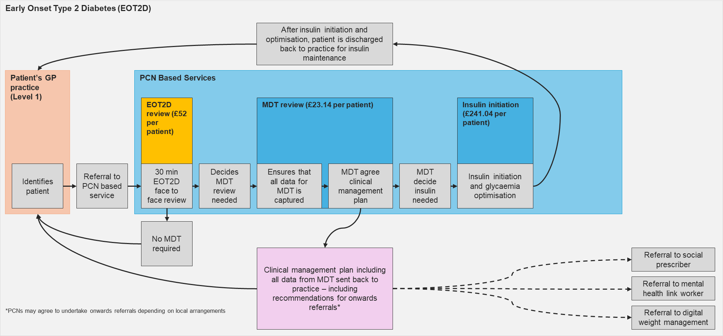
Example pathway for a patient with Early Onset Type 2 Diabetes – illustrating that one patient may attract payments for more than one service. Note that the EOT2D review is a separate but linked service specification. All onwards referrals are examples only, but are illustrative of the kind of support which may be required.
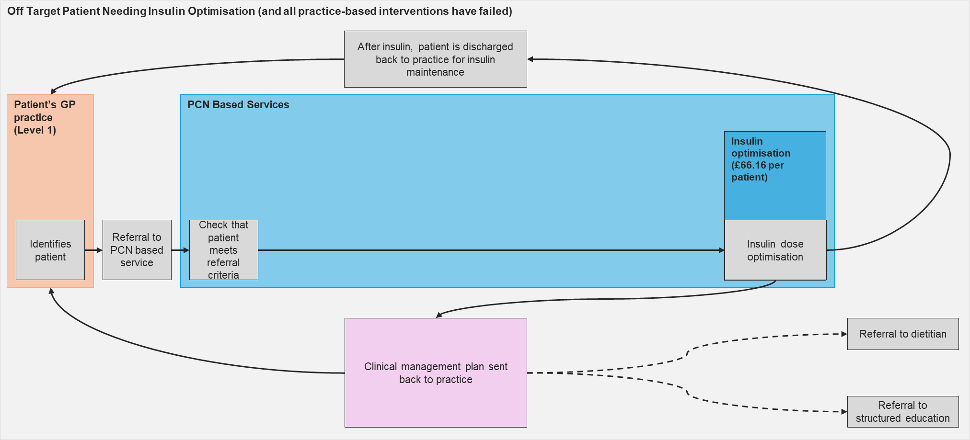
Example pathway for a patient referred by their GP practice requiring insulin optimisation but not MDT review. All onwards referrals are examples only, but are illustrative of the kind of support which may be required.

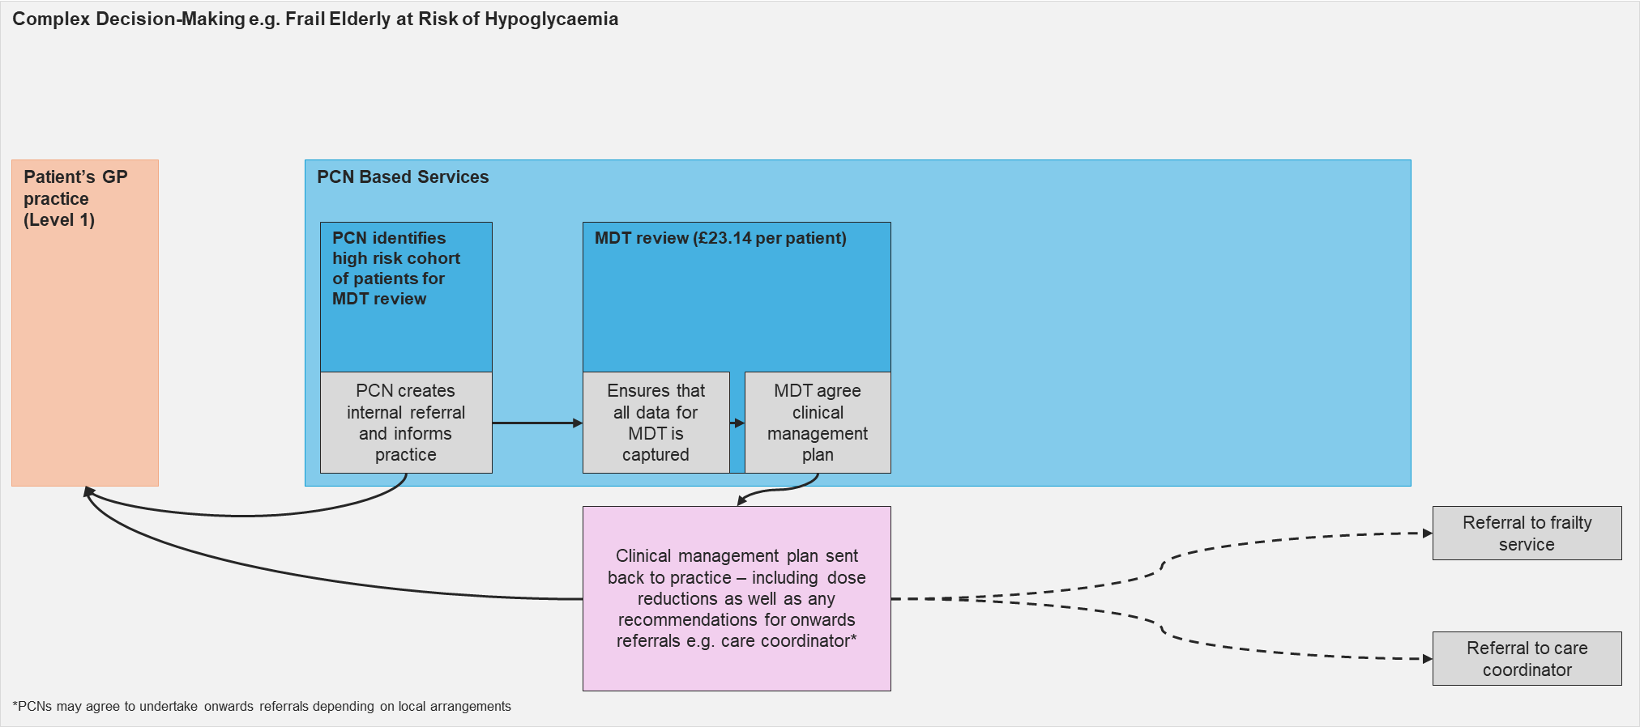
Example pathway for a patient identified through PCN-based clinical system or WSIC searches. In this case the MDT recommendation back to the patient’s practice is for de-intensification of diabetes medication and onwards referral to a frailty service and care coordinator.

APPENDIX 2: STEPS IN THE MDT PROCESS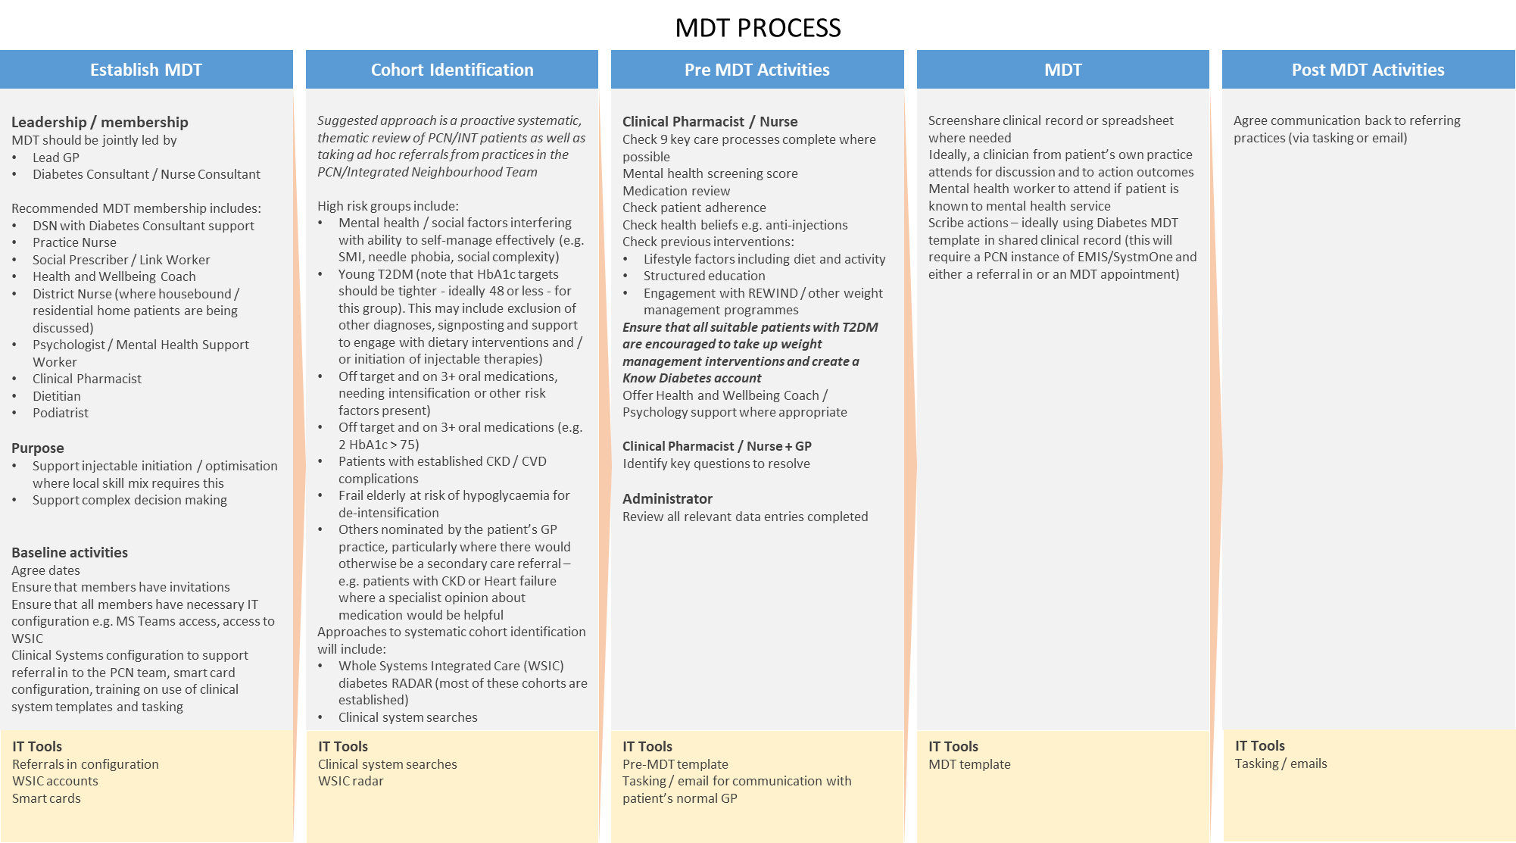
APPENDIX 3 - CONTRACTUAL REQUIREMENTS
DIABETES LEVEL 2
Unit Price | Each of the level 2 activities carries a separate tariff. These are as follows:
  Activity | Target Thresholds | Price per patient
  DL201: Review in MDT Diabetes Clinic | 10 % of Diabetes Population (capped) | £23.79
  DL203: Insulin treatment initiated (or GLP-1 initiation in patients already on insulin) | N/A | £247.86
  DL204: GLP-1 / tirzepatide therapy initiated | N/A | £179.83
  DL205: Insulin optimisation | N/A | £68.03
Business Rule | MDT Review | 1 review per patient per financial year  Capped at 10% of diabetes population
Business Rule | Insulin Initiation/GLP-1 initiation | 1 initiation per patient per financial year
Business Rule | Insulin Optimisation | 1 optimisation per patient per financial year
Service Type | Package | Pop-Up used to Record Enhanced services administration (166221000000105)
Referral Criteria | Patients aged 18 years and above are Mandatory under this contract

APPENDIX 4 – MDT REVIEW, INSULIN INITIATION, GLP-1 INITIATION, INSULIN OPTIMISATION

CODING NECESSARY FOR PAYMENT
Ref. | Description | SNOMED CT
DL201 | Number of patients discussed at MDT | Seen in multidisciplinary diabetic clinic (198841000000104)  AND  Enhanced services administration (166221000000105)
DL203 | Number of patients initiating insulin | Insulin treatment initiated (345041000000101)  AND  Enhanced services administration (166221000000105)
DL204 | Number of patients initiating GLP-1 therapy | Incretin mimetic therapy started (702542006)  AND  Enhanced services administration (166221000000105)
DL205 | Number of patients requiring insulin optimisation or intensification | Insulin dose changed (703972004)  AND  Enhanced services administration (166221000000105)

DIABETES (LEVEL 2): PAYMENT/KPI RULES
To Achieve Payment for Patients discussed at MDT DL201
- Patient must be Aged 18 and Over AND
- Has SNOMED code of QoF Diabetes cluster without being resolved AND
- Has SNOMED code Seen in multidisciplinary diabetic clinic (198841000000104) AND
- Has Enhanced services administration (166221000000105) recorded at the same time as multidisciplinary diabetic clinic

To Achieve Payment for Insulin Initiation DL203
- Patient must be Aged 18 and Over AND
- Has a SNOMED code of QoF Diabetes cluster without being resolved AND
- Has a SNOMED code of Insulin treatment initiated (345041000000101) AND
- Has Enhanced services administration (166221000000105) recorded at the same time as insulin initiation

To Achieve Payment for GLP-1 Initiation DL204
- Patient must be Aged 18 and Over AND
- Has a SNOMED code of QoF Diabetes cluster without being resolved AND
- Has a SNOMED code of Incretin mimetic therapy started (702542006) AND
- Has Enhanced services administration (166221000000105) recorded at the same time as GLP-1 initiation

To Achieve Payment for Insulin Optimisation or Intensification DL205
- Patient must be Aged 18 and Over AND
- Has a SNOMED code of QoF Diabetes cluster without being resolved AND
- Has a SNOMED code of Insulin dose changed (703972004) AND
- Has Enhanced services administration (166221000000105) recorded at the same time as insulin optimisation or intensification

APPENDIX 5 - QUALITY METRICS – MDT REVIEW

QUALITY METRICS
Ref. | Description | SNOMED Code | Measurement |  | Target  achievement | % of total payable for achieving target | Frequency of Monitoring
DL206a | Average change in HbA1c 3m, 6m, 12m following MDT review | Haemoglobin A1c level – IFCC standardized (999791000000106) OR  Haemoglobin A1c level (monitoring ranges) - International Federation of Clinical Chemistry and Laboratory Medicine standardised (1049321000000109) | Numerator: | Denominator: |  | NA | Monthly – via the WSIC Tier 2 Dashboard
DL206b | Average change in BP 3m, 6m, 12m following MDT review | O/E - Systolic BP reading  (72313002)  O/E - Diastolic BP reading  (1091811000000102) |  |  |  |  | Monthly – via the WSIC Tier 2 Dashboard
DL206c | Average change in lipids 3m, 6m, 12m following MDT review | Non high density lipoprotein cholesterol level (1030411000000101) |  |  |  |  | Monthly – via the WSIC Tier 2 Dashboard
DL206d | Average change in weight 3m, 6m, 12m following MDT review | On examination - weight (162763007) |  |  |  |  | Monthly – via the WSIC Tier 2 Dashboard
DL206e | Average change in BMI 3m, 6m, 12m following MDT review | Body Mass Index - observation (60621009) |  |  |  |  | Monthly – via the WSIC Tier 2 Dashboard
DL206f | % of patients referred to weight management programmes | Any of the following:  - Referral to NHS Digital Weight Management Programme (1402911000000108)  - Referral to weight management service (1326201000000101)  - Referral to National Health Service Tier 3 specialist weight management service (1403011000000103)  - Referral to NHS Tier 4 specialist weight management service (1402991000000104)  - Referral to total diet replacement programme (1239571000000105)  - Referral to bariatric surgeon (698563003)  - Referral for pre-bariatric surgery assessment (907731000000102) |  |  |  |  | Monthly – via the WSIC Tier 2 Dashboard
DL206g | % of patients referred to ARRS team | Any of the following:  - Referral to social prescribing service (871731000000106)  - Referred for health coaching (276221000000100)  - Referral to mental health link worker (1362951000000104)  Referral to pharmacist (306362008)  - Referral to community-based dietitian (306353006)

APPENDIX 6 - QUALITY METRICS – Insulin initiation or optimisation

QUALITY METRICS
Ref. | Description | SNOMED Code | Measurement |  | Target  achievement | % of total payable for achieving target | Frequency of Monitoring
DL208a | Average change in HbA1c 3m, 6m, 12m following insulin initiation | Haemoglobin A1c level – IFCC standardized (999791000000106) OR  Haemoglobin A1c level (monitoring ranges) - International Federation of Clinical Chemistry and Laboratory Medicine standardised (1049321000000109) | Numerator: | Denominator: |  | NA | Monthly – via the WSIC Tier 2 Dashboard
DL208b | Average change in BP 3m, 6m, 12m following insulin initiation | O/E - Systolic BP reading  (72313002)  O/E - Diastolic BP reading  (1091811000000102) |  |  |  |  | Monthly – via the WSIC Tier 2 Dashboard
DL208c | Average change in lipids 3m, 6m, following insulin initiation | Non high density lipoprotein cholesterol level (1030411000000101) |  |  |  |  | Monthly – via the WSIC Tier 2 Dashboard
DL208d | Average change in weight 3m, 6m, following insulin initiation | On examination - weight (162763007) |  |  |  |  | Monthly – via the WSIC Tier 2 Dashboard
DL208e | Average change in BMI 3m, 6m, following insulin initiation | Body Mass Index - observation (60621009) |  |  |  |  | Monthly – via the WSIC Tier 2 Dashboard
DL208f | % of patients referred to weight management programmes | Any of the following:  - Referral to NHS Digital Weight Management Programme (1402911000000108)  - Referral to weight management service (1326201000000101)  - Referral to National Health Service Tier 3 specialist weight management service (1403011000000103)  - Referral to NHS Tier 4 specialist weight management service (1402991000000104)  - Referral to bariatric surgeon (698563003)  - Referral for pre-bariatric surgery assessment (907731000000102)Referral to bariatric surgeon (698563003) |  |  |  |  | Monthly – via the WSIC Tier 2 Dashboard
DL208g | % of patients referred to ARRS team | Any of the following:  - Referral to social prescribing service (871731000000106)  - Referred for health coaching (276221000000100)  - Referral to mental health link worker (1362951000000104)  - Referral to pharmacist (306362008)  - Referral to community-based dietitian (306353006)

APPENDIX 7 - QUALITY METRICS – GLP-1 / tirzepatide initiation

QUALITY METRICS
Ref. | Description | SNOMED Code | Measurement |  | Target  achievement | % of total payable for achieving target | Frequency of Monitoring
DL209a | Average change in HbA1c 3m, 6m, 12m following GLP-1 / tirzepatide initiation | Haemoglobin A1c level – IFCC standardized (999791000000106) OR  Haemoglobin A1c level (monitoring ranges) - International Federation of Clinical Chemistry and Laboratory Medicine standardised (1049321000000109) | Numerator: | Denominator: |  | NA | Monthly – via the WSIC Tier 2 Dashboard
DL209b | Average change in BP 3m, 6m, 12m following GLP-1 / tirzepatide initiation | O/E - Systolic BP reading  (72313002)  O/E - Diastolic BP reading  (1091811000000102) |  |  |  |  | Monthly – via the WSIC Tier 2 Dashboard
DL209c | Average change in lipids 3m, 6m, following GLP-1 / tirzepatide initiation | Non high density lipoprotein cholesterol level (1030411000000101) |  |  |  |  | Monthly – via the WSIC Tier 2 Dashboard
DL209d | Average change in weight 3m, 6m, following GLP-1 / tirzepatide initiation | On examination - weight (162763007) |  |  |  |  | Monthly – via the WSIC Tier 2 Dashboard
DL209e | Average change in BMI 3m, 6m, following GLP-1 / tirzepatide initiation | Body Mass Index - observation (60621009) |  |  |  |  | Monthly – via the WSIC Tier 2 Dashboard
DL209f | % of patients referred to weight management programmes | Any of the following:  - Referral to NHS Digital Weight Management Programme (1402911000000108)  - Referral to weight management service (1326201000000101)  - Referral to National Health Service Tier 3 specialist weight management service (1403011000000103)  - Referral to NHS Tier 4 specialist weight management service (1402991000000104)  - Referral to total diet replacement programme (1239571000000105)  - Referral to bariatric surgeon (698563003)  - Referral for pre-bariatric surgery assessment (907731000000102) |  |  |  |  | Monthly – via the WSIC Tier 2 Dashboard

APPENDIX 8 - context
Diabetes care is one of the major challenges facing the NHS in the coming years and the quality-of-care provision varies throughout the country. The number of people in the UK with diabetes is increasing and is projected to rise to 5.3 million by 2023. As of July 2023 in North West London, over 171,000 people have been diagnosed with diabetes with about 40,000 as yet undiagnosed. The total number of people living with diabetes in North West London is expected to be at least 224,000 by 2030. In North West London, there are approximately 25,000 people living with blood glucose levels above relaxed target values (HbA1c > 64mmol/mol), with over half being younger than 60 years of age.

Diabetes, particularly when blood sugars are persistently above target, can lead to serious life-threatening and life-limiting complications for people with diabetes, as well as higher costs for health and social care services. These include;

- blindness;
- foot disease leading to amputations;
- kidney disease leading to dialysis;
- heart disease;
- stroke;
- dementia.

In North West London, at least £350m (around 10% of health spend) is spent on diabetes care with an additional, as yet unquantified, amount in lost productivity and social care costs. 80% of costs are related to treating diabetes complications - with foot disease being the largest contributor - and approximately 40% of all emergency admissions and acute bed days are for diabetes-related complications. An individual may, along with diabetes, have other long-term conditions, e.g. hypertension, chronic obstructive pulmonary disease (COPD). Those living with Type 1 Diabetes Mellitus may also have other auto-immune conditions including coeliac disease and/or thyroid abnormalities.

Up to 60% of people with diabetes state that they are living with mental health or emotional difficulties. There is clear evidence that these often go undetected and untreated, leading to impaired ability to effectively self-care and resulting in poorer diabetes outcomes. The mental health difficulties people experience are broad and range from diabetes distress, depression and anxiety; to eating disorder, psychosis and dementia and yet there is a lack of a clear whole pathway integrated provision for people with specific needs in this area locally and nationally. There is good local and national evidence that, if mental health and emotional difficulties are addressed, this can lead to improved diabetes outcomes.

There is a strong evidence base for the effectiveness of lifestyle change programmes creating reductions in Type 2 diabetes incidence, and for the importance of including lifestyle interventions into any obesity intervention for it to be effective. Similarly, there is evidence for the cost saving and cost effectiveness of risk assessment and screening in pre-diabetes populations and those at high risk of developing diabetes.

Additionally, there is good evidence that multidisciplinary team (MDT) working in diabetes improves outcomes, but this needs to be supported by good team leadership, good communication and a system that supports this type of working.

A prevention and population approach will be vital for the size of the task and will require the addressing of social determinants of health, collaboration with local government and use of social prescribing to address these issues. This represents a clear opportunity for joint commissioning between ICBs, public health, patient and support groups and the third sector, with or without additional social finance investment.

Service | Early Onset Type 2 Diabetes Service
Delivery Point | Primary Care Networks or Integrated Neighborhood Teams

- National context and evidence base
Early onset Type 2 diabetes (EOT2D) is defined as the development of Type 2 diabetes below the age of 40 years. It is more common in people from ethnic minorities (particularity in people with South Asian ethnicity) and people living in the most socio-economically deprived areas. A high proportion of people with EOT2D are living with obesity and may also have concurrent unmet psychological and social needs.

The National Diabetes Audit (NDA) shows that prevalence is increasing yearly, with 137,260 people with Type 2 diabetes aged 18-39 in England in the latest report (21/22). In North West London specifically, there are approximately 8235 people with EOT2D, the majority of whom are cared for exclusively in General Practice, with an average of ~180 adults with EOT2D per Primary Care Network (PCN).

EOT2D is associated with a more aggressive diabetes phenotype than older-onset Type 2 diabetes, including more rapid progression of glycaemia and early development of complications with significant reduction in life expectancy. Despite this, people with EOT2D are less likely to receive all NICE-recommended care processes and tend to have higher HbA1c than older people with Type 2 diabetes1.

54% of pregnancies in people with diabetes in 2020 related to those affected by Type 2 diabetes, representing a doubling in proportion since 2002. Attaining HbA1c < 48 mmol/mol is associated with better neonatal outcomes; however, in 2020 only 11% of women with Type 2 diabetes who became pregnant had evidence of adequate preparation for pregnancy, reducing to only 6% of those living in the most deprived areas.

National funding is being made available to all ICBs for the T2Day: Type 2 Diabetes in the Young Programme, a 2-year initiative (for 23/24 and 24/25) aiming to improve care for people with EOT2D.

In North West London, the aim is to integrate the Early Onset Type 2 Service within the MDT Level 2 Service Specification in April 2024, once the MDT Level 2 Service is rolled out universally to all PCNs.

- Aims and objectives of service
1.) to work with people with EOT2D to provide high quality care and optimise glycaemia, cardiovascular risk and weight, aiming to reduce long-term complications and morbidity
2.) to support better preparation for pregnancy in women with Type 2 diabetes, including supporting access to contraception for those not trying for pregnancy
3.) to help address unmet psychological and social needs and support overall wellbeing

- Service Description/Care Pathway
This Early Onset Type 2 Diabetes service specification fits within a wider pathway for people living with diabetes, which operates to allow people to move between levels seamlessly and as their needs dictate and where more experienced clinicians are required to manage their care.

- Non Diabetic Hyperglycaemia (NDH): This largely primary care service will be responsible for proactive identification of NDH and referral into nationally commissioned NHS Diabetes Prevention Programme to support the prevention of Type 2 Diabetes.
- Diabetes (Level 1): The primary care service at Level 1 will have primary responsibility for the person with Type 2 Diabetes
- Diabetes (MDT Level 2): The MDT level 2 service is a PCN/INT-based service which integrates level 1 primary care services and specialist support and uses methodologies including an MDT approach to optimise patient care. The objectives of the MDT include to integrate complex decision making inter-professionally and bring levels 2,3 and 4 together rapidly, improving patient outcomes and reducing the need for direct F2F Level 4 contact as well as to initiate insulin and GLP-1 agents. The MDT will also integrate mental health and social prescribing input in order to help direct the clinical team towards the most appropriate support pathways for patients with more complex mental health and social care needs. Lastly, the MDT Level 2 service will provide more intensive support for people with EOT2D.
- Diabetes (Level 3): The consultant-led community-based diabetes team acts as the link between generalist clinicians and specialists. Specialists who provide the Level 3 diabetes service should spend a proportion of their time leading, advising and facilitating the work of the primary care based Level 1 and Level 2 diabetes teams. Staff will fast-track people with diabetes safely back to primary care or to Level 4 (where clinically appropriate) and allow the Level 3, 2 and 1 teams to provide care closer to the patient’s home.
- Diabetes (Level 4): Specialist diabetes services have primary responsibility for those with Type 1 and rarer forms of diabetes. All people with Type 1 Diabetes and other forms of diabetes, such as monogenic diabetes e.g. maturity-onset diabetes of the young (MODY), mitochondrial diabetes, diabetes due to chronic pancreatitis or total pancreatectomy, should have access to specialist diabetes services including those commissioned by NHS England. Provision needs to be made in the community for people with Type 1 Diabetes who refuse to be seen in secondary care or on end of life pathways.

The ultimate aim is to integrate pathways and funding further, particularly for level 2 and 3 services, in order to provide a more seamless experience for patients.

All people with Type 2 diabetes (particularly those with EOT2D) should be offered, where appropriate, the opportunity to participate in a diabetes remission or intensive weight management support programme, whether through a low calorie total diet replacement (TDR) programme, through other education programmes such as X-PERT, or through bariatric surgery.

People with diabetes (seen at any level) should have access to the Know Diabetes Service, structured education, social prescribing and emotional and mental health support according to need, commissioned services available and choice.

Accountability for the incidence of onset of complications and incidence of hard clinical endpoints such as amputation and blindness lies across the health economy, and responsibility will be shared by all providers of diabetes care as well as by the wider integrated care system.

Care planning, care delivery, plan review and adjustment and operational improvement should underpin the approach to all service delivery.

Additional Support for Early Onset Type 2 Diabetes

All people with EOT2D should be encouraged to attend an extended (at least 30 minute) face to face review and where appropriate, discussed at an MDT meeting.

- Data gathering to support reviews / opportunistic care process delivery
- For clarity, it is expected that completion of all 9 NICE recommended annual care processes should occur in all people with diabetes, independent of this intervention
- Prior to a review, appropriately up-to-date values of relevant clinical markers should be obtained to guide shared decision-making and therapeutic approach (e.g., re-checking HbA1c prior to review, particularly if there has been an intervening change to glucose-lowering medication or last HbA1c was recorded more than 6 months ago)
- The additional contact / review(s) funded by this intervention also present an opportunity to ensure completion of any care processes that were previously missed

- Consideration of potential misclassification of diabetes type
- During reviews, consideration should be given to any features suggesting that diabetes type may be other than Type 2 diabetes, taking into account any prior correspondence from specialist services
- If there is suspicion that misclassification may have occurred, local pathways for further assessment should be followed (this is likely to include a referral to specialist services)

- Contraception and planning for possibility of pregnancy
For all women with EOT2D and potential to become pregnant, discuss contraception, the importance of pre-pregnancy planning and what to do if they have a positive pregnancy test.

For women with potential to become pregnant, who are not trying for pregnancy, encourage use of contraception:
- Offer initiation of contraception or signpost/refer as appropriate

For women with potential to become pregnant who are trying for pregnancy / likely to become pregnant (including those who are sexually active and not using contraception):
- Prescribe folic acid supplementation of 5mg daily
- Avoid use of medications which are not suitable in pregnancy. This includes many glucose-lowering medications (except metformin and insulin) as well as other medications which are not used for glucose-lowering (e.g., statins, ACE-i etc)
- Emphasise the importance of intensive glycaemic control in reducing the risk of adverse maternal and foetal outcomes in pregnancy. Referral to specialist services for insulin initiation may be indicated

Women with EOT2D should be informed that they should urgently notify their GP practice (or diabetes team if applicable) if they have a positive pregnancy test so that they can be urgently referred to the Diabetes in Pregnancy team (for antenatal clinic review within a week to reduce pregnancy risks).

- Optimisation of glycaemia and cardiovascular risk and weight
It is recommended that clinicians follow NICE guidance on management of glucose, cardiometabolic risk factors and weight, with the avoidance of therapeutic inertia and undue delay in intensification.
This includes use of non-pharmacological treatments, with particular consideration of suitability for the NHS Type 2 Diabetes Path to Remission Programme (which is currently available in most of England and will be available nationwide by the end of 23/24).
Glycaemia:
- In accordance with NICE NG28, individualised targets should be discussed and agreed. These should take into account the more aggressive nature of EOT2D and the high lifetime risk of complications
- Targets are therefore likely to be more intensive than those which may be typically used in people developing Type 2 diabetes at more advanced age
- NICE Patient Decision Aid may support discussions on HbA1c
- It is important to avoid therapeutic inertia and discuss treatment escalation promptly if individualised targets are not met
- Offer referral to Structured Education, taking into account individual needs and preferences (note the availability of nationally commissioned digital structured education)
Cardiovascular risk:
- Lipid-lowering therapies (e.g., statins) should be offered in line with NICE CG181⁶
- SGLT2 inhibitors should be offered in line with NICE NG28⁶ for addressing cardiovascular risk (and renal protection in CKD)
- NICE NG1368 recommendations for the diagnosis, treatment and monitoring of hypertension should be followed
- Offer support with smoking cessation including referral / signposting as appropriate
Weight:
- Weight management support is likely to be indicated in the majority of people with EOT2D. This may include pharmacological interventions (in line with NICE guidance) and/or appropriate referral to weight management services
- Given the high prevalence of obesity in people with EOT2D, a high proportion may be eligible for GLP-1 receptor agonist treatment, in line with NICE guidance. This may be as an intensification of glucose-lowering therapy in accordance with NICE NG28, or as a treatment for weight management in line with relevant NICE guidance and technology appraisals.
- Psychological wellbeing unmet and social needs
Assess unmet psychological needs and manage accordingly
Explore unmet social needs and consider social prescribing and other support services
Consider availability and opportunities for peer support

Funding and commissioning: Funding allocations for systems have been based on the number of people with EOT2D in each system (NDA quarterly data – 2022/23 Q3). These are the minimum allocations (initially £53.12 per adult with EOT2D) which may increase depending on take-up of the offer across all ICBs.

All systems receiving funding in 2023/24 will receive the same level of funding in 2024/25 (subject to annual confirmation). There will be no future opportunities for expressing interest beyond August 2023.

Although systems should consider sustainability from the outset, there is no specific requirement for systems to commit to sustaining the service following the period of national funding.

Reporting: Evaluation of the service will be supported by the National Diabetes Audit as well as data from nationally commissioned services (e.g., NHS Type 2 Diabetes Path to Remission Programme). It is recommended that systems also monitor applicable metrics (such as those listed in the section above, in addition to others considered relevant) to assess performance, identify need and inform ongoing quality improvement. This may also support local service sustainability. Systems participating must confirm mobilisation but no further reporting will be required.

Equity: Service providers should make sure systems are in place to address health inequalities and ensure equity of access to the enhanced support and any treatment interventions. They should deliver the service in a culturally sensitive way to meet the needs of their local, diverse populations.
Supporting resources: The following documents are enclosed:
• Annex B: Example of Supporting Information for Clinical Reviews
• Annex C: Prevalence Data and Minimum ICB Funding Allocations
• Annex D: National Webinar Slide pack. A recording of the national webinar is also available at EOT2D Webinar
• Annex E: Memorandum of Understanding

Annex B: Example of Supporting Information for Clinical Reviews is a resource to support clinicians carrying out reviews of people with EOT2D. It should be adapted by systems according to local needs, pathways, processes, services, formulary etc., signed off by local clinical leads and ‘owned’ by the ICB. Systems are therefore encouraged to modify sections, add elements to suit local need and change
presentation / formatting, providing the key elements of the service remain.

Outcomes

Metrics used to evaluate impact include:
- Completion of all NICE recommended care processes
- Improvements in treatment target achievement
- Proportion with HbA1c ≤ 48 mmol/mol
- Proportion achieving > 5% weight loss
- Prescribing data relating to management of diabetes, weight, and cardiovascular risk
- Referral / uptake of NHS Type 2 Diabetes Path to Remission Programme (once available)
- Use of other services, e.g., Digital Weight Management, NHS Talking Therapies etc.
- Proportion of women with potential to become pregnant with preparation for pregnancy (preconception advice and folic acid)
- Rates of maternal and neonatal adverse outcomes at NWL or national level

- Across relevant metrics, inequality including by ethnicity and socioeconomic deprivation

- Any Acceptance and exclusion criteria and thresholds
Inclusions:
- Patients aged 18-39 with assumed Type 2 Diabetes

Exclusions:
- People with known Type 1 Diabetes or MODY
- Patients aged under 18 or 40 or above

- Training, Skills and Experience
Diabetes Clinician:

- Minimum Grade:
- Agenda for Change Band 7 or equivalent.
- Education, Qualifications &Training
- Minimum competencies in line with Training Research and Education for Nurses in Diabetes (TREND) recommendations www.trend-uk.org/documents/TREND_3rd.pdf for “competent nurse” and working towards competencies for “experienced or proficient nurse”.
- PITSTOP or similar training for insulin and GLP-1 initiation / optimisation
Add in other qualifiers

- Equipment
There is no specialist equipment required for the delivery of this service.

APPENDIX I - CONTRACTUAL REQUIREMENTS
EARLY ONSET TYPE 2 DIABETES
Unit Price
  Activity | Target Thresholds | Price per patient
  DL202: Review of patients with EOT2D | 100% of EOTD patients | £53.47
Business Rule | 1 activity per patient per financial year
Service Type | Package | No Pop-Up
Referral Criteria | Patients aged 18 years and above are Mandatory under this contract

APPENDIX II – EOT2D REVIEW

Ref. | Description | SNOMED Code | Measurement |  | Target  achievement | % of total payable for achieving target | Frequency of Monitoring
DL202 | Number of patients receiving EOT2D review | Diabetes self-management plan review (810961000000103) | Numerator:  Number of patients with EOT2D (coded as T2DM and aged 18-39) with diabetes self-management plan review | Denominator:  Number of patients with EOT2D (coded as T2DM and aged 18-39) |  |  | Monthly via dashboard

PAYMENT/KPI RULES:
To Achieve Payment for EOT2D DL202
- Patient must be Aged 18-39 AND
- Has a SNOMED code of Type 2 Diabetes Mellitus without being resolved AND
- Has a SNOMED code of Diabetes self-management plan review (810961000000103)

APPENDIX III - QUALITY METRICS – EOT2D REVIEW

QUALITY METRICS
Ref. | Description | SNOMED Code | Measurement |  | Target  achievement | % of total payable for achieving target | Frequency of Monitoring
DL207a | Average change in HbA1c 3m, 6m, 12m following EOT2D review | Haemoglobin A1c level – IFCC standardized (999791000000106) OR  Haemoglobin A1c level (monitoring ranges) - International Federation of Clinical Chemistry and Laboratory Medicine standardised (1049321000000109) | Numerator: | Denominator: |  | NA | Monthly – via the WSIC Tier 2 Dashboard
DL207b | Average change in BP 3m, 6m, 12m following EOT2D review | O/E - Systolic BP reading  (72313002)  O/E - Diastolic BP reading  (1091811000000102) |  |  |  |  | Monthly – via the WSIC Tier 2 Dashboard
DL207c | Average change in lipids 3m, 6m, 12m following EOT2D review | Non high density lipoprotein cholesterol level (1030411000000101) |  |  |  |  | Monthly – via the WSIC Tier 2 Dashboard
DL207d | Average change in weight 3m, 6m, 12m following EOT2D review | On examination - weight (162763007) |  |  |  |  | Monthly – via the WSIC Tier 2 Dashboard
DL207e | Average change in BMI 3m, 6m, 12m following EOT2D review | Body Mass Index - observation (60621009) |  |  |  |  | Monthly – via the WSIC Tier 2 Dashboard
DL207f | % of people with EOT2D referred to weight management programmes | Any of the following:  - Referral to NHS Digital Weight Management Programme (1402911000000108)  - Referral to weight management service (1326201000000101)  - Referral to National Health Service Tier 3 specialist weight management service (1403011000000103)  - Referral to NHS Tier 4 specialist weight management service (1402991000000104)  - Referral to total diet replacement programme (1239571000000105)  - Referral to bariatric surgeon (698563003)  - Referral for pre-bariatric surgery assessment (907731000000102) | Numerator:  Number of patients with EOT2D (coded as T2DM and aged 18-39) with weight management referral | Denominator:  Number of patients with EOT2D (coded as T2DM and aged 18-39) |  |  | Monthly – via the WSIC Tier 2 Dashboard
DL207g | % of patients with EOT2D referred to ARRS team | Any of the following:  - Referral to social prescribing service (871731000000106)  - Referral for health coaching (276221000000100)  - Referral to mental health link worker (1362951000000104) | Numerator:  Number of patients with EOT2D (coded as T2DM and aged 18-39) with ARRS referral | Denominator:  Number of patients with EOT2D (coded as T2DM and aged 18-39)
DL207h | % of female patients with EOT2D with record of preconception advice | Pre-conception advice (171012002) | Numerator:  Number of female patients with EOT2D (coded as T2DM and aged 18-39) with preconception counseling code | Denominator:  Number of female patients with EOT2D (coded as T2DM and aged 18-39)
DL208i | % of female patients with EOT2D with record of folic acid prescription | Folic acid prescribed in last 6m | Numerator:  Number of female patients with EOT2D (coded as T2DM and aged 18-39) with folic acid prescription in last 6m | Denominator:  Number of female patients with EOT2D (coded as T2DM and aged 18-39)

APPENDIX: T2Day: Type 2 Diabetes in the Young –Supporting Information for Reviews

Early onset Type 2 diabetes (EOT2D) is defined as the development of Type 2 diabetes below the age of 40 years. It is more common in people from ethnic minorities (particularity in people with South Asian ethnicity) and people living in the most socio-economically deprived areas. A high proportion of people with EOT2D are living with obesity and may also have concurrent unmet psychological and social needs.
The National Diabetes Audit (NDA) shows that prevalence is increasing yearly, with 137,260 people with Type 2 diabetes aged 18-39 in England in the latest report (2021/22). It is associated with a more aggressive phenotype than older-onset Type 2 diabetes, including more rapid progression of glycaemia, and earlier complications with significant reduction in life expectancy. Despite this, people with EOT2D are less likely to receive all recommended care processes and tend to have higher HbA1c levels than people with older-onset Type 2 diabetes1. Preparation for pregnancy and pregnancy outcomes are also poorer than in people with Type 1 diabetes; during 2018-2020, only 11% of women with Type 2 diabetes who became pregnant had evidence of adequate preparation for pregnancy reducing to only 6% of those living in the most deprived areas3.
Please note that although this document relates to the reviews of adults with early onset Type 2 diabetes, the process for identifying this group is likely to involve system searches for all people aged under 40 years who are recorded as having Type 2 diabetes. If any people aged under 18 years are identified, they should be supported to access specialist care for management, as recommended in NICE NG18 (2023) guidance.

Before the reviews:
- NICE-recommended annual care processes should be completed, and up-to-date values of relevant measures obtained (e.g., re-checking HbA1c prior to review, particularly if there has been an intervening change to glucose-lowering medication or last HbA1c was checked > 6 months ago)
- Please note these reviews are additional to the usual routine care provided for people with EOT2D

During the reviews:
As well as opportunistically addressing any missed care processes, the four key elements of reviews are:
1) Classification of diabetes type – is this Type 2 diabetes?
2) Contraception and planning for possibility of pregnancy
3) Optimisation of glycaemia, cardiovascular risk, and weight
4) Psychological wellbeing and unmet social needs

- Classification of diabetes type – is this Type 2 diabetes?
- Young people may have subtypes of diabetes other than Type 2 diabetes such as Type 1 diabetes or monogenic diabetes (e.g., maturity onset diabetes of the young, MODY)
- Although it can be difficult to distinguish Type 2 diabetes from other types of diabetes based on clinical features, it is worth considering ‘are there features here that don’t fit with early onset Type 2 diabetes?’
  - For example, they have a relatively lean BMI, they do not have any features of insulin resistance or metabolic syndrome, there is no family history of Type 2 diabetes. Note that in people of South Asian ethnicity, EOT2D may develop at lower levels of BMI than people of white ethnicity, although they would usually still have a BMI falling within the overweight or obese category
  - NICE NG17 (2022) states that people with Type 1 diabetes typically (but not always) have 1 or more of: ketosis, rapid weight loss, age of onset < 50 years, BMI < 25 kg/m2, personal and/or family history of autoimmune disease. Do not use age, BMI, or ethnicity alone to exclude Type 1 diabetes
  - MODY is usually characterised by a strong family history of which may have been identified in multiple generations at young ages (50% chance of being passed to the next generation). Bear in mind that a parent may have been misclassified as having Type 1 or Type 2 diabetes
  - The agreed national guidelines for eligibility for testing for MODY (R141 guidelines) are available at https://www.diabetesgenes.org/tests-for-diabetes-subtypes/guidelines-for-genetic-testing-in-mody/
- Although classification of diabetes type should be considered at time of diagnosis, it should also be regularly reviewed as features may develop that indicate an alternative diabetes subtype
- If there is concern that this may not be Type 2 diabetes, follow the local pathway for further assessment. In most areas, this is likely to include a referral to specialist teams. If Type 1 diabetes is strongly suspected, urgently discuss with specialist care, and do not delay starting treatment

- Contraception and planning for possibility of pregnancy
- Women with EOT2D have an increased risk of stillbirth and neonatal morbidity. The major modifiable risk factor for this is glucose control at the start of pregnancy (this may be before the woman is aware she is pregnant). HbA1c > 48 mmol/mol is associated with poor pregnancy outcomes
  - According to NPID data (2014 to 2020), only 11% of pregnant women with Type 2 diabetes had received adequate pre-pregnancy care
- Note that many of the medicines used to manage glucose and cardiovascular risk are not advised in pregnancy. Contraception should be used if taking these drugs. If not wishing to use contraception, consider likelihood of pregnancy occurring (it may be reasonable to assume that pregnancy is likely – almost half of all pregnancies are unplanned)
- If not trying for pregnancy, contraception should be offered and initiated / arranged as appropriate
- Women trying for pregnancy or likely to become pregnant should be prescribed folic acid 5mg daily and have their medication reviewed
  - The only safe glucose-lowering drugs in pregnancy are metformin and insulin. If insulin initiation is needed, this should be commenced in line with local pathways
  - If actively trying for pregnancy, an HbA1c target of < 43 mmol/mol may be suggested
  - Follow local pathways for pre-conception support / review
- Women with EOT2D should be informed that they should urgently notify their GP practice (or diabetes team if applicable) if they have a positive pregnancy test so that they can be urgently referred to the Diabetes in Pregnancy team (for antenatal clinic review within a week to reduce pregnancy risks)

- Optimisation of glycaemia, cardiovascular risk, and weight
- Consider referral to the NHS Type 2 Diabetes Path to Remission Programme (T2DR; will be available nationwide by April 2024) or other intensive lifestyle change interventions
- Early outcomes from the NHS T2DR programme show mean weight loss of 11kg at 12 months. It is expected to improve glycaemia, blood pressure and cardiovascular risk (data on remission rates is awaited). See your local referral form for full eligibility requirements
- Glycaemia:
- NICE NG28 recommends discussing and agreeing an individual HbA1c target. One factor the accompanying NICE decision aid specifies is ‘thinking about my age and my health overall, my quality of life in the long term is important.’ The decision aid is found at
- https://www.nice.org.uk/guidance/ng28/resources/patient-decision-aid-pdf-2187281198
- People with EOT2D are at higher risk of complications that those who develop Type 2 diabetes later in life. There is therefore rationale for agreeing more intensive glycaemic targets in people with EOT2D than typically used. Given the higher risk profile, the QOF-incentivised HbA1c target of ≤ 58 mmol/mol is unlikely to be suitable; a target of ≤ 48 mmol/mol may be more appropriate
- Note that people with EOT2D may have faster progression with increasing HbA1c than is typically seen with onset at older ages. NICE recommend rechecking HbA1c every 3-6 months until HbA1c is stable on unchanging therapy and then 6 monthly. It is important to avoid therapeutic inertia and to escalate treatment promptly if individualised targets are not met
- NICE NG28 sets out guidance on use of glucose-lowering therapies, including recommendations for each step of intensification. Note that, in addition to glucose-lowering impact, SGLT2 inhibitors and GLP-1 receptor agonists have additional benefits in supporting weight loss and reducing CV risk and may therefore be particularly appropriate for people with EOT2D at applicable steps of intensification, in line with NICE guidance (not suitable if trying for pregnancy / likely to become pregnant)
- Offer diabetes structured education, even if previously attended. Take into account individual needs and preference and discuss options available. Note that Healthy Living is a nationally commissioned, digital structured education service which can be accessed at www.healthyliving.nhs.uk
- Cardiovascular risk:
- Statins and SGLT2 inhibitors may be indicated for reducing cardiovascular risk
- Anyone with EOT2D and known CVD / HF should be offered a statin as well as an SGLT2 inhibitor
- Due to particularly elevated lifetime risk of CVD, NICE recommends consideration of the use of SGLT2 inhibitors in people with EOT2D and any of hypertension, dyslipidaemia, smoking, obesity, and family history (in a first-degree relative) of premature cardiovascular disease
- While setting the threshold to offer statins for primary prevention at a 10-year QRISK3 score of ≥ 10%, NICE CG181 states ’do not rule out treatment with atorvastatin 20 mg for the primary prevention of CVD just because the person's 10‑year QRISK3 score is less than 10% if they have an informed preference for taking a statin or there is concern that risk may be underestimated’
- Note that the 10-year QRISK3 score will not reflect lifetime CVD risk for people with EO2TD and therefore consideration for statin therapy, in line with the criteria set out for considering use of SGLT2 inhibitors, may be appropriate
- Statins are also recommended if there is co-existent CKD, as are SGLT2 inhibitors. Note that the guidance for each SGLT2 inhibitor varies for this indication. Follow your local pathway and formulary
- SGLT2 inhibitors and statins are not suitable if trying for pregnancy / likely to become pregnant
- Blood pressure should be managed in line with NICE NG136, with a clinic BP target of < 140/90 mmHg (or average home BP of < 135/85 mmHg) for people with EOT2D and hypertension
- NICE recommends that an ACE-inhibitor or Angiotensin Receptor Blocker (ARB) is used preferentially as the first-line medication for managing high blood pressure in people with Type 2 diabetes, with an ARB more suitable in people of Black ethnicity. Note that these medicines are not suitable in women if trying for pregnancy / likely to become pregnant
- Offer support with smoking cessation in line with local pathways
- Weight:
- If not referring to the NHS Type 2 Diabetes Path to Remission Programme, consider other appropriate weight management support, including local service offers
- The NHS Digital Weight Management Programme is available for people with diabetes and BMI ≥ 30 (adjusted to BMI ≥ 27.5 in ethnic minorities)
- Also consider referring to specialist obesity services in line with local pathways
- Psychological wellbeing and unmet social needs
- People with EOT2D may have concurrent psychological needs. These should be assessed, and appropriate support offered in accordance with relevant NICE guidance and local pathways
- Explore unmet social needs and consider if social prescribing and/or other support may be indicated
- Consider local opportunities for peer support

Service | Anticoagulation Warfarin Service
Date of Review | January 2023

- National context and evidence base
Since 2019 North West London (NWL) has been implementing The NHS Long Term Plan which increases the focus of the provision of services based on population health through Primary Care Networks (PCNs) which has led towards the development of Enhanced Services that are outcome focused and population based.
- Aims and objectives of service
- An anticoagulation service which ensures high quality care is delivered as close to the patients home as is appropriate
- Improves patient access to safe and clinically effective anticoagulation initiation for patients starting warfarin therapy using near patient testing and decision support software
- Ensures all patients are treated to the same high quality standard across NWL and to prevent patient safety incidents through proper training, systems maintenance and contingency planning
- The service is intended to support and enable general practitioners to provide patient care in a seamless and integrated way
- This service is in addition to those existing contracted services that providers are providing to their registered patients.
- The specification of this service is designed to cover the enhanced aspects of clinical care of the patient, which are considered beyond the scope of essential services and additional services.
- Service Description/Care Pathway
- The scope of the service includes warfarin initiation, warfarin monitoring and cessation of therapy when and if clinically appropriate.
- This includes blood monitoring, determination of INR and dosing of warfarin provided to all patients during a single clinic attendance and at a frequency appropriate to clinical need.
- The preferred computerised decision support software (CDSS) is INRStar which integrates with EMIS/SystemOne and requires capillary blood samples. However some providers use DAWN and this is an acceptable alternative.
- This service includes domiciliary visits to housebound patients.

Initiation is the process of starting patients on warfarin for the first time or after a significant break from taking warfarin. The process of initiating a patient on warfarin is more time consuming than warfarin monitoring. For warfarin this requires more frequent monitoring and requires a greater level of clinical competency to prevent thromboembolic events.

This Anticoagulation Service is for patients who:

- Require slow initiation of oral anticoagulant when this has been recommended by a Secondary Care doctor or GP in line with guidance from NICE
- Require restart of warfarin following a prolonged absence from warfarin treatment.

The service provider will:

- Counsel the patient regarding clinic procedure, and check for:
- Bleeding or thrombotic incidences
- Tablet compliance and change of concomitant medication (N.B. OTC medicines)
- Acute illness, diarrhoea or vomiting
- Lifestyle changes e.g. alcohol intake

- Obtain a capillary blood sample from the patient and undertake analysis of blood. The use of venous sampling is not recommended as the analysis method and results differ from near patient testing and can result in unnecessary dose changes
- Use Point of Care Testing (Coaguchek XS Plus) and INRstar during a single visit, patients should be dosed, any clinical interventions that are required should be undertaken and an appointment for the next visit should be made.
- Assess condition requiring warfarin considering the risks versus benefits of warfarin treatment and checking they have a clear understanding of the referrer’s intended treatment target and duration or in line with NICE guidance.
- Ensure that all patients receiving warfarin (and/or carers and support staff, when appropriate) are given appropriate education at the start of therapy and at regular intervals thereafter. This should include information on the management and prevention of secondary complications.
- Ensure that each patient is provided with an individual management plan, which gives the diagnosis, planned duration and therapeutic INR target to be obtained. Each patient must be provided with an NPSA Oral Anticoagulation Therapy (OAT) patient information booklet or equivalent which can be ordered via PCSE.
- Ensure there is a robust and systematic call and recall of patients on the register
- Have a system in place for follow-up of patients who do not attend appointments
- Have the ability to offer patients an appointment within 2 working days
- Complete and provide patient with an OAT record book with verbal and written instruction regarding dosage, recall and relevant treatment information
- Record all clinical information related to the provision of this service in patient-specific records retained by the service provider and must ensure that the patient’s registered GP is provided with a summary of every monitoring visit.
- A robust mechanism for communication must be in place for any patient who is housebound and the sample is taken at home and the test/dose calculation takes place at a different venue. Calibration/QC checks on machines should be made before home visits and a QC test done before a patients sample.
- Carry out and annual review of all patients on a long-term OAT.
- Assess whether anticoagulation therapy is still appropriate.

Warfarin Prescribing
- The patient’s own GP is responsible for prescribing (after latest INR reading and recommended dosage guidance).
- The provider must have adequate systems in place for clinical governance to ensure that information is transferred to the patient’s registered practice in a timely manner to facilitate prescribing.

Dosing and Monitoring
The service provider will:

- Provide INR testing at necessary intervals according to results
- The frequency of monitoring is determined by the stability of the INR and should normally be determined by the (CDSS) algorithm. The maximum length of time between tests being twelve weeks (or six weeks for those with mechanical heart valves). INR should be monitored more frequently in patients at increased risk of over-coagulation (e.g. those with severe hypertension, liver or renal disease) and in those for whom adherence may be poor.
- If there is no evidence of an INR test within the last 12 weeks, prescribers must balance the risk between prescribing and not prescribing warfarin. Providers must work in cooperation with prescribers to provide reliable channels of communication to ensure patients receive safe care.
- Ensure that the decision to manually dose a patient is risk assessed and documented appropriately.
- Warfarin should be given once daily and dosing is based on individual patient requirements

The NPSA Alert issued in March 2007 recommends the following:

- Use the least number of tablets each day
- Use constant dosing and not alternate day dosing
- Avoid use of half tablets
- All strengths of warfarin tablets should be used to best meet the needs of individual patients. Not all patients will need all strengths of tablet
- Doses should always be expressed in milligrams and not tablet number

Managing sub-therapeutic INR
The clinician should follow INR-STAR dosing recommendations. Sub-therapeutic INR as defined in NICE guidance, details it as two INRs above 5 or one INR above 8 in the last 6 months; or two INRs below 1.5 in the last 6 months; or a TTR<65% (calculated electronically or as a simple percentage of tests within the therapeutic range). NICE recommends that anticoagulant quality is reviewed at least annually.

In cases where the INR is significantly sub-therapeutic, such that INR-STAR does not offer dosing instructions, clinicians should consider boosting doses and/or consider referral to secondary care for bridging with low molecular weight heparin.
Referral for low molecular weight heparin should be particularly considered for high-risk patients including:

- Patients with mechanical and prosthetic mitral heart valves
- Patients with APS/Protein C and Protein S deficiency
- Recurrent VTE
- AF and recent embolic stroke (within last 6-8 weeks)
- Patients in the first 4-6 weeks of VTE treatment

Surgery
- It is the responsibility of the surgeon to advise the patient and service provider/patient’s own GP when and for how long warfarin should be stopped prior to surgery and to conduct necessary additional INR checks to ensure INR is within an appropriate range prior to the surgery/procedure.
- The provider should have access to information regarding any planned surgery so that the patient can be appropriately counselled and appraised.

Stopping Warfarin
- Most adverse events reported with warfarin are as a result of over-coagulation and so it is important that the need for therapy is reviewed regularly and discontinued when no longer appropriate. The service must insert a ‘date’ and ‘reason’ for every patient discontinuing OAT.
- Patients with a history of a single thromboembolic event may be prescribed warfarin for a specific period of time. The end date of treatment should be clearly stated on the original referral form. At the end of treatment, the patient should be assessed by the provider with regard to continuing treatment, the default position being to stop warfarin
- For all other patients: To discontinue warfarin it is advised to obtain written confirmation from the clinician who commenced warfarin therapy or the patient’s usual GP. Treatment cessation should be Read coded on the GP clinical computer system and the patient’s GP advised that warfarin should be removed from repeat prescriptions. The patient should be deactivated from INRstar or DAWN if they are not to be restarted
- When stopping warfarin therapy, the service provider must formally inform the patient’s GP.

Patient Information
- At the start of therapy, all patients must be educated on the impact and implications of OAT, potential drug interactions, symptoms for which they should seek medical attention and how to deal with bleeding episodes. The service provider must ensure that all new patients are given an OAT pack (yellow patient information booklets) on initiation of OAT and on completion of a previous book
- On-going education should be provided throughout the duration of therapy and a check made of patients understanding of their therapy at the first appointment and on an on-going basis throughout their treatment
- All INR results and dosing instructions should be communicated to patients and their GP at the OAT clinic appointment and documented in the OAT book. Colour copies from INRstar/DAWN should be given to patients to advise them of their current dose
- The service provider must ensure that each patient under their care has received the revised OAT patient information booklet – ‘Oral Anticoagulant Therapy: Important Information for patients’
- Patients should be encouraged to carry their yellow OAT book with them at all times and show it to any health professional whenever they seek treatment or advice and when requesting and collecting prescriptions

Minimum reporting and data collection requirements
- The service provider must undertake an annual review of each patient with the purpose of establishing whether continuation on warfarin remains clinically indicated
- On a quarterly basis, providers must submit the patient count and contact count
- The service provider must input information obtained following testing on to the Clinical Decision Support Software (CDSS), INRstar or DAWN to determine the appropriate warfarin dosage

The service provider must be able to produce an up-to-date register of OAT patients for clinical management and audit purposes, this will include:

- Patient’s name, address and date of birth
- Indication for OAT
- Duration of therapy – including stop date (where appropriate)
- Details of concomitant medication and any changes
- Target INR
- Dosing information
- Current INR and dosage in milligrams
- Date of next appointment
- Relevant notes supporting dose decision, counselling and self-management
- Bleeding episodes and adverse events associated with the use of OAT
- Information on adherence to treatment, changes in diet, changes in smoking or alcohol or planned surgery
- Name of referring consultant or GP
- Name of hospital consultant recommending warfarin (if known)
- OAT dates of missed appointments
- Education material and advice given
- Any additional actions taken to be recorded in the patient’s record
- Therapeutic Time in Range (TTR) – must be ≥ 65%

The service must provide annual report, to include as a minimum

- service user experience, with an action plan to address any issues identified through responses.
- An audit of waiting times, with a minimum standard to 95% of patients to be offered an appointment within 2 working days from referral
- Service time in therapeutic range
- Proportion of patients with high INR
- Proportion of patients with low INR
- Minimum number of test per year
- Number of patients referred onto secondary care and why
- Any reported Serious Incidents or near misses

Equipment
An equipment tariff will be provided by the commissioner, which will provide funding towards for the Point of Care Testing POCT (Coagucheck XS Plus) machine and the licences for the clinical decision support software (INRstar/DAWN) to Practices contracted to deliver Anticoagulation Services.

The service provider will provide:
- All other necessary equipment and consumables (including gloves and single use lancets)
- Point of care testing test strips (these must not be prescribed on FP10 prescription forms; the only exception is if the patient is self-monitoring) – the cost for these is included within the tariff for the service itself.
- Computer and colour printer
- Internal QA samples / solution
- External QA via NEQAS
- The equipment must be properly maintained and calibrated and serviced annually in accordance with the manufacturer’s’ instructions.
- Tests of blood coagulation must also be quality assessed externally by U.K. National External Quality Assessment Scheme (NEQAS) for Blood Coagulation. It is the responsibility of the Service provider to register and pay external auditing materials from NEQAS http://www.ukneqas.org.uk/) and undertake testing, as required
- Internal quality assurance (IQA) procedures must be in place to test the consistency of the results and must be reviewed weekly by the clinical lead. IQA is essential to perform and must be documented using the form available on INRstar
- Internal testing must involve control samples with known INRs in the coagulometers to ensure the equipment is calibrated correctly and working accurately. Control test samples are stored in a clinical fridge at 2-8OC or according to manufacturer’s instructions.
- If there is >1 operator of the machine, operator lists should be set up and each operator should undertake an internal QC monthly- this can be organized as detailed in manual set-up.
- Internal quality assurance should routinely be performed:
- Weekly after cleaning the Coaguchek XS Plus monitor according to manufacturer’s instructions, and
- Whenever a new batch of test strips is opened for use
- When commencing use of newly delivered strips (even if the same lot number as before)
- It should also be performed ad hoc:
- If the machine is dropped, or;
- If incorrect storage and handling of test strips is suspected, or:
- If an unexpectedly high or low INR result is obtained on a patient

- The manufacturer’s instructions for this process are to be followed – ready reference guide must be kept with machine
- Date of test, name/ID of operator, batch (or lot) number of control sample, batch (or lot) number of test strip and the INR result must be logged in the “quality control log” along with the reason for testing i.e. routine or ad hoc. (INR star has a facility to record this)

- The provider must register with the National External Quality Assessment Scheme (NEQAS) centre in Sheffield. This involves quarterly distribution of samples, which are then tested on the Coaguchek XS Plus monitor and results returned for comparison with other centres using the same device. Records of this should include: date received, NEQAS BN, date of testing, PT BN, PT expiry, result, interpretation operator ID and procedure for equipment failure. (INRstar has a facility to record this)
- Any acceptance and exclusion criteria and thresholds
Acceptable
The Anticoagulation service is required for patients aged 18 and above who:

- Require slow initiation of oral anticoagulant when this has been recommended by a Secondary Care doctor or GP in line with guidance from NICE
- Require restart of warfarin following a prolonged absence from warfarin treatment (slow initiation only)
- Patients who require adjustments and intensive monitoring after hospital admission

Exclusions
- Contraindications and cautions to management in primary care must be considered on an individual patient basis, taking into account his / her medical condition(s), home situation and any additional support that may be required. Patients with problems and conditions listed below should be excluded from the primary care service. Those with factors that increase the risk of bleeding should have INR monitored more frequently and consideration of shorter duration of therapy
- Known hypersensitivity to warfarin or to any of the excipients
- Haemorrhagic stroke
- Clinically significant bleeding
- Within 72 hours of major surgery with risk of severe bleeding
- Within 48 hours postpartum
- Pregnancy (first and third trimesters)
- A known hereditary or acquired bleeding disorder or thrombophilia
- Documented evidence of CNS haemorrhage in the previous six months
- Liver failure
- Gastro-intestinal bleeding in the previous six months
- On chemotherapy for cancer (to be managed by Oncologist and Haematologist)
- Intravenous (IV) drug user
- Children under 18yrs (to be managed by hospital).

Cautions
Caution should be used for patients with the following conditions / problems:
- A known alcohol problem
- Renal impairment
- Drug misuse
- Recent ischaemic stroke
- Bacterial endocarditis
- History of previous GI bleeding
- Active peptic ulceration
- Significant risk drugs interactions.

- Patients who require rapid anticoagulation
- Patients who have been rapidly initiated in secondary care and then are discharged home unstable do NOT fall under this specification.
- Training, Skills and Experience
Service Lead
- The service lead must be an accountable clinician (GP/Nurse/Pharmacist registered with a professional body and will take overall clinical responsibility of the service), who has attended an accredited university course on anticoagulation. Further learning is available at: https://bjcardio.co.uk/category/anticoagulation-learning/
- To maintain competence, the provider should manage a minimum of 10 patients per annum

All Staff
- Additionally, all staff delivering the service must follow:
- Anticoagulation Competency Framework.docx
- BMJ Training:
- Maintaining patients on oral anticoagulants: how to do it https://learning.bmj.com/learning/module-intro/anticoagulants-maintaining-.html?moduleId=5004429&locale=en_GB
- Starting patients on oral anticoagulants in primary care: how to do it https://learning.bmj.com/learning/module-intro/anticoagulants-primary.html?moduleId=10052760&searchTerm=“anticoagulation”&page=1&locale=en_GB

APPENDIX I - CONTRACTUAL REQUIREMENTS
ANTI-COAGULATION
Unit Price | Warfarin Initiation - £52.40 Per Quarter when the patient is seen (Maximum of £208.22 per patient per  annum)  Warfarin Monitoring - £36.38 Per Quarter when the patient is seen (Maximum of £144.56 per patient per annum)  Home visit - £10.34 (capped at one visit per day per patient)
Business Rule | Warfarin Initiation  Warfarin Monitoring | 1 activity per patient per quarter
Business Rule | Home Visit | 1 visit per patient per day across all services
Service Type | Quarterly payment on activity | Pop-Up used to Record ‘Enhanced services administration (166221000000105)
Referral Criteria | - Patients aged 18 years and above are Mandatory under this contract  - Housebound patients

CODING NECESSARY FOR PAYMENT
Ref. | Description | SNOMED Code
AC01 | Number of patients initiated | Warfarin Therapy Started (170920007)  AND  International normalised ratio (165581004)
AC02 | Number of Home Visits undertaken for warfarin initiation | Home Visit (439708006)
AC03 | Number of patients warfarin monitored | Warfarin Monitoring (268526009)  AND  International normalised ratio (165581004)
AC04 | Number of Home Visits undertaken for Warfarin monitoring | Home Visit (439708006)
PAYMENT/KPI RULES
To Achieve Quarterly Payment for Warfarin Initiation AC01
- Registered patient must be Aged 18 and Over AND
- Has SNOMED code of Warfarin Therapy Started (170920007) recorded by the provider in the payment Quarter
- Has SNOMED code of International normalised ratio (165581004) recorded by the provider in the payment Quarter
- Has SNOMED code of Enhanced Services Administration (166221000000105) recorded at the same time as the International normalised ratio

To Achieve Quarterly Payment for Warfarin Initiation Home Visit AC02
- Has achieved coding for AC01 AND
- Has SNOMED code of Home Visit (439708006) recorded at the same time as International normalised ratio

To Achieve Quarterly Payment for Warfarin Monitoring AC03
- Registered patient must be Aged 18 and Over WITHOUT being initiated by the provider on Warfarin Initiation in same quarter
- AND
- Has SNOMED code of Warfarin Monitoring (268526009) recorded by the provider
- Has SNOMED code of International normalised ratio (165581004) recorded by the provider in the payment Quarter
- Has SNOMED code of Enhanced Services Administration (166221000000105) recorded at the same time as the International normalised ratio

To Achieve Quarterly Payment for Warfarin Monitoring Home Visit AC04
- Has achieved coding for AC03 AND
- Has SNOMED code of Home Visit (439708006) recorded at the same time as International normalised ratio

Service | Latent Tuberculosis Testing

- National context and evidence base
The national Latent Tuberculosis Infection (LTBI) testing and treatment programme is 1 of 10 key activities in the NHS England/PHE Collaborative Tuberculosis (TB) Strategy for England, that aims to reduce TB in England.

The number of people with TB in England has fallen from a peak of 8,280 in 2011 to 4,655 in 2018 – a reduction of approximately 44%. The incidence of TB in 2018 (8.3 per 100,000 population) was the lowest TB rate ever recorded in England. 86% of TB cases are notified more than 2 years after entry to the UK and are likely due to reactivation of Latent TB Infection.
TB rates in England remain high and are associated with significant morbidity, mortality and costs. This is attributed to delayed diagnosis resulting in poor outcomes for the individual, and in the case of pulmonary TB, a transmission risk to the public. There are also significant inequalities in the rate of TB; the most deprived 10% of the population have a rate more than 7 times higher than the least deprived 10%, and people born outside the UK have a rate 13 times higher than people born in the UK. Nearly 13% of people notified with TB have a social risk factor.

Since 2015 NHS England has funded a LTBI testing and treatment programme and funding has been secured until 2024/25. The programme has delivered

- A total of 45,121 LTBI tests have been reported from programme commencement to 31st March 2019
- 17% of all LTBI tests were positive for LTBI
- 64% of people with a positive LTBI test commenced treatment
- 69% of people with a positive LTBI test who commenced treatment completed treatment

North West London has a TB incidence rate of 36 per 100,000 population. The majority (82%) of people with TB in London were born outside the UK, most of whom had been in the UK a long time prior to TB notification.
- Aims and objectives of service
The aim of this service is to support the national LTBI testing and treatment programme which sets to identify eligible migrant populations to reduce the prevalence of TB in North West London by:

- Early detection, diagnosis and treatment of LTBI
- Increased awareness of Active and LTBI within Primary Care
- Increased awareness within local Communities of the importance for LTBI screening
- Improved quality of care and cost effectiveness of treating TB
- Cost savings after 3-5 years resulting from reduced treatment for Active TB
- Service Description/Care Pathway
Based on evidence of cost effectiveness, LTBI testing and treatment will be limited to persons who are from countries with a WHO estimated incidence of over 150 per 100,000 or from Sub-Saharan Africa and who have arrived in England within the last five years.

Step One: Offer TB Screening to Eligible Patients
- The LTBI testing and screening template (SystmOne and EMIS) is to be used to capture the required variables and populate the data fields for the programme.
- GP staff to explain why the LTBI test is being offered and patients given a copy of the national LTBI patient information sheet.
- If, a new registrant has symptoms of active TB, organise immediate referral to local TB services and follow standard national infection control guidelines.
- Screening and clinical assessment to be managed in accordance with NICE Guidelines for TB.

Step Two: IGRA (TB) Blood testing pathway of eligible patients
- The IGRA (Interferon Gamma Release Assay) TB blood testing pathway to be followed:
- Record all IGRA blood results on SystmOne / EMIS.
- GP practices may use this opportunity to test for HIV, if appropriate, in particular among people from countries where co-infection is common (e.g. Sub-Saharan Africa) or other HIV high incidence areas.
- GP practices to consider combining LTBI testing with other health checks, such as for diabetes or blood born viruses (BBVs) as appropriate.
- The test to be ordered via ICE and the sample sent to your current pathology laboratory as normal.
- LTBI testing will be performed with a single IGRA blood test at IGRA test-processing laboratory as per agreed local pathway.
- The provider will follow-up patients who are non-compliant at least 3 times. Use relevant codes each time the patient has been contacted
- If patient explicitly declines the test, GP Practice to record this using the appropriate code – appendix 2
- Providers are responsible for informing patients of their IGRA test results.
- Patients with negative test results will be informed of their results (either by telephone call or letter) and given information on the signs and symptoms of TB disease.
- If a patient has symptoms of active TB, the provider will organise immediate referral to local TB services and follow standard national infection control guidelines.
- The provider will record patients with a BCG scar using appropriate coding
- Awareness should be raised among practice staff to ensure they have an increased index of suspicion for TB in patients who present with any of the common signs or symptoms of TB or who have other, unexplained symptoms.
- Pregnant women can be tested and symptomatic TB patients need to be referred to TB services immediately. However, for pregnant patients with positive IGRA tests and who are asymptomatic, LTBI treatment should wait until after delivery. The provider will ensure that arrangements are made for treatment to be scheduled after delivery.
- If the patient is a child from high-risk countries and have not received BCG vaccination they will be offered BCG as per national guidelines.

Step Three: Referral to TB Clinic (positive IGRA)
- All positive IGRA blood tests to be referred to the TB Clinic, in accordance with local pathways, protocols and Nice Guidelines.

If a patient has a positive result to Latent TB infection, where the family/people they are living with have followed the same path into the country they should also be registered and offered screening.

Data Entry & Data Quality Assurance
Good data entry will form the basis of all remuneration and all data fields on the LTBI template on SystmOne/EMIS are required to be completed are completed

This service requires:

- GP staff to ensure data entered into the practice template is correct
- The number of outstanding data quality errors at Practice level will be monitored
- GP staff to work with Public Health England (PHE) to resolve data quality issues

All practices who participate will need to share data with the Public Health England (PHE) secure data warehouse via direct upload. Under regulation 3 of section 251 (National Health Service Act 2006) Public Health England has obtained the legal ability to collect patient identifiable data without patient consent. GPs will provide a patient information leaflet to inform patients on how their information is processed and used along with instructions for patients who would like to opt out of sharing their data. Patient identifiable data will not be provided to any other third parties.

The programme is monitored and evaluated by NHS England based on data submitted to and reported on by Public Health England to NHS England and LTBI programme partners.

Detailed Service Requirements
Service provision | Requirements of Service
Element 1:  Patient invited for testing but declined | - Identify patients that meet the inclusion criteria detailed above and populate mandatory data fields.  - Patients identified at registration or from retrospective searches/ Flag 4 data  - Offer IGRA test and record if patient declines the offer  - If no response record at least three attempts to contact identified patient.  - Contact can be in the form of a telephone call, letter, text message or any other communication process already established at the practice.  - After the third attempt record as declined  - Record all demographic data (as specified in the section below) in the NW London template.
Element 2:  Patients invited and were tested | - Invite and test patients  - Record the outcome of the IGRA test using the codes
Element 3:  Identification of patients with a positive IGRA test result. | - Examination for suspected tuberculosis  - Record IGRA tests in clinical system  - A referral to a locally specified TB Clinic is made.  - Referral to tuberculosis screening service

- Any acceptance and exclusion criteria and thresholds
Inclusion Criteria
Practices are expected to identify patients at the point of registration or retrospectively (through searches or flag 4 data) provided the patient meets the following eligibility criteria for LTBI testing and treatment:
- Registered with a GP practice in the last 5 years
- Born or spent >6 months in a high incidence country (≥150 per 100,000 or Sub-Saharan Africa (complete list of countries found in specification)
- Entered the UK within the last 5 years
- Aged 16-35
- Not previously been tested or treated for LTBI in the UK
- Not previously screened for LTBI

Patients should still be referred for testing even if they have had;
- BCG - the vaccination is not 100% effective so they could still have latent TB.
- Chest X-ray – (usually part of the visa application process) an x-ray only detects active TB so they could still have latent TB.
- If a patient knows they have been in the presence of someone with TB then they should also be offered testing as a duty of care

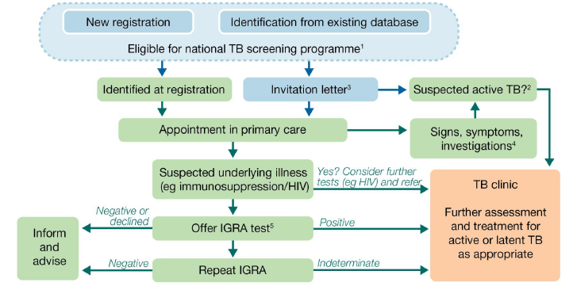
- Training, Skills and Experience
The service should be delivered by an appropriately registered clinician. There are no specifc training needs required as part of their delivery.
- Equipment
There is no specifc equipment reqiuired in the delivery of this service.

APPENDIX I - CONTRACTUAL REQUIREMENTS

LATENT TUBERCULOSIS TESTING
Unit Price | Offering Testing LTBI - £4.98  Patients identified but declined or did not respond after 3 invitations  Latent TB Testing - £19.02  Number identified and tested  Positive IGRA Test - £42.29  Number of patients testing positive LTBI and referred to hospital TB Clinic
Business Rule | Offering Testing LTBI | 1 activity per patient ever  Patient cannot have had IGRA Testing completed
Business Rule | Latent TB Testing | 1 activity per patient ever  Patients cannot have been invited more than 3 times or declined
Business Rule | Positive IGRA Test | 1 activity per patient ever
Service Type | - Episodic | No Pop-Up
Referral Criteria | Patients aged 16-35 are Mandatory under this contract
Target Population
Patients included in Target population TB00:
- Patients must be aged 16-35
- Registered with a GP Practice in last 5 years
- Entered UK within the last 5 years (860021000000109)
- Born OR Lived >6 months in a high incidence country
- No previous history of TB or LTBI
- Not previously screened for LTBI (171400006/1087701000000104)

CODING NECESSARY FOR PAYMENT
Ref. | Description | SNOMED Code
TB01 | Invited for screening 3 times or have declined | Latent tuberculosis screening invitation (<<925541000000101) (3 times)  OR  Latent tuberculosis screening declined (926261000000105)
TB02 | Patients who have been tested | Either:  IGRA Positive (440662009)  IGRA Negative (440661002)  IGRA Indeterminate (439996009)
TB03 | Identification of patients with a positive IGRA test result and referral to TB service | IGRA Positive (440662009)  AND EITHER  Referral to tuberculosis screening service (519121000000100)  Examination for suspected tuberculosis (171400006)

PAYMENT/KPI RULES
To Achieve Payment for Latent TB Invitation (3 times) or Declined for TB01
- Patient is in target population TB00 AND
- Has SNOMED code of Latent tuberculosis screening invitation at least 3 times (<<925541000000101) 3 times OR Latent tuberculosis screening declined (926261000000105) recorded by the provider

To Achieve Payment for Latent TB Testing TB02
- Patient is in target population TB00 AND
- Has either SNOMED code of IGRA Positive (440662009) OR IGRA Negative (440661002) OR IGRA Indeterminate (439996009) recorded by the provider

To Achieve Payment for Positive IGRA Result and Referral to TB Service TB03
- Patient is in target population TB00 AND
- Has SNOMED code of IGRA Positive (440662009) recorded by the provider AND
- Has SNOMED code of Referral to tuberculosis screening service (519121000000100) OR Examination for suspected tuberculosis (171400006) recorded by the provider

Service | Ring Pessary

- National/ Local context and evidence base
This specification describes the Locally Commissioned Service for Ring Pessary to be provided within primary care. A vaginal ring pessary is an effective treatment for pelvic organ prolapse and is more appropriate for some patients than surgery. The procedure is suitable for primary care provision. This specification is intended to cover the enhanced aspects of clinical care of the patient, which are beyond the scope of GMS essential services and the quality and outcomes framework.

All practices are expected to provide essential and those additional services they are contracted to provide to all their registered patients. This Locally Commissioned Enhanced Service (LES) specification for Ring Pessary outlines the more specialised services to be provided. No part of this specification by commission, omission or implication defines or redefines essential or additional services. This service must be provided in a way that ensures it is equitable in respect of race, creed, culture, diversity, disability, sex, and age.

In 2019 all CCGs in North West London began the implementation of a five-year framework for GP Contract reform, to provide a foundation for The NHS Long Term Plan. Following the development of a PCN arrangement and the commissioning of the Network Contract DES, PCNs have begun working with system partners to meet the increasingly complex needs of local populations.

This service is aimed at women who need a ring pessary and is intended to enable the management, refitting and removal of ring pessaries to take place within Primary Care. Effective treatment and symptom relief for prolapse can be achieved by the use of an appropriately sized and fitted pessary. This route is recommended by NICE [NG123] where appropriate before surgical options are explored. Ring pessaries are also sometimes used as a temporary measure in the management of vaginal prolapse in women who are planning another pregnancy and sometimes used in the management of stress incontinence caused by prolapse.
- Aims and objectives of service
- The ICB is commissioning services that must be delivered by a group of GP providers to all patients registered with these practices ensuring equitable access and quality of service to the entire population group. The GP provider grouping and location(s) for delivery of the service (number of delivery points) will need to be agreed with the Borough Primary Care team.
- The ICB is commissioning a ring pessary service that supports its strategic commissioning intentions to ensure that high quality care is delivered as close to the patient’s home as appropriate.

The service will do this by:

- Delivering a timely, effective and personalised ring pessary service in a safe environment
- Providing appropriate patient education so that patients may make informed choices and fully participate in their care and improve concordance.
- Preventing unnecessary referrals and admissions to specialist services, hospital or nursing homes. But where onward referrals are necessary completing these in clinically appropriate timeframes.
- This service is in addition to those existing contracted services that GP providers are providing to their registered patients. This service specification is designed to cover the enhanced aspects of clinical care of the patient, which are considered beyond the scope of essential services and additional services.
- This service aims to improve access to ring pessaries in primary care and reduce the need for patients to attend secondary care.
- Service Description/Care Pathway
The registered GP will make the necessary assessment to recommend a ring pessary in-house or refer the patient refer the patient to the local Community Gynaecology Service, or Ring Pessary clinic within their PCN or to secondary care for assessment, sizing and initial fitting. It is expected that a significant number of patients requiring a ring pessary assessment/fitting might have already been assessed in secondary care and will be referred back to GP practices for further management. It is expected that all patients referred to the Provider will have had an assessment of their suitability for other forms of management of symptoms and an informed discussion regarding the use of a ring pessary.

First Consultation
The service provider will:
- The service provider will issue acute necessary prescriptions; the prescribing of repeat medicine as part of ongoing management remains the responsibility of the patient’s registered GP. This means the service provider will ensure that the patient has a prescription for a pessary from their registered GP prior to their appointment (if required). If after being assessed the patient needs an acute prescription for a different size pessary or for some topical oestrogen, then that should be done by the provider.
- Ensure that patient consent has been obtained to access their record
- Assess the patient and fit the ring pessary
- Agree a follow up appointment time with the patient and provide safety netting advice regarding ring pessary care.
- The provider is expected to achieve at least a first to follow up ratio of 1:2 within a calendar year. Follow-up every 4 to 6 months

On-going Follow-up in Primary Care (for review/replacement)
The service provider will:
- Ensure patients are invited for follow-up every 4 to 6 months, depending on any specific product instructions. At each follow-up appointment:
- The service provider will carry out an assessment to check whether the pessary gives adequate symptom relief
- The service provider will remove the pessary and inspect the vagina for evidence of pressure necrosis, atrophic vaginitis or granulation tissue
- Depending on the type of pessary, either a new one should be inserted or the pessary should be washed and replaced
- Advise the patient on the timescale for their next follow up.
- Review symptom control, and return the patient to their registered GP for consideration of referral to secondary care if symptom control by ring pessary is not possible.
- Ensure the consultation summary is available to the patient’s registered GP following each appointment.
- Provide appropriate counselling and screening prior to insertion in accordance with NICE Guidelines
- Hold a caseload and ensure that there is systematic call and recall of patients under the service. The service provider is responsible for follow up of any patients who do not attend their scheduled ring pessary appointment in Primary Care. Patients should be discharged back to their registered GP if there is no response to two letters or phone calls.
- Refer patients with complications back to the specialist team, via the patient’s GP, if necessary
- Patients should be able to return to the to the local Community Gynaecology Service,Ring Pessary clinic within their PCN/Federation orto secondary care service specialist team as soon as possible if there are any problems within the first 6 weeks of fitting, if the management cannot be provided in Primary Care

Population Covered
- This service will cover all patients with a registered GP in North W London either at a practice level or at PCN level. PCNs may collaborate to work at scale. The GP provider grouping and location(s) of delivery of the service (number of delivery points) must be agreed with the Borough Primary Care team.
- Where the provider is not the patient’s registered practice, the provider must ensure that the patient’s registered practice is given all appropriate clinical details for inclusion in the patient’s record within a reasonable timeframe, and no longer than five days.
- Any acceptance and exclusion criteria and thresholds
Acceptance
Female patients aged 18 and above with symptomatic pelvic organ prolapse requiring vaginal ring pessaries in primary care.

Exclusions
This service is for ring pessary only. Therefore, the service does not include:
- Estring (Pharmacia) ring pessary which may be used for atrophic vaginitis
- Insertion of prostaglandin pessary
- Insertion of abortifacient pessary NEC

Referral sources
- The PCN should have appropriate agreement with practices in the PCN to provide the service on their behalf or other arrangement.
- Often GPs will fit ring pessaries and will refer up to the Urogynaecology team in secondary in secondary care for more complex prolapses and for women who haven’t responded to conservative treatments who need further assessment and investigations.

Interdependencies with other services
- The service will be interdependent with any local community Gynae service where available
- The service provider should ensure that any referral pathways that are required between themselves and other interdependent services (i.e. Secondary Care/Community) are in place.
- Training, Skills and Experience
Workforce Requirements
- The service provider must ensure that staff delivering the service meet the training and competency requirements to safely fit and change ring pessaries.
- The service can be provided by a GP or suitably qualified registered nurse.
- Nurses providing this service must be competent in bi-annual examination in line with the competencies set out in Genital Examination in Women (RCN,2020) and good understanding of Urogynaecology as set out by the RCN
- There should be at least two members of staff on the premises when this procedure is performed, which should be conducted in line with GMC recommendations for chaperones

Minimum clinical governance requirements
- The service provider will need to be able to deliver, manage and report on service performance in line with the contractual requirements
- Within the PCN or GP provider grouping there will need to be a mechanism for referring and receiving clinical information about patients between the referring practices and the service delivery points that will need to be supported by robust governance processes
- The service provider must ensure that there are robust governance processes in place to ensure clinical services are delivered safely in each delivery point and are coordinated across the PCN or GP provider grouping
- The service provider should ensure that all delivery points meet CQC requirements for the delivery of medical services which as a minimum should be those required for the delivery of general medical services
- The service provider should ensure that all standards of communication should adhere to Caldicott and Data Protection guidelines
- Data generated in the course of delivering the service should be available to the commissioner on request. The commissioner will give due regard to data protection and confidentiality requirements
- If required to ensure that the service is operating effectively, the commissioner can interview the service provider's staff
- The service provider should comply with commissioner requests for clinical audit
APPENDIX I - CONTRACTUAL REQUIREMENTS
RING PESSARY
Unit Price | Ring Pessary - £30.08 per six months when the patient is seen. (Maximum of £59.76 per patient per  annum)
Business Rule | 1 activity per patient per 6 months
Service Type | - Episodic | Pop-Up used to Record Enhanced services administration (166221000000105)
Referral Criteria | - Patients aged 18 and over are Mandatory under this contract

CODING NECESSARY FOR PAYMENT
Ref. | Description | SNOMED Code
R01 | Consultations completed for ring pessary | Insertion of ring pessary into vagina (176726001)  OR Removal of ring pessary (236865002) OR Renewal of ring pessary in vagina (236861006)

PAYMENT/KPI RULES
To Achieve Payment for Ring Pessary R01
- Has SNOMED code of Insertion of ring pessary into vagina (176726001) OR Removal of ring pessary (236865002) OR Renewal of ring pessary in vagina (236861006) recorded by the provider AND
- Has SNOMED code of Enhanced services administration (166221000000105) recorded at the same time as the Ring Pessary

Activity Planning Assumptions
To achieve the full payment of tariff the provider must complete a full treatment cycle in line with the NICE guidance of 2-3 (every 4 to 6 months) consultations within a calendar year. These consultations should include a first initial appointment and one/two follow up appointments within the year. This will equate to a maximum first to follow up ratio of 1:2.

Service | Near Patient Testing for Disease-modifying anti-rheumatic drugs (DMARDs)

- National context and evidence base
Since 2019 NWL CCG has been implementing The NHS Long Term Plan which increases the focus of the provision of services based on population health through Primary Care networks (PCNs) which has lead towards the development of Enhanced Services that are outcome focused and population based.

Disease Modifying Anti-Rheumatic drugs (DMARDs) are prescribed in the treatment of rheumatoid arthritis (RA) to suppress inflammation; they may be used as monotherapy or more commonly in combination. DMARDs are also used for the treatment of other rheumatology conditions (e.g. connective tissue disease and vasculitis) and in other specialities, including dermatology, respiratory medicine, neurology, ophthalmology and gastroenterology. Patients are initiated on these drugs by the hospital specialists and the transfer of prescribing and monitoring to primary care is after the patients have been stabilised, usually after 3 months and under shared care with the specialist hospital team.

To promote a standard approach to Shared Care Protocols (SCPs), on behalf of the national Regional Medicines Optimisation Committees (RMOCs) system, RMOC (North) led the development of Shared Care for Medicines Guidance – A Standard Approach. This guidance defines the principles for a national system of shared care for medicines. The guidance provides a framework for the seamless shared care and decision making between the patient, specialist service and primary care prescriber in relation to medicines use. It builds on the NHS England guidance Responsibility for prescribing between primary and secondary/tertiary care (2018). As part of this work, number of national SCPs for DMARDs have recently been published by NHS England in July 2022.

The SCPs are clinically focussed and provide the information required to support safe and effective shared care for the specified medicines. They include licensed indications and established off-label uses. Standardised templates will improve patient safety, reduce duplication and reduce inequity of access. There is no legal obligation nor mandatory requirement to use the SCPs however North West London ICB will be reviewing these via the NW London Integrated Formulary Panel for a decision.

The national SCDs have been developed for the following DMARDs for adults only (18 years and over)

Along with using these protocols, please ensure that summaries of product characteristics (SPCs), British National Formulary (BNF) or the Medicines and Healthcare products Regulatory Agency (MHRA) or NICE websites are reviewed for up-to-date information on any medicine.

- Azathioprine and mercaptopurine for patients within adult services (non-transplant indications) (last updated January 2022)
- Ciclosporin (oral) for patients within adult services (non-transplant indications) (last updated January 2022)
- Hydroxycarbamide for myeloproliferative disorders and sickle cell disease for patients within adult services (last updated January 2022)
- Hydroxychloroquine for patients within adult services (last updated January 2022)
- Leflunomide for patients within adult services (last updated January 2022)
- Methotrexate (oral and subcutaneous) for patients in adult services (excluding cancer care) (last updated January 2022)
- Mycophenolate mofetil and mycophenolic acid for patients within adult services (last updated January 2022)
- Sulfasalazine for patients within adult services (last updated January 2022)

Penicillamine is a DMARD that is rarely used now and a national SCD is not currently available. There is a minority of patients in NW London that continue to be on this medication thus penicillamine is included in this service. It is anticipated that there will be no new patients. Monitoring recommendations for this drug are based on Specialist Pharmacy Services in the absence of a national SCD. A local SCD will be developed.
- Aims and objectives of service
- To enable key DMARDs to be prescribed and monitored safely in primary care by mutual agreement.
- The treatment of several diseases within the fields of medicine, particularly in rheumatology, gastroenterology and dermatology, is increasingly reliant on drugs that, while clinically effective, need regular monitoring. This is due to the potentially serious side-effects that these drugs can occasionally cause.
- The Near Patient Testing for Disease-modifying anti-rheumatic drugs (DMARDs) Service is designed to be one in which:
- therapy should only be continued in primary care for recognised indications for specified lengths of time
- maintenance of patients first stabilised in the secondary care setting should be properly controlled thereafter
- the service to the patient is convenient
- the need for continuation of therapy is reviewed regularly
- the therapy is discontinued when appropriate
- the use of resources by the National Health Service is efficient.

The ICB is commissioning a near patient testing service that means the service provider will:
- Provide the service for patients in their PCN
- Provide a maintenance service for patients first stabilised in Secondary Care and where the patient is well controlled
- Ensure that patients have regular blood tests, recognising that the interval and tests are different for each drug
- Conduct a robust call and recall system
- Deliver a service that is convenient to the patient and will take any necessary action in response to any DNA.
- Discontinue therapy in response to blood test results and in liaison with the patient’s Consultant.

The service will do this by:
- Delivering a timely, effective and personalised service in a safe environment
- Providing appropriate patient education so that patients may make informed choices and fully participate in their care and improve concordance
- Promoting the use of individualised care management plans for all patients
- Preventing unnecessary referrals and admissions to specialist services, hospital or nursing homes. But where onward referrals are necessary completing these in clinically appropriate timeframes
- This service is in addition to those existing contracted services that providers are providing to their registered patients. The specification of this service is designed to cover the enhanced aspects of clinical care of the patient, which are considered beyond the scope of essential services and additional services
- Ensuring the contact details of the responsible specialist/clinic is made available to the service provider e.g., direct number/e-mail address with a reasonable response time of 72 hours
- Service Description/Care Pathway
The near patient testing service is designed to be one in which:
- Initial treatment is started by the Consultant Specialist will retain the prescribing and monitoring responsibility for at least 12 weeks for most DMARDs
- The patient is stabilised
- The patient is then transferred under shared care arrangements to the service provider with clear instructions from the specialist on the duration of treatment, potential side effects, monitoring timetable, and when to transfer back if there are complications
- The service provider should be the patient’s registered GP practice/PCN.
- The service must be convenient for the patient
- The therapy is discontinued when appropriate and as recommended by the Hospital Consultant.

The service shall provide a drug monitoring service in which:
- Therapy should only be started for recognised indications for specified lengths of time
- Maintenance of patients first stabilised in the secondary care setting (should be properly controlled thereafter)
- The need for continuation of therapy is reviewed regularly
- The therapy is discontinued when appropriate
- The service to the patient is convenient
- Maintain an up to date register of all patients seen within this service
- For all patients managed under the agreed protocol provides repeat prescriptions and undertakes appropriate tests to monitor patients in line with the agreed protocol
- Ensure that the appropriate Patient Held Record (Purple book for Methotrexate) and other appropriate record books for other drugs (as available) is up to date at all times
- If the patient does not have the purple book the practice/service provider will supply this to the patient
- The patient’s electronic record in the practice has up to date records of monitoring blood test results. This is to support a robust system of recall and monitor patients systematically and prescribe methotrexate safely. This follows the NPSA guidance for hand held records.
- Ensure that the service has an adequate supply of the required record books to give to the patient as necessary
- Contact secondary care for advice where the patient’s results are abnormal
- Refer patients back to secondary care following the agreed protocol where necessary for follow up within a reasonable time frame
- To record any changes in therapy in the clinical record on receipt of such communication from secondary care
- To monitor the patient’s overall health and wellbeing including the Disease Activity and to report any adverse drug reactions or interactions, and worsening Disease Activity to secondary care
- The use of resources by the National Health Service is efficient
- Any acceptance and exclusion criteria and thresholds
Inclusion
- All patients must be agreed to the transfer by the consultant, the patient and the GP.
- Adults 18 years and over.
- Patients will be initiated and stabilised by the specialist hospital team before transfer to primary care- at least 12 weeks after initiation.
- List of drugs included in this service:
- Azathioprine
- Ciclosporin
- Hydroxycarbamide
- Hydroxychloroquine
- Leflunomide
- Mercaptopurine
- Methotrexate (oral and injectable)
- Mycophenolate mofetil and mycophenolic acid
- Penicillamine
- Sulfasalazine

Exclusion
- Children under 18 years
- Where a patient, for clinical reasons is referred back to secondary care within the year the payment will cease from the first day of the following quarter, and resumed from the quarter that the patient is transferred back for monitoring. In some instances, practices may be requested to continue to monitor these patients, in which case they are applicable for reimbursement in the scheme
- Training, Skills and Experience
The service provider must ensure all staff delivering the service meet the training and competency requirements.
- Equipment
There is no specifc equipment required for the delivery of this service.

APPENDIX I - CONTRACTUAL REQUIREMENTS

NEAR PATIENT TESTING
Unit Price | £15.19 Per Quarter when the patient is seen (Maximum of £60.35 per patient per annum)  Provider can also receive an additional tariff for Phlebotomy as part of the delivery of Near Patient Testing
Business Rule | 1 activity per patient per quarter
Service Type | - Episodic | Pop-up not required
Referral Criteria | - Patients aged 18 years and above are Mandatory under this contract  - Patient is prescribing a medication as listed with the specification  - Patient has formal Shared Care Protocols (SCPs)

CODING NECESSARY FOR PAYMENT
Ref. | Description | SNOMED Code
NPT01 | Number of consultations for Near Patient Testing | Near Patient Testing Enhanced Service completed (166451000000101)

PAYMENT/KPI RULES
To Achieve Payment for Near Patient Testing
- Patients must be aged 18 and over AND
- Has SNOMED code of Near patient testing enhanced service completed (166451000000101) recorded by the provider in payment Quarter

Clinical Information for the Near Patient Testing for Disease-modifying anti-rheumatic drugs (DMARDs) and Immunosuppressant Drugs

National Shared Care Protocols
To promote a standard approach to Shared Care Protocols (SCPs), on behalf of the national Regional Medicines Optimisation Committees (RMOCs) system, RMOC (North) led the development of Shared Care for Medicines Guidance – A Standard Approach. This guidance defines the principles for a national system of shared care for medicines. The guidance provides a framework for the seamless shared care and decision making between the patient, specialist service and primary care prescriber in relation to medicines use. It builds on the NHS England guidance Responsibility for prescribing between primary and secondary/tertiary care (2018).

SCPs are clinically focussed and provide the information required to support safe and effective shared care for the specified medicines. They include licensed indications and established off-label uses. Standardised templates will improve patient safety, reduce duplication and reduce inequity of access. There is no legal obligation nor mandatory requirement to use the SCPs.

SCPs includes all information required for safe prescribing in strict accordance with current guidance.

Penicillamine is a DMARD that is rarely used now and a national SCD is not currently available. There is a minority of patients in NW London that continue to be on this medication thus penicillamine is included in this service. It is anticipated that there will be no new patients. Monitoring recommendations for this drug are based on Specialist Pharmacy Services in the absence of a national SCD. A local SCD will be developed.

Along with using these protocols, please ensure that summaries of product characteristics (SPCs), British National Formulary (BNF) or the Medicines and Healthcare products Regulatory Agency (MHRA) or NICE websites are reviewed for up-to-date information on any medicine.

Some DMARDs are used for transplant patients and the national shared care protocols exclude these patients as anti-rejection DMARD drugs prescribing and monitoring should remain with the hospital transplant team.

Note that

- Monitoring at baseline and during initiation is the responsibility of the specialist; only once the patient is optimised on the chosen medication with no anticipated further changes expected in immediate future will prescribing and monitoring be transferred to primary care.
- Transfer of monitoring and prescribing to primary care is normally after at least 12 weeks, and when the patient’s dose has been optimised and with satisfactory investigation results for at least 4 weeks.
- The duration of treatment & frequency of review will be determined by the specialist, based on clinical response and tolerability.
- All dose or formulation adjustments will be the responsibility of the initiating specialist unless directions have been discussed and agreed with the primary care clinician.
- The specialist will retain the responsibility for monitoring the patient’s ongoing response to treatment and advise if a dose change or treatment cessation is appropriate. This should usually be undertaken annually.
- After each review, the specialist is to advise primary care whether treatment should be continued, confirm the ongoing dose, and whether the ongoing monitoring outlined in the SCD remains appropriate.
- Primary care to provide ongoing vaccinations as appropriate for examples, Shingles, influenza, COVID-19 and pneumococcal vaccinations
- Please refer to the individual SCD for full details.
Drugs included in the Near Patient Testing DMARD Service

NO | Drug | National Shared Care Protocol:  NHS England » Shared Care Protocols (SCPs) | Indications included in the Service
NO | Drug |  | Licenced Indications | Off-label indications  These indications are off-label. The specialist must specify the indication for each patient when initiating shared care and clearly state when use is off-label.
1 | Azathioprine | Yes: Azathioprine and mercaptopurine for patients with adult service (non-transplant indications) | Licensed indications include:  - Auto-immune chronic active hepatitis  - Auto-immune haemolytic anaemia  - Chronic refractory idiopathic thrombocytopenic purpura  - Dermatomyositis  - Inflammatory bowel disease (IBD)  - Pemphigus vulgaris  - Polyarteritis nodosa  - Polymyositis  - Pyoderma gangrenosum  - Rheumatoid arthritis  - Systemic lupus erythematosus (SLE) | Including treatment of chronic inflammatory conditions where off-label use of azathioprine is appropriate, including, but not limited to the following specialities and conditions:  - Dermatology (e.g. severe eczema)  - Neurology (e.g. myasthenia gravis, demyelinating conditions)  - Ophthalmology (e.g. uveitis, scleritis)  - Oral medicine (e.g. Behçet’s disease, refractory inflammatory oral disease)  - Renal medicine (e.g. immune-mediated nephritis)  - Respiratory disease (e.g. interstitial lung disease)  - Rheumatology (e.g. inflammatory arthritis, connective tissue disease, vasculitis, giant cell arteritis)
2 | Ciclosporin | Yes: Ciclosporin (oral) for patients within adult services (non-transplant indications) | Licensed indications:  - Endogenous uveitis  - Nephrotic syndrome  - Rheumatoid arthritis  - Psoriasis  - Atopic dermatitis | Chronic inflammatory conditions where off-label use of ciclosporin is appropriate, including, but not limited to, the following specialities and conditions:  - Rheumatology (e.g. psoriatic arthritis, systemic lupus erythematosus, connective tissue disease, vasculitis)  - Dermatology (e.g. urticaria, inflammatory dermatoses, bullous conditions)  - Gastroenterology (e.g. severe ulcerative colitis)  - Renal medicine (e.g. vasculitis, lupus nephritis)  - Neurology (e.g. myasthenia gravis)
3 | Hydroxycarbamide | Yes: Hydroxycarbamide for myeloproliferative disorders and sickle cell disease for patients within adult services | Licensed indications include:  - Chronic myeloid leukaemia  - Essential thrombocythaemia  - Polycythaemia vera  - Sickle-cell disease | Other myeloproliferative disorders and inflammatory conditions where off-label use of hydroxycarbamide is appropriate, including:  - Primary myelofibrosis^{ǂ}  - Unclassified myeloproliferative disorders^{ǂ}  - Psoriasis^{ǂ}
4 | Hydroxychloroquine sulfate | Yes: Hydroxychloroquine for patients within adult services | Licensed indications:  - Active rheumatoid arthritis  - Systemic and discoid lupus erythematosus  - Dermatological conditions caused or aggravated by sunlight | Chronic inflammatory conditions where off-label use of hydroxychloroquine is appropriate, including but not limited to the following specialities and conditions:  - Rheumatology (e.g. inflammatory arthritis, connective tissue disease, Sjögren’s syndrome, myositis)  - Dermatology (e.g. urticaria, other inflammatory skin diseases)  - Respiratory disease (e.g. interstitial lung disease, sarcoidosis).  - Renal medicine
5 | Leflunomide | Yes: Leflunomide for patients within adult services | Licensed indications:  - Rheumatoid arthritis  - Psoriatic arthritis | Off-label use for other inflammatory conditions including:  - Rheumatology conditions (e.g. systemic lupus erythematosus, axial spondyloarthopathy)  - Interstitial lung disease  - Vasculitis
6 | Mercaptopurine | Yes: Azathioprine and mercaptopurine for patients with adult service (non-transplant indications) | None: licensed oncology indications remain responsibility of hospital | Including treatment of chronic inflammatory conditions where off-label use of azathioprine is appropriate, including, but not limited to the following specialities and conditions:  - Inflammatory bowel disease  - Autoimmune encephalitides  - Autoimmune hepatitis
7 | Methotrexate: Oral and sub-cut injection | Yes: Methotrexate (oral and subcutaneous) for patients in adult services (excluding cancer care) | The licensed indications include:  - Active rheumatoid arthritis  - Mild to moderate Crohn’s disease in patients refractory or intolerant to thiopurines (licensed indication of subcutaneous preparations)  - Severe psoriasis  - Severe psoriatic arthritis  Licensed indications vary with brand. See relevant summary of product characteristics for full details. | Other chronic inflammatory conditions where off-label use of methotrexate is appropriate, including, but not limited to, the following specialities and conditions:  - Rheumatology (e.g. inflammatory arthritis, connective tissue disease, vasculitis)  - Dermatology (e.g., severe eczema, bullous conditions)  - Gastroenterology (e.g. severe Crohn’s disease or other inflammatory bowel disease)  - Neurology (e.g. myasthenia gravis, inflammatory neuropathies)  - Ophthalmology (e.g. uveitis, scleritis)  - Respiratory disease (e.g. sarcoidosis, interstitial lung disease)
8 | Mycophenolate mofetil and mycophenolic acid | Yes: Mycophenolate mofetil and mycophenolic acid for patients within adult services (non-transplant indications) |  | Off-label use for the treatment of chronic inflammatory conditions where use of mycophenolate is appropriate, including but not limited to the following specialities and conditions:  - Dermatology (e.g. myositis, severe psoriasis, severe atopic dermatitis/eczema, autoimmune bullous dermatoses, SLE)  - Gastroenterology (e.g. Crohn’s disease, ulcerative colitis)  - Haematology (e.g. idiopathic thrombocytopenic purpura)  - Hepatology (e.g. auto-immune hepatitis)  - Neurology (e.g. inflammatory neuropathies, myasthenia gravis)  - Ophthalmology (e.g. uveitis, scleritis)  - Oral medicine (e.g. Behçet’s disease, refractory inflammatory oral disease)  - Renal medicine (e.g. immune-mediated nephritis)  - Respiratory disease (e.g. interstitial lung disease)  - Rheumatology (e.g. rheumatoid arthritis, systemic lupus erythematosus [SLE], vasculitis)
9 | Penicillamine | No: Rarely used, historical patients continue to require close monitoring | The licensed indications for penicillamime include:  - Severe, active rheumatoid arthritis, including juvenile forms  - Wilson's disease (hepatolenticular degeneration) in adults  - Cystinuria-dissolution and prevention of cystine stones in adults  - Chronic active hepatitis in adult
10 | Sulfasalazine | Yes: Sulfasalazine for patients within adult services | The licensed indications for sulfasalazine are:  - Rheumatoid arthritis (EC tablets only)  - Ulcerative colitis  - Active Crohn’s disease | Off-label use for other chronic inflammatory disorders including:  - Seronegative spondyloarthropathies such as psoriatic arthritis  - Sarcoidosis

Near Patient Monitoring for DMARDs

NO. | Drug | Refer to individual Shared Care Document for detailed information
NO. | Drug | Baseline investigations, initial monitoring and ongoing monitoring to be undertaken by specialist (here for information) | Ongoing monitoring requirements to be undertaken by primary care
1 | Azathioprine | Baseline investigations:  - Height and weight  - Blood pressure  - Full blood count (FBC)  - Urea and electrolytes (U&Es) & creatinine clearance (CrCl)  - Alanine aminotransferase (ALT) and/or aspartate aminotransferase (AST), and albumin  - Baseline thiopurine methyl transferase (TPMT) status  - Screening for viral infections as per local policy, e.g. HIV, hepatitis B and C, varicella zoster, Epstein Barr virus, cytomegalovirus  - Screening for lung disease, including tuberculosis, should be undertaken at clinician discretion on a case by case basis  - Confirm cervical screening is up to date  Initial monitoring and at dose change:  To be repeated every 2 weeks until the dose has been stable for 6 weeks, then monthly for 3 months:  - FBC  - U&Es, including creatinine and CrCl  - LFTs, including AST and/or ALT, and albumin  Following a dose increase repeat every 2 weeks until the dose has been stable for 6 weeks, then revert to previous schedule. More frequent monitoring is appropriate in patients at higher risk of toxicity. | Monthly for three months, unless already completed in secondary care. Thereafter at least every 12 weeks, and more frequently in patients at higher risk of toxicity, as advised by the specialist team.  - FBC  - U&Es including creatinine and CrCl  - ALT and/or AST, and albumin  - Rheumatology patients: CRP &/or ESR  The exact frequency of monitoring to be communicated by the specialist in all cases
2 | Ciclosporin | Baseline investigations:  - Height and weight  - Blood pressure (BP)  - HbA1c  - Full blood count (FBC)  - Urea and electrolytes (U&Es) & creatinine clearance (CrCl), ideally on two occasions prior to starting ciclosporin  - Serum magnesium  - Alanine aminotransferase (ALT) and/or aspartate aminotransferase (AST), albumin, and bilirubin  - Serum lipids and uric acid  - Screening for HIV and hepatitis B and C  - Screening for lung disease, including tuberculosis, should be undertaken at clinician discretion on a case by case basis  - Consider baseline pregnancy testing, if clinically appropriate  - Provide or request appropriate vaccination prior to treatment initiation, according to local arrangements (e.g. pneumococcal, shingles, influenza, COVID-19)  Initial monitoring and at dose change:  To be repeated every 2 weeks until the dose has been stable for 6 weeks, then monthly. After which, the transfer of prescribing to primary care should normally only take place when the patient has received a stable dose for at least 4 weeks and their blood and physical tests results have been satisfactory. It is anticipated that this should be around 12 weeks after initiation of the medicine, but may be sooner in some indications.  - BP  - HbA1c  - FBC  - U&Es, including creatinine and CrCl  - AST and/or ALT, albumin, and bilirubin  - Rheumatology patients: C-reactive protein (CRP) &/or erythrocyte sedimentation rate (ESR)  Following a dose change repeat every 2 weeks until the dose has been stable for 6 weeks, then revert to previous schedule.  After one month of treatment:  - Serum lipids  More frequent monitoring is appropriate in patients at higher risk of toxicity. Monitoring of ciclosporin drug levels, where clinically appropriate, would usually be undertaken by the specialist if indicated.  Prescribing and dispensing of ciclosporin should be by brand name to avoid inadvertent switching.  If it is necessary to switch a patient to a different brand, this should be done cautiously under specialist supervision. The patient should be monitored closely for changes in the following:  - Serum creatinine  - BP | Monthly:  - BP  - HbA1c  - FBC  - U&Es including creatinine and CrCl  - ALT and/or AST, albumin, and bilirubin  - Rheumatology patients: CRP &/or ESR  Patients who have been stable for 12 months can be considered for reduced frequency monitoring on a case-by-case basis.  Six monthly:  - Serum lipids  - Uric acid  - Serum magnesium  The exact frequency of monitoring to be communicated by the specialist team in all cases.
3 | Hydroxycarbamide | Baseline investigations:  - FBC  - Urea and electrolytes (U&Es)  - LFTs  - Screening for viral infections as per local policy, e.g. HIV, hepatitis B and C, varicella zoster, Epstein Barr virus, cytomegalovirus  - Screening for lung disease, including interstitial lung disease and tuberculosis, should be undertaken at clinician discretion on a case by case basis  - Provide or request appropriate vaccination prior to treatment initiation, according to local arrangements (e.g. pneumococcal, shingles, influenza, COVID-19)  Additional baseline investigations for patients with sickle-cell disease:  - Reticulocyte count  Initial monitoring:  To be repeated every 2 weeks until dose has been optimised and all test results are stable (minimum of 8 weeks).  - FBC  - U&Es  - LFTs  - Reticulocyte count (sickle cell disease only) | Every 8-12 weeks  - FBC  - U&Es  - LFTs  - Reticulocyte count (for sickle-cell disease patients)  The exact frequency of monitoring to be communicated by the specialist in all cases.
4 | Hydroxychloroquine | Baseline investigations:  - Urea and electrolytes (U&Es) & creatinine clearance (CrCl)  - Alanine aminotransferase (ALT) and/or aspartate aminotransferase (AST), & albumin  - Full blood count (FBC)  - Weight  - Height and blood pressure (if indicated)  - Assess for co-morbidities which may influence DMARD choice, including risk factors for retinopathy (e.g. concomitant tamoxifen use, eGFR <60 mL/min)  - Electrocardiogram (ECG), if concerns exist regarding the QT-interval, see SCD for details  Ongoing monitoring:  - No routine ongoing laboratory monitoring is required for hydroxychloroquine. Monitoring may be required if the patient is prescribed an additional DMARD.  - After the patient has been on hydroxychloroquine for five years, refer to ophthalmology (or other commissioned service as appropriate) for annual monitoring for retinopathy.  - Patients who are at higher risk of retinal toxicity will need to be referred earlier. | Remind the specialist when the patient is approaching 5 years of treatment (or 1 year in patients with additional risk factors). These patients require referral from the specialist to ophthalmology (or other commissioned service as appropriate) for annual retinopathy monitoring. See RCOphth guidelines.  Risk factors may change over time; primary care should discuss with specialist if new risk factors that are ‘high risk’ are identified before the five-year mark.  - Annually after 5 years of treatment, or  - After 1 year if additional risk factors are present. Risk factors include:  - concomitant tamoxifen use  - impaired renal function (eGFR <60mL/min/1.73m²)  - hydroxychloroquine dose (>5mg/kg/day)
5 | Leflunomide | Baseline investigations:  - Height and weight  - Blood pressure  - Full blood count (FBC)  - Urea and electrolytes (U&Es) & creatinine clearance (CrCl)  - Alanine aminotransferase (ALT) and/or aspartate aminotransferase (AST), and albumin  - Screening for viral infections as per local policy, e.g. HIV, hepatitis B and C, varicella zoster, Epstein Barr virus, cytomegalovirus  - Screening for lung disease, including interstitial lung disease, should be undertaken at clinician discretion on a case by case basis.  - Provide or request appropriate vaccination prior to treatment initiation, according to local arrangements (e.g. pneumococcal, shingles, influenza, COVID-19)  - Pregnancy should be excluded before starting treatment.  Initial monitoring:  To be repeated every 2 weeks until the dose has been stable for 6 weeks, then monthly for 3 months.  - FBC  - U&Es, including creatinine and CrCl  - AST and/or ALT, and albumin  Following a dose change repeat every 2 weeks until the dose has been stable for 6 weeks, then revert to previous schedule.  More frequent monitoring is appropriate in patients at higher risk of toxicity; e.g. concurrent use of more than one DMARD. This is particularly important for patients co-prescribed methotrexate and leflunomide. The combination is highly effective but potentially synergistically toxic to liver and bone marrow, and increase monitoring frequency is strongly advised. | Monthly for the first three months of treatment followed by: at least every 12 weeks, and more frequently in patients at higher risk of toxicity, as advised by the specialist team.  - FBC  - U&Es including creatinine and CrCl  - ALT and/or AST and albumin  - BP & weight  - Rheumatology patients: CRP &/or ESR  The exact frequency of monitoring to be communicated by the specialist in all cases.
6 | Mercaptopurine | Baseline investigations:  - Height and weight  - Blood pressure  - Full blood count (FBC)  - Urea and electrolytes (U&Es) & creatinine clearance (CrCl)  - Alanine aminotransferase (ALT) and/or aspartate aminotransferase (AST), and albumin  - Baseline thiopurine methyl transferase (TPMT) status  - Screening for viral infections as per local policy, e.g. HIV, hepatitis B and C, varicella zoster, Epstein Barr virus, cytomegalovirus  - Screening for lung disease, including tuberculosis, should be undertaken at clinician discretion on a case by case basis  - Confirm cervical screening is up to date  Initial monitoring and at dose change:  To be repeated every 2 weeks until the dose has been stable for 6 weeks, then monthly for 3 months:  - FBC  - U&Es, including creatinine and CrCl  - LFTs, including AST and/or ALT, and albumin  Following a dose increase repeat every 2 weeks until the dose has been stable for 6 weeks, then revert to previous schedule. More frequent monitoring is appropriate in patients at higher risk of toxicity. | Monthly for three months, unless already completed in secondary care. Thereafter at least every 12 weeks, and more frequently in patients at higher risk of toxicity, as advised by the specialist team.  - FBC  - U&Es including creatinine and CrCl  - ALT and/or AST, and albumin  - Rheumatology patients: CRP &/or ESR  The exact frequency of monitoring to be communicated by the specialist in all cases
7 | Methotrexate | Baseline investigations:  - Height and weight  - Blood pressure  - Full blood count (FBC)  - Urea and electrolytes (U&Es) including creatinine and creatinine clearance (CrCl)  - Alanine aminotransferase (ALT) and/or aspartate aminotransferase (AST), and albumin  - Screening for HIV and hepatitis B and C  - Screening for lung disease, including interstitial lung disease and tuberculosis, should be undertaken at clinician discretion on a case by case basis  - Provide or request appropriate vaccination prior to treatment initiation, according to local arrangements (e.g. pneumococcal, shingles, influenza, COVID-19)  - Psoriasis patients: serum procollagen 3 N-terminal peptide (PIIINP)  Initial monitoring and at dose change:  To be repeated every 2 weeks until the dose has been stable for 6 weeks, then monthly for 3 months. After which, the transfer of prescribing to primary care should normally only take place when the patient has received a stable dose for at least 4 weeks and their blood and physical tests results have been satisfactory.  - FBC  - U&Es, including creatinine and CrCl  - ALT and/or AST, and albumin  - Rheumatology patients: CRP &/or ESR  - Psoriasis patients: serum PIIINP  Following a dose change repeat every 2 weeks until the dose has been stable for 6 weeks, then revert to previous schedule.  More frequent monitoring is appropriate in patients at higher risk of toxicity. | At least every 12 weeks, and more frequently in patients at higher risk of toxicity, as advised by the specialist team.  - FBC  - U&Es including creatinine and CrCl  - ALT and/or AST and albumin  - Rheumatology patients: CRP &/or ESR; specialist to confirm  - Psoriasis patients: serum PIIINP  The exact frequency of monitoring to be communicated by the specialist in all cases.
8 | Mycophenolate mofetil and mycophenolic acid | Baseline investigations:  - Full blood count (FBC)  - Urea and electrolytes (U&E), including creatinine and creatinine clearance (CrCl)  - Alanine aminotransferase (ALT) and/or aspartate aminotransferase (AST), and albumin  - Height & weight  - Blood pressure  - Screening for viral infections as per local policy, e.g. HIV and hepatitis B and C, varicella zoster, Epstein Barr virus, cytomegalovirus  - Before starting mycophenolate mofetil treatment, people of childbearing potential should have a negative pregnancy test. Two serum or urine pregnancy tests with a sensitivity of at least 25 mlU/mL are recommended. A second test should be done 8-10 days after the first one and immediately before starting mycophenolate mofetil, unless exceptional circumstances exist whereby a delay in the initiation of treatment would cause harm to the patient and the prescriber is satisfied that a single test is adequate to rule out pregnancy. Pregnancy tests should be repeated as clinically required (e.g. after any gap in contraception is reported). See MHRA Drug Safety Update for more detail  - Screening for lung disease, including tuberculosis, should be undertaken at clinician discretion on a case by case basis  - Provide or request appropriate vaccination prior to treatment initiation, according to local arrangements (e.g. pneumococcal, shingles, influenza, COVID-19)  Initial monitoring:  To be repeated every 2 weeks until the dose has been stable for 6 weeks, then monthly for 3 months:  - FBC  - U&Es, including creatinine and CrCl  - AST and/or ALT, and albumin  Following a dose increase repeat every 2 weeks until the dose has been stable for 6 weeks, then revert to previous schedule. | Monthly for three months unless already completed in secondary care, thereafter at least every 12 weeks, and more frequently in patients at higher risk of toxicity, as advised by the specialist team.  - FBC  - U&Es including creatinine and CrCl  - ALT and/or AST and albumin  - Rheumatology patients: CRP &/or ESR  The exact frequency of monitoring to be communicated by the specialist in all cases.
9 | Penicillamine | Baseline investigations:  - Urea and electrolytes (U&Es) including creatinine and creatinine clearance (CrCl)  - Alanine aminotransferase (ALT) and/or aspartate aminotransferase (AST), & albumin  - Full blood count (FBC)  - Urinalysis  TBC:  - Weight  - Height and blood pressure  - Assess for co-morbidities which may influence DMARD choice  - Screening for HIV and hepatitis B and C  - Screening for lung disease, including tuberculosis, should be undertaken at clinician discretion on a case by case basis.  - Provide or request appropriate vaccination prior to treatment initiation, according to local arrangements (e.g. pneumococcal, influenza, COVID-19)  Initial monitoring and at dose change:  To be repeated every 2 weeks for 6 weeks to 3 monthly:  - Creatinine and creatinine clearance (CrCl)  - Alanine aminotransferase (ALT) and/or aspartate aminotransferase (AST), & albumin  - Full blood count (FBC)  - Urinalysis | Monthly for 12 months, then every 3 months:  - Creatinine and creatinine clearance (CrCl) – increase to every 2 weeks if renal impairment  - Alanine aminotransferase (ALT) and/or aspartate aminotransferase (AST), & albumin  - Full blood count (FBC)  - Urinalysis  The exact frequency of monitoring to be communicated by the specialist in all cases.
10 | Sulfasalazine | Baseline investigations:  - Urea and electrolytes (U&Es) including creatinine and creatinine clearance (CrCl)  - Alanine aminotransferase (ALT) and/or aspartate aminotransferase (AST), & albumin  - Full blood Count (FBC)  - Weight  - Height and blood pressure  - Assess for co-morbidities which may influence DMARD choice  - Screening for HIV and hepatitis B and C  - Screening for lung disease, including tuberculosis, should be undertaken at clinician discretion on a case by case basis.  - Provide or request appropriate vaccination prior to treatment initiation, according to local arrangements (e.g. pneumococcal, influenza, COVID-19)  Initial monitoring and at dose change:  To be repeated every 2 weeks until the dose has been stable for 6 weeks, then monthly for three months.  - BP  - FBC  - U&Es, including creatinine and CrCl  - AST and/or ALT, albumin, and bilirubin  - Rheumatology patients: C-reactive protein (CRP) &/or erythrocyte sedimentation rate (ESR)  Following a dose change repeat every 2 weeks until the dose has been stable for 6 weeks, then revert to previous schedule. | Monthly  - FBC  - U&Es including creatinine and CrCl  - ALT and/or AST and albumin  - Rheumatology patients: CRP &/or ESR  After 12 months no routine monitoring is required for the majority of patients.  Annual serum creatinine or eGFR may be considered.  The decision to discontinue monitoring should be following advice from the specialist for the individual patient.

Service | Coil Fitting for Non-Contraception

- National context and evidence base
The Women’s Health Strategy for England was released in August 2022 with a number of objectives to improve women’s health in response to over 100,000 responses about the services they currently receive. One of the six points of the plan is to Improve access to services – ensuring women can access services that meet their reproductive health needs across their lives, and prioritising services for women’s conditions. In the call for evidence, the strategy found that it is important that women and girls are able to access services that meet all their reproductive health needs from adolescence through to menopause. They reported it can be difficult for women to access the women’s health services they need in ways that are convenient to them and fragmented commissioning and delivery of sexual and reproductive health services negatively impacts women’s access to services, in particular access to contraception. Some written responses highlighted barriers to women accessing contraception for non-contraceptive purposes, for example Long Acting Contraception (LARC) to treat heavy menstrual bleeding (HMB).

The provision of LARC delivered via Intrauterine methods and other methods is procured by borough level Local Authority under Public Health Local Service Agreements. These agreements specifically exclude payment for the fitting of levonorgestrel-releasing Intrauterine devices (LNG-IUDs) where these are used for the primary indications of HMB, hormone replacement therapy (HRT), or other non-contraceptive uses.

The 52mg LNG-IUD is effective for the management of HMB studies vary for the majority of the reduction in menstrual blood loss appears to be achieved in the first 3 months. One well conducted randomised control trial reported reductions in bleeding from baseline of up to 90%.

One 52mg LNG-IUD, Mirena, is also licenced for use for endometrial protection as part of HRT, it can also be used in the management of other gynaecological conditions including polycystic ovary syndrome, the treatment of endometrial hyperplasia and individuals who desire menstrual suppression.
In commissioning this service for non-contraceptive uses, NHS NW London intends to provide improved access to LNG-IUDS, for HMB or as part of a HRT regime, in line with NICE recommendations.
- Aims and objectives of service
Providing this service to all patients registered with a NW London GP would:
• Help reduce inequality of care across NW London
• Provide convenient primary care locations for all patients
• Offer choice for all patients
• Provide a cost effective alternative to secondary care supporting national and local ICB priorities and ensuring value for money
• Provide access in primary care to LNG-IUDs for non-contraceptive indications for all NW London patients.
• Reduce the number of referrals to secondary care for the insertion / removal of LNG-IUDs for non-contraceptive uses.

This service is intended to fund:
• Fitting and removal of LNG-IUDs for non-contraceptive indications where appropriate
• LNG-IUDS removal of devices not fitted by the practice

Prior to referral into the service patients must have;
- Been assessed as medically suitable for LNG-IUD
- Been counselled as to the reason for the indication of LNG- IUD and effects on bleeding pattern
- Had a sexual history taken prior to insertion and screening offered to individuals at risk of sexually transmitted infections (STIs)

This service is for women with Heavy Menstrual Bleeding and progesterone opposition of HRT and NOT for women only requiring contraception
- Service Description/Care Pathway
For LNG-IUD Fitting the provider will:
- Provide the appropriate LNG-IUD device via a prescription.
- Check patient’s suitability for LNG-IUDs for non-contraceptive indications in line with appropriate clinical guidance and best practice.
- Check the patient’s understanding of the effects of the LNG-IUD including contraception effect, duration of use, potential bleeding patterns and side effects, considering use of interpreting service as required.
- Provide advice about what they can expect during the procedure of fitting an LNG-IUD and risks including infection, perforation and pain that can be expected. Consider offering Lidocaine 10% spray.
- Assess the patient to reasonably exclude pregnancy (Box 1 Intrauterine Contraception - Faculty of Sexual and Reproductive Healthcare)
- Offer the patient a chaperone.
- Asses for risk of STI and offer screening at the time of the procedure. It should be made clear that no form of LARC provides protection against HIV and other sexually transmitted infections. This should include promotion and advice around use of condoms to prevent infection.
- Have an appropriately trained assistant in the room or available on site to provide additional equipment, monitor the condition of the patient and call for help if needed.
- Perform a bimanual examination.
- Provide fitting of LNG-IUDs in line with clinical guidance and best practice (Faculty of Reproductive and Sexual Health).
- Have mechanisms in place for management of a failed fitting of an LNG-IUD.
- Provide advice about after care and who to contact if they have any problems relating to their intrauterine method. Women should be given verbal and written details about the lifespan of the LNG-IUDS, side effects and effectiveness in a format appropriate to their needs.
- With the exception of PPIUC, routine post-insertion check-ups are not required. Patients should be advised to check for their threads within the first 4-6 weeks after insertion and then at regular intervals.

For LNG-IUD Removal the provider will:
- Check the patients understanding of the impact on their indication, eg. Return of HMB, need for an alternative progesterone opposition for HRT.
- Check for pregnancy risk and the potential need for Emergency contraception.
- Identify threads visually or with a retriever.
- Removal LNG-IUD
- Have mechanisms in place for management of a failed removal of an LNG- IUD.
- Any Acceptance and exclusion criteria and thresholds
This specification relates only to the provision of LNG-IUDs where the primary indication is not for contraceptive purposes.
Where the primary indication is contraception, practices should refer to their Local Authority Public Health Local Service Agreement for LARC fitting.

Complex procedures should be referred to complex coil clinic in sexual health services (were commissioned) or secondary care, for example:
• where threads are not visible or retrievable
• previous difficult fitting
• unsuccessful fitting in primary care
- Training, Skills and Experience
It is the practice’s responsibility to ensure that all clinicians and staff involved in delivery of this LCS are familiar with the requirements of the service, any relevant guidance and are appropriately trained.

All clinicians undertaking procedures under this service must
- Have an up-to-date Faculty of Sexual and Reproductive Healthcare (FSRH) letter of competence (LoC) in IUD/S insertion and removal and this to be maintained and re-certified in accordance with FSRH regulations every 5 years.
- Hold current FRSH associate membership
- Should fit a minimum of 12 Intrauterine devices per year, this can be across this and other contracts.

Clinicians must be up to date with mandatory training, basic life support and anaphylaxis training in accordance with employer’s policy.
- Equipment
The provider will:
- Be responsible for provision of adequate equipment for fitting and removal of LNG-IUDS including;
- An appropriate room fitted with a couch and with adequate space
- Equipment for resuscitation including oxygen and basic drugs e.g. adrenaline.
- A variety of vaginal specula, cervical dilators, and equipment for cervical anesthesia also need to be available.
- Disposable sterile instruments for IUD fitting.
- Have infection control policies that are compliant with national guidelines including the handling of used instruments, aseptic technique and the disposal of clinical waste.

APPENDIX I - CONTRACTUAL REQUIREMENTS
COIL FITTING FOR NON CONTRACEPTION
Unit Price | £116.01 per patient insertion  £33.26 per patient removal
Service Type | - Episodic | Pop-Up used to Record ‘Enhanced services administration (166221000000105)
Referral Criteria | Patients aged 18 years and above are Mandatory under this contract

CODING NECESSARY FOR PAYMENT
Ref. | Description | SNOMED Code
COF00 | Non-contraceptive indication | History of menorrhagia (161782001) OR  Hormone replacement therapy (266717002) OR  History of gynaecological disorder (271902005) OR  Pain in female pelvis (426702003)
COF01 | Insertion or replacement of LNG-IUD | Insertion of hormone releasing intrauterine contraceptive device (472837007) OR  Replacement of intrauterine system (844911000000104) OR  Unsuccessful intrauterine contraceptive device insertion (416548008)
COF02 | Removal of LNG-IUD | Removal of hormone releasing intrauterine contraceptive device (472838002) OR  Unsuccessful intrauterine contraceptive device removal (429596008)

PAYMENT/KPI RULES
To Achieve Payment Insertion or Replacement of LNG-IUD COF01
- Female patient must be aged 18 and over AND
- Has history of non-contraceptive indicator COF00 recorded AND
- Has SNOMED code of Insertion of hormone releasing intrauterine contraceptive device (472837007) OR
Replacement of intrauterine system (844911000000104) OR Unsuccessful intrauterine contraceptive device insertion (416548008) recorded in the payment period by the provider AND
- Has SNOMED code of Enhanced services administration (166221000000105) recorded at the same time as the Insertion or replacement of LNG-IUD

To Achieve Payment Removal of LNG-IUD COF02
- Female patient must be aged 18 and over AND
- Has history of non-contraceptive indicator COF00 recorded AND
- Has SNOMED code of Removal of hormone releasing intrauterine contraceptive device (472838002) OR Unsuccessful intrauterine contraceptive device removal (429596008) recorded in the payment period by the provider AND
- Has SNOMED code of Enhanced services administration (166221000000105) recorded at the same time as the Removal of LNG-IUD
Service | Asylum Seeker Service for Interim Accommodation Centres  Please note that this does not include Overnight Initial Accommodation Centres (OIACs) which operate under a separate contractual arrangement.
Delivery Point | Where possible (where space is appropriate and upon agreement from the commissioner) in an outreach clinic in the hotel.  Alternatively, the provider’s delivery points should be from its own practice sites where GMS/PMS/APMS services are delivered.

- Aims and objectives of service
This service has been put in place in recognition of the additional clinical and administrative pressures placed on general practice in the proximity of asylum seeker IAC hotels, given the complex care needs of asylum seekers and the volume of throughput in delivering health services for this patient population.

The aims of the service are:
- To provide an equitable, patient focussed, easily accessible and high quality service
- To reduce in patients attending Accident and Emergency/Urgent Treatment Centre for minor illnesses
- To reduce burden on Primary Care services in GMS delivery
- To improve patient access to community services
- To improve patient choice and experience
- To provide clarity regarding activity to inform on-going commissioning needs
- To provide clear pathways for the management of care for patients from this vulnerable cohort
- To provide promotion of self-care techniques and preventative measures to improve health and wellbeing of Asylum Seekers

The desired outcomes are:
- Reduce the number of SUs attending Accident and Emergency/Urgent Treatment Centre for minor illnesses
- Reduce the burden on Primary Care services in the local area of patient registrations and ongoing care needs
- Reduce Accident and Emergency follow up
- Improve Service User experience
- Provide clarity regarding activity and ongoing health needs of this specific cohort to inform on-going commissioning needs
- Provide an equitable, patient focussed and easily accessible service
- Provide clear pathways for the management of care for patients from this vulnerable cohort
- Provide promotion of self-care techniques and preventative measures to improve health and wellbeing of Asylum Seekers
- Service Description/Care Pathway
This service replaces all other NWL Primary Care schemes for IACs.

Each Primary Care Network with hotels in their vicinity will receive a list of the hotels in its area which will require care under this LES. It is the responsibility of the Network to allocate lead practice(s) per IAC in their geographical area. The same lead practice does not have to be the same practice for all hotels in one network geography. The provider must offer both same day and routine care to its patients registered from the hotel for which they are the responsible practice. PCNs should discuss their plans with the Commissioner to ensure that there is an equitable care model across each Network. The number of hotels and the number of residents may change over the course of a year. PCNs may also collaborate across networks to cover historical arrangements where agreed with the commissioner. Where existing patients are registered across a range of different practices, these registrations should not change unless initiated by the patient.

Asylum Seekers are eligible to access all core GMS, PCN DES and LES services commissioned by NHS NW London.

Where possible, an outreach model will be operational, where staff will provide these clinics at their designated IAC on a rota basis and will have a dedicated consultation room on the hotel site.

Where this is not possible within the confines of the hotel premises following discussions with the hotel, specific clinics should be offered at a nearby GP practice premises. This will be made upon agreement between the commissioner and the PCN and as per the process document in Appendix 2 outlines.

The provider will work with the Borough Primary Care Team in NHS North West London Integrated Care Board (NWL ICB) on setting-up the clinics and infrastructure at each of the IACs, including any medical and IT equipment.

Where a hotel has patients registered from multiple practices in the PCN under historical allocation arrangements, the responsible practice(s) in each PCN may choose to enable the asylum seeker clinics to be remotely bookable on the clinical system for the practices within their PCN who have SUs registered at their practice to utilise. This structure would work much like Enhanced Access hubs etc and allow for equitable care for patients regardless of which practice they are registered too. This can be a solution should the patients not choose to register with the Responsible Practice. This access allows the ICB to ensure equity of access and full population coverage of SUs in the IAC hotels.

The Provider will be responsible for providing a team of clinical and non-clinical staff (these roles could be outside of their existing staffing structure if desired). This team must not reduce day to day staffing within General Practice and therefore impact on delivery of core GMS services for the practice.

The Provider will be responsible for providing services to all arrivals into their designated IAC in the Borough. SUs will be registered on the practice’s clinical system unit until their stay at the IAC ends. It will be the responsibility of the Provider to ensure that the health needs of the SUs registered on their clinical system are met in timely manner during this time, including referrals for necessary checks and screening, any referrals for secondary/community health care treatment, prescriptions for medication, immunisations and signposting SUs to appropriate health and wellbeing provision e.g. Social Prescribers, IAPT etc.

The Provider will be required to utilise the clinical entry templates in the clinical system to allow clinicians to document the health screening, and hereafter all clinical encounters will be required to be recorded in the patient’s record as per all GMS activity, alongside any referrals made to community, mental health and secondary care services but there will be no fixed template for this. The template for screening will be iterative, based on feedback from GP users and to ensure that it is fit for purpose. The template for health screening will be in place in its initial format from the launch of the specification. Feedback from users for the template should come into the Enhanced Services inbox nhsnwl.enhancedservices@nhs.net

The Provider will be responsible for prescribing all medication indicated, including medicines usually obtained over the counter in light of the likely situation of an SU not being able to purchase these in the normal way due to not having recourse to public funds or being able to work. The NWL ICB Medicines Management Team will be advised of this in order that variation in prescribing costs are clearly understood.

  - Service Requirement
For all patient registration for SUs residing in the PCN IAC(s) with no GP registration:

The Provider will:
- liaise with IACs to register the SUs as a permanent registered patient on the practice clinical system within 5 working days of arrival at the hotel accommodation.
- Arrange and conduct a face-to-face healthcare assessment within 15 working days of the patient being registered with the practice:
  - This initial assessment is to be conducted by GP or Nurse Practitioner and is to be offered as part of a minimum 30-minute consultation appointment;
  - This assessment is to be offered from the SU’s registered IAC premises where possible, or from the GP premises, as agreed with the commissioner;
  - This assessment is to be recorded on the practice clinical system using a suitable template and using prescribed SNOMED codes (Appendix A of service specification);

For all patients residing in the IAC:
- Provide regular outreach sessions on site in the IAC (minimum 1 session per week for hotel sites of 100 beds or more), or where not possible due to space restrictions on sites, in practice with bespoke clinics at the responsible practice nearby. This is to be agreed with the Borough Team commissioner. The frequency and structure of the clinics must be agreed with the commissioner prior to commencement.
- In respect of hotel IAC sites with less than 100 resident beds the frequency and structure of the clinics (whether at the hotel site or at a local practice) must be agreed with the commissioner prior to commencement. In some cases, this may be less than 1 session per week or may vary dependent on patient numbers/need. However, the requirement for in person health screens within 15 days of arrival still applies.
- Provide all SUs within the designated IAC with access to routine and same day health services should they be required.
- These consultations are to be recorded on the practice clinical system using a suitable template and SNOMED codes if appropriate.
- Complete all necessary referrals to Community, Mental Health and Secondary Care providers.
- If appropriate, complete pre-dispersal documents to support the medical needs of a SU in the dispersal process or move to another IAC hotel.
- Provide remotely bookable clinics for all practices within the PCN to book SUs accommodated in the designated IAC where necessary.

  - Service Delivery: Healthcare Assessment and Treatment
The healthcare assessment offered should include the following:
- General physical health;
- Drug and alcohol usage;
- Mental health;
- Medications;
- Discuss future plans for any screening and vaccinations including any mandatory checks;
- Issuing of prescriptions and either dispensing of medication or electronic transfer of prescription to nominated pharmacy;
- Recording of all test results, investigations etc. on a patient’s medical record, taking necessary action in relation to any abnormal results as part of the patients care plan;
- Referrals to secondary care and other services as and when necessary;
- Ensure that the specific vulnerabilities of these patient groups including COVID-19, TB, Hepatitis B and C, HIV and substance misuse are recognised and onward referral for the screening is conducted;
- Identifying and addressing any safeguarding issues as appropriate, including FGM and Modern Slavery

The above list is not exhaustive and must be relevant for the patients’ needs. It may not be possible to deliver the entire assessment within a single appointment.

  - Responsibility
The Provider will:
- Register SUs under their practice by completing GMS1 form and undertake face to face clinics at the IACs on rota basis to provide immediate and necessary and on-going care;
- Ensure that all care and outreach clinics are delivered in line with the provider’s Infection Prevention and Control policies, CQC guidelines, and safely manage the disposal of clinical waste;
- Provide outreach clinics on site where possible;
- Ensure that they register people on the principles of:
  - Do not insist on proof of address documents;
  - Do not insist on proof of identification;
  - Never ask to see a visa or proof of immigration status;
- Ensure all registrations are coded accurately including any onward referrals for screening, tests, etc.;
- Participate in Safe Surgeries Approach, which includes training and resources to support primary for this population;
- Providers should adopt a flexible approach where letters are requested for this patient cohort that recognises their unique situation. Practices are not expected to charge patients at IAC sites for letters;
- Share agreed KPI data with Commissioners on a mutually agreed basis;
- Set-up clinics on the clinical system as required at each of the IACs to host face to face clinics (as negotiated with the Borough Team);
- Ensure clinics are remotely bookable for all practices within the PCN to book SU from the designated IAC if this arrangement is required within the PCN and agreed by practices to share workload within the PCN;
- Work in collaboration with the NWL Health Protection Team and Borough Public Health Teams in the identification, flagging and response to any communicable disease outbreak;
- Ensure appropriate interpretation and translation services through Silent Sounds are provided to SUs as and when required for ease of communication;
- Work with the Local Authority, the VCSE, wider system partners and other stakeholders for any matters requiring wellbeing support for SUs, including escalating safeguarding concerns;
- Ensure that SUs residing in hotels have full access to all Out of Hospital Services commissioned by NHS NW London;
- Work with the ICB as commissioners on service monitoring and improvement to ensure that service requirements are being fully met and appropriate levels of care are being provided to Service Users;
- Ensure that all Service Users (including adults) are offered catch up to the UK Immunisation Schedule;
- Regularly compare patient lists with lists from the Clearsprings ReadyHomes portal in order to ensure accurate list cleansing is taking place. At a minimum this should take place once per quarter.

- Any acceptance and exclusion criteria and thresholds
Acceptance criteria
- Resident in a Home Office-commissioned Interim Accommodation Centre

Exclusion criteria
- Resident in any other Home Office Hotel e.g. short stay
- Resident in Local Authority dispersal accommodation

- Training, Skills and Experience
- Ensure that practice staff demonstrate understanding and sensitivity towards asylum seekers
- Ensure relevant practice staff are meeting the required children and adult safeguarding training levels
- Ensure that a patient registration policy, that includes registering asylum seekers, is in place and adhered
- Ensure practice staff and clinicians participate in the appropriate training and education to improve knowledge and understanding of the needs of asylum seekers, refugees and the homeless. Doctors Of The World, a third sector medical charity offer free 1-1.5 hour training sessions for GP practices accessible at: Safe Surgeries Peer-to-peer training - Doctors of the World
- Clinicians should ensure that they are utilising translation services accordingly
- The Responsible Provider should ensure that clinical teams are appropriately trained in order to manage this. As well as standard NHS staff training, the Provider may want to consider that all staff are fully aware of the informaiton in:

Useful Documents
Doctors of the World Toolkit | https://www.doctorsoftheworld.org.uk/wp-content/uploads/2022/04/DOTW-Access-to-healthcare-in-initial-and-contingency-accommodation-report-April-2022.pdf  https://www.doctorsoftheworld.org.uk/wp-content/uploads/2022/03/Asylum-Seeking-Children-in-IACs-Contingency-Accomodation-Final.pdf  https://www.doctorsoftheworld.org.uk/wp-content/uploads/2018/11/DOTW-evidence-from-medical-assessments-in-the-barracks.pdf  https://www.doctorsoftheworld.org.uk/translated-health-information/
Safer Surgeries | Safe Surgeries Toolkit - Doctors of the World
Migrant health | Migrant Health - Resources and Information
BMA Refugee and Asylum Seeker Patient Health Toolkit | https://www.bma.org.uk/advice-and-support/ethics/refugees-overseas-visitors-and-vulnerable-migrants/refugee-and-asylum-seeker-patient-health-toolkit
FGM Pathway | https://assets.publishing.service.gov.uk/government/uploads/system/uploads/attachment_ data/file/542650/FGM_Flowchart.pdf  https://assets.publishing.service.gov.uk/government/uploads/system/uploads/attachment_data/file/573782/FGM_Mandatory_Reporting_-_procedural_information_nov16_FINAL.pdf
NHS Entitlements: Migrant Health Guide | https://www.gov.uk/guidance/nhs-entitlements-migrant-health-guide
Homeless and Inclusion Health standards for commissioners and service providers | Homeless and Inclusion Health standards for commissioners and service providers
CQC- Registration and treatment of asylum seekers, refugees and other migrants | CQC - Registration and treatment of asylum seekers, refugees and other migrants
NHS England leaflet for asylum seekers and refugees | Follow the guidance in the NHS England leaflet for asylum seekers and refugees; How to Register with a Doctor (GP) – Gateway Reference 06277
Advisory Council on the Misuse of Drugs Report 2019 | Advisory Council on the Misuse of Drugs Report 2019
Modern Slavery | Modern slavery and human trafficking - National Crime Agency  Modern Slavery Helpline
Immunisation Schedule | The complete routine immunisation schedule from February 2022 (publishing.service.gov.uk)

- Equipment

- Practices should utilise existing equipment in order to deliver services, including laptops
- Where additional equipment is required in order to faciltate outreach clinics, additional equipment may be purchased/ requested in negotiation with the ICB Borough Team, depending on what local stocks are available and what equipment may already be in the system.
APPENDIX I - CONTRACTUAL REQUIREMENTS

Asylum Seekers
Unit Price | Tariff is £154.25 per head. Per head will be based on the full financial year average per head occupancy as per Home Office reports
Service Type | - Block payment | Pop up used to record administration
Referral Criteria | Resident in NW London IAC hotel

CODING NECESSARY FOR MONITORING
Ref. | Description | SNOMED Code
AS01D | Registration of Asylum Seeker | Asylum seeker (390790000)
AS02N | Completion of Health Assessment for all  New patients  (100% of new patients registered from  date of commencement of service) | Height | Standing Height (248333004)
AS02N |  | Weight | Body weight (27113001)
AS02N |  | BMI | Body mass index (60621009)
AS02N |  | Blood pressure | Systolic arterial pressure (72313002) AND  Diastolic arterial pressure (1091811000000102)
AS02N |  | Pulse rate or rhythm | - Pulse rate (78564009)  - Pulse regular (271636001)  - Pulse irregular (61086009)  - O/E pulse irregularly irregular (163000006)  - O/E pulse regularly irregular (163001005)
AS02N |  | Smoking status | - Light cigarette smoker (160603005)  - Moderate cigarette smoker (160604004)  - Heavy cigarette smoker (160605003)  - Very heavy cigarette smoker (160606002)  - Ex-smoker (8517006)  - Never smoked tobacco (266919005)  - Smoking cessation education (225323000)
AS03N | Medication review done | Medication review done (314530002)
AS04N | 100% of the identified eligible patients to be offered an annual influenza immunization  PCNs will be monitored on their flu vaccination uptake for this identified cohort and all PCNs should aim to achieve an uptake rate of at least 20% | - Administration of first inactivated seasonal influenza vaccination (985151000000100)  - Administration of first intranasal seasonal influenza vaccine (884861000000100)  - Administration of second inactivated seasonal influenza vaccination (985171000000109)  - Administration of second intranasal seasonal influenza vaccine (884881000000109)  - Seasonal influenza vaccination declined (822931000000100)  - Seasonal influenza vaccination given by other healthcare provider (955651000000100)  - Seasonal influenza vaccination given by pharmacist (955691000000108)  - Seasonal influenza vaccination given while hospital inpatient (955701000000108)
AS05N | Safeguarding record | - Adult safeguarding concern (766561000000109)  - Adult no longer safeguarding concern (766601000000109)  - Child is cause for safeguarding concern (836881000000105)  - Child no longer safeguarding concern (810771000000107)  - No safeguarding concern identified (1010194003)
AS06N | Mental Health Assessment | - Mental Health PHQ-9 Score (720433000)  - Psychological review (165981000000108)
AS07N | Care Plan | Care Plan (734163000)
 | All lead practices for IACs in the PCN to be accredited as a Safe Surgery with Doctors of the World (DOTW) or can evidence that they are working towards getting accreditation status by March 2024  (desirable: all practices in the PCN to  undertake Safe Surgeries training) | Confirmation by DOTW that the practice is accredited. This information is provided by DOTW to the Borough Primary Care Team.  Practice to advertise on their practice website that they are a safe surgery and what this means for them as a patient.

PAYMENT/KPI RULES
- All PCNs must include patients from the target group unless they can demonstrate that they do not have any eligible patients.
- PCNs to provide a declaration to confirm the dedicated clinics in place as per the number of sessions and frequency agreed with borough team
- PCNs can support practices to build relationships with partner organisations through joint MDT meetings.
- Payment mechanism is as per the Enhanced Service Contract. Specific coding will need to be used for assurances. PCNs to review delivery of this service on a quarterly basis utilising Clinical System Search & Report data against the deliverables.
- All lead practices for IACs in the PCN to be accredited as a Safe Surgery with Doctors of the World (DOTW) or can evidence that they are working towards getting accreditation status by March 2024
- Each PCN will be allocated with a budget to conduct these health assessments within. Any PCN that exceeds this budget will not be funded further. PCN should monitor activity against the budget to manage internal finances and ensure that the most vulnerable patients are prioritised.

The block payment may be reviewed if the PCN total hotel resident population increases/decreases by more than 15% ie. If a PCN is covering 3 hotels it would be 15% increase/decrease in the total number of people living across those sites or additional hotels open within the PCN’s boundary that increases the total population care for. This may be reviewed as part of the PCN’s quarterly monitoring meetings or at year end reconciliation.

APPENDIX 2 - Process Map for Mobilisation of Outreach Clinics
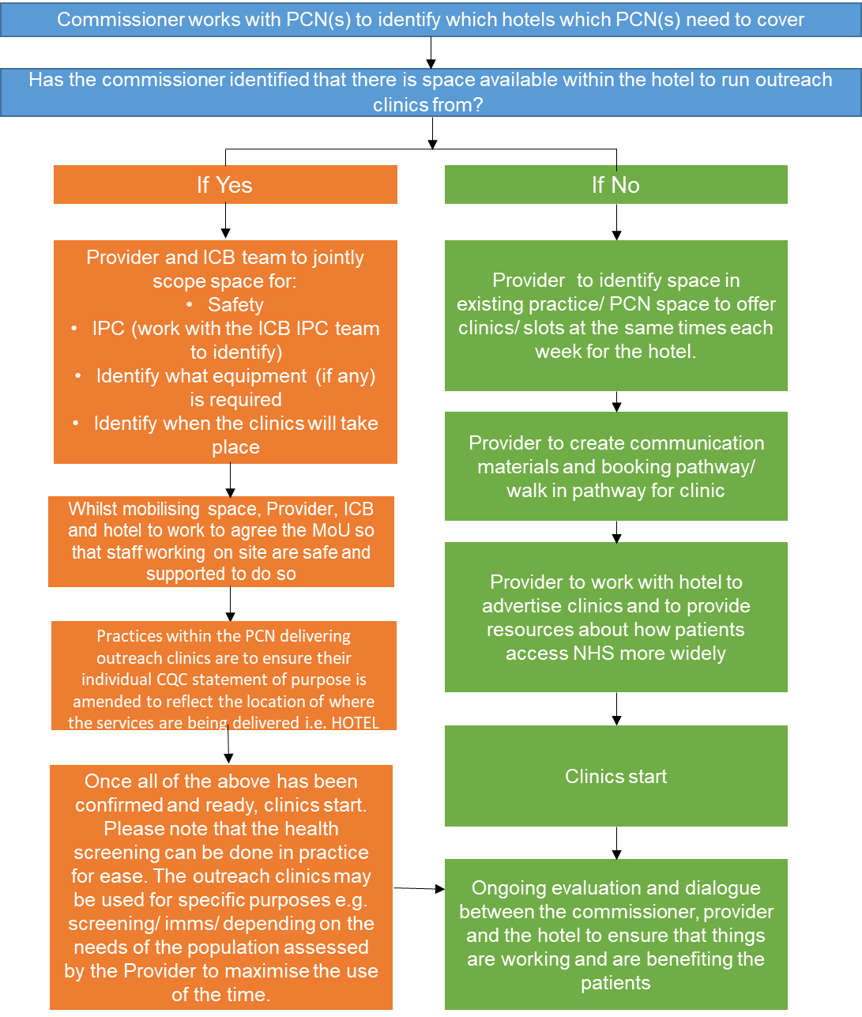

Service | Asylum Seeker Service for Overnight Initial Accommodation Centres - OIACs (This service does not include the Initial Accommodation Centres (IACs) which operate under a separate contractual arrangement)
Delivery Point | Where possible (where space is appropriate and upon agreement from the commissioner) in an outreach clinic in the hotel. Alternatively, the provider’s delivery points should be from its own practice sites where GMS/PMS/APMS services are delivered.

- National context and evidence base
OIA’s known as Overnight Initial Accommodation Centre’s OIACs are used by UKVI for pre-asylum cases. Currently across NW London, there are three OIA’s commissioned by the Home Office.

The period of stay is 72hr’s, however some SU’s have been in OIACs for 4 weeks or more due to the delays within the system caused by high numbers of asylum seekers arriving in to the UK.
The number of service users (SUs) changes frequently, more often than not decreasing rather than increasing of which SUs are relocated at short notice.

The picture changes with instruction from the Home Office with hotels standing up and standing down.

SUs are a vulnerable cohort requiring prompt access to healthcare services to address their acute health needs. In many cases, SUs will not have any documentation relating to their healthcare history, and some may not have had access to healthcare for some time. It is essential, therefore, to provide comprehensive health care including health checks as early as possible in order to detect any immediate healthcare needs and reduce any risk to individuals and the wider community especially in relation to potential communicable diseases. In order to reduce potential risks, providing timely registrations enabling easily accessible clinics for SUs is important. It is also important to ensure that access to Primary Care is provided in a consistent way in order to ensure equality of access to services, regardless of where in the ICS an OIAC is located.

It is also worth noting that whilst SUs may face many of the same health problems as the UK population, they may additionally:

  - Have poor awareness of the NHS and fear barriers to accessing treatment;
  - Come from countries of origin with poor/different healthcare;
  - Suffer health impacts (mental and physical) after leaving their country and arriving in the UK;
  - Do not have access to any public funds and are therefore not able to purchase medication over the counter;
  - Have experienced war, conflict, or torture;
  - Be separated from family;
  - Have poor housing and be socially isolated.

As part of a pilot in 2022, a lead GP practice with a Primary Care Network (PCN) provided service provision and registration to this cohort based on the catchment area of the OIACs.

Local practices which covered the geographical location of the OIAC’s were provided with a set monthly administration fee. The funding was used to deliver immediate necessary treatment to this cohort and was underpinned by a MOU between the lead GP practice and North West London ICB (NWL ICB). This has been deemed costly due to the rapid fluctuation in SU’s being relocated when compared with the number of arrivals arriving. This scheme is designed to replace the previous arrangements.
- Aims and objectives of service
This service has been put into place in recognition of the additional clinical and administrative pressures placed on general practice in the proximity of asylum seeker OIAC hotels, given the complex care needs of asylum seekers and the volume of throughput in delivering health services for this patient population.

The aims of the service are:
- To provide an equitable, patient focussed, easily accessible and high-quality service
- To provide immediate necessary service
- Reduce in patients attending Accident and Emergency/Urgent Treatment Centre for minor illnesses
- To reduce burden on Primary Care services in GMS delivery
- To improve patient access
- To provide clarity regarding activity to inform on-going commissioning needs
- To provide clear pathways for the management of care for patients from this vulnerable cohort
- To provide promotion of self-care techniques and preventative measures to improve health and wellbeing of Asylum Seekers

The desired outcomes are:
- Reduce the number of SUs attending Accident and Emergency/Urgent Treatment Centre for minor illnesses
- Reduce the burden on Primary Care services in the local area of patient registrations and ongoing care needs
- Reduce Accident and Emergency follow up’s
- Improve Service User experience
- Provide clarity regarding activity and ongoing health needs of this specific cohort to inform on-going commissioning needs
- Provide an equitable, patient focussed and easily accessible service
- Provide clear pathways for the management of care for patients from this vulnerable cohort
- Provide promotion of self-care techniques and preventative measures to improve health and wellbeing

- Service Description/Care Pathway
This service replaces all other NWL Primary Care ICB schemes for OIACs. Each Primary Care Network with hotels in their vicinity will receive a list of the OIAC hotels in its area which will require care under this LES. It is the responsibility of the Primary Care Network to allocate a lead practice(s) per OIAC within its geographical area. The same lead practice does not have to be the same practice for all OIA hotels within the primary care network geography.
The provider must offer same day acute care to its patients registered from the OIA for which they are the responsible practice.

PCNs should discuss their plans with the Commissioner to ensure there an equitable care model across each Primary Care Network. The number of hotels and the number of residents may change over the course of the year. PCNs may also collaborate across networks to cover arrangements where it is agreed with the commissioner. Where existing patients are registered across a range of different practices, these registrations should not change unless initiated by the patient.

Asylum Seekers are eligible to access immediate necessary treatment as part of acute care. Where possible, an outreach model will be operational where staff can provide these clinics at the designated OIAC on a rota basis and will have a dedicated consultation room on the hotel site. Where this is not possible within the confines of the hotel premises following discussions with the hotel, specific clinics should be offered at the GP practice premises. This will be made upon agreement between the commissioner and the PCN and as per the process document in appendix 1.

The provider will work with the Borough Primary Care Team in NHS North West London Integrated Care Board (NWL ICB) on setting-up the clinics and infrastructure at each of the OIACs, including any medical and IT equipment.

The PCN may choose to enable the asylum seeker clinics to be remotely bookable on the clinical system for the practice within their PCN who have SUs registered at their practice to utilise. This structure would work much like Enhanced Access hubs etc and allow for equitable care for patients regardless of which practice they are registered too. This can be a solution should the patients not choose to register with the Responsible Practice. This access allows the ICB to ensure equity of access and full population coverage of SUs in the OIAC hotels.

Where a hotel has patients registered from multiple practices in the PCN under historical allocation arrangements, the responsible practice(s) in each PCN may choose to enable the asylum seeker clinics to be remotely bookable on the clinical system for the practices within their PCN who have SUs registered at their practice to utilise. This structure would work much like Enhanced Access hubs etc and allow for equitable care for patients regardless of which practice they are registered too. This can be a solution should the patients not choose to register with the Responsible Practice. This access allows the ICB to ensure equity of access and full population coverage of SUs in the OIAC hotels.

The Provider will be responsible for providing a team of clinical and non-clinical staff (these roles could be outside of their existing staffing structure if desired). This team must not reduce day to day staffing within General Practice and therefore impact on delivery of core GMS services for the practice.

The Provider will be responsible for providing services to those arrivals in the designated OIA’s that require immediate care. SUs will be registered as a temporary patient on the practice’s clinical system. It will be the responsibility of the Provider to ensure that the health needs of the SUs registered on their clinical system are met in timely manner during this time, including referrals for necessary checks, any referrals for secondary and community health care treatment, prescriptions for medication and signposting to appropriate health and wellbeing provision e.g. Mental Health support out of hours.

The Provider will be responsible to utilise the clinical entry template in the clinical system to allow clinicians to document referrals made to community and secondary care.

The provider will be responsible for prescribing all medication indicated, including medicines usually obtained over the counter in light of the likely situation of an SU not being able to purchase these in the normal way due to not having recourse to public funds or being able to work. The NWL ICB Medicines Management Team will be advised of this in order that variation in prescribing costs are clearly understood.

3.1 Service Requirement
For all patient registration for SUs residing in the PCN OIAC(s) with no GP registration:

The Provider will:
- Liaise with OIACs to register those SUs that require immediate necessary treatment on the practice clinical system within 24hrs of arrival at the hotel accommodation.

For all patients residing in the OIAC:
- Provide regular outreach clinic sessions on site in the OIAC (minimum 1 session per week for hotel sites of 100 residents), or where not possible due to space restrictions on sites, in practice with bespoke clinics at the responsible practice. This is to be agreed with the Borough Team commissioner. The frequency and structure of the clinics must be agreed with the commissioner prior to commencement.
- A clinic session is: 4 hrs GP time; 30 mnts nurse time - 30 minute GP apps per patient.
- Provide all SUs within the designated OIAC access same day health services should they be required.
  - Clinics will be recorded on the practice clinical system using a suitable template and SNOMED codes if appropriate
- Complete all necessary referrals to Community Mental Health and Secondary Care Providers.
- Provide remote bookable clinics for all practices within the PCN to boo SU’s accommodated in the designated OIAC where necessary.

3.2 Responsibility
The Provider will:
- Register SUs under their practice as a temporary patient and undertake face to face clinics at the OIACs on rota basis to provide immediate necessary treatment
- Ensure that all care and outreach clinics are delivered in line with the provider’s Infection Prevention and Control policies, CQC guidelines, and safely manage the disposal of clinical waste
- Ensure acute health needs of the SUs are met in timely manner during this time, including onward referrals were appropriate, A&E letters and prescriptions for medication
- Provide outreach clinics on site where possible
- Ensure that they register on the principles of:
      - Do not insist on proof of address documents
      - Do not insist on proof of identification
      - Never ask to see a visa or proof of immigration status

- Ensure registrations and clinics and any onward referrals are coded accurately on the practice’s clinical system unit
- Participate in Safe Surgeries Approach, which includes training and resources to support primary for this population
- Share agreed KPI data with Commissioners on a mutually agreed basis
- Set-up clinics on the clinical system as required at each of the OIACs to host face to face clinics (as negotiated with the Borough Team)
- Ensure clinics are remotely bookable for all practices within the PCN to book SU from the designated OIAC if this arrangement is required within the PCN and agreed by practices to share workload within the PCN
- Work in collaboration with the NWL Health Protection Team and Borough Public Health Teams in the identification, flagging and response to any communicable disease outbreak’s
- Ensure appropriate interpretation and translation services through Silent Sounds are provided to SUs as and when required for ease of communication
- Highlight interpretation and translation service issues to the Borough Team
- Work with the London Borough of Hillingdon, Hillingdon Public Health Team, Health visitors, Mental Health service and other relevant stakeholders for any matters requiring wellbeing support for SUs, including escalating safeguarding concerns
- Work with the ICB as commissioners on service monitoring and improvement to ensure that service requirements are being fully met and appropriate levels of care are being provided to Service Users
- Develop and build a working relationship with the hotel management staff
- Ensure the hotel management is made aware what services SUs residing in the hotels can access out of hours i.e. 111, Mental Health crisis team etc
- Work with the ICB as commissioners on service monitoring and improvement to ensure that service requirements are being fully met and appropriate levels of care are being provided to Service Users
- Be responsible for prescribing all medication, including medicines usually obtained over the counter in light of the likely situation of an SU not being able to purchase these in the normal way due to not having recourse to public funds or being able to work
- Regularly compare patient lists with lists from the Clearsprings Readyhomes portal in order to ensure accurate list cleansing is taking place. At a minimum this should take place once a month
- Acceptance and exclusion criteria and thresholds
Acceptance criteria
Resident in a Home Office-commissioned Overnight Interim Accommodation Centre

Exclusion criteria
- Resident in any other Home Office Hotel e.g. Interim Accommodation Centre (IAC)
- Resident in Local Authority dispersal accommodation
- Training, Skills and Experience
- Ensure that practice staff along with the PCN ARR’s staff demonstrate understanding and sensitivity towards asylum seekers;
- Ensure relevant practice staff are meeting the required children and adult safeguarding training levels;
- Ensure that a patient registration policy, that includes registering asylum seekers temporarily is in place and adhered to;
- Ensure there is a business continuity plan in place whereby there is off site provision and that it is robust

Note: Clinicians should ensure that they are utilisng translation services accordingly.
- Equipment

- Practices should utilise existing equipment in order to deliver services, including laptops
- Where additional equipment is required in order to facilitate outreach clinics, additional equipment may be purchased/ requested in negotiation with the ICB Borough Team, depending on what local stocks are available and what equipment may already be within the system.
- Funding
- £454.51 per clinic (based NWL tariff of 4 hrs GP time; 30 minutes’ nurse time and 15 minute’s admin time)
- Number of weekly clinic sessions to be agreed with Borough team prior to implementation

Caveat
When Ready Homes and/or the Home Office notify the borough team of changes to the length of stay e.g. service users staying for prolonged periods of time the number and frequency of clinics will
be reviewed.

APPENDIX I - CONTRACTUAL REQUIREMENTS

Asylum Seekers
Unit Price | £454.51 per clinic (clinic session is 4 hrs GP time; 30 minutes’ nurse time)  No of clinic’s to be agreed by the commissioner
Contract Type | Block payment | No Pop-up
Referral Criteria | Residents residing within a NW London OIAC hotel

PAYMENT/KPI RULES

- Formal coding is not required to recognise the service is a reactive model to needs. The Provider can use IACs asylum Seeker Template if deemed beneficial
- PCNs to provide a declaration to confirm the dedicated clinics in place as per the number of sessions and frequency agreed with borough team. As part of the declaration, PCNs are required to confirm number of patients treated quarterly
- PCN will be allocated with a budget to conduct clinics.

Useful Documents
Doctors of the World Toolkit | https://www.doctorsoftheworld.org.uk/wp-content/uploads/2022/04/DOTW-Access-to-healthcare-in-initial-and-contingency-accommodation-report-April-2022.pdf  https://www.doctorsoftheworld.org.uk/wp-content/uploads/2022/03/Asylum-Seeking-Children-in-IACs-Contingency-Accomodation-Final.pdf  https://www.doctorsoftheworld.org.uk/wp-content/uploads/2018/11/DOTW-evidence-from-medical-assessments-in-the-barracks.pdf  https://www.doctorsoftheworld.org.uk/translated-health-information/
Safer Surgeries | Safe Surgeries Toolkit - Doctors of the World
Migrant health | Migrant Health - Resources and Information
BMA Refugee and Asylum Seeker Patient Health Toolkit | https://www.bma.org.uk/advice-and-support/ethics/refugees-overseas-visitors-and-vulnerable-migrants/refugee-and-asylum-seeker-patient-health-toolkit
NHS Entitlements: Migrant Health Guide | https://www.gov.uk/guidance/nhs-entitlements-migrant-health-guide
Advisory Council on the Misuse of Drugs Report 2019 | Advisory Council on the Misuse of Drugs Report 2019

Useful Documents
FGM Pathway | https://assets.publishing.service.gov.uk/government/uploads/system/uploads/attachment_ data/file/542650/FGM_Flowchart.pdf  https://assets.publishing.service.gov.uk/government/uploads/system/uploads/attachment_data/file/573782/FGM_Mandatory_Reporting_-_procedural_information_nov16_FINAL.pdf
Homeless and Inclusion Health standards for commissioners and service providers | Homeless and Inclusion Health standards for commissioners and service providers
CQC- Registration and treatment of asylum seekers, refugees and other migrants | CQC - Registration and treatment of asylum seekers, refugees and other migrants
NHS England leaflet for asylum seekers and refugees | Follow the guidance in the NHS England leaflet for asylum seekers and refugees; How to Register with a Doctor (GP) – Gateway Reference 06277
Modern Slavery | Modern slavery and human trafficking - National Crime Agency  Modern Slavery Helpline
Immunisation Schedule | The complete routine immunisation schedule from February 2022 (publishing.service.gov.uk)

Note: Refugees, asylum seekers, refused asylum seekers, and undocumented migrants, can apply to the NHS low income scheme for help with medical costs, including prescription charges, dental treatment, and sight tests. Individuals must fill in an HC1 form and will receive an HC2 certificate if eligible.

APPENDIX 1 - Process Map for Mobilisation of Outreach Clinics
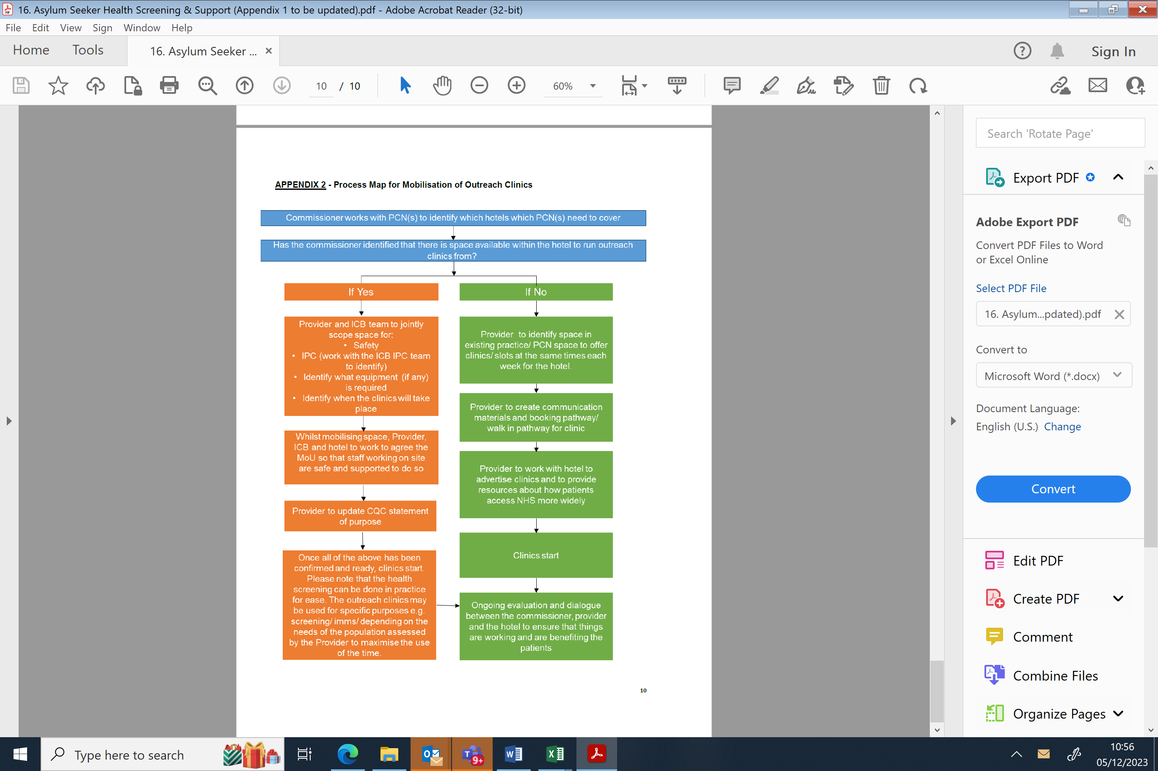

Service | Safeguarding Adults and Children

- National context and evidence base
This service is designed to provide support to GP practices to enable them to fulfil their professional obligation to assist with safeguarding investigations for both adults and children and provide reports for safeguarding conferences.

Local Authorities have overarching responsibility for the safeguarding of all children, and adults with care and support needs in their area. They have a number of statutory functions under the 1989 and 2004 Children Act, and the Care Act 2014 which include specific duties in relation to children in need and children and adults with care and support needs suffering, or likely to suffer, significant harm.

Whilst Local Authorities play a lead role, safeguarding all children, and adults with care and support needs and protecting them from harm is everyone’s responsibility. Everyone who comes into contact with children and families has a role to play. Within the Children Act 1989 and 2004, and the Care Act 2014, the statutory duty is described for all relevant agencies who are required to co-operate with local authorities to promote the well-being of children, and adults with care and support needs in each local authority area. This service seeks to strengthen the co-operation that exist between Partner organisations.

In addition to national context, there is a London Multi-Agency Safeguarding Data Sharing Agreement for Safeguarding and Promoting the Welfare of Children and set of procedures
Professionals working within agencies with these duties are responsible for ensuring that they fulfil their role and responsibilities in a manner consistent with their statutory duties. The agencies include all GP surgeries and Out of Hours providers, and the professionals include all GPs and the wider professional workforce.

No part of this ES specification by commission, omission or implication defines or redefines essential or additional services.

This specification aims to provide financial recompense for the time required to support Child Protection Case Conference and for an Adult Safeguarding Enquiries. Practices and PCNs will be encouraged to develop their safeguarding infrastructure and processes to enable the delivery of suitable high-quality reports for consideration at Child Protection Case Conference and for an Adult Safeguarding Enquiry. This Enhanced Service reflects the additional work that the Practice will need to undertake to support the case reviews.
- Aims and objectives of service
This service aims to support the ongoing development and maintenance of more robust arrangements in General Practice to Safeguard Children in line with Working Together to Safeguard Children and GMC Good Practice guideline, and in a manner consistent with Good Practice in Adult Safeguarding as referenced in the Royal College of General Physicians Adult Safeguarding Toolkit (2017), including:

- Raising awareness of statutory and legal requirements of Child and Adult Safeguarding legislations
- Supporting PCNs and practices to meet the standards set out in the Specification.
- Provide level of assurance in respect of arrangements for safeguarding children, young people and children looked after, and adults with care and support needs in primary care general practice.
- Supporting practices to provide high quality reports to Local Authority partners for information related to safeguarding issues linked to patients registered with the Practice.
- Service Description/Care Pathway
If a request for information is made by the Local Authority to a GP Practice to assist with a Child Protection Enquiry (s47) or provide a Child Protection Case Conference report or an Adult Protection Enquiry (s42) or provide a report for Conference, it is a statutory duty to share this information; this Enhanced Service is designed to support the Practice achieve this requirement.

All requests for Safeguarding information for both adults and children, including Case Conference reports must be recorded, even if no information is shared by the Practice. An explanation of why no information was shared should be recorded.

Pre-requisites to sign-up

The pre-requisites for this enhanced service are set out below, practices will be requested to confirm the requisites below are in place prior to sign up:

- Practice has an identified Named lead and Deputy safeguarding lead for adults and children. (The Child and Adult Safeguarding Leads and any deputy Leads should be GPs or other clinicians trained to level 3, as per ‘Safeguarding children and young people: roles and competences for health care staff – Intercollegiate document’.
- Practices to keep a register of all patients who are on a Child Protection Plan, Child in Need Plan (where notified) or are Looked After Children, or on an Adult Safeguarding Plan or if the surgery is aware that they are experiencing domestic abuse. Practices should keep this register updated at all times, including the outcome of any Practice/multiagency/professional meetings and the date for the next meeting.
- Complete audits requests (e.g. biennial section 11 audit (as and when requested by NHS North West London through an approved reporting audit)

Child Protection Conference
- A claim can be made for each case conference where
  - Child Protection Report is submitted within the requested timeframe
  - Attended the case conference if requested by the Chair
  - A minimum data set (template to be available on SystmOne and EMIS) to be completed for each case for the purpose of quality assurance, timeliness and payment.
  - There can only be one claim made for each case conference.

- A “Case Conference Report” to be completed in accordance with the following guidance:
  - The wording on the report must be in a legible form that can be understood by non-medical professionals and the parents.
  - Include information about any medical problems (including mental health concerns, alcohol/drug misuse and reported domestic abuse) or other information that is relevant for safeguarding for each parent of a child named in the conference and each adult in the household of children named at the conference who is registered at the surgery. Do not put the children’s medical information on this form.
  - Please include an explanation of why these problems are relevant for safeguarding.
  - Information from the parents or adults in the household’s records that is not relevant for safeguarding should not be sent as per the Data Protection Act (Principle 3).
  - The parents / adults should be informed that their medical information will be shared with the case conference, even if they do not agree or consent, as per the “Information sharing Advice for practitioners providing safeguarding services to children, young people, parents and carers”. If appropriate and safe, parents / adults should be given opportunity to view what information will be shared. This is reinforced by the London agreed safeguarding procedure for information sharing
  - Any other information relevant to the case review.

Adult Safeguarding Enquiry

- A claim can be made for each adult safeguarding enquiry where
  - Adult Safeguarding Report is submitted within the requested timeframe
  - A minimum data set (template to be available on SystmOne and EMIS) must be completed for each case for the purpose of quality assurance, timeliness and payment.

- The wording on the report to be in a form that may be understood by non-medical professionals and the patient.

- The patient should be contacted where they have capacity and an offer made via letter or phone call for them to review the Report in advance of it being sent to the Adult Safeguarding Team, unless this would be felt to increase the risk to the adult or affect any possible criminal investigations.

- Provide any other information which may assist Partner organisation with the case review

Interdependence with other services/providers

- It is best Practice for the GP who has written the report to liaise with the chair and/or the allocated social care worker of the case conference or adult safeguarding enquiry to discuss the report in advance of the conference, unless they will be attending the conference, however this will not form part of the payment and may not always be possible.
It is the PCN responsibility is to submit a claim form on behalf of practices declaring number of reports completed.

Audit

- Practices to confirm the pre-requisites requirements have been met
- Learning from case reviews to be shared with GP practices to aid training and development
- In the event where reports are not to the expected standard or meet timelines for submission, payment may be withheld for the identified reports.
- Any Acceptance and exclusion criteria and thresholds
Acceptance criteria:
- Any request for a child protection case report by a Local Authority including follow-up clarification requests.
- Any request for an Adult Safeguarding report from the Local Authority Adult Safeguarding Team, including follow-up clarifications requests
Exclusion:
- If a duplicate request is made (same member from same family) within a reasonable timeframe (1/month 6 weeks), the Local Authority should be referred to the information they already have. Records should be reviewed and any relevant additional safeguarding information shared if applicable.
- Training, Skills and Experience
Each Practice should have a nominated Child Safeguarding Lead and Adult Safeguarding Lead with deputy Leads as appropriate to promote this work, as referenced in ‘Working Together to Safeguard Children 2018’, RCGP Adult Safeguarding Toolkit and RCGP Child Safeguarding Toolkit.

The Child and Adult Safeguarding Leads and any deputy Leads should be GPs or other clinicians trained to level 3, as per ‘Safeguarding children and young people: roles and competences for health care staff – Intercollegiate document. 3rd Edition and RCGP Adult Safeguarding Toolkit.

APPENDIX I - CONTRACTUAL REQUIREMENTS
SPIROMETRY
Unit Price | Activity  A payment of £50.75 per “Child Protection Case Conference Report” or “Adult Safeguarding Report” as requested by the Local Authority with the MDS template completed.  Please note that only one claim can be made for a child protection case conference report, regardless of the number of siblings included in the report.
Service Type | - Episodic | No Pop-Up
Referral Criteria | - Acceptance: Any request for a Child Protection Case Conference report by a Local Authority, Acceptance: Any request for an Adult Safeguarding report from the Local Authority Adult Safeguarding Team

CODING NECESSARY FOR PAYMENT
Ref. | Description | SNOMED Code
SG01 | Safeguarding report | Safeguarding Report (909021000000108)

PAYMENT/KPI RULES
To Achieve Payment for Safeguarding Reporting

- Has SNOMED code of Safeguarding Report (909021000000108)
- PCN will be required to submit claim form, this is because the ICB is not able to distinguish, through the clinical system reporting, whether the template was completed for an individual child or for siblings.

Service | Respiratory

- National context and evidence base
Respiratory disease is the third biggest killer in the UK. It affects 1 in 5 people, from children to older people, and places demands on primary, secondary, community and specialised care, particularly during winter. Although much of the disease burden from Asthma and COPD is preventable or treatable, these diseases have received less attention than other prominent non communicable diseases such as cardiovascular disease, diabetes and cancer. Respiratory care is therefore often a neglected area in our healthcare systems. (https://pmc.ncbi.nlm.nih.gov/articles/PMC9448269/)

- The UK has the worst death rates for lung disease in Europe
- Respiratory conditions have a bigger gap in mortality rate between rich and poor than any other major condition.
- Respiratory conditions are the biggest driver of hospital admission and winter NHS pressures
- Respiratory conditions are the second biggest contributor to NHS bed days

Aiming to increase accurate diagnosis for respiratory conditions is one of the drivers for the respiratory diagnosis enhanced service specification and the creation of PCN level diagnostic hubs, and should be considered as adjacent to this specification.

The recent update in August 2023 of the DHSC Major Conditions Strategy includes chronic respiratory disease as a key area, and includes a focus on prevention (smoking, obesity, vaccinations), management (annual reviews, a personalised action plan, appropriate inhaler optimisation and advice on smoking cessation) and living with the condition (pulmonary rehabilitation). Delivered at scale, this basic care has the potential to enhance quality of life, reduce hospitalisations, improve healthy life expectancy, and alleviate winter pressures on the NHS. (Asthma & Lung UK)

To see these results, sufficient resourcing of primary care to have the appropriately trained staff to deliver good basic respiratory care is necessary (Asthma & Lung UK).

This service specification reflects the potential power of targeted primary care interventions in improving outcomes for patients with asthma and COPD, whilst also recognizing the scope of work needed to tackle health inequalities and public health issues is significantly wider.

Context for Targeted Interventions

Importance of inhaler technique and adherence
For people living with asthma, annual asthma reviews that include an inhaler technique check and written action plan are evidenced to reduce exacerbations and mortality, decrease oral corticosteroid use and the need for unscheduled healthcare (NHS England. RightCare Asthma Toolkit. 2022)

Risk of unmanaged COPD and best way to improve
COPD is a Core20plus5 priority condition. The Optimise COPD programme targets the cohort of ‘rising risk’ COPD patients who make up 50% of COPD hospital admissions. By identifying and proactively supporting these patients through consistent and comprehensive reviews, the risk of exacerbation and subsequent admissions is reduced.

Harm of SABA overuse and evidence behind MART & AIR efficacy and improvement of outcomes
The new NICE/BTS/SIGN Asthma Guidelines 2024 promote the use of MART (ICS/Formoterol) inhaled regimes, and are clear that an asthmatic should never be prescribed a SABA alone. Using a licensed ICS/Formoterol inhaler in place of ICS plus SABA has been shown to reduce exacerbations, admissions and asthma deaths. MART therapy delivers the ICS when the person needs it the most, is more cost effective for patients, and is SABA FREE. Overuse of SABA is associated with poor outcomes.
For people who are diagnosed with mild asthma, AIR (ICS/Formoterol) is licensed for when required use. It’s the same treatment as MART but isn’t required as daily maintenance, only when a person has symptoms. AIR has been shown to reduce exacerbations, hospitalisations, and the need for systemic steroids vs SABA alone and ICS + SABA in studies.
- Aims and Objectives of The Service
The service aims to:

- Upskill primary care in the basics of asthma and COPD management and to emphasise the importance of inhaler technique in self-management;
- Proactively manage ‘rising risk’ COPD patients in order to decrease exacerbation and reduce admissions;
- Reduce the prescription of short-acting beta 2 agonists (SABA) and their associated overuse, and to increase the use of MART and AIR inhaled therapy regimes (where clinically appropriate), leading to better asthma outcomes.
- Service Description/Care Pathway
Asthma

Annual asthma review for all asthma patients by a competent clinician

Asthma patients should receive a review every 12 months (and after every exacerbation). Proactive structured reviews, rather than opportunistic or unscheduled reviews, are associated with reduced exacerbation rate and fewer days lost from normal activity, (Rightcare asthma toolkit).

Best practice includes the following components:

- Monitor asthma control
Use of validated asthma control test
Number of exacerbations and admissions
Use of oral corticosteroids and SABA inhalers

- Assess triggers and risk factors
Smoking exposure
Weight management
Treat co-morbidities

- Observe and optimise inhaler technique (and spacer if using) and adherence

- Medication optimisation review
Safe inhaler disposal
Appropriate inhaler choice, including environmental impact
Consideration of switch to MART for poorly controlled asthma

- Review of personalised asthma action plan

- Measurement of peak flow where clinically appropriate

- Encourage vaccination (Influenza, Pneumococcal and Covid (if appropriate)

New Asthma Diagnoses

In newly diagnosed asthmatic patients >12 years offer ICS/Formotorol as anti-inflammatory reliever therapy (AIR) or as maintenance and reliever therapy (MART) as per the new NICE guidance. (https://www.nice.org.uk/guidance/ng245/chapter/recommendations#pharmacological-management-in-people-aged-12-and-over)

COPD

Patients diagnosed with COPD are offered a personalised management plan in-line with the relevant NICE 2011 quality standards ( https://www.asthmaandlung.org.uk/conditions/copd-chronic-obstructive-pulmonary-disease/your-copd-self-management-plan )

The Optimise COPD programme includes 8 care processes:
COPD Winter Planning Targeted Funding 24/25 - NHS @home - FutureNHS Collaboration Platform

- Optimise treatment
- Medicines for patients are prescribed according to the North West London Integrated formulary; unless specialist exemption
- People with stable COPD and a persistent resting stable oxygen saturation level of 92% or less are referred for Oxygen assessment
- If end stage COPD is suspected, then collaborate with the palliative care team as appropriate. Other pointers include low BMI, weight loss, heart failure (see NICE)
- Pulmonary rehab
- Patients with stable COPD and exercise limitation due to breathlessness, or who have had a recent hospital admission for an acute exacerbation, are referred to a pulmonary rehabilitation programme in-line with local pathways (MRC grade 3 or higher)

- Tobacco dependence services
- Patients with COPD are offered smoking cessation treatment with a qualified smoking cessation professional

- Inhaler technique

- Maximising vaccine coverage
- Patients with COPD are offered appropriate vaccination eg. COVID19, Flu, PPV vaccinations
- RSV >75 years

- Increasing physical activity
- Advise people that lack of activity increases risk of exacerbation
- For those who are frail or housebound the following resources may help:
- https://www.nhs.uk/live-well/exercise/physical-activity-guidelines-older-adults/
https://www.nhs.uk/live-well/exercise/sitting-exercises/
- Support for psychosocial wellbeing
- Patients with COPD are screened for anxiety and depression and then referred to IAPT services if required or managed according to NICE guidance and local pathways
- Consider referral to social prescriber for housing, finance, food and fuel poverty

- Education and self-management
- Education around disease and exacerbation management including rescue packs where clinically appropriate

Virtual group consultations will also be acceptable in terms of achievement of targets
- Any acceptance and exclusion criteria and thresholds
Acceptance Criteria:

All patients with asthma and COPD.

Some Exceptions:

Older Patients
It is recommended that clinicians encourage exercise even if patients are frail or housebound, due to the known impact on lung health. E.g. the below 'armchair exercise' guide:
https://weareundefeatable.co.uk/media/ruelg5b2/wau-sofa-movement-guide_1.pdf

Palliative patients or those with advanced dementia could be excluded.

- Training, Skills and Experience
Respiratory Champion
The service provider will be expected to identify a clinical lead/respiratory champion for each PCN and become part of the NWL Respiratory Community of Practice for Primary Care. Please see appendix for more details on this role and the benefits offered.

Mandatory Training
At least one clinician per practice who delivers annual reviews for asthma and COPD should attend both the in person NWL training days.
Training 1: Tier 3 CYP asthma training that includes inhaler technique for adults (as well as children).
Training 2: How to deliver COPD Optimise reviews

There will be training delivered in each borough. Attendance at the training will provide a resource pack of placebo inhalers for each practice to aid in effective demonstration and understanding, and to enable spread of good practice among colleagues.

It is recommended that a different staff member attends the asthma training each year to skill up the practice workforce.

We encourage all staff involved with asthma care to complete the following training:

1. Adults - https://portal.e-lfh.org.uk/Asthmaadults
2.Children - Asthma (Children and young people) - elearning for healthcare (e-lfh.org.uk) Tier 3

Additional Training Opportunities
There will be a series of NWL respiratory webinars.

APPENDIX I – Contractual requirements

Respiratory
Unit Price | A maximum total of £0.49 per weighted patient can be achieved subject to meeting Key Performance indicators as listed below.  The tariff and thresholds will be split as follows based on PCN performance:
  Tariff | KPI | Target Thresholds | Financial Achievement
  £0.14 | % of Optimise COPD search patients with 8 care processes completed  Note payment is only eligible if the practice sends a representative to attend the NWL bespoke training on OPTIMISE COPD. Practices will need to provide a self-declaration to show they have attended training. | <50% | 0%
  £0.14 |  | 50-80% | 50%
  £0.14 |  | >80% | 100%
  Tariff | KPI | Target Thresholds | Financial Achievement
  £0.20 | % of Asthma or COPD patients who have inhaler technique and adherence checked as part of their annual review either in person or by video consultation  Note payment is only eligible if the practice sends a representative to attend the NWL bespoke training on CYP Asthma including all age inhaler technique. Practices will need to provide a self-declaration to show they have attended training. | <50% | 0%
  £0.20 |  | 50-75% | 50%
  £0.20 |  | >75% | 100%
  Tariff | KPI | Target Thresholds | Financial Achievement
  £0.15 | % newly diagnosed asthma patients aged ≥ 12 years old initiated on MART or AIR inhaled therapy  Please note clinical judgement is required for any prescription choice. | <50-75% | 0%
  £0.15 |  | 75% | 100%
Service Type | - Capitation
Referral Criteria | Patients aged 6 years and above

TARGET POPULATION RULES
Patients included in Target Population for Respiratory RESP01D
- Patient coded with COPD (COPD QoF cluster) without a more recent COPD resolved code (COPDRES QoF cluster) AND
- Excluding very severe or end stage COPD (End stage chronic obstructive pulmonary disease (135836000) OR Very severe chronic obstructive pulmonary disease (293991000000106) WITHOUT a more recent Mild/moderate/severe COPD (Mild chronic obstructive pulmonary disease (313296004) OR Moderate chronic obstructive pulmonary disease (313297008) OR Severe chronic obstructive pulmonary disease (313299006) AND
- Has an issue a prescription of Prednisolone 5mg tablets AND Antibacterial drugs on the same day in last 12 months AND
- Excluding COPD review (Chronic obstructive pulmonary disease 3 monthly review (760601000000107) OR Chronic obstructive pulmonary disease 6 monthly review (760621000000103) OR Chronic obstructive pulmonary disease annual review (394703002) recorded on same day as issue date of Prednisolone 5mg tablets and Antibacterial drugs

Patients included in Target Population for Respiratory RESP02D
Patient is in either:
- Patient aged 6 and over AND
- Excluding SNOMED code Inhaled bronchodilator declined (27591000175101) recorded in financial year AND
- Has Asthma diagnosis (AST QoF cluster) WITHOUT a more recent QOF Cluster Asthma resolved recorded AND
- Has medication asthma related drug (QOF ASTTRT) recorded in last 12 months
OR
- Patients coded with COPD (COPD QoF cluster) without a more recent COPD resolved code (COPDRES QoF cluster) AND

Patients included in Target Population for Respiratory RESP03D
- Patients aged 12 and over AND
- Has first Asthma diagnosis (AST QoF cluster) WITHOUT a more recent QOF Cluster Asthma resolved (ASTRES QoF cluster) recorded in the financial year AND
- Is in Asthma QOF register

CODING NECESSARY FOR PAYMENT
Ref. | Description | SNOMED Code |  | Measurement
RESP01N | % of Optimise COPD search patients with 8 care processes completed | Optimise treatment | - Chronic obstructive pulmonary disease medication optimisation (473202005) | Numerator:  The number of patients with all 8 care key care processes recorded in the financial year | Denominator:  The number of patients on Optimise COPD search (fixed number taken at start of financial year)
RESP01N |  | Pulmonary Rehab | One of:  - Referral to pulmonary rehabilitation (24461000000105)  - Pulmonary rehabilitation declined (305371000000101)  - Pulmonary rehabilitation programme commenced (391128002)  - Pulmonary rehabilitation programme completed (391130000)  - COPD patient unsuitable for pulmonary rehabilitation (371611000000107)  - Did not complete pulmonary rehabilitation programme (860931000000107)
RESP01N |  | Tobacco dependence services | Either:  - Never smoked tobacco (266919005)  - Ex-smoker (8517006)  OR  - Smoker (77176002)  AND either:  - Smoking cessation advice (225323000)  - Referral to smoking cessation service (871661000000106)
RESP01N |  | Inhaler technique | One of:  - Demonstration of inhaler technique (736601004)  - Inhaler technique – good (170625000)  - Inhaler technique – moderate (390869002)  - Inhaler technique – poor (170626004)  - Inhaler technique observed (170614009)
RESP01N |  | Offered or administered Vaccine | One of:  COVID  - Administration of fifth dose of SARS-CoV-2 (severe acute respiratory syndrome coronavirus 2) vaccine (<<1363831000000108)  - Administration of first dose of SARS-CoV-2 (severe acute respiratory syndrome coronavirus 2) vaccine (<<1324681000000101)  - Administration of first dose of SARS-CoV-2 mRNA vaccine (<<1144997007)  - Administration of fourth dose of SARS-CoV-2 (severe acute respiratory syndrome coronavirus 2) vaccine (<<1363791000000101)  - Administration of inactivated whole SARS-CoV-2 antigen vaccine (<<1157196000)  - Administration of SARS-CoV-2 DNA plasmid encoding spike protein vaccine (<<1193583000)  - Administration of SARS-CoV-2 mRNA vaccine (<<1119350007)  - Administration of SARS-CoV-2 non-replicating viral vector vaccine (<<1157107003)  - Administration of SARS-CoV-2 recombinant spike protein antigen vaccine (1162645008)  - Administration of SARS-CoV-2 vaccine (<<1156257007)  - Administration of SARS-CoV-2 virus-like particle antigen vaccine (<<1179496000)  - Administration of second dose of inactivated whole SARS-CoV-2 antigen vaccine (<<1157197009)  - Administration of second dose of SARS-CoV-2 (severe acute respiratory syndrome coronavirus 2) vaccine (<<1324691000000104)  - Administration of second dose of SARS-CoV-2 mRNA vaccine (<<1144998002)  - Administration of second dose of SARS-CoV-2 recombinant spike protein antigen vaccine (<<1162646009)  - Administration of second dose of SARS-CoV-2 virus-like particle antigen vaccine (<<1179497009)  - Administration of second dose SARS-CoV-2 non-replicating viral vector vaccine (<<1157108008)  - Administration of third dose of SARS-CoV-2 (severe acute respiratory syndrome coronavirus 2) vaccine (<<1363861000000103)  - Immunisation course to maintain protection against SARS-CoV-2 (severe acute respiratory syndrome coronavirus 2) (<<1362591000000103)  - SARS-CoV-2 (severe acute respiratory syndrome coronavirus 2) antigen vaccination (<<840534001)  - SARS-CoV-2 (severe acute respiratory syndrome coronavirus 2) vaccination invitation email (<<1403101000000104)  - SARS-CoV-2 (severe acute respiratory syndrome coronavirus 2) vaccination invitation letter (<<1402921000000102)  - SARS-CoV-2 (severe acute respiratory syndrome coronavirus 2) vaccination invitation short message service text message (<<1403031000000106)  - SARS-CoV-2 (severe acute respiratory syndrome coronavirus 2) vaccination telephone invitation (<<1402931000000100)  Pneumococcal  - Administration of pneumococcal 13-valent conjugate vaccine (1119366009)  - Administration of pneumococcal 13-valent conjugate vaccine (1296904008)  - First pneumococcal conjugated vaccination (247631000000101)  - Pneumococcal 13-valent conjugate vaccination given (139791000119105)  - Pneumococcal vaccination invitation SMS (short message service) text message sent (950331000000105)  - Pneumococcal vaccination verbal invitation (340801000000104)  - Second pneumococcal conjugated vaccination (247641000000105)  - Supplemental pneumococcal conjugated vaccination (820741000000108)  - Third pneumococcal conjugated vaccination (247651000000108)  RSV  - Administration of RSV (respiratory syncytial virus) vaccine (1303503001)  - Administration of RSV (respiratory syncytial virus) vaccine (1853491000000104)  - RSV (respiratory syncytial virus) vaccination invitation letter (2242701000000103)  - RSV (respiratory syncytial virus) vaccination invitation SMS (short message service) text message (2242691000000103)  Influenza  - Invite for flu vaccination codes (FLUINVITE QOF cluster, ^999020331000230100)  - Flu vaccination code (FLU QOF cluster, ^999012771000230105)  Shingles  - Administration of Varicella-zoster vaccine for shingles (<<722215002)  - Administration of live attenuated Human alphaherpesvirus 3 vaccine (871898007)  - Administration of live attenuated Human alphaherpesvirus 3 vaccine via subcutaneous route (871899004)  - Herpes zoster vaccination (859641000000109)  - Herpes zoster vaccination invitation (<<895931000000104)
RESP01N |  | Physical activity | Either:  - Activity exercise pattern (<<106020009)  - Physical activity finding (<<129861002)  AND  One of:  - Patient given exercise advice (183073003)  - Referred for exercise programme (416974006)  - Referral to healthy lifestyle programme (892281000000101)  - Exercise physically impossible (160629005)
RESP01N |  | Support for psychosocial wellbeing | - Biopsychosocial assessment (1067261000000105)
RESP01N |  | Education and self-management | Either:  - COPD self-management plan agreed (811961000000106)  - COPD self-management plan review (810951000000101)
RESP02N | % of Asthma and COPD patients who have inhaler technique and adherence checked as part of their annual review either in person or by video consultation | One of:  - Demonstration of inhaler technique (736601004)  - Inhaler technique – good (170625000)  - Inhaler technique – moderate (390869002)  - Inhaler technique – poor (170626004)  - Inhaler technique observed (170614009) |  | Numerator:  Patients who have inhaler technique and adherence checked in the financial year | Denominator: Patients on asthma or COPD registers
RESP03N | % newly diagnosed asthma patients aged ≥ 12 years old initiated on MART or AIR inhaled therapy | Either  - Single inhaler maintenance and reliever therapy started (919601000000107)  - As-needed symptom relief therapy using anti-inflammatory reliever inhaler (2611311000000103)  AND  - Enhanced Services administration (166221000000105) |  | Numerator:  Number of patients initiated on MART or AIR inhaled therapy in the financial year | Denominator: Total number of patients first diagnosed with asthma in financial year

CODING NECESSARY FOR PAYMENT
To achieve payment for Respiratory RESP01N
- Patient must be in RESP01D AND
- Has all 8 key care processes recorded in the financial year

To achieve payment for Respiratory RESP02N
- Patient must be in RESP02D AND
- Has either Demonstration of inhaler technique (736601004), Inhaler technique – good (170625000), Inhaler technique – moderate (390869002), Inhaler technique – poor (170626004), Inhaler technique observed (170614009) recorded in the financial year
PCNs will need to submit declaration that all practices have attended training on inhaler technique to receive payment for this indicator

To achieve payment for Respiratory RESP03N
- Patient must be in RESP03D AND
- Has Single inhaler maintenance and reliever therapy started (919601000000107) OR As-needed symptom relief therapy using anti-inflammatory reliever inhaler (2611311000000103) recorded in the financial year AND
- Has Enhanced services administration (166221000000105) at the same time as therapy started

APPENDIX II - PCN clinical lead/respiratory champion

The service provider will be expected to identify a clinical lead/respiratory champion for each PCN. This role does not come with specific funding and as such the time commitment is flexible. PCNs are free to incentivise the role as appropriate, and this role will help PCNs achieve enhanced service specification and QoF targets.

Aims of the Respiratory Champion role:
- Building up expertise and encouraging wider staff training and best practice
- Helping PCN and practice meet the specification of the Enhanced Service and targets to ensure payment
- Interacting with WSIC respiratory dashboards (COPD and LADS) to understand local population trends and health inequalities
- Linking to local services and being part of evolving MDTs and Community of Practice

A Primary Care Respiratory Champion will have:
- Enthusiasm for supporting and influencing improvements in respiratory care and outcome for patients
- Experience of delivering respiratory care in primary care
- An interest in supporting other clinicians improve the care they provide
- An ability to develop productive working relationships with peers

Benefits of being involved:
- Becoming part of a NWL community of practice
- Access to teams channel to share learning and best practice
- The opportunity to improve respiratory care in your local area
- Subsidised access to training to upskill in respiratory disease

Training Offer to support this role:
- Paid Membership to the PCRS (Primary Care Respiratory Society) for 2 members of staff per PCN Inspiring best practice in respiratory care | Primary Care Respiratory Society (pcrs-uk.org). Applications will have to come via the NWL Training Hub, recommended that PCN champion attends.
- Access to CPD to pay for Foundation Modules in Asthma and CPD for Nurses and AHPs
- Access to Foundation Modules for Pharmacists – max 1 per PCN
- Access to advanced modules for PCN Respiratory Champions (1 per PCN)

Community of Practice (open to all)
Request access to the teams channel: NWL Respiratory Champions 24 and 25 | General | Microsoft Teams
Once nominated champion please email candice.clark@nhs.net

Appendix III

Proposed Training for Management of Respiratory Disease in primary Care in NWL
The following is based on a 3-year programme of training for all staff working in General Practice in NWL. It ranges from staff having basic respiratory ‘awareness’ and the ability to signpost to specialist clinical skills coupled with leadership and teaching skills. Each level builds on the other so staff cannot do one without having done the one before.

Role / Level of Care | Proposed Training needed | Example Provider of training
Reception / Admin  Signposting / Having Awareness | Tier 1 Paeds Asthma e-learning module | e-lfh
HCA / GPA  Opportunistic education | Tier 1 Paeds Asthma e-learning module.  Plus 1 days training on Inhaler Technique, Measuring Peak Flow and identifying red flags | e-lfh  Geltech
Nurse / Pharmacist / PA  Annual Reviews / managing stable patients / identifying red flags | Core Foundation Training  Paeds Tier 2 | Rotherham Respiratory Core Modules (Asthma, COPD)  e-lfh
Nurse / Pharmacist / PA  Provision of more specialist clinical interventions: Diagnostic tests / Education | Spirometry training / ARTP  Paeds Tier 3 | Rotherham Respiratory Spirometry Module  ARTP Portfolio Registration  e-lfh
Nurse / Pharmacist / PA / GP  Diagnostics / Staff supervision and training / service design and evaluation | Advanced clinical training modules (Asthma / COPD etc)  Time spent with clinical specialists leaders | Rotherham Respiratory Advanced Modules  Time for training / support from senior clinicians / leaders

APPENDIX VI – NWL Spirometry Service Specification and information on Optimise – supporting people with COPD resource

Service | Applicable Service Standards

- Context
The implementation of Out of Hospital (OOH) Strategies in 2015 changed the way both acute and community services are delivered with a focus on delivering care as close to patients’ homes as is possible and ensuring that patients are at the centre of care delivered by quality services in Primary Care. The services contained within this contract increase the focus of the provision of services based on population health through Primary Care networks (PCNs) and NWL has developed Enhanced Services that are outcome focused and population based.

The services aim to:

- Improve prevention and tackling health inequalities in the delivery of primary care
- Support better patient outcomes in the community through proactive primary care
- Support improved patient access to primary care services
- Deliver better outcomes for patients on medication
- NHS Outcomes Framework Domains & Indicators
Domain 1 | Preventing people from dying prematurely | √
Domain 2 | Enhancing quality of life for people with long-term conditions | √
Domain 3 | Helping people to recover from episodes of ill-health or following injury | √
Domain 4 | Ensuring people have a positive experience of care | √
Domain 5 | Treating and caring for people in safe environment and protecting them from avoidable harm | √

- Local defined outcomes
Individual Empowerment and Self Care
The specifications require the provider to make available the appropriate information to patients’ specific care which will help patients achieve good clinical outcomes.
Access, Convenience and Responsiveness
The specifications require the provider to deliver the services as close to a patients home as possible.
Care Planning and Multidisciplinary Care Delivery
The specifications require the services to be provided in a setting where the patient is also receiving other aspects of care at the same time. Individuals will experience coordinated, seamless and integrated services using evidence based care pathways, case management and personalised care planning where their primary care clinician has access to their results through EMIS or SystmOne. Effective care planning and preventative care will anticipate and avoid deterioration of conditions.
Population and Prevention
The specifications set out the requirement for the provider to proactively engage with the patient, as appropriate, to support up take for screening, medical review, attendance at forthcoming appointments and prevent infection/ complications. The ICB expects the service provider to ensure that the service is accessible to all patients registered with GP providers within NWL ICB.
Safe and High Quality
The provider should have access to the whole patient records, where clinically indicated and with patient consent, so they can contextualise patient results and advise on next steps.

- Interdependence with other services /providers
The provider should ensure fast and local access for patients either in their own practice or in a practice or hub in the Primary Care Network. Where appropriate, and agreed with local borough teams, the Primary Care Network can arrange, through appropriate subcontracts, to provide a service borough wide.

In addition, the Primary Care Network should ensure they are:

- Preventing unnecessary referrals and admissions to secondary care services. But where onward referrals are necessary completing these in clinically appropriate timeframes
- Delivering services to adult patients (people aged 18 and over) registered at practices in a NWL PCN.
- If practices are not providing this service they will be expected to have a local agreement with their PCN to ensure their patients receive this service in Primary Care.
- Adverse incidents are to be recorded along with details of staff training in managing the equipment, and type of equipment in use.

The Provider will develop relationships with other providers in order to become an integral member of the Health and Social Care Community.

- NWL Integrated Care Board (ICB) and local borough teams
- Acute trust
- Community trust
- Third sector organisations
- Borough Council
- Service users as key stakeholders
- Other Primary Care Networks in North West London
- Local and North West London Training Hubs
- Applicable national standards
All specifications should be delivered following all applicable service standards for the service they are delivering, these may include:

- NICE Guidelines
- Public Health England Guidelines
- Applicable standards set out in Guidance and/or issued by a competent body (for example, Royal Colleges)
- Applicable local standards
The provider must ensure that
- All specifications will be delivered as a basket of services accessible to all patients in the network and will be at 100% population coverage.
- Other than clinical and operational appropriateness, it will be for PCNs to decide the model of service delivery
- Data sharing is an obligatory requirement of this contract
- All member practices within the PCN will ensure the rates of pay for staff are appropriate to the role and responsibility, taking into account agenda for change rates and the levels set under the London Living Wage
- Subcontracting will be the responsibility of the primary care network to arrange with their member practices, evidence of subcontracting arrangement will be required by NWL ICB.
- Care is being provided to the highest standards, managing quality and training as a part of its governance of working at scale.
- As a minimum the Provider will ensure that the service is available to the population covered by this contract between 08:00 and 18.30, Mondays to Fridays, excluding Bank Holidays

All specifications should be delivered following all applicable service standards for the service they are delivering, these may include:

- NWL IPC Guidance
- Revised Incident Reporting Guidelines
- Infection control Guidelines
- Services may be reviewed in light of national changes or replaced with PCN outcome delivery requirement
- Disability, equality and diversity
The service provider will adhere to all national and local legislation and practice guidance with reference to disability, equality and diversity. This includes reasonable adjustments for patients with learning disabilities, people with dementia or sensory impairments, including support from carers and/or easy read information as appropriate, and patients who may have autistic spectrum disorder who may require additional time to prepare for appointments. This also includes ensuring the service complies with the Public Sector Equality.

In particular the provider must ensure they have paid due regard to the Equality Act 2010 and can evidence, that they meet the needs of those covered by the requirements of the protected characteristics.
- Minimum clinical governance requirements
The PCN will need to have in place the organisational and contractual structure to be able to deliver, manage and report on service performance in line with the contractual requirements

The provider should:
- Have a clearly documented process / Standard Operating Procedure for the services provided
- Have a clearly documented delivery points and referral pathways for each service
- Ensure that there are robust governance processes in place to ensure clinical services are delivered safely in accordance with infection prevention control requirements.
- Robust governance processes must be in place to report all serious incidents associated with the delivery of the services
- Ensure that the service meets CQC requirements for the delivery of medical services which as a minimum should be those required for the delivery of general medical services
- Ensure that all standards of communication should adhere to Caldicott and data protection guidelines
- Data generated in the course of delivering the service should be available to the commissioner on request. The commissioner will give due regard to data protection and confidentiality requirements
- If required to ensure that the service is operating effectively, the commissioner can interview the practice / PCN's staff
- Comply with commissioner requests for clinical audit where appropriate.
- Premises
The premises where these services are delivered should be easily accessible with provision for people with disabilities including waiting areas. The provider will ensure that all premises and equipment comply with all current NHS standards, good clinical practice and good healthcare practice, legislative standards and any applicable quality standards and that they are clean, safe and sufficient

Service | Medicines Optimisation Enhanced Service 2026/27
Delivery Point | The provider’s delivery points should be from its own practice sites where GMS/PMS/APMS services are delivered for the eight North West London boroughs of Brent, Central London (Westminster), Ealing, Hammersmith and Fulham, Harrow, Hillingdon, Hounslow and West London (Kensington and Chelsea).

- National context and evidence base
The National Health Service (NHS) is experiencing a significant financial challenge so whilst all health professionals must provide the best service possible there is a need to take account of the resources available and to allocate these resources with consideration of the individual patient’s needs but also the needs of the wider population.

Prescribing is the most common patient-level intervention in the NHS and is the second highest area of spend in the NHS, after staffing costs. The NHS drugs bill is growing faster than other areas of the NHS budget because of the continued growth of patients with multi-morbidities and the impact of newer medicines replacing older categories of treatment. The NHS Long Term Plan recognises that there are also opportunities for efficiencies, so NHS West and North London Integrated Care Board (W&N London ICB) will continue to develop plans and strategies to ensure prescribing is patient centered, safe, best value and identifies areas of prescribing that are of low clinical value. It addresses unwarranted variation, reduces waste and supports people to manage their own health. Whilst the Long Term Plan expects the NHS to reduce prescribing of low clinical value medicines and items which are readily available over the counter; support has been pledged where pharmacists can help to relieve pressure on GPs by reviewing medicines and to encourage the use of prescribing systems that support patients to get the best from their medicines and to reduce errors. Primary Care Network (PCN) clinicians and Neighbourhood Teams are ideally placed to deliver this at the network/neighbourhood level working with support from teams at place and Integrated Care Board (ICB) level.

In line with the Primary Care Strategy, supported by The NHS Long Term Plan, NHS West and North London ICB is working collaboratively with PCNs and neighbourhoods in North West London, to deliver health services at scale; thus ensuring 100% population coverage in their geographically based areas. This will enable more patients to benefit from services commissioned, and enable the development and sharing of best practice, through collaboration and peer support.

In line with this, the Medicines Optimisation Enhanced Service will be commissioned at a primary care network level. The delivery of the service will be by individual GP practices within a PCN and must ensure 100% population coverage.

North West London
There are significant opportunities to improve patient outcomes in North West London through improved working with GP practices, primary care networks and the development of integrated neighbourhood teams. Investment has continued within the eight boroughs of the North West London Medicines Optimisation Enhanced Service with the aim of supporting efficiency savings and improving quality outcomes in prescribing. This enhanced service specification has been developed to support our demanding demographics and improve the quality of prescribing by reducing unwarranted variation within the eight boroughs of North West London.
- Aims and objectives of service
Implementing this scheme will improve patient care as medicines are systematically reviewed and ensure prescribing is safe and effective. Additionally, the service should support the eight boroughs of North West London achieve financial balance and value for money.
The principles of the scheme are:
- to award improvements in patient care such as at individual patient and population level, reducing health inequalities as well as promoting the efficient use of resources.
- designed to support financial stability without compromising patient care.
- to encourage primary care networks to consider how patients can be supported to get the best from their medicines, promote self-care and how they can benefit from both clinical and cost-effective prescribing.
The scheme will run from 1st April 2026 to 31st March 2027.
100% achievement of the Medicines Optimisation Enhanced Service for 2026/27 will be paid at £1.02 per weighted patient.
- Service Description
1. Achievement of Network Prescribing Budget (20% award)
PCN based achievement

To enable achievement of the network prescribing budget:

- All practices to have a named practice GP prescribing lead to facilitate medicines optimisation.
- A Clinical Pharmacist from every practice in the PCN plus a minimum of one GP Prescribing Lead or PCN CD representing the PCN to attend at least one annual PCN prescribing meeting with the ICB Medicines Optimisation Team by the 31st July 2026, to discuss prescribing data and agree a set of actions for implementation.
- OptimiseRx to be enabled on all clinical systems.

Each PCN and practice will be allocated their practice and overall network prescribing budget. Setting the budget at practice and PCN level aims to support integration and encourage practices in a PCN to work together in managing prescribing expenditure. Setting budgets for larger populations also reduces the chance of expenditure varying significantly from the annual budget as variation arising from patient characteristics and clinical practice in smaller populations become less impactful when budgets are set for larger populations.

Network practices should work collaboratively to ensure prescribing is safe and cost-effective; identify areas of prescribing that are of low clinical value; address unwarranted variation; and help people to manage their own health.

Achievement of this target will be measured using monthly ePACT2 data and payment will be based on achievement of the PCN indicative budget. This recognises that with ongoing changes in prescribing guidance and the use of new medicines there is a need for all prescribers to continually review and adjust their prescribing so that their indicative network budget is achieved and maintained.

Achievement in this area will not be finalised until the end of the financial year, but this work should be initiated as earlier in the year as possible in order to give practices the best possible chance of delivering. Achievement will be verified using year end ePACT2 data (2026-27) which will be available June 2027.

PCN prescribing budget achievements and awards:
- PCN expenditure to be under budget to achieve the full award (20%)
- PCN expenditure is > 0% to ≤ 1% overspend (15% award)
- PCN expenditure is > 1% to ≤ 3% overspend (10% award)
- PCN expenditure is > 3 % to ≤ 5% overspend (5% award)
- PCN expenditure is > 5% overspend (0% award)

2.1 Prescribing Efficiency Initiatives (30% award)
PCN based achievement

The prescribing efficiency indicators set out in this specification to be implemented by practices and PCNs to support medicines optimisation, deliver prescribing efficiencies and ensure effective management of PCN prescribing budgets. PCNs to demonstrate progress against these indicators, which will be monitored through agreed reporting arrangements, including the use of ePACT2 prescribing data.

Implementation of the indicators requires targeted patient-level prescribing reviews and where clinically appropriate, prescribing of the recommended, cost-effective alternatives in accordance with relevant national and local guidance.

Delivery of these indicators is anticipated to generate prescribing efficiencies in excess of £3 million across the eight boroughs of North West London, supporting system sustainability and reinvestment in patient care.

The indicators have been selected to improve alignment with national prescribing benchmarks and priorities. Analysis of NW London prescribing data indicates that there is opportunity for improvement in line with other London ICBs.

The prescribing efficiency initiatives included are:
a) Optimising prescribing of sodium-glucose co-transporter-2 (SGLT2) inhibitors with generic dapagliflozin.
b) Increasing the prescribing of generic quetiapine immediate release (IR) tablets.
c) Increasing the prescribing of Affenid XL® brand (preferred choice) or Delmosart MR® tablets where methylphenidate MR tablets are prescribed.
d) Optimising adherence of NW London Adults ONS Formulary products or increasing the prescribing of cost-effective menopause treatments.

Please refer to Medicines Optimisation Enhanced Service (MOES) 2026/27 Supporting Information Document (SID) for full details, this can also be accessed via the ‘Resources for General Practice’ on the NW London Medicines Optimisation and Community Pharmacy website.

2.2. Cardiovascular Disease (10% award)

PCN based achievement – All practices to achieve the targets

The following to be undertaken by each practice in the PCN:

2.2a. Prescribe a ‘best-value’ direct-acting oral anticoagulant (DOAC) as outlined within the NHSE national medicines optimisation opportunities 2024/25 (2.5% award).

Increase the percentage of patients prescribed a ‘best value’ DOAC for atrial fibrillation (target ≥ 80%).
NHS England, commissioning recommendations for national procurement of DOACs classes both generic rivaroxaban and generic apixaban as joint best value DOACs. West and North London ICB monitors the use of ‘best-value’ DOACs in line with the national medicines optimisation opportunities, however to enable efficient delivery of this indicator we will utilise real time clinical system data, as for 25/26.

2.2b. Optimising DOAC prescribing in patients with atrial fibrillation (7.5% award).

Review patients prescribed a DOAC for atrial fibrillation. Ensure DOAC therapy is optimised with appropriate monitoring, dose adjustment as well as supporting patients with adherence to therapy as outlined in the national medicines optimisation opportunities 2024/25.
See Specialist Pharmacy Service (SPS) and product of Summary of Product Characteristics (SPC) (‘product datasheet’) of the respective DOACs for monitoring guidance (https://www.medicines.org.uk/emc).
By reviewing treatments for these cohorts of patients, the aim is to increase the percentage of patients with a creatinine clearance coded in the previous 12 months and subsequent specified SNOMED codes to reflect the DOAC dose has been reviewed (target ≥60%).

2.3. Diabetes (20% award)

2.3a PCN based achievement

2.3b PCN based achievement – All practices to achieve the targets

2.3a. Blood Glucose Test Strips (BGTS) - Choosing the most cost-effective quality-assured products (10% award).

The aim of this indicator is to ensure that patients are prescribed products approved by NHSE for quality and cost-effectiveness and to maximise savings by choosing the least expensive products which meet patients’ needs.
The following must be achieved by each PCN:
- Reduce the spend per test strip to a net ingredient cost (NIC) of ≤ 14p/strip (2.5% award). By reducing spend further to a NIC of ≤ 13p/strip an additional 7.5% award is achievable.

In order to achieve the full 10% award, practices will need to review patients who are prescribed some of the more expensive products within the NHSE list of preferred products and consider changing to the least expensive product appropriate to that patient.

2.3b. Review of continuous glucose monitoring (CGM) and capillary blood glucose testing (10% award)

Prescribing of CGM sensors for people with type 2 diabetes mellitus (T2DM) to be in line with eligibility criteria as described in NICE Guidelines (NG28), NICE Guidelines (NG18) and the pan-London implementation document for continuous glucose sensors for people living with type 2 diabetes. The quantity of CGM sensors and blood glucose test strips should not exceed what is clinically required.
The aim of this review is to support the appropriate and equitable use of diabetes technologies to maximise patient benefits and improve blood glucose control. Thus improving long term health outcomes for patients.

The following to be undertaken by each practice in the PCN:
- To review patients with a diagnosis of T2DM being prescribed CGM sensors:
  - To ensure eligibility criteria are met.
- Where CGM is to be continued, review the number of sensors prescribed so that it does not exceed the quantity needed as recommended by the relevant manufacturer.
- Review the quantity of capillary blood glucose test strips where this is co-prescribed with CGM to ensure the quantity is appropriate for the needs of the patients as recommended by their specialist.
- To review patients being prescribed CGM sensors without a diabetes diagnosis and either deprescribe or update the diagnosis on the clinical system.
- Submit the completed practice declaration form by 31st March 2027 using the template provided.

Practices will be provided with an audit template and specified SNOMED codes.

2.4 Antimicrobial stewardship (10% award)

PCN based achievement – All practices to achieve the targets

2.4a. Proportion of broad-spectrum antibiotic prescribing in primary care (5% award).

The number of co-amoxiclav, cephalosporin and fluoroquinolone items as a percentage of the total number of antibacterial items prescribed in primary care to be ≤ 10%.
Achievement will be verified using 12 months to March 2027 ePACT2 data.

2.4b. Optimising doxycycline treatment course length in General Practice for Respiratory Tract Infections (RTIs) (5% reward)

To increase the proportion of doxycycline capsule/dispersible tablet, 200mg first day then 100mg once a day, prescribed as a 5-day course to ≥ 40%.
Achievement will be verified using 12 months to March 2027 ePACT2 data.

2.5. Repeat Prescribing Quality Improvement (10% award)
PCN based achievement – All practices to achieve the targets

Repeat prescribing plays a significant part in the supply of medicines to patients in primary care. NHS Digital demonstrated that two thirds of prescriptions generated in primary care are for patients needing repeat supplies of regular medicines and these account for nearly 80% of medicines costs in primary care.
Conduct a self-assessment of the repeat prescribing process using the Royal College of General Practitioners (RCGP) and the Royal Pharmaceutical Society (RPS) Repeat Prescribing Toolkit:
- Review the NHS Business Service Authority (NHSBSA) Oversupply Dashboard to identify potential oversupply, agree and implement actions
- Convene a ‘Repeat Prescribing Working Group’
- Seek the views of patients via the local Patient Participation Group (PPG) forum or similar
- Collaborate with local Community Pharmacies and agree a date on which the practice will cease to accept medicines ordered on behalf of patients, unless in exceptional circumstances
- Promote patients ordering medicines via the NHS App
- Submit the completed practice declaration form by 31st March 2027 using the template provided
A sample of action plans may be requested for review.

In-year adjustments may be made to this specification in specific circumstances for example if there is a national change in policy, national updates to NHSBSA indicators or medicines shortages.

4. Any acceptance and exclusion criteria and thresholds
Acceptance criteria
- Registered as a general practice in one of the eight North West London boroughs of Brent, Central London (Westminster) Ealing, Hammersmith and Fulham, Harrow, Hillingdon, Hounslow or West London (Kensington and Chelsea). Please review specific indicator where relevant for criteria.
Exclusion criteria
- Please review specific indicator where relevant for any exclusion criteria.
5. Training, Skills and Experience
The service will be provided by a GP, Clinical Pharmacist, Pharmacy Technician, Nurse or suitably trained staff member who is clinically competent in undertaking the medicines and pharmacy initiative/s.
Contractual Requirements
MEDICINES OPTIMISATION
Unit Price | £1.02 per head of weighted population for full achievement.  Payments will be based on weighted population as of the 1st April 2026.  Dates for achievement and submission are specified below and additional information will be included in the supporting information documents (SIDs) provided via the ICB Medicines Optimisation Team.  Further detail on payment structure can be found below.
Service Type | Capitation | No Pop-up
Referral Criteria | All patients registered within practices in the Primary Care Network.

 | Indicator description |  | Timescale/data for achievement | Requirements | Award percentage
Budget | 1.0 | Achievement of Network Prescribing Budget  To enable achievement:  - All practices to support delivery of the indicative PCN prescribing budget.  - All practices to have a named GP prescribing lead to facilitate medicines optimisation.  - A Clinical Pharmacist from every practice in the PCN plus a minimum of one GP Prescribing Lead or PCN CD representing the PCN to attend at least one annual PCN prescribing meeting with the ICB Medicines Optimisation Team by the 31st July 2026, to discuss prescribing data and agree a set of actions for implementation  - OptimiseRx to be enabled on all clinical systems. | ePACT2 March 2027 expenditure against indicative budget. | Achievement: PCN based  PCN prescribing budget achievement/award:  under budget to achieve the full award - 20%  > 0% to ≤ 1% overspend - 15% award  > 1% to ≤ 3% overspend - 10% award  > 3% to ≤ 5% overspend - 5% award  > 5% overspend - 0% award  Named GP Prescribing Lead.  Annual PCN prescribing meeting by 31st July 2026.  OptimiseRx to be enabled. | 20%
Prescribing Efficiency Initiatives | 2.1a | Optimise prescribing of sodium-glucose co-transporter-2 (SGLT2) inhibitors with generic dapagliflozin  Review patients prescribed branded dapagliflozin and other branded and generic SGLT2 inhibitors: empagliflozin, canagliflozin and ertugliflozin (including combination products) and where appropriate change to the cost effective generic dapagliflozin in line with NHSE recommendation of appropriate patients for generic dapagliflozin:  - Type 2 diabetes mellitus (T2DM)  - Heart failure  Note that NHSE does not recommend switching those with chronic kidney disease (CKD) without T2DM. | % patients on generic dapagliflozin as a total of all patients on SGLT2 inhibitors.  Achievement will be verified using EMIS/SystmOne searches run on the 1st October 2026. | Achievement: PCN based  ≥ 80% = 15% award  ≥ 70% to < 80% = sliding scale of 10% to < 15% award | 15% if ≥ 80%  10% if ≥ 70% achieved, with a sliding scale for achievement between  ≥ 70% to < 80%
Prescribing Efficiency Initiatives | 2.1b | Increase the prescribing of generic quetiapine immediate release tablets  Review patients currently prescribed both generic and branded quetiapine modified-release (MR) and where appropriate change to generic quetiapine immediate release (IR), in line with West London NHS Trust and Central & North West London NHS Foundation Trust recommendations. | % items of generic quetiapine IR as a total of all quetiapine IR and MR items.  Achievement will be verified using October to December 2026 ePACT2 data. | Achievement: PCN based  ≥ 60% | 5%
Prescribing Efficiency Initiatives | 2.1c | Increase prescribing of Affenid XL® brand (preferred choice) or Delmosart MR® tablets where methylphenidate MR tablets are prescribed  Review patients prescribed generic and branded methylphenidate MR tablets and Concerta XL® tablets and change to Affenid XL® brand (preferred choice) or Delmosart MR® tablets.  Methylphenidate MR capsules are excluded from this initiative. | % items of Affenid XL® or Delmosart MR® tablets as a total of all generic and branded methylphenidate MR tablets.  Achievement will be verified using October to December 2026 ePACT2 data. | Achievement: PCN based  ≥ 55% | 5%
Prescribing Efficiency Initiatives | 2.1d | PCN to select either i) or ii)  i) Optimise adherence of NW London Adults ONS Formulary products  Review patients prescribed non formulary Adults ONS products and consider switching to a suitable formulary alternative where clinically appropriate. For new initiations, where clinically appropriate consider products on the NW London ONS Formulary.  Or  ii) Increase prescribing of cost-effective menopause treatments  Review and switch where clinically appropriate, patients who are prescribed  - vaginal estriol cream to generic estriol 1mg/g (0.1%) vaginal cream  - oral branded progesterone micronised 100mg capsules to generic progesterone micronised 100mg capsules | i) Optimise adherence of NW London Adults ONS Formulary products  % items of NW London formulary adult ONS products as a total of all adult ONS items.  Or  ii) Increase prescribing of cost-effective menopause treatments  % items of estriol 1mg/g (0.1%) vaginal cream and generic progesterone micronised 100mg capsules as a total of all generic and branded estriol vaginal creams and all generic and branded progesterone micronised 100mg capsules.  Achievement will be verified using October to December 2026 ePACT2 data. | Achievement: PCN based  i) Optimise adherence of NW London Adults ONS Formulary products  ≥ 55%  Or  ii) Increase prescribing of cost-effective menopause treatments  ≥ 70% | 5%
Cardiovascular Disease | 2.2a | Prescribing a ‘best-value’ DOAC in patients with atrial fibrillation  Prescribe a ‘best-value’ DOAC as outlined within the national medicines optimisation opportunities 2024/25 | No. of patients prescribed generic apixaban or rivaroxaban for atrial fibrillation as a % of total no. of patients prescribed a DOAC for atrial fibrillation.  Achievement will be verified using EMIS/SystmOne searches run on the 1st April 2027. | Achievement: All practices in the PCN meet the criteria:  ≥ 80% prescribed generic apixaban or rivaroxaban | 2.5%
Cardiovascular Disease | 2.2b | Optimising DOAC prescribing in patients with atrial fibrillation  Ensure anticoagulation therapy is optimised with appropriate monitoring, dose adjustment as well as supporting patients with adherence to therapy as outlined in the national medicines optimisation opportunities 2024/25.  See Specialist Pharmacy Service (SPS) and product of Summary of Product Characteristics (SPC) (‘product datasheet’) of the respective DOACs for monitoring guidance (https://www.medicines.org.uk/emc). | Practices to record creatinine clearance in last 12 months (see EMIS/SystmOne search) and use specified SNOMED code to record DOAC dose checked and correct.  Achievement will be verified using EMIS/SystmOne searches run on the 1st April 2027 | Achievement: All practices in the PCN meet the criteria:  ≥ 60% reviewed with specified SNOMED coding provided | 7.5%
Diabetes | 2.3a | Review of Blood-Glucose Test Strips (BGTS) prescribing and implementation of NHSE Commissioning Recommendations  Prescribe the most cost effective products in line with national and NW London recommendations as clinically appropriate. | Reduction in the net ingredient cost (NIC) of test strips as per the recommended targets.  Achievement will be verified using March 2027 ePACT2 data | Achievement: PCN based  Reduce NIC ≤ 14p/strip = 2.5% award  Reduce NIC further to ≤ 13p/strip = additional 7.5% award | 10%
Diabetes | 2.3b | Review of continuous glucose monitoring and capillary blood glucose testing  Prescribing of CGM sensors for people with type 2 diabetes mellitus (T2DM) to be in line with eligibility criteria as described in NICE Guidelines (NG28), NICE Guidelines (NG18) and the pan-London implementation document for continuous glucose sensors for people living with type 2 diabetes.  Review patients with a diagnosis of T2DM being prescribed CGM sensors to ensure eligibility criteria are met.  Review patients being prescribed CGM sensors without a diabetes diagnosis and either deprescribe or update the diagnosis on the clinical system. | Practices to use specified SNOMED codes to record reviews.  Submit practice declaration form by 31st March 2027 | Achievement: All practices in the PCN meet the criteria | 10%
Antimicrobial stewardship | 2.4a | Proportion of broad-spectrum antibiotic prescribing  The number of co-amoxiclav, cephalosporin and fluoroquinolone items as a percentage of the total number of antibacterial items prescribed in primary care. | Achievement will be verified using 12 months to March 2027 ePACT2 data | Achievement: All practices in the PCN meet the criteria: ≤ 10% | 5%
Antimicrobial stewardship | 2.4b | Optimising doxycycline treatment course length in General Practice for Respiratory Tract Infections (RTIs)  To increase the proportion of doxycycline capsule/dispersible tablet 200mg first day then 100mg once a day prescribed as 5-day course | Achievement will be verified using 12 months to March 2027 ePACT2 data | Achievement: All practices in the PCN to meet the criteria: ≥ 40% | 5%
Repeat Prescribing Quality Improvement | 2.5 | Repeat Prescribing Quality Improvement  Conduct a self-assessment of the repeat prescribing process using the Royal College of General Practitioners (RCGP) and the Royal Pharmaceutical Society (RPS) Repeat Prescribing Toolkit:  - Review the NHS Business Service Authority (NHSBSA) Oversupply Dashboard to identify potential oversupply, agree and implement actions  - Convene a ‘Repeat Prescribing Working Group’  - Seek the views of patients via the local Patient Participation Group (PPG) forum or similar  - Collaborate with local Community Pharmacies and agree a date on which the practice will cease to accept medicines ordered on behalf of patients, unless in exceptional circumstances  - Promote patients ordering medicines via the NHS App | Submit practice declaration form by 31st March 2027 | Achievement: All practices in the PCN meet the criteria | 10%

Service | Improving Access in General Practice 2026/27
Date of Review | September 2026/27

- Context and evidence base
Across NW London and England, improving access remains a priority because of multiple converging pressures:
Rising demand and constrained capacity
- In NWL, GP numbers have increased by 3.2% (1,266.5 – 1,308.5) since 2024. At the same time, however, the weighted, normalised list size shows that the population has increased by 3.5% (2,577,894 – 2,670,058). In addition, we have seen an increase in demand across all of our services which significantly impacts on the workforce
- This further coincides with there being increasingly complex patients, and longstanding premises constraints
Patients feedback on accessing care
- Survey feedback shows a mixed response regarding patient experience of accessing general practice:
    - In 2024, the NWL-wide survey identified ongoing challenges in securing timely GP appointments and, in spite of an increase in their use, barriers to accessing and engaging with digital tools
    - In the 2025 national GP Patient Survey, NW London performed above the national average for patient experience and access, with over half of patients reporting good ease of access to general practice via the phone, practice websites and the NHS App
    - The 2025-26 Office for National Statistics, Health Insights Survey shows that NW London performed below the national average for patient experience of general practice. On average, NWL - 71.2% / London - 72.7% / National - 73.4%
Inequalities
- Access challenges disproportionately affect deprived groups, as well as those with learning disabilities, long-term conditions, and people for whom digital routes are difficult, which can exacerbate inequitable outcomes and drive unnecessary use of urgent care
Shift of care from hospitals to primary care
- More activity once undertaken in hospitals is now expected in general practice - currently without matched increases in resource or workforce, increasing pressure on GP teams
Government and NHS England policy drivers
- The Delivery Plan for Recovering Access to Primary Care, Fuller Stocktake Report and the NHS 10-Year Plan have committed to significant access improvements at a national level

General practice services in NW London have worked hard to improve access in recent years, demonstrating:
- significant increases in the number appointments, with over 1.6 million appointments delivered in 2025-26
- sustained improvement in overall patient experience in general practice since 2022, as reflected in the national GP Patient Survey
- well-established ways for working together at scale, including Enhanced Access at evenings and weekends
- better use of innovative tools and approaches
- dedicated improvement work through the national Practice Level Support Programme (PLS) and the Support Level Framework (SLF)

- Purpose of the specification
The 2026/27 Access Specification is designed to support general practice to continue the journey to improve access and to build directly on what has been learned and achieved through the 2024/25 and 2025/26 cycles. To that end, it is based on the same underlying themes:

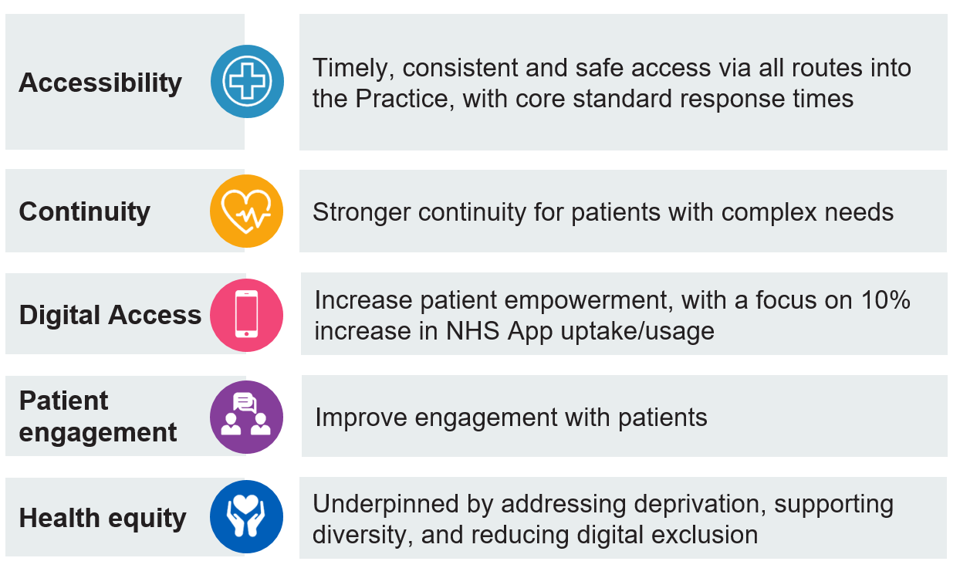

The specification for 2026/27 also employs the principle of evolution, not revolution, ensuring practices continue to make progress in areas such as continuity of care, data quality, demand management, digital access and strengthened equity-focused approaches. By retaining core metrics (e.g., telephony, continuity and patient engagement) and refining them where appropriate, the specification aims to embed consistency, preserve improvements already delivered, and demonstrate year-on-year progress and added value.

The specification provides a framework for incremental, sustainable improvement—supporting practices to
- continue balancing reactive, proactive and preventative care
- improve patient experience across all access channels
- target interventions appropriately to high or rising-risk groups, identified through risk stratification
- strengthen health equity and community engagement/outreach approaches
- ensure patients can be safely redirected into timely primary care options
- improve access and reduce pressure on urgent and emergency services

The specification also sets the foundation for future years by aligning with wider system priorities such as integrated neighbourhood working, digital enablement, supporting patients to be seen in the most appropriate setting for their presentation and outcomes-focused commissioning. In doing so, the 2026/27 specification consolidates prior progress and creates space for innovation, ensuring practices of all starting points can further mature their access models while contributing to a more consistent, equitable experience for residents across NW London. It also looks to indicate a direction of travel, where possible, so that general practice can understand the ambition and look to the future.

- Scope
GP Contract 2026/27

This specification seeks to align with and support Practices to achieve the 2026/27 national GP contract changes by maintaining its focus on timely, equitable, and digitally enabled access, ensuring that local improvement requirements - such as meeting core response standards, supporting continuity for complex patients, and optimising demand management - complement the national requirements. With a view to removing duplication, the 2025/26 Access metric relating to Online Consultation, has been removed from this specification.

The specification also looks to influence and inform improvement in general practice. The focus is therefore on issues within the control of PCNs/Practices.

Interdependencies
There are a number of workstreams that will have an impact on improving access which are aligned to but out of scope of this contract specification, as they are provided for by separate funding and/or are managed in separate workstreams.

These workstreams also look to make best use of clinical time, ensure care is as efficient and effective as possible (both for the practice and the patient), and support the appropriate management of patient need. These include:
- the interface between secondary/primary care
- the need to promote more self-referral pathways
- the development of neighbourhood health models
- the clinical effectiveness programme
- development/refinement of the WSIC Risk Stratification tool

- Aims and objectives
2.1 Aims and Objectives
Across NW London, we want patients to know they will get high quality, timely care at their local GP practice. This means ensuring that patients can quickly access care when they need it, and that practices can provide continuity of care where required. It is also expected that improving access will take pressure off other parts of the system, including urgent and emergency care in the longer term.

The specification looks to support general practice services across NW London to develop models which build resilience and make effective use of resource. This should mean better access, best use of clinical time, reduced waiting times, and increased continuity and proactive care for those that need it. The specification also looks to support Practices to work more closely with colleagues at place-level, to go out into the communities they serve. This should be done to build relationships and trust, strengthen meaningful Practice-patient dialogue and foster greater patient empowerment.

To this end, our objectives are to:

- improve access to general practice making use of learning derived from patient engagement, the development of local access plans in 2024/25 and 25/26 and audits in 2025/26
- support practices to embed the changes they have made to deliver improved access, and to deliver the new requirements associated with the updated 2026/27 general practice contract – taking the time to reflect on what has worked, what can be further developed and refined in light of feedback received and learning gleaned from peers, and to drive up staff and patient skills
- move towards a more nuanced way of demonstrating value in general practice services, moving away from a reliance on counting GP appointments as the only measure of success
- empower patients to take greater responsibility for their own health and wellbeing, supporting them to take up digital opportunities, where appropriate, navigate the NHS and help individuals from disengaged/excluded communities to re-engage with general practice and have a positive experience

Best practice in improving access

Across NW London there are different models of access to general practice. While this specification does not mandate a specific model, it does expect practices and PCNs to work towards delivering best practice for patients, in which:
- patients are confident they can get the support they need from general practice when clinically appropriate, without having to seek urgent help from other parts of the system
- patients have a good understanding of the routes into general practice, know what response they are likely to receive and in what timeframe, reducing unnecessary use of acute services
- patients know who will follow up on their care and, if they have appointment, know who that appointment is with and their role in the practice/PCN
- practices are making best use of a multi-disciplinary team of professionals, underpinned by an up-to-date directory of services and clear protocols to ensure consistency and quality
- staff have the right skills and knowledge to support patients to find the best resolution for their need, whether within the practice or through other services
- practices continually review appointment types and the balance of on-the-day vs. proactive capacity to ensure the appropriate mix of appointments is available
- patients are making full use of digital routes to access (e-consultation and NHS App), including taking advantage of the full functionality within the NHS App, and training/support is available for people who need extra help with these tools as routine
- every opportunity is to be taken to promote self-care, digital, pharmacy first and self-referral options, on the website and in person
- practices have a systematic population health management approach that ensures patients who need ongoing and episodic continuity of care have access to it, understand what it means to have been flagged for continuity, and what they can expect as a consequence. This should be supported by good record-keeping to allow people to be stepped up or down for continuity as circumstances change
- practices actively work to build relationships and trust to support patients, including those from our CORE20Plus5 population and/or those who do not currently engage well, to have a positive experience of general practice care and be actively engaged, and regularly seek patient feedback, to shape the design and delivery of their care

While there is no requirement to submit a formal Improvement Plan for 2026/27, it is advised that each PCN does agree a plan and has it approved by its constituent practices as good practice and to ensure that each Practice is clear about the expectations and their role.
- Service Description and Care Pathway
This second year of delivery within the Enhanced Services specification, will focus on embedding the themes from year one, building on the foundations of the models established.

It is expected that, by the third year of operation, this specification will move to a more outcome-focused model based on improved patient experience and satisfaction alongside better self-management and less reliance on urgent care services.

The model for this year aligns to a number of measures and quality markers to be tracked throughout the course of 2025/26, with a focus on:
- improved patient satisfaction through continuing to improve processes for booking appointments, measured through waiting times and response rates
- making best use of clinical time through using a quality improvement approach, and better recording of clinical contacts
- improved continuity with a focus on Practices further developing continuity processes to ensure they are effective, as well as systematically identifying more patients in high and/or rising risk stratification categories who should be benefiting from consistent access to a named clinical team
- patient empowerment through increased promotion of the NHS app and PCN/practice led surveys and outreach to build relationships and stress the importance of patient feedback in helping to shape the local care offer

The below provides an overview of the changes for this year
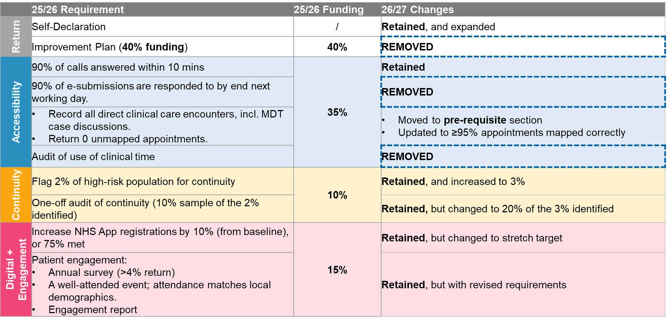

The detail of what PCNs need to do can be found below:

- Submit a PCN-level self-declaration form

PCNs are expected to confirm that the following are in place via a self-declaration that all constituent practices are already:
- delivering all GMS/PMS/APMS core contract requirements, including the new GP contract requirements for 2026/27
- using the full functionality of cloud-based telephony systems during core hours, including the use of call-back, waiting times, and queuing messages signposting patients to online options
- Online Consultations (e-Consultations) are available throughout core hours with no caps or restrictions of availability
- actively promoting use of Pharmacy First (and appropriately diverting suitable conditions to the PF service)/ Online consultation services and the NHS App services, to their patients. This includes providing prominently-displayed, clear and consistent signposting and information 1/ inside their individual Practices 2/ on the Practice website home pages 3/ on the PCN website home pages [please see Appendices re: Pharmacy First]
- accurately coding ≥95% of their direct clinical care interactions, through accurate mapping of their GP practice appointments using the standardised categories (GPAD)
- where clinical activity doesn’t translate to an appointment, actively applying a unique SNOMED code in the patient’s record. [Please see Appendices for details and definitions]
- signed up for the ‘safe surgeries’ initiative https://www.doctorsoftheworld.org.uk/safesurgeries/
- working to improve uptake of the Friends and Family test, submitting results and taking action on findings

NEW for 2026/27:
PCNs are expected to confirm that:
- each Practice is supporting easy/direct access for healthcare professionals into the Practice, through publishing of their practice bypass number and Practice email address on the NHS Service Finder website (on the secure staff section of the site): https://digital.nhs.uk/services/nhs-service-finder
- every Practice that has an online consultation solution which supports translation, has enabled it for patients to use
- ensure all incoming calls are answered within 15 minutes of queuing
- they will oversee the assurance processes relating to provision of slots for 111/UTC use (as set out in the Accessibility section below)
- they will work in partnership with local communities to deliver effective outreach and target care to address health inequalities, complementing the 2025/26 PCN DES (Refer to paragraph 8.3 – Network Contract DES - Contract specification 2025/26 – PCN requirements)

Measuring success in 2026/2027:
Ask | Measures | Method | Timeframe
Every PCN will submit a self-declaration to confirm that they have the necessary pre-requisites in place | Self-declaration is signed by all the constituent practices and returned | Submission of a signed self-declaration form | By 15 May 2026

- Improve accessibility of care: making a preliminary assessment of patient needs, supporting care navigation and patients being seen in the more appropriate setting to meet their presentation need

The ask for 2026/27:

Improving responsiveness

Retain the focus on response times for telephone access.

This measure will set a standard to strengthen patient confidence in being able to access care when required. It will also demonstrate that practices are systematically applying capacity and demand modelling and improving the processes and protocols that underpin the streamlining of patient access. This will ensure that sufficient capacity is available throughout the day, supporting the nationally mandated standards for managing both clinically urgent and non-urgent requests.

Appointment slots for 111 and Urgent Treatment Centre Use

Under the terms of their core contract, Practices are obliged to make appointments available for 111 use at the rate of 1 appointment/ 3000 registered patients.

To support patients presenting with primary care needs being seen in a primary care setting, Practices will additionally be required to make extra appointment capacity available. This additional capacity (above the national baseline) must be explicitly labelled for NHS 111/UTC use.

Provision must be delivered during core hours, and not out of hours, e.g., evenings or weekends. It may be delivered at individual practice level or via an at-scale PCN model in core hours, and Practices/PCNs may choose whether these appointments sit within a named clinician’s rota or are created as virtual appointments within a dedicated worklist rota provided the required capacity is clearly identifiable and compliant.

It should be noted that UTCs in some areas of NW London are already supporting re-direction. All redirection is the responsibility of the UTC triage nurse whose role it is to propose an appropriate route following observations and support by clinical decision-making tools. The triage nurse is, therefore, responsible for the clinical decision to redirect and to determine the most appropriate setting for re-direction.

PCNs are expected to self-declare that they will monitor provision and support Practices to engage with UTCs when the opportunity for re-direction arises, noting that UTCs don’t currently have direct booking capability.

Many Practices provide telephone triage appointments to patients referred via 111. For the additional appointments, however, the Practices (with PCN oversight) are expected to offer a greater level of flexibility that take into account:
- the referring clinician’s triage assessment which could be considered as that of a trusted assessor, removing the need to repeat the triage.
- that any perceived additional barriers may result in patients re-attending UTC or even Emergency Department (ED).
- where a patient is booked into their registered practice, there should be a clear expectation regarding next steps, including whether they will receive a call back, telephone appointment or a face-to-face appointment, depending on the practice’s arrangements.

This supports the management of primary care-appropriate patients with low-acuity conditions that should be seen in a primary care setting.

PCNs must also confirm that Practices are making slots available at the specified times (or comparable), ensuring distribution throughout the day, and that all 111/UTC‑labelled slots are visible to NHS 111/UTCs at least 48 hours in advance, with no embargoes applied.

Additionally, the ICB will undertake spot checks to ensure compliance or provision, and will review UTC “streamed to primary care service/GP” data to ascertain utilisation levels.

See Appendices for the number of slots each Practice will be expected to deliver and for the required slot times. These set out both the number of additional slots required for 111/UTC use and the number of contractual 111 slots. A supporting guide will also be appended and provided in Q1.

Measuring success in 2026/2027:

Ask | Measures | Method | Level of delivery/ timeframes/ assessments
Practices/PCNs develop and deliver access models to ensure patients  - Can access safe care, supported by protocols  - Have a choice of routes into care that are managed equitably  - Are working to a core minimum standard for timely response  - Are offered an appointment or appropriate alternative care on first contact | - KPI - 90% of calls are answered within 10 mins | - Self-reporting against 10 mins (individual Practice and PCN raw numbers to be submitted each quarter)  - Share the numerator (number of calls answered within 10 mins) and denominator (total calls answered)  - Practices can request telephony provider to configure reporting to align with the metric, or access their own data via the practice-level GP Appointments Dashboard. | - Reporting level: Practice raw numbers and PCN raw numbers  - Timeframe: Quarterly submissions by PCNs  - Assessment: PCNs are expected to achieve an average performance of ≥90% across the year (Q1-Q4)
Practices to deliver the required 111/UTC slots:  - At a minimum ratio of 1/2000 registered slots  - At the times specified  - Without any embargoes in place so that 111/UTC can see availability at least 48 hours ahead  PCNs to:  - agree how the extra appointments will be provided  - monitor Practice adherence to requirements  - ensure Practices are supporting engagement with UTCs when opportunity to re-direct arises | Every Practice is delivering 1/2000 registered slots in line with requirements, as reported and checked by PCNs | - PCNs to self-declare that they oversee delivery of the additional appointment slots for 111/UTC use.  - PCNs to regularly monitor the number of appointment slots delivered by each Practice, and ensure that all slots are distributed throughout the day, without any embargoes in place, in line with the guidance (see Appendices)  - The ICB will conduct monthly spot-checks of Practices via the Appointment Checker. | - Reporting level: Practice count and PCN count  - Timeframe: PCN Self-declaration by 15 May 2026. Monthly spot-checks by the ICB.  - Assessment: PCNs to ensure the required number of additional slots are delivered

- Digital; increasing use of the NHS App as a means to empower patients and reduce practice demand

The NHS App continues to be the national flagship digital tool to improve access for patients - helping people to manage their health more easily by enabling them to easily view their health records, order repeat prescriptions, access test results and receive secure messages from their GP. While the app is not perfect and digital is not for everyone, it does offer the opportunity to both improve patient self-care and empowerment and help reduce demand levels on general practice.

To that end, for 2026/27, we propose to retain the ask of individual Practices with registration levels currently below 75% to deliver an uplift against their March 2026 baselines (as taken from the NHSE dashboard), by year end. In recognition that achieving further increases in NHS App registrations becomes progressively more challenging as practices approach the 75% threshold - and that more substantial improvements are needed from those starting at a lower baseline - a graduated sliding scale of requirements has been introduced for this year. [See sliding scale in the Appendices]

To support delivery of these targets, every PCN and every Practice needs to identify at least one member of staff to act as an NHS App Ambassador to register formally with NHSE as the link point regarding NHS App information. The staff member can be from any background and work in any role, clinical or admin. These roles are intended to act as champions for NHS App use – promoting the app, helping patients to set it up and register, as well as ensuring that patients have notifications switched on to support effective use. The PCN-level Ambassador will take on a co-ordinating role, working with the NHS App champions in the constituent practices.

Practices should make full use of their PCN-based NHS App Ambassadors and also access a full range of campaign materials, including social media assets, digital display images and posters at the link below. We encourage practices to review the available resources and use them to support local promotion of the NHS App.
👉 Click here to access the NHS App Campaign Resource Centre and find out more about the campaign

Details on how to become an NHS Ambassador and what the role involves, can be found in the Appendices. The report that PCNs need to complete at year end will be provided in Q1, along with other templates.

Measuring Success in 2026/27

Ask | Measures | Method | Level of delivery/ timeframes/ assessments
Every PCN/practice will support patient empowerment and effective utilisation of Practice resource, through using every opportunity to promote the NHS App, and supporting patients to register and use it. | KPI - Increase NHS App registration from the Practice baseline, in line with the sliding scale provided | - Increase NHS App registrations (P9 + P5 registrations) against March-26 baseline, in line with the sliding scale provided (see Appendices)  - Practice-level and PCN-level data will be extracted from the NHSE NHS App Reporting Dashboard. | - Reporting level: Practice % and PCN %  - Timeframe: Quarterly data automated  - Assessment: PCNs are expected to increase NHS App registration in line with the sliding scale targets.
To support the above aim, each PCN and each Practice shall  - identify at least 1 member of staff to act as an NHS App Ambassador  - ensure they are registered with NHSE  - Have these roles act as champions for NHS App use | Each PCN and each of its constituent Practices, has at least 1 identified NHS App Ambassador registered with NHSE | - PCN NHS App Ambassador and Practice NHS App Ambassador must be registered in Q1.  - PCNs to email the ICB confirming the registered individual, their role/organisation, and the registration date, by 15 May 2026.  - This will be validated and reflected in NHSE reported data.  - PCNs to submit a report at year-end to confirm what the NHSE Ambassadors have done, using the template provided (see Appendices) | - Reporting level: Practice count and PCN count  - Timeframe: PCNs to confirm registrations via email by 15 May 2026, and submit a report by 19 March 2027.  - Assessment: 1 Ambassador per PCN and 1 Ambassador per Practice in post, with a report provided to ICB by 19 March 2027.

- Providing continuity of care for more patients

The ask for 2026/27:
In 2025/26, practices were asked to identify 2% of the high risk patients on their registered list, flag them in the clinical system and provide them with continuity of clinical team and improved co-ordination of care. Practices identified patients using data from across the system, as well as their own knowledge of their patients.

For 2026/27, Practices are asked to continue to provide and refine their continuity provision for this existing 2% group, building on the learning gathered from their 2025/26 audits. Additionally, they will need to identify, flag and provide continuity for further 1% of patients on their registered list, bringing the total cohort to 3% of the registered population for continuity of care.

This 3% cohort should be maintained as a rolling target throughout the year, rather than a fixed population, to ensure it remains dynamic and responsive as patients’ needs change and patients move in and out of the cohort.

Practices are expected to use the WSIC Risk Stratification tool (below) to support identification, which supports the new national core contract requirement for PCNs to identify and prioritise cohorts for continuity of care using risk stratification tools. However, due to the phased rollout of the tool, from April 2026 until full implementation, practices should continue to use the 2025/26 approach (applying continuity flags supported by local intelligence) to identify the full 3% cohort.

Once the WSIC Risk Stratification tool is fully implemented, Practices should use the tool alongside local intelligence to identify the total rolling 3% cohort.

Using the WSIC Risk Stratification tool, PCNs together with their individual practices, may decide to identify rising-risk or high-risk patients in addition to the high-risk patients already flagged, as this may better reflect the needs of the patients they serve.

The aim is to support practices and PCNs to embed approaches to segmentation, care planning and continuity of care, to better use resources and skill mix across their teams. Practices can find an example of what might be achieved in the appendices.

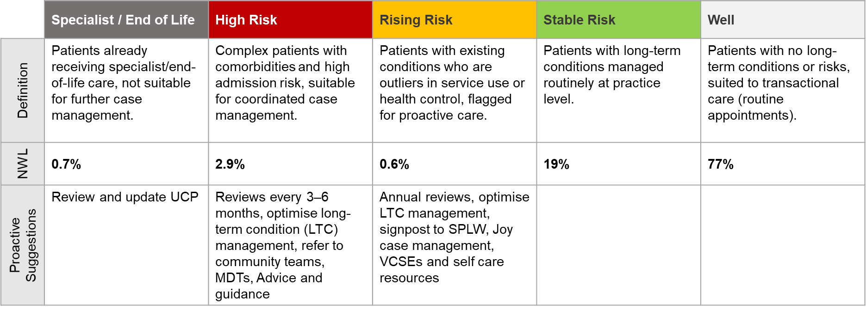

A one-off audit of 20% of the 3% of identified patients, will need to be conducted between November 2026 and January 2027. At the end of that time period, PCNs should bring practices together to review the audit findings and submit an over-arching summary of findings and actions taken to the ICB by Friday 19th March 2027. Consideration should be given to whether patients would recognise and feel the difference in the care that is being provided to them.

Best practice in this context is that:
- The continuity flag appears on the home page of a patient’s record
- Flagged patients are assigned a named team comprising a GP, Nurse and Allied Health Professional, or other combination depending on local staff mix and clinical need
- Patients are notified of the names of their assigned team and how and when to contact the different professionals involved in their care
- The Practices use the learning from audits and the peer-peer discussions held within their PCN, to make continuous improvements to how they deliver continuity
- Patients feel the difference in the service they are getting

This is an enhancement of the 2025/26 PCN DES Risk stratification to support continuity of care. Refer to page 47 Table 1 network-contract-guidance-part-b.pdf

Measuring success in 2026/27:

Ask | Measures | Method | Level of delivery/ timeframes/ assessments
Every Practice will retain provision of continuity for the 2% high risk patients identified in 2025/26. | Practices can demonstrate at least 3% of their REGISTERED patient list have a SNOMED code assigned and a continuity flag noted on the patient record, throughout the year | - Practices to continue to provide continuity of care for the 2% high-risk patients identified in 25/26  - Practices to use the 25/26 methodology to identify a rolling 3% registered population, until full rollout of the WSIC Risk Stratification tool.  - Once available, use the WSIC Risk Stratification tool to identify the high-risk/rising-risk population.  - Practices to determine whether to focus on high-risk or rising-risk category, based on their understanding of the data and patient knowledge. | - Reporting level: Identification at practice level, with total, rolling 3% at PCN level demonstrated.  - Timeframe: Practices to identify throughout the year. Monthly data automated.  - Assessment: A total 3% of patients are flagged for continuity.
Every Practice will identify (via the WSIC Risk Stratification tool), flag and provide continuity to an additional practice population (high risk or rising risk)
Every Practice will audit whether patients received continuity of care from their assigned team | One-off review of a 20% sample of the identified 3% Practice registered list size population | - Practices should complete the one-off audit at any point between Nov-26 and Jan-27, using the Practice audit template provided (see Appendices).  - PCNs should then bring Practices together to review findings, key learning points, and actions taken in response to 2025/26 learning to ensure continuity.  - PCNs should submit a PCN-level summary report using the report template provided (See Appendices). | - Reporting level: PCN-level summary report.  - Timeframe: One-off audit in Nov-26 to Jan-27.  - Assessment: PCNs to submit a PCN-level summary report on learning by 19 March 2027.

Detail of audit

Patient Identifier | Is a named practice team in place? |  | Total clinical contacts in last 12 months |  |  | No. of contacts: named team in last 12 months |  | Is the patient also identified via WSIC Risk Stratification tool as high-risk or rising-risk? |  | If so, what is the risk category? |  | Is practice level Care Plan in place? |  | Is Universal Care Plan in place? |  |  | Is this patient part of regular MDT review? |  | No. unplanned hospital admissions in last 12 months |  | No. of times practice followed up post discharge | Medication review or optimisation in last 12 months
 | Yes/No |  | #contacts |  |  | #contacts |  | Yes/No |  | High-risk/  Rising-risk |  | Yes/No |  | Yes/No |  |  | Yes/No |  | #contacts |  | Yes/No | Yes/No
What actions are being taken for the patient to ensure and maintain continuity? |  |  |  | Description of actions

- Relationship building, Engagement, Education, Empowerment and Developing a sustained dialogue with our communities

For 2026/27, there will be a greater emphasis on staff getting out of the practice and supporting patients in the environment in which they live and go about their lives, working with neighbourhood partner organisations to build trust and support those who are disengaged with general practice, to re-engage and have a good experience. This element of the specification aims to recognise that
- many of those who experience health inequalities often don’t engage well with general practice, leading to poor condition management and higher levels of hospital use
- high quality feedback provides vital insight to shape service development and drive continuous improvement of the patient experience
- the aim is to make patient dialogue a fundamental and business-as-usual component of general practice
- partnerships with trusted community organisations, in spaces already known and frequented, are essential to supporting improved access and engagement, and for delivering health education messages

The ask for 2026/27:

- Practices will deliver a survey on the subject of access to all of their patients who are over the age of 14 years. The survey shall be disseminated widely (email/NHS App/texts/practice and PCN websites/waiting room poster/PPG and paper copies for those who need it, plus promoted via outreach sessions – see below), with a least 1 reminder sent. PCNs may use a platform of their choice to deliver the survey. All PCNs are required to complete a standardised template provided for central data collection to enable year-on-year comparisons.

Survey Design
- Required questions:
To support year-on-year comparison and monitoring of patient satisfaction levels over time, the Practice will use the following 5 questions from the 2024/25 survey:
- I am satisfied with how easy it is to contact my surgery during opening hours (08:00-18:30, Mon-Fri) [Strongly agree – Agree – Neither agree nor disagree – Disagree – Strongly disagree]
- I can book a same day / next day appointment for urgent matters/care [Strongly agree – Agree – Neither agree nor disagree – Disagree – Strongly disagree]
- I can book an appointment in advance; 1-2 weeks for non-urgent matters/care [Strongly agree – Agree – Neither agree nor disagree – Disagree – Strongly disagree]
- If you have used the online consultation service (e.g., PATCHS, Blinx, Accurx) offered by your practice, how satisfied were you with it? [Very satisfied, Satisfied, Neutral, Dissatisfied, Very dissatisfied]
- What changes, if any, would you like to recommend to improve your experience when contacting your GP Surgery? [Free text]

- Additional questions:
Practices are encouraged to supplement the required questions with any additional questions they wish to include and that are relevant to the work that they have done/are planning to improve patient access, or as agreed across the PCN for consistency and comparison. Where possible, practices should co-design these additional questions with their patients to ensure they capture what matters most to those using the service. However, the selection of questions remains at the discretion of the Practice and PCN.

- Required demographic questions:
To support understanding some key elements regarding audience and identification of trends, patterns and gaps, practices should include the below demographic questions as a minimum:

- What age group do you belong to?
(Choose any one option)
- 16-25
- 26-35
- 36-45
- 46-55
- 56-65
- 66-75
- 76-85
- 86+
- Prefer not to say

- How would you describe your gender?
(Choose any one option)
- Female
- Male
- Prefer to self-identify
Prefer not to say

- What is your ethnic group? Please select one option that best describes your ethnic group or background?
(Choose any one option)
- Asian/ Asian British (Bangladeshi)
- Asian/ Asian British (Chinese)
- Asian/ Asian British (Indian)
- Asian/ Asian British (Sri Lankan/ Tamil)
- Asian/ Asian British (Pakistani)
- Asian/ Asian British (Other)
- Black/ Black British (African)
- Black/ Black British (Caribbean)
- Black/ Black British (Somali)
- Black/ Black British (Other)
- White (British)
- White (Irish)
- White (gypsy or Irish traveller)
- White (other)
- Mixed/ multiple (white and black Caribbean)
- Mixed/ multiple (white and black African)
- Mixed/ multiple (white and Asian)
- Mixed/ multiple (other)
- Prefer not to say
- Other (please specify)

- Community Outreach Champions and Outcomes

The ask: PCNs to complete targeted community outreach activities with one or more of their population cohorts who have reported difficulty accessing care or who engage less with healthcare/are seldom-heard communities within their footprint.

The target population/s: constituent practices in a PCN to agree who their target population/s should be, using WSIC, the shared needs assessment and other shareable data to support their decision-making.

Who should lead the outreach: PCNs are expected to identify both a clinical and a non-clinical champion to lead the outreach activities on behalf of the PCN. The staff members performing the function of champion should remain consistent where possible to support relationship building.

Purpose: The primary purpose of this role is to
- build trusted relationships between patients and general practice with a view to improving access into general practice and support improved outcomes in the identified communities
- work collaboratively with local partner organisations, community groups, and voluntary sector partners to build relationships with each other and the community, and deliver consistent messages. This will support neighbourhood working and developing neighbourhood services.

How:
EITHER
- build on formal and informal events, forums, and community meetings, where they exist
OR
- set up specific sessions for the chosen cohort/s
Regardless of which of the above approaches is used, all sessions should be run in conjunction with other system partners – this will likely mean that the sessions have a wider lens with a general practice element built in. They should focus primarily on developing trust between general practice and the identified community. It will also support PCN learning through having a two-way dialogue between communities and general practice.

Additional patient outcomes may include having an improved understanding of how to navigate the NHS, how and when to use of digital tools such as the NHS App. The dialogue may also encourage disenfranchised patients to re-engage with general practice or NHS services more generally, contributing to a reduction in avoidable hospital use. Where this happens, Practices will need to ensure support is put in place so that any returning patients have a good experience of using their services, with a view to ensuring the sustainability of the re-engagement.

A list of the planned community events and outreach/in-reach sessions that the ICB Communications team is aware of, will be provided. PCNs should, however, appreciate that the list will not be comprehensive (particularly during the period of ICB restructure and merger) and they will also need to identify their own local sessions to support. PCNs may find the Joy platform a useful resource.

Measuring success in 2025/2026:
Ask | Measures | Method | Level of delivery/  timeframes/  assessments
Refresh the bullet points on their website relating to Access, outlining:  - their achievements in 25/26  - their access plans for 26/27  so that patients have visibility | - Bullet points on the website are easily accessible to patients, by 15 May 2026. | Once published, PCNs should share links to the relevant webpages with the ICB. | - Reporting level: On both PCN and constituent Practice websites.  - Timeframe: By 15 May 2026.  - Assessment: Spot checks to validate publication.
Every Practice will  - engage with their patients to track experience and satisfaction with care  - identify local issues related to access, using the feedback received to improve their access processes | - A patient experience survey, using the set questions and demographic questions provided, supplemented with extra Practice questions, is run in-year, with >4% return. | - Complete the Survey Results template provided (see Appendices)  - Complete the Engagement Report template provided (including case study template) (see Appendices)  - Attend a borough-based session to share learning and a case study | - Reporting level: Practice-level and PCN-level data/results submitted by PCN.  - Timeframe: Any point of the year, no later than 19 March 2027.  - Assessment: An overall >4% response rate is required. Submit a PCN-level Engagement Report, documenting findings/key learning points/case study.
Every PCN will identify one or two target population group/s and 2 champions to lead outreach on behalf of the constituent practices | - Each PCN will participate in 4 sessions of outreach (formal and informal) during the year to build relationships with the target population/s

Reporting requirements and timelines
- Metrics should be collected from April 2026; with quarterly returns to the ICB to end of 2026/27. [See timelines in the Appendices]
- PCNs are be expected to submit a summary of findings and actions taken across practices by Friday 19 March 2027.
6.Future Expectations
This section has been included to show the ICB’s current thinking regarding the future focus of some elements of the Access specification, and where they might move to in the next iteration. These are, of course, subject to change but have been included so PCNs can see the likely direction of travel and set aspirational stretch goals for themselves where they might wish to make ahead‑of‑the-curve improvements.

- Response times for telephone access: The metric to attain remains the same as last year (90% within 10 mins) but PCNs will have noted that the recently issued letter regarding GP Contract changes for 2026/27 have put an emphasis on call waiting times. While no target has yet been set, the NHSE dashboard currently looks at the number of calls over 10 mins, the number of calls within a 2-5 minute timeframe and the number answered in <2 mins. On this basis, we will also include data regarding Practice/PCN performance against the 2-5min NHSE targets in the Access dashboard

- Same day appointments for all clinically urgent patients: The 2026/27 GP contract requires that all clinically urgent patients to be seen on the same day, supporting the Medium-Term Planning Framework ambition of 90% by the end of 2026/27. This reflects the national focus on same day appointments, whether by telephone, walk-in or online. A key part of this ambition is ensuring that all appointments are recorded accurately within General Practice Appointments Data (GPAD), providing a true picture of GP appointment activity and helping practices to understand their own pressure points and improvement opportunities.

6.Contractual requirements
As with previous access specifications, and in line with other Enhanced Services, this contract is between the ICB and the PCN. The associated funding will be based upon weighted list size data from March 2026 but, when working to identify and support specific patients (such as in the continuity and engagement sections), Practices/PCNs will be expected to use their actual registered list size as the baseline. [See list size requirement in the Appendices]

The ICB will determine overall achievement of metrics at a PCN-level, unless otherwise stated in the tables above. Data submissions are expected from each PCN, however, they should include raw data at an individual practice level as well as the PCN level, so the ICB can calculate ICB-wide reports and determine whether all practices are contributing to the whole and can respond to any specific queries or appeals.

Practices are expected to come together within their PCN to share learning, support each other to scale and spread successes, and achieve more for their patients and staff.

Further changes to the 2026/27 GP Contract may overlap with or duplicate elements of this Access specification. As a result, requirements may be subject to change during the year in response to national contractual updates.

Documentation and Reporting

All documentation should be provided to nhsnwl.localservices@nhs.net with a clearly defined subject on the email e.g., Access Continuity Audit_XXPCN_Submission Date.

To support interactive reporting, streamline processes, and reduce administrative workload, the ICB may use dashboards, SharePoint, and Microsoft Forms for documentation and reporting.

All supporting templates, guidance materials, and FAQs will be provided in Q1.

APPENDICES

Appendix 1 - PAYMENT/KPI RULES
Funding process

Funding will be allocated throughout 2026/27 on a capitation basis. Practices will be eligible for up to £2.50 per patient (using April 2026 weighted list sizes).

In line with other Enhanced Service specifications, 80% of funding will be provided up front on a 12 equal-monthly basis, with the final 20% provided upon reconciliation at year end.

Retention of funding will be subject to:
- delivery against the identified targets
- evidence of compliance with the expectations set out in the specification and provided supporting documentation
- meeting the deadlines for submission of all elements

It is for individual PCNs to assure themselves that their constituent practices are meeting the requirements of the specification during the course of the year, to provide support and encouragement as needed, with a view to ensuring overall PCN achievement of the metrics.

It is also for each PCN to agree with its constituent practices how any funding should be split in line with the level of work actually completed by each of them.

100% funding will be allocated as indicated below, for each of the themes in the specification:

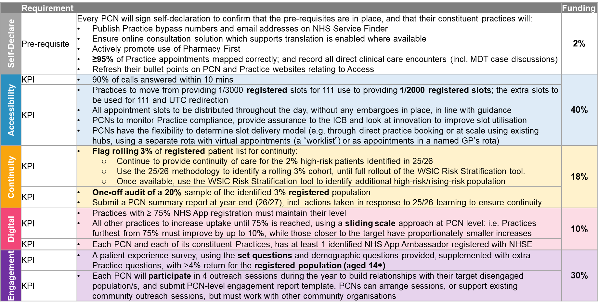

In Summary, To Achieve Payment

 | PCNs will need to demonstrate: | Timeline | List size requirement
Pre-requisites | • compliance through a signed self-declaration confirming that all pre-requisites are in place. | Return by 15/05/2026
Pre-requisites | • they have published their bypass number and email address for healthcare professional use on the NHS Service Finder website | By 15/05/2026
Pre-requisites | • have turned on their online consultation translation support | By 15/05/2026
Pre-requisites | • maintenance or improvement of Pharmacy First activity | Throughout 2026/27
Pre-requisites | • all clinical contacts have been recorded in the ledger, with any clinical contacts not leading to appointments being coded in line with established SNOMED principles | Throughout 2026/27 | Registered list size
Pre-requisites | • have refreshed the bullet points on their website relating to Access 2025/26 to show what they have achieved, and added new bullet points for 2026/27 that build on the previous ones | By 15/05/2026
Accessibility | • on average, 90% of calls are answered within 10 minutes and that the Practices are working towards a 2-5 minute timeframe in line with NHSE reporting | Quarterly submissions: 10/07/2026, 09/10/2026, 15/01/2027, 09/04/2027
Accessibility | • that they are providing and monitoring ongoing provision of 111/UTC slots at the required rate and in line with guidance on timings and visibility, and are supporting UTCs to utilise the slots effectively | Monthly monitoring | Registered list size
Continuity | • a rolling total of 3% of registered patients at high risk/rising risk are flagged, identified and provided with continuity of care | Identification throughout 2026/27 | Registered list size (rolling)
Continuity | • a continuity audit of a 20% sample of the identified 3% registered population has been conducted, with learnings from 2025/26 applied to improve management, and learnings from 2026/7 consolidated and shared across the PCN | • One-off audit at any point between 11/2026 - 01/2027  • PCN summary report due by 19/03/2027 | Registered list size
Digital | • an improvement against the provided baseline in registrations on the NHS App that is in line with the sliding scale provided, or maintenance of 75% | Quarterly monitoring
Digital | • NHSE champions have been identified and confirmed as such and a report submitted | • Email confirmation by 15/05/2026  • Report due by 19/03/2027
Engagement | • a patient survey has been carried out, with a return of >4% of the local 14 years+ population | Survey results due by 19/03/2027 | Registered list size (aged 14+)
Engagement | • Engagement champions have been identified and have led a minimum of 4 PCN-level outreach sessions throughout the year | Engagement report due by 19/03/2027

Practice weighted list size and registered list size – to be provided in Q1

Appendix 2 – SUPPORTING THE PRE-REQUISITES SECTION
Self-declaration Form

Coding clinical care interactions
Practices will need to continue to code every direct clinical care interaction to better capture activity and value within primary care. This will be achieved through
- accurate mapping of GP Practice appointments so that the direct patient clinical activity is accounted for in its entirety. PCNs will be expected to ensure that all appointment types are appropriately mapped through GP practice appointment systems. Where PCN activity is recorded within GP practice appointments systems, those appointments will be included.

In recognition that there are some obstacles within the TPP SystmOne clinical system to achieving a perfectly mapped dataset, the ask for 2026/27 is for PCNs to demonstrate that they have ≥95% of appointments mapped correctly by year end. The definition of ‘unmapped’ is provided in the appendices, along with NW London wide data for January 2026, as a baseline.

Requirements
- Practices should select a national category that best fits the description of an appointment
- Where category data is not received then an appointment is assigned as ‘Unmapped’
- ‘Unmapped’ indicates that there was no record of a category against an appointment. This could be due to an error receiving the data, or an appointment type has not been mapped

- where clinical activity does not translate to an appointment in the ledger, a unique SNOMED code will need to be added to the patient record (see list below)

Definition: Clinical activity here is defined as a clinician's direct interaction with a patient or an intervention which results in a change in clinical management for the patient. This includes MDT activity.

Excluded activities are repeat prescribing, administrative tasks and actions, call and recall, report writing, reception or administrative staff patient related activities, referral processes.

SNOMED codes to be used:
- Non-ledgered direct clinical care: SNOMED Report of clinical encounter (371531000)
- MDT case discussions (not advice and guidance): Multi-agency case management review (1026051000000106)

The Access dashboard will automate SNOMED counts on a monthly basis.

NW London baseline: January 2026

The data below shows appointments recorded in GP practice appointment books systems in NW London in January 2026.

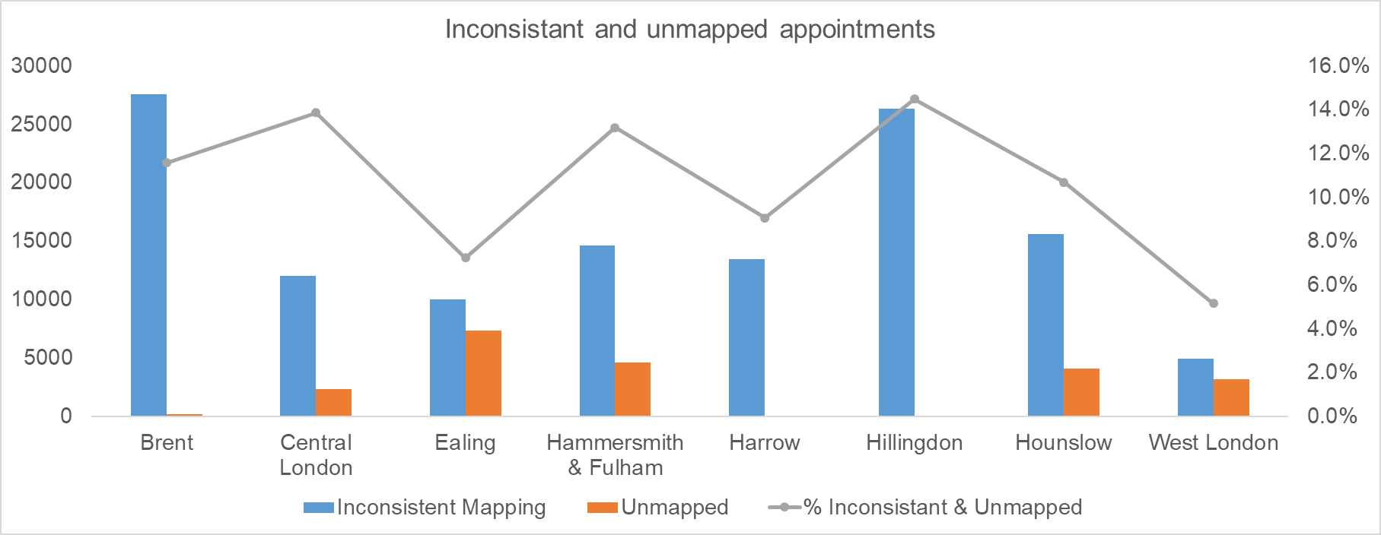

Borough | Normalised Weighed List Size | Appts | Appts Per 1,000 Patients | Av. Appts per week | In-consistent Mapping | Unmapped | % of Total | % Unmapped
Brent | 484,911 | 240,405 | 496 | 54,285 | 27,600 | 216 | 11.6% | 0.1%
Central London | 255,080 | 103,859 | 407 | 23,452 | 12,065 | 2,330 | 13.9% | 2.2%
Ealing | 439,811 | 240,251 | 546 | 54,250 | 10,051 | 7,337 | 7.2% | 3.1%
H&F | 306,815 | 146,560 | 478 | 33,094 | 14,670 | 4,651 | 13.2% | 3.2%
Harrow | 266,859 | 148,201 | 555 | 33,465 | 13,442 | 4 | 9.1% | 0.0%
Hillingdon | 329,316 | 181,959 | 553 | 41,088 | 26,350 | 9 | 14.5% | 0.0%
Hounslow | 345,146 | 184,674 | 535 | 41,701 | 15,603 | 4,142 | 10.7% | 2.2%
West London | 273,953 | 158,823 | 580 | 35,863 | 4,982 | 3,209 | 5.2% | 2.0%
NWL | 2701,890 | 1404,732 | 520 | 317,198 | 124,763 | 21,898 | 10.4% | 1.6%

Pharmacy First

For access to work effectively across all parts of the system, it is key for patients to be seen in the most appropriate place for the acuity level they are presenting with. As part of their triage processes, Practices need to direct patients with pharmacy-appropriate conditions to go directly to the pharmacy. If patients can be safely signposted to other services, this will help reduce pressure on general practice.

There are three parts to the Pharmacy First service:
- Minor illness consultations
- Seven Clinical conditions consultations
- Supply of urgent medicines (and appliances)
Additionally, there are other national community pharmacy services such as blood pressure/ABPM checks and oral contraception services.

The ICB will be monitoring improvement in the overall PF activity relating to each Practice and, where Practices are promoting the service and triaging patients appropriately, they would be expected to maintain/increase the number of registered patients using the PF services. A KPI target has not, however, been set for this in recognition that patient safety and appropriateness of referral to PF is key as is patient choice, plus the ambition to support patients to choose to go directly to PF services and not via general practice.

The ICB to share the total count of PCN Pharmacy First referrals (March 2026) so that PCNs can monitor service usage.

Please note that when promoting Pharmacy first, any online tools need to cover all pharmacies (i.e., without being selective)

Appendix 3 – SUPPORTING THE ACCESSIBILITY SECTION
111/UTC slot provision and timings

The core contract notes that slots for 111 use must be provided at the following rate:
(a) one, where the Contractor has 3,000 registered patients or fewer; or
(b) one for each whole 3,000 registered patients, where the Contractor has more than 3,000 registered patients

For the Access specification the practices are required to provide additional slots to ensure overall delivery at a rate of 1 slot for each whole 2,000 registered patients.

The table below outlines both the number of additional slots required for 111/UTC use, and the number of contractual 111 slots. Practices must continue to meet their contractual requirement for 111 provision, while also delivering the additional slots set out in this Access specification.

Set out below is the optimum times of day when these slots should be made available to maximise utilisation. This is also to avoid instances that are currently evident in some Practices where all 111/UTC slots are provided at 8AM.

When a patient is booked into their registered practice, there should be a clear expectation regarding next steps, including whether they will receive a call back or a face-to-face appointment, depending on the practice’s arrangements.

Practice registered  list size | Contractual  slots  (1/3,000) –  For 111 use | New total slot  requirement  (1/2,000) | Additional  slots required  above the contract  – For 111/UTC use | Optimum Time of Delivery
<999 | 1 | 1 | 0 | 14:00
1,000–1,999 | 1 | 1 | 0 | 14:00
2,000–2,999 | 1 | 1 | 0 | 14:00
3,000–3,999 | 1 | 1 | 0 | 14:00
4,000–4,999 | 1 | 2 | 1 | 11:00 & 14:00
5,000–5,999 | 1 | 2 | 1 | 11:00, 14:00
6,000–6,999 | 2 | 3 | 1 | 11:00, 14:00, 16:00
7,000–7,999 | 2 | 3 | 1 | 11:00, 14:00, 16:00
8,000–8,999 | 2 | 4 | 2 | 09:00, 11:00, 14:00 and 16:00
9,000–9,999 | 3 | 4 | 1 | 09:00, 11:00, 14:00 and 16:00
10,000–10,999 | 3 | 5 | 2 | 09:00, 11:00, 14:00, 16:00 and 17:00
11,000–11,999 | 3 | 5 | 2 | 09:00, 11:00, 14:00, 16:00 and 17:00
12,000–12,999 | 4 | 6 | 2 | 09:00, 10:00, 11:00, 14:00, 16:00 and 17:00
13,000–13,999 | 4 | 6 | 2 | 09:00, 10:00, 11:00, 14:00, 16:00 and 17:00
14,000–14,999 | 4 | 7 | 3 | 09:00, 10:00, 11:00, 14:00, 15:00, 16:00, 17:00
15,000–15,999 | 5 | 7 | 2 | 09:00, 10:00, 11:00, 14:00, 15:00, 16:00, 17:00
16,000–16,999 | 5 | 8 | 3 | 09:00, 10:00, 11:00, 12:00, 14:00, 15:00, 16:00 and 17:00
17,000–17,999 | 5 | 8 | 3 | 09:00, 10:00, 11:00, 12:00, 14:00, 15:00, 16:00 and 17:00
18,000–18,999 | 6 | 9 | 3 | 09:00, 10:00, 11:00, 12:00, 14:00 (x2 slots), 15:00, 16:00 and 17:00
19,000–19,999 | 6 | 9 | 3 | 09:00, 10:00, 11:00, 12:00, 14:00 (x2 slots), 15:00, 16:00 and 17:00
20,000+ | 6+ | 10+ | 4+ | 09:00, 10:00, 11:00 (x2 slots), 12:00, 14:00 (x2 slots), 15:00, 16:00 and 17:00;  Provide further slots at additional intervals in line with required numbers

A supporting guide will also be appended and provided in Q1 to support with implementation and delivery.

Appendix 4 – SUPPORTING THE DIGITAL SECTION
NHS App

Practices are required to improve against their March 2026 baseline in line with the sliding scale below:

March 2026 baseline | Proposed Target (26/27)
<60% | + 10%
60-64% | + 8%
65-69% | + 6%
70-74% | Increase to 75% and maintain
≥75% | Maintain level during the year

NHS App registrations March 2026 baseline data – to be provided in Q1

NHS Ambassadors
Please sign up here: https://digital.nhs.uk/services/nhs-app/become-an-nhs-app-ambassador.
NB: Applicants MUST ensure that the ICB name, their employing organisation type and employing organisation name are entered at point of sign up, to support ICB oversight of which PCNs and Practices have signed up.

NHS App Ambassadors report template (PCN) – to be provided in Q1

Appendix 4 – SUPPORTING THE CONTINUITY SECTION
Continuity
- Audit template (Practice) – see below
- Audit Summary Report template (PCN) – to be provided in Q1

Examples of models:

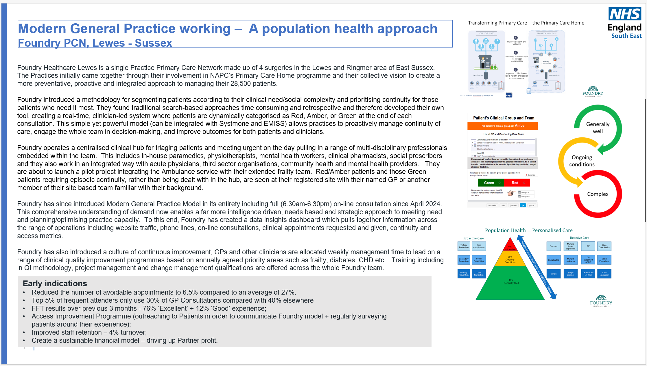

Appendix 4 – SUPPORTING THE ENGAGEMENT SECTION
Survey Results template (PCN) – to be provided in Q1
Engagement Report template (PCN) – to be provided in Q1
The latest information held by the ICB re: existing engagement events – to be provided by the Comms
and Involvement team in Q1

The RCGP’s Fairer Practice Toolkit offers helpful insight and suggested actions relating to reducing
health inequalities and enhancing access. In Section 3, it includes actions that specifically support some
of the key themes of this specification, including:

 | LOCATION
THEME | SECTION | ACTION CODE | DESCRIPTOR
Engagement | Foundation Actions | HNA_01 | Identify & Define a Patient Focus Group
 | Engaging Actions | CARE_01 to _08 | Understand the Health and Care of Your Focus Patients
 | Engaging Actions | MIN_02 | Use Ethnicity Data to Identify and Respond to Disparities in Access, Experience and Outcomes
 | Engaging Actions | STIG_01 | Foster Welcoming Practice Environments
 | Achieving Actions | MIN_05 | Feedback Loops for Ethnic Minorities
 | Leading Actions | AC_21 | Integrate Community Outreach into Routine Practice
 | Leading Actions | ADV_03 | Strengthen Partnerships with Third-Sector Organisations
Accessibility | Engaging Actions | ACC_03 | Flexible Appointment Booking
 | Achieving Action | ACC_10 | Flexible Appointment Structures
Continuity | Engaging Actions | CONT_01/02/03 | Measure and Discuss Continuity of Care in the Practice Team
 | Achieving Action | ACC_14 | Access and Flexibility – Named GP
 | Achieving Action | CONT_05 | Proportionate Continuity for High-Need Patients
 | Leading Action | CONT_07 | Adjust Appointment Lengths to Support Continuity
Digital | Engaging Actions | DIG_01 | Proactively Identify Digitally Excluded Patients

This link might also help with PCN thinking re: which partners it might be useful to work with:
What works: Community engagement and empowerment to address health inequalities - Health Equity Evidence Centre

Child Health Hubs as part of Neighbourhood Teams
NWL Service Specification

- National context and evidence base
  - National context

Children and young people make up nearly one-third of England’s population. In 2024, the Darzi report highlighted an unprecedented increase in demand for children and young people’s services, which coincides with increasing complexity in their health and care needs. Early identification and intervention are essential to giving children the best possible start in life.

Child Health Hubs address some of these major challenges by delivering integrated and timely care closer to home. They provide early access to specialist medical expertise in a local GP setting, bringing together primary and secondary care through specialist clinics and multidisciplinary teams (MDTs) to address children and young people’s physical and mental health needs. Child Health Hubs provide more coordinated, appropriate and proactive care closer to home, bringing specialist expertise into the community,
avoiding the need for the child to visit hospital or other specialist children’s health services. They support early identification and management of conditions outside hospital settings, improving outcomes and child and family experience through continuity and collaboration and reducing health inequalities and unwarranted variation.

Child Health Hubs play a vital role in giving children the best possible start in life. They maintain strong links with wider hubs and local assets, including Best Start Family Hubs, which provide families with easy access to support including classes, activities, health services and advice, all in one place. Together, Child Health Hubs and Best Start Family Hubs help identify emerging issues early and connect families to the right help at the right time. Child Health Hubs also aim to achieve parity of esteem between mental and physical health by embedding mental health expertise within MDTs, bridging the gap between Primary Care and Child and Adolescent Mental Health Service (CAMHS).

Child Health Hubs are central to enabling North West London (NWL) to meet the ambitions set out in the 10 Year Health Plan and achieve the shifts from hospital to community and sickness to prevention. National guidance outlining the principles and core components of Child Health Hubs is outlined in NHS England’s Guidance on Neighbourhood Multidisciplinary Teams for Children and Young People.

  - Local context

Child Health Hubs were established in NWL in 2014 as part of the Connecting Care for Children (CC4C) programme led by Imperial College. They have become a model of best practice nationally, cited in the 2022 Fuller Stocktake of Primary Care services and NHS England’s Guidance on Neighbourhood MDTs for Children and Young People, and have laid the foundations for other ICS areas to develop similar models of care.

Data from the NWL Integrated Needs Assessment shows that children with long term conditions or complex health needs are more likely to attend A&E and have unplanned hospital admissions relative to their population size. Additionally, healthy children in NWL have high rates of A&E attendance compared with their population size, as well as higher rates of mental health contacts than healthy adults. Child Health Hubs support the management of existing conditions outside of a hospital setting and minimise the likelihood of secondary care intervention being required. They embed Population Health Management (PHM) approaches for children and families with known or anticipated risk factors to enable targeted support based on identified local needs and promote equity of access.

Parallel contracting arrangements are being established with other partners that will contribute to the Child Health Hub.

- Aims and objectives of service
Child Health Hubs in NWL aim to:
- Provide the core neighbourhood infrastructure to support children and young people with the greatest needs in the most efficient way, while creating a flexible framework for delivering further targeted initiatives.
- Deliver integrated, holistic, and needs-led care for children and young people closer to home.
- Improve outcomes and experience for children and young people, as well as families and carers.
- Increase opportunities for earlier identification and proactive support for children and families at risk of poor health and development outcomes via a population health management approach.
- Reduce health inequalities and disparities in access, experience and outcomes.
- Support key public health outcomes such as child tooth decay, obesity and school readiness by age of five.
- Reduce hospital admissions, attendances and avoidable repeated appointments
- Minimise duplication, reduce delays and ensure timely access to the most appropriate support.
- Improve clinical knowledge and collaboration among health and care professionals and enhance clinician experience and learning.
- Service Description
  - Routes into the service

One Child Health Hub will be delivered per PCN grouping or neighbourhood of approximately 50,000.
The model consists of two core components: joint clinics and MDT case discussions. Routes into the clinic and MDT will be determined locally and may include GPs, other MDT members such as Family Hub Leads (and non-clinical navigators), Public Health professionals (health visitors and school nurses), Community Health Workers, Clinical Nurse Specialists, and professionals from education settings, as applicable. The Child Health Hub clinic or MDT case discussion might suffice or might serve as the first point of contact to ensure the issue is addressed by the most appropriate services.

  - Population Health Management (PHM) and case finding

Each Hub has dedicated PHM support to proactively identify children and young people who may benefit from early intervention and ensure they receive appropriate care. Using data and insights from WSIC, and other sources, such as the Joint Strategic Needs Assessment (JSNA) and other intelligence from local public health colleagues, professionals in the Hubs will conduct proactive case-finding to identify families in need and refer children with known or anticipated risk factors to the MDT for case discussion, including those in Core20Plus5 cohorts. Hubs will target input to address local needs, such as identifying potential cases of undiagnosed asthma within areas of higher deprivation, supporting children in the care system and improving school readiness. To guide practices, a Child Health Hub Population Health Management Toolkit, will be appended to this Specification. This risk-stratification approach facilitates earlier diagnosis of complex conditions and enables targeted intervention to reduce disparities in access, experience and outcomes.

Opportunities for case finding developed across NWL will be shared via a NWL-wide Community of Practice. Examples of successful case finding initiatives are outlined in Appendix 1.

  - MDT case discussion

MDT case discussions bring together Consultant Paediatrician, GP, clinical psychology and other health and care colleagues (including Family Hub Leads, school nursing and health visiting) to discuss patient cases, usually in a virtual setting for 1 hour per month. These sessions have no set parameters and can be utilised to discuss any child or young person that is causing concern. Nine to twelve cases are discussed per session and the most appropriate next steps for the child or young person and their family or carer are agreed. This may include providing clinical advice and guidance, onward referrals to the joint clinic, secondary care, community and mental health services, school nursing, health visiting, Best Start Family Hubs and follow-up by the GP or other appropriate pathways. Feedback from the discussion is provided to the child or young person and their family or carer, as well as to the referrer.

The composition of the MDT will be determined locally and depend on workforce and patient need. Where possible, the same paediatrician and mental health professional(s) should participate consistently to maintain continuity and strengthen relationships. Shared learning is enhanced when multiple GPs from the practices attend the MDT.

  - Joint clinics located in GP surgeries

Joint clinics, usually undertaken monthly, enable sharing of paediatric expertise to ensure that specialist care can be delivered closer to home. The clinics are co-delivered by a GP and Consultant Paediatrician for three hours per month. Shared learning and professional expertise is enhanced when a different GP hosts the clinic each month, in rotation.

Clinics deliver direct care to children and young people who need it, replacing the need to travel to the local hospital for a paediatric outpatient appointment, and fostering collaboration between primary and secondary care, enabling earlier access to support for those with physical and mental health needs.

  - Interdependence with other services

Integration of Child Health Hubs with other local services at neighbourhood level is critical. Child Health Hub MDTs will work and maintain links with local assets including Best Start Family Hubs (or Children’s Centres where Family Hubs are not established), Early Years and Youth Hubs, Children’s Disability Centres, Child Development Centres, CAMHS and Public Health commissioned services to tackle health inequalities. This includes ensuring Family Hub leads, CAMHS, health visiting and school nursing are actively involved in MDTs and can easily refer into clinics, as well as signposting, information and advice. Consideration should also be given to maintaining links with VCSE organisations for wider support.

Many hubs are already live and this specification will replace any previous arrangements. Where a hub is not yet live, the PCN will confirm the intended date of go-live with payment starting when the model and plan is assured to go live by the commissioner.
- Outcome measurement
  - Reporting from each Hub each month

Hubs will be required to collect the following information on an ongoing basis. The Child Health Hub Coordinator will produce monthly reports and an annual case study and share iteratively across NWL via the Community of Practice:

Joint clinics:
- Attendance
  - Which GP and Practice hosted
  - Which paediatrician (or other specialist) in attendance
- Number of patients seen
  - Breakdown by practice
- Patient Reported Experience Measure (PREM) offered to every patient who attends, using the NWL proforma (Included in briefing pack – to be sent separately)
  - Number of PREMs collected
  - Feedback data from PREMs
- Was Not Brought (WNB) / Did Not Attend (DNA) rate
  - Number
  - Breakdown by practice
- Case studies (2 per annum - No particular format required)

MDTs:
- Attendance
  - Which GP and Practice hosted
  - Breakdown of attendance by profession
  - Breakdown of attendance by Practice/Organisation
- Number of patients discussed
  - Breakdown by practice
- Whether there was a specialist teaching topic arranged
  - Topic

Hubs will be expected to contribute and cooperate with evaluation of the overall programme and elements may change as a result
- Any acceptance and exclusion criteria and thresholds
Child Health Hubs provide a universal service available to all babies, children and young people up to the age of 18. See Appendix 2 for examples of Population Segments in Child Health Hubs.
- Training, skills and experience
To support practices on enhancing their approach to Child Health Hubs and working as a part of a neighbourhood the NWL Training Hub will support with specific training advertised through the normal routes and the Community of Practice. Practice/PCNs will be encouraged to take up these offers of training as they become available.
These could include but are not limited to:
- workshops (for the PCN &/or borough &/or sector)
- facilitated MDTs
- peer review sessions
- community of practice meetings

It is expected that over the next year more opportunities will become available around working as neighbourhoods which will complement this programme

- Coding necessary for payment/monitoring
Ref. | Description | SNOMED Code | Frequency of monitoring
CHH01 | - Child Health hub Conducted | Seen in community  paediatric clinic  (439362007)  AND  Enhanced services  administration  (166221000000105)  Both recorded at the same time | Monthly via Enhanced  services Dashboard
CHH02 | - PREM offered to every patient who attends the clinic | In CHH01  AND  Provision of patient  satisfaction  questionnaire  (711124002) recorded at  same time as CHH01 | Monthly via Child Health  hubs Dashboard
CHH03 | - MDT Review | In CHH01  AND  Multidisciplinary review  (708004003) recorded at  same time as CHH01 | Monthly via Child Health  hubs Dashboard
CHH04 | - Confirmation of all practices in PCN actively referring (as described in section 4) | N/A | Monthly submission by hub
CHH05 | - Was not brought rate | N/A | Monthly submission by hub
CHH06 | - 2 Cases studied submitted | N/A | Annual Submission by hub
- Payment/KPI rules
Professional Group | New Responsibilities in Job Plan | Continued Responsibilities
General Practitioner (GP) | 1 hour/month (MDT)  All GP surgeries in the neighbourhood actively participate in MDT meetings to co-design care plans for complex cases with secondary care colleagues, providing the primary care context and longitudinal patient history to inform decision-making. Also, learning from others and sharing insights with others  4 hours/month (population health & triage)  One GP in the neighbourhood undertakes monthly population health management work for the neighbourhood population; this will identify, and proactively manage through MDT discussion, cohorts of high need (e.g. from those with asthma, school absence, new baby); and support triage decisions  4 hours/year (clinic)  Once a month a GP and paediatrician do a joint clinic. As the GP person rotates, this equates to once every 12 – 18 months, each GP participates in the practice-based clinic with the Neighbourhood Paediatrician; for relationship-building and CPD (rotating around the practice staff each month) | Conducting routine child health appointments and managing common childhood illnesses.  The time commitment shifts slightly as there are fewer appointments spent managing children who are awaiting a specialist opinion, as these cases are now discussed and triaged within the Neighbourhood MDT.

1. New Hubs will receive £1000 to support with set up
2. All Hubs have £500 for ad hoc expenses
3. GP Direct Staff Costs £ 4,556 per annum (for 2 years initially)
4. PHM Support Costs £1,726 per annum
5. CHH Coordinator Costs £3,452 per annum

Total:

New Hubs : £11,233
Existing Hubs : £10,233

Appendix 1: Case finding examples in NWL

Population health playbook in development and will follow

Appendix 2: Population Segments in Child Health Hubs

Child Health Hubs support the population of children that are registered with those GP practices. The Hubs offer an opportunity to consider the needs of all children.

Segmenting according to need can be helpful when considering how best to be proactive. This segmentation model is used for child health:

This figure illustrates activities that are relevant to each segment. Hubs may choose to implement these or design their own intervention.

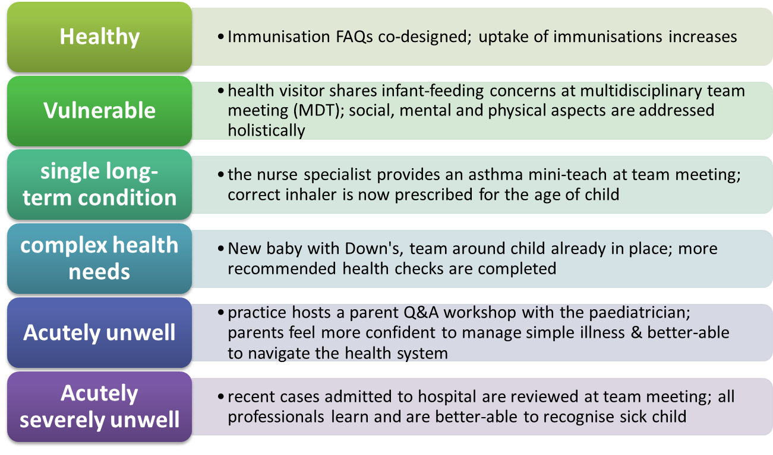
Appendix 3: System outcomes (DRAFT)

An evaluation partner will be appointed to measure the impact of Child Health Hubs on the system. The following table is indicative of likely parameters:

Outcome | Clinic or MDT | Method of measurement
Improvement in health system utilisation | MDT | - Reduction in number of referrals by PCN GPs to secondary outpatient care for patient cohort.  - Reduction in A&E attendances/non-elective admissions for patient cohort.  - Reduction in repeat GP appointments for patient cohort.  - Reduction in inappropriate referrals to CAMHS.  - Measured by tracking cases through the Child Health Hub and comparing against previous years’ baseline data.
Improved population health and identification and diagnosis of long-term conditions | MDT | - High risk/high deprivation cohorts proactively identified and addressed through MDTs.  - Proportion of patients identified via PHM case-finding methodology diagnosed with long term condition.  - Overall proportion of CYP in NWL with diagnosis of specified condition (e.g. asthma).
Positive patient experience | Clinic | - Patient Reported Experience Measures (PREM).  - Case studies.
Positive impacts reported by clinicians | Both | - Annual staff survey.  - Peer to peer feedback.
Improved relationships between primary / secondary care | Both | - Annual staff survey.

Service | Cardiovascular-Renal-Metabolic (CRM) Conditions

Executive Summary
This Local Enhanced Service specification has been developed in collaboration with clinical and programme leads from across North West London (NWL) Integrated Care Board (ICB), and with input from the London-wide Local Medical Committee (LMC), NWL clinicians, public health, the voluntary sector, and people with lived experience.
The specification describes a consistent and holistic approach to the delivery of care and support for people with Cardiovascular-Renal-Metabolic (CRM) conditions within general practices and Primary Care Networks (PCNs) and builds on previous NWL Local Enhanced Services within the NWL Single Offer as well as the Quality and Outcomes Framework (QOF).
The holistic approach to the conditions in scope for this specification will deliver a better patient experience, common outcomes, and better use of system resources, while ensuring greater consistency across NWL. The specification builds upon the excellent examples of NWL LTC care that already exist
The specification incorporates learning from the Harrow CRM model and the North Central London (NCL) LTC Locally Commissioned Service (LCS).
This specification covers the CRM specification: scope, Model of Care, finance, and resourcing, contracting, outcomes and delivery.
This service aims to improve outcomes through earlier detection, more consistent management, and personalised support, while reducing the burden on primary care and improving access in underserved communities.

Scope
Conditions in scope are Atrial Fibrillation (AF), Cardiovascular Disease (CVD - including Ischaemic Heart Disease [IHD], Stroke, TIA, Peripheral Vascular Disease [PVD], Heart Failure [HF]), Chronic Kidney Disease (CKD), Diabetes (Type 1, Type 2 and other types), Heart Failure (HF), Hypertension (HTN), Metabolic dysfunction-associated steatotic disease (MASLD), Non-Diabetic Hyperglycaemia (NDH).

Model of Care
The North West London CRM Model of Care is based around the Year of Care approach, widely implemented across the UK, which uses the House of Care as a framework.
Personalised care and support planning, holistic and proactive care are at the heart of the Model of Care. The Model of Care draws on existing evidence-based approaches that will enable practice staff to collaborate with patients to define and work towards their individual care goals and to plan and coordinate care, particularly for those higher risk patients with multimorbidity, living with complex health and care needs.
The Model of Care includes diagnosis as well as optimal treatment, supporting practices to close their prevalence gap through case finding. It includes risk segmentation of all those in scope, and a recommended frequency of contacts, to support effective primary care workforce planning over the year of care.

Call and Recall
Practices should consider the approach to call and recall that best suits their population and ways of working, including how they are working at scale across their PCN.
There is an expectation that PCNs will use a range of recall methods and influencing tactics that speak to their population as texting / NHS App reminders may not be enough or suitably motivating for some cohorts or communities. In-reach activities (e.g. using Community Health and Wellbeing Workers to engage under-served communities) may be deployed to support engagement.
Call and recall could be organised by birth month or by risk level, each with its own strengths. The table below outlines the case for each.

Month of birth | Risk stratification group
Pros:  - Simple, easy to implement and predictable: easy for clinicians and patients to remember when their follow-up is due. This can help to maintain consistency of care year by year.  - Even distribution of workload: recall workload evenly spread throughout the year, avoiding peaks/troughs. This can help workforce resource allocation and planning.  Cons:  - Lack of prioritisation: patients with higher risks may not be prioritised, potentially leading to delays in care for those who need more frequent monitoring.  - Missed opportunity for earlier intervention: as not based on clinical need, there may be missed opportunities for early intervention in patients whose condition have a higher likelihood to worsen before the next scheduled recall. | Pros:  Prioritisation of higher risk patients: patients who are at higher risk of complications need to be seen more frequently. By calling them earlier in the year their care may be more timely so potentially resulting in improved health outcomes.  Personalised and proactive care: focusing on patient risk means more proactive management earlier in the year, so maximising care in advance of winter when there are more seasonally related illnesses so potentially reducing hospital admissions.  Cons:  Complexity / Resource intensive: requires more complex searches and patient tracking, more frequent patient assessments and clinical input, could stretch practices where resource, both admin and clinical, is limited.  Potential for missed low-risk patients: patients who are considered low-risk might not be seen as frequently, so could lead to missed or delayed identification of worsening long- term conditions.

Practice / PCN Organisation
Nominate a CRM Lead to oversee the process.
Ensure staff complete CRM competency framework (includes training in CRM conditions, influence of lifestyle factors on CRM outcomes and motivational interviewing). Training framework to follow, developed by the London Kidney Network.

Finance and Resourcing
PCNs will receive a single block monthly payment based on 80% of the contract value for the numbers of patients in scope and within each of the Risk Segments, paid to the lead practice or local GP federation. The payment takes into account both the medical and the social complexity of the patients (calculated through the Lifetime Risk calculation) and the amount of resource required to support the optimisation of their care (both medical optimisation and support for improving behavioural and social factors).

Contracting

Work has been carried out with all eight boroughs to ensure the NWL CRM Enhanced Service Specification does not create duplication with the core (e.g., Quality and Outcomes Framework, existing health checks).

PCN Outcomes
The outcomes framework for the CRM conditions in scope has been developed with input from clinical and programme leads from across NWL. The aim of the PCN outcomes scheme is to reduce variation in LTC outcomes across NWL.
A single target across NWL will be set for each outcome measure. However, individualised per PCN payment thresholds will be used, based on current achievement, where this data exists, in order to reduce inequalities.
Outcomes are listed in Appendices I-IX.

Documentation and Reporting
Practices should use the NWL CRM template to aid delivery of the Model of Care and to support documentation of personalised care and support as well as achievement of QOF– note that not all fields are mandatory.
Practices should ensure they are using the latest searches. If practices come across any incorrect coding within the risk stratification searches, please contact us via PRIMARY CARE IT EMAIL. Please do not correct this at practice level as the GP IT team will correct it for all practices.
The Primary Care BI Team CRM Dashboard should be used to track delivery of the MoC and outcome goals to all risk groups and support practices to focus on their goals for the year. Outcomes will be visible in the dashboard with progress on achievement and linked finance also visible. For any issues with the CRM Dashboard, please contract nhsnwl.oohsash@nhs.net
The GP Services Overview Dashboard should be used to track progress toward outcome goals. From 2025-26, all LTC LCS outcomes will be visible in the dashboard with the incentivised outcome highlighted and progress on achievement and linked finance also visible.
KPIs are listed in Appendix A and relevant reporting requirements should be met.

Scope

Conditions in Scope
Conditions in scope are Atrial Fibrillation (AF), Cardiovascular Disease (CVD - including Ischaemic Heart Disease [IHD], Stroke, TIA, Peripheral Vascular Disease [PVD], Heart Failure [HF]), Chronic Kidney Disease (CKD), Diabetes (Type 1, Type 2 and other types), Heart Failure (HF), Hypertension (HTN), Metabolic dysfunction-associated steatotic disease (MASLD), Non-Diabetic Hyperglycaemia (NDH).

Notwithstanding the list of conditions in scope, the Model of Care takes a holistic approach to care and aims to support practices to consider multiple long-term conditions and wider biopsychosocial needs.

Aims and Objectives
For NWL patients with LTCs in scope of this service, the aim is to:
- Replace the existing NWL Single Offer services (Atrial Fibrillation, CKD, Hypertension, Level 1 Diabetes, Non-Diabetic Hyperglycaemia) for the LTCs that are in scope for this NWL specification.
- Support the delivery of a holistic approach to long term conditions management including the delivery of related QOF activity.
- Offer a service that focusses on detection, and management of prevention, CRM conditions in scope.
- Proactively identify patients at risk of developing a CRM LTC and help close the prevalence gap for those with an undiagnosed CRM condition (see 3.1.1).
- Systematically deliver personalised care and support planning for CRM patients in scope over a year of care, ensuring patients and staff are prepared for shared decision-making and goal-setting conversations.
- Support patients at risk of, or living with, CRM LTCs to self-manage their condition(s), enabling them to achieve their personalised health and lifestyle goals.
- Encourage a proactive multidisciplinary team (MDT) approach to the care of people with the greatest need and maximise the MDT impact.
- Reduce unplanned hospital admissions and progression to end-organ damage.
- Ensure equitable access and outcomes, particularly for deprived or under-served populations.
- Ensure that people living with type 1 diabetes have access to specialist support and technology to optimise their self-management.

Model of Care

Model of Care
The recommended model of care is shown below.
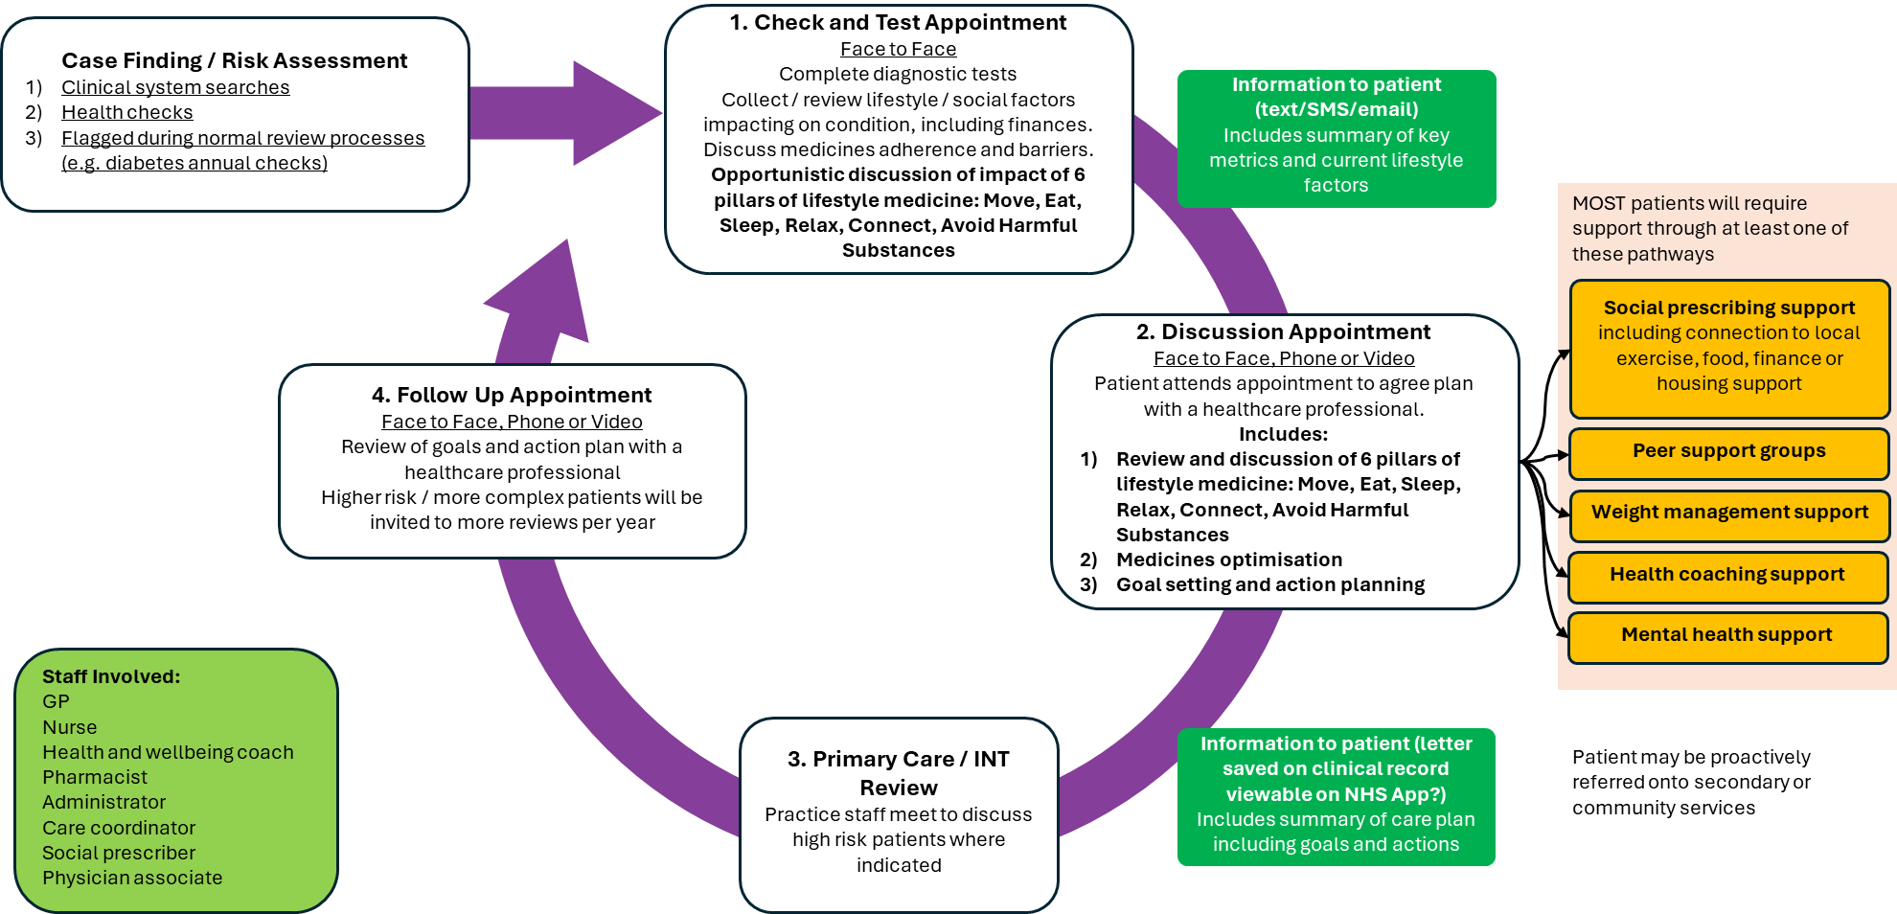
This can also be shown more linearly as below:
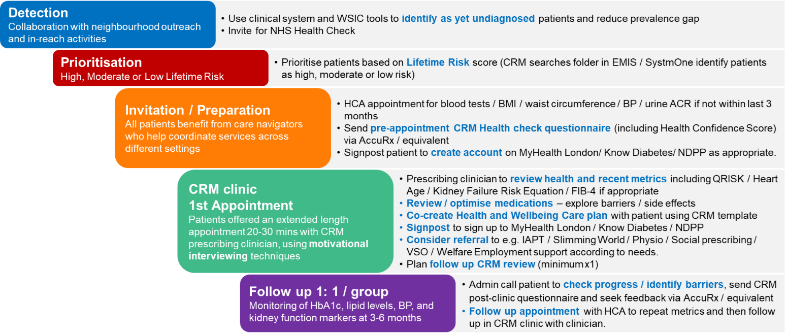

Patient Identification – Not Yet Diagnosed / At Risk of Developing a CRM Condition
- Objective: Identifying people at risk using routine data and community outreach.
- Approach: Leverage GP data, NHS Health Checks, and WSIC (for hypertension and diabetes risk calculators). Collaborate where possible with community organisations and local councils to target underserved populations through community outreach and in-reach activities.
- Focus on high-risk groups: As yet unidentified people, including deprived populations and ethnic minorities.
- Collaboration: Requires collaboration between PCNs, ARRS teams, VCSEs, community groups. Neighbourhood health model.
Ensuring that patients at risk of developing a CRM are identified maximises the changes that they can be provided with a review of their risk factors and supported to reduce the risk of developing a LTC later on. In addition, patients diagnosed with a LTC will be added to the appropriate disease register, helping to reduce the prevalence gap and provide access to the full Model of Care.
The case finding list includes:
- Opportunistic AF case finding in those with CRM conditions.
- People with potential Chronic Kidney Disease (CKD) but not currently coded (low eGFR or raised urine ACR).
- People with possible Diabetes but not coded (raised HbA1c).
- People with raised BP (>140/90 or >135/85 on home monitoring) but no code of hypertension or more recent normal BP.
- People with possible NDH but not coded.
EMIS and SystmOne searches will help support the identification of these patients.
There are additional tools available / becoming developed in WSIC, which will help identify additional patients with risk factors for developing CRM conditions.

Risk Segmentation
- Objective: Identify individuals at risk of disease progression early based on lifetime risk using an approximation to QRISK3-Lifetime. This will focus on people who are more frequently of working age, from areas of higher deprivation, underserved or disengaged from routine care, who have the largest number of life years to be saved from CRM complications.
- Approach: Use approximation to QRISK3-Lifetime within SystmOne and EMIS clinical system searches (provided by NWL BI team) to identify three groups of patients – Group 1 (Highest Lifetime Risk), Group 2 (Moderate Lifetime Risk) and Group 3 (Lower Lifetime Risk). Those in Group 1 and Group 2 groups will attract more resources than those in Group 3, allowing prioritisation of focus.
- Collaboration: Requires collaboration between PCNs, ARRS teams, VCSEs, community groups. Neighbourhood health model.
- Impact: Supports earlier intervention, reduces health inequalities, and prevents disease progression.

The risk segmentation is based on Lifetime Risk, approximating QRISK3-Lifetime https://qrisk.org/lifetime/. These have been built using searches within the GP Clinical Systems (EMIS and SystmOne) in order to reduce primary care workload and ensure that the necessary segmentation tool is as closely integrated with GP workflow as possible.
QRISK3-Lifetime estimates lifetime risk of a cardiovascular event calculated from a number of factors including age, gender, ethnicity, deprivation, presence/absence of various long-term conditions, SMI, smoking status, cholesterol, blood pressure and BMI.
This will focus resource on people who are more frequently of working age, from areas of higher deprivation, underserved or disengaged from routine care, who have the largest number of life years to be saved from CRM complications.
Depending on the risk segmentation score, patients will be classified in SystmOne and EMIS as Group 1, Group 2 or Group 3. Depending on the risk category, patients will need more or less intensive input (type of clinician, length of appointment, number of follow-ups). Tariffs are adjusted appropriately for the amount and type of work required and the members of the primary care team required to undertake it.
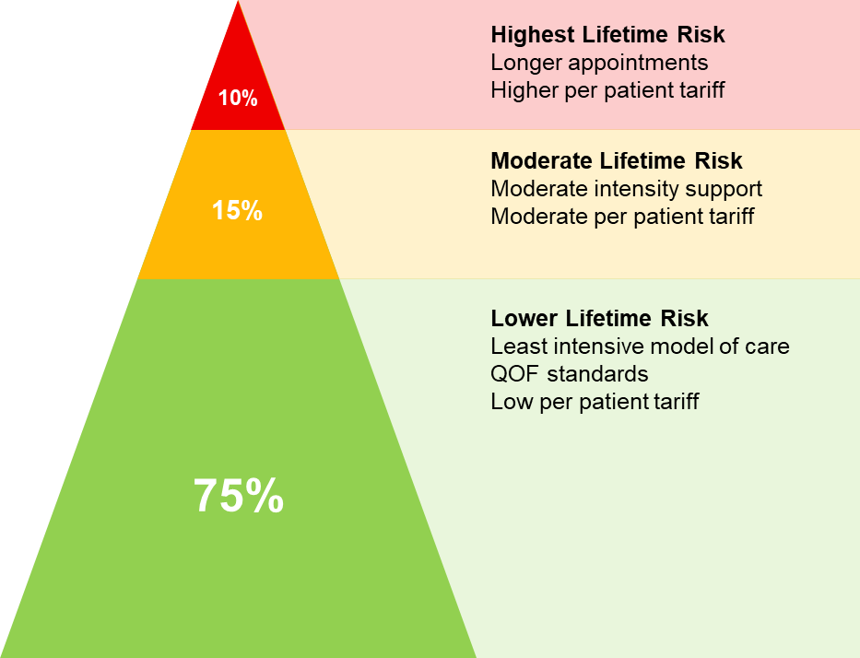

Whichever risk cohort patients fall into based on the latest data at the beginning of April (or on first entry into the CRM register) will be the cohort that they align to for the rest of the Year of Care. Each year they will be re-stratified based on the latest data at the beginning of April.
Any patients added to the CRM register during the year will be added to the register denominator for payment purposes.

Check and Test Appointment
- Purpose: To deliver a coordinated, one-stop assessment for cardio-renal-metabolic risk – reducing the need for patients to attend multiple appointments.
- Approach: Comprehensive risk assessment including social, lifestyle and medical factors to guide personalised prevention and health and wellbeing planning.
- Integrated Pathway: Service assesses all three condition clusters in a single encounter, reducing duplication and improving patient experience.
- Community-Based Access: Where possible, also delivered in trusted, local venues to improve reach, especially among underserved populations (some of this may need to wait until the full Neighbourhood model is rolled out).
- Outcome: A streamlined, patient-centred assessment model enabling earlier diagnosis and efficient integrated care.

All patients identified with a LTC in scope for the CRM specification, regardless of risk severity, will be invited to a Check and Test Appointment.
GP surgeries should send out the electronic Health Check questionnaire to patients in advance of their appointment, as this will help capture relevant data and free up more time in the appointment for clinical discussion.
This includes:
- Social and lifestyle factors (including six pillars of lifestyle medicine – eat, move, sleep, relax, connect, avoid harmful substances)
- Mental health screening questions
- An opportunity to self-assess their QRISK3 Heart Age based on their demographics and most recent results
- A patient-reported outcome measure called the Health Confidence Score (see Appendix XI), which assesses 4 dimensions – health knowledge, self-care, access to help and shared decision-making – will be used to evaluate an individual’s confidence in their capability, opportunity and motivation to participate in and look after his or her own health. Conducted prior to the Check and Test appointment and after a Follow-Up appointment, this simple questionnaire will measure changes in health confidence, activation and health literacy in order to understand the impact of interventions and capture changes in the patient’s ability to take an active role in their own care. It is shorter (4 questions) and has a lower reading age than other widely used instruments e.g. Patient Activation Measure (PAM).
At the Check and Test appointment, relevant baseline data will be collected:
- Cardiovascular (Blood Pressure and Pulse Rate and Rhythm, Lipids, Heart Age)
- Renal (eGFR and uACR)
- Metabolic (HbA1c)
- Liver function (LFTs plus FBC/AST for FIB-4 calculation every 39 months where patient has T2DM, abnormal LFTs or where MASLD has already been identified on Ultrasound Reports)
- BMI (Height and weight)
- Waist circumference (including autocalculation of waist circumference to height ratio)
- Foot check
- Social and Lifestyle risk factors (where not already collected electronically)
- Mental health screening (where not already collected electronically)
- Health Confidence Score (where not already collected electronically)
Practices may wish to consider a ‘one stop shop’ approach to improve convenience for patients and consider how this relates to options for at scale delivery.
At the end of the assessment, the clinician will explain the personalised care and support planning process to the patient, advise the patient that they will receive their results and a Care Plan document, which they can complete in advance of their next appointment if they want. In addition, the clinician should check with the patient the way that the patient would like to receive future communications (by letter, text message, phone, or email).
Note that the Check and Test Appointment is provided under QOF.
If appropriate, referrals to system partners including voluntary and community services can be completed, as well as to any of the Personalised Care roles (e.g., Social Prescribing Link Worker, Care Coordinator or Health and Wellbeing Coach). The clinician should also confirm with the patient if an interpreter is required for future appointments and of the language required.

Activities After the Check and Test Appointment
For all patients: The results from the baseline assessment in the Check and Test Appointment will be collated and sent to the patient with their test results, an explanation of the test results, and a Care Plan template to optionally complete before the Discussion Appointment. These materials will be sent by the patient’s preferred means of communication (letter, text message or email) stated during the Check and Test Appointment. It is recommended the patient receives these materials 2-4 weeks after the Check and Test Appointment and practices text patients informing them their results are ready. In due course, patients will be able to check their results directly online through the NHS app in line with patient access to online data. Once a patient’s baseline assessment has been completed after the Check and Test Appointment, their baseline results are used to re-run the risk stratification search.

Discussion Appointment
Health and Wellbeing Care Planning
Purpose: To support patients in managing their cardio-renal-metabolic conditions through structured, co-produced Health and Wellbeing care plans.
Delivery Model: A 30-minute appointment with an appropriately trained clinician to allow collaborative discussion focused on what matters most to the patient, clinical goals, lifestyle and social factors which influence outcomes. Clinicians undertaking the care planning appointment should have received training in motivational interviewing, health coaching or personalised care and support planning within the last 3 years.
Holistic Assessment:
- Incorporates physical health, mental wellbeing, six pillars of lifestyle medicine (eat, move, sleep, relax, connect, avoid harmful substances) and wider social needs — including housing, employment, and access to food or activity.
- Development of personalised care plan including goals and actions.
Local Support Integration: Direct referral to Practice / PCN / neighbourhood-based services including:
  - Health and wellbeing coaches.
  - Social prescribing link workers.
  - Community and voluntary sector offers.
Continuity and Review: Care plans are recorded, shared with the patient (and others, where necessary, with consent), and reviewed regularly to support ongoing engagement and accountability.
Outcome: Improves self-management, personalises care delivery, and addresses the broader factors that influence health outcomes.
Medicines Optimisation
  - Hypertension Management: Stepwise treatment aligned with NICE guidance. Note that BP target of 130/80 has been set based on British and Irish Hypertension Society’s call to action https://www.nature.com/articles/s41371-025-01055-z (likely to be reflected in the new NICE guidelines when updated) as well as European and American Guidelines. The target for patients with moderate / severe frailty and those aged ≥ 80 is 150/90. Clinical judgement should be exercised when setting a BP target for an individual patient. Not all patients will tolerate a lower BP - allowance for this is made within the service specification payment thresholds. BP optimisation supported by service clinicians and pharmacists; Adherence support and lifestyle interventions.
  - Diabetes Management: Initiation or titration of oral agents (including offering SGLT2 inhibitors in line with NICE Type 2 DM guidance https://www.nice.org.uk/guidance/ng28 and https://www.nice.org.uk/guidance/ng28/resources/visual-summary-full-version-choosing-medicines-for-firstline-and-further-treatment-pdf-10956472093 ); Pathway access to GLP-1 inhibitors where appropriate, in line with draft NICE Type 2 DM guidelines; Referral for insulin initiation or weight management as needed. Clinical judgement should be exercised when prescribing SGLT2 inhibitors as these won’t be tolerated by all patients. Exceptions are made for patients with moderate / severe frailty and those aged ≥ 80, but there may be other groups who are unable to tolerate or refuse to take SGLT2 inhibitors. Allowance for this is made within the service specification payment thresholds.
  - CKD Management: Optimisation of RAAS blockade and SGLT2i; BP and Microalbuminuria / Proteinuria Control; Medication Review and Optimisation. Clinical judgement for prescribing of SGLT2 inhibitors should be exercised as above.
  - Multidisciplinary Input: Delivered by trained clinicians (GPs with extended roles, pharmacists, nurses) with clear escalation pathways to specialists.
Patient Engagement and Education
Purpose: To empower patients with knowledge and skills for effective self-management.
Key Components:
  - Education Sessions: Group or individual sessions on condition management, addressing social factors, lifestyle changes and medication adherence.
  - Digital Resources: Access to apps, websites, and online communities tailored to cardio-renal-metabolic health.
  - Ongoing Support: Regular follow-up, motivational coaching, and peer support networks.

All patients will be invited back by the GP practice to have a Discussion appointment to address the patient’s concerns, set goals that will enable the patient to address their concerns and identify what support they may need to achieve their goals.
This appointment should be held two to four weeks after the Check and Test appointment. It can be held either in person, by phone or by video call (depending on the patient’s preference stated in the Check and Test appointment) and lasts up to 30 minutes. An interpreter should be booked for relevant patients (as agreed in the Check and Test appointment). Patients can also be accompanied by a family member, friend, or carer if they want support.
Practices should organise the delivery of the Discussion appointment by the clinical team to reflect what is most appropriate for the patient’s care and level of risk.
The personalised care and support planning conversation undertaken using health coaching/motivational interviewing skills will focus on what is important to the patient. The patient’s concerns and goals will be documented in the Health and Wellbeing Care Plan. Goals will be agreed with the patient to support them to achieve better outcomes. The patient may have chosen to start completing their Health and Wellbeing Care Plan after the Check and Test appointment or may have waited until the Discussion appointment. The Health and Wellbeing Care Plan document will be saved within the electronic health record and a copy provided to the patient. This copy should be in whichever format the patient requests. To help patients achieve their goals, the plan may include referral to additional roles in primary care, such as social prescribing link workers, voluntary and community services and/or local authority services. A timeframe for the follow-up appointment will be agreed and documented.
It is recognised that innovative approaches to support personalised care and support planning and goal setting have been trialled within general practice e.g., group consultations, and this specification supports new ways of working if they help to deliver improved outcomes.

Follow-Up Appointment
The patient’s concerns and agreed goals, as identified during the Discussion appointment, will be reviewed to identify if any further support is needed or to identify new concerns and goals. Patients will also be asked whether anything else important is happening in their life and what has been most important about the service received. This will be recorded in a document called a Follow-up Care Plan Form.
Adult patients in scope, across all risk levels, should be offered a single annual cycle of proactive, personalised care, including a Check and Test appointment, sharing of Results letter, Discussion appointment and at least one Follow-up appointment. Further follow-ups as required to achieve improved outcomes should be determined by the practice or PCN.
Wherever possible, for continuity of care the Follow-up appointment should be with the same clinician who delivered the Discussion appointment.
The Follow-up appointment can be held in person, by phone or by video call (depending on the patient’s preference stated in the Check and Test appointment) and lasts between 10-15 minutes, depending on patient risk level.
An interpreter should be booked for patients where confirmed needed in the Check and Test appointment. Patients can also be accompanied by a family member, friend, or carer if they want support. Practices/PCNs will need to develop processes to ensure robust call and recall is established to ensure patient’s care is systematically reviewed.
After the Follow-Up appointment, patients should be offered the Health Confidence Score questionnaire to complete. This can be completed via a digital or paper format outside of the consultation. Results of the questionnaire should be recorded via SystmOne or EMIS. If paper responses are received, the practice administration team can complete the questionnaire on the clinical system with the exact responses.

Patients with Hypertension Only, Stratified as Group 3 and with Controlled BP
For patients with hypertension only and who are risk stratified as Group 3 and whose BP is well controlled (≤130/80 or ≤150/90 in moderate/severe frailty), practices are not expected to deliver the whole Model of Care i.e. patients can receive only the Check and Test Appointment.

Digital Tools & Follow-up
Where possible, data should be captured (e.g. using AccuRx or equivalent codified questionnaires) prior to the care planning appointment to allow the focus to be on personalised care and support planning rather than the capturing of information. Patients will be asked to calculate their own heart age https://www.nhs.uk/health-assessment-tools/calculate-your-heart-age based on their clinical data. A link to this is provided on the CRM clinical template and can be sent to the patient prior to their appointment.
Following the care planning review, the patient should be provided with a digital or paper copy of the care planning document including agreed goals and actions.

Any acceptance and exclusion criteria and thresholds
Acceptance criteria:
- Patients 17 years of age and above.
- Option for patients under 17 years of age where clinically appropriate
- Registered at a practice in a NWL Primary Care Network.

Exclusion criteria:
- Patients on end-of-life pathway

Training, Skills and Experience
Because of the difference which Motivational Interviewing / Health Coaching approaches make to outcomes, practices should aim to ensure that 70% of clinical staff have undertaken Personalised Care and Support Planning / Motivational Interviewing / Health Coaching training within the last 3 years.
The service provider must ensure that the staff delivering the service meet appropriate training and competency standards. The London Kidney Network are developing a CRM competency framework with links to suitable training materials, which provides per topic education appropriate for various types of staff.

Equipment
It is the Providers responsibility to purchase all equipment and consumables
It is the Providers responsibility to clean, calibrate and arrange for servicing of the device in line with the manufacturer’s guidance
It is the Providers responsibility to ensure equipment is cleaned between uses
It is the Providers responsibility to monitor the life span of the device and to purchase a new device as required.
It is the Provider’s responsibility to replace any lost/ stolen equipment.

APPENDIX I - CONTRACTUAL REQUIREMENTS
CARDIOVASCULAR-RENAL-METABOLIC
Unit Price | A maximum total of £107.08 per patient classified as Group 1; £53.13 per patient classified as Group 2; £24.09 per patient classified as Group 3 subject to meeting Key Performance indicators as listed below.  The tariff will be split as follows:  - 20% when a PCN reaches full achievement for identifying and coding patients who likely have AF, CKD, DM, Hypertension or NDH (Appendix II)  - 20% when a PCN reaches full achievement for the care processes in patients on the CRM register (Appendix III)  - 5% when a PCN reaches full achievement for achievement of the BP target in patients on the CKD, DM or HTN registers (Appendix IV)  - 5% when a PCN reaches full achievement for statin prescribing (Appendix V)  - 5% when a PCN reaches full achievement for ACEI/ARB prescribing in patients on the CKD register (Appendix VI)  - 5% when a PCN reaches full achievement for SGLT-2 prescribing in patients on the CKD and/or T2DM registers (Appendix VII)  - 30% when a PCN reaches full achievement for completion of health and wellbeing care plan in patients classified as Group 1 / Group 2 on the CRM register (Appendix VIII)  - 5% when a PCN reaches full achievement for improvement in at least one of:  - GPPAQ status from inactive/moderately active to a more active group OR increase in weekly aerobic activity from zero to more frequent  - reduction in BMI  - smoking status from any smoker status to non-smoker/ex-smoker status in patients in patients classified as Group 1 / Group 2 on the CRM register (Appendix IX)  - 5% when a PCN reaches full achievement for improvement in Health Confidence Score in patients in patients classified as Group 1 / Group 2 on the CRM register (Appendix X)  Per PCN Payment Thresholds  Targets will be set across NWL for each outcome measure.  For CRM02 and CRM07-09, the thresholds will be fixed and the same for each PCN, as these outcomes measures are new (or include new coding requirements) and so all PCNs will be working from the same base of zero.  For CRM01A-E and CRM03-CRM06, individualised per PCN payment thresholds will be used, based on current achievement, in order to reduce inequalities.  These individual PCN targets are provided in Appendix XII and are explained further below.  A “narrow the gap” approach requires each PCN to narrow the gap between their 25/26 year end achievement and the NWL target by 50%. Where a PCN is already exceeding the NWL target, no further improvement is needed.  An example explanation is given below:  PCN A:  - PCN A is currently achieving 32.5% for CRM03. The ideal target is set for 52.5% of patients to achieve a BP ≤ 130/80, so they are currently 20% below target  - At the end of the year:  - If they reach 41.5% (narrow the gap by 9/20 = 45%) they get half payment for that KPI (5% of the total contract value)  - If they reach 43.5% (narrow the gap by 11/20 = 55%) they get the full payment for that KPI (10% of the total contract value)  PCN B:  - PCN B is currently achieving 42.5% for CRM03. The ideal target is set at 52.5% of patients to achieve a BP ≤ 130/80, so they are currently 10% below target  - At the end of the year:  - If they reach 46.5% (narrow the gap by 4/10 = 40%) they get half of the payment for that KPI (10% of the total contract value)  - If they reach 48.5% (narrow the gap by 6/10 = 60%), they get the full payment for that KPI (20% of the contract value)  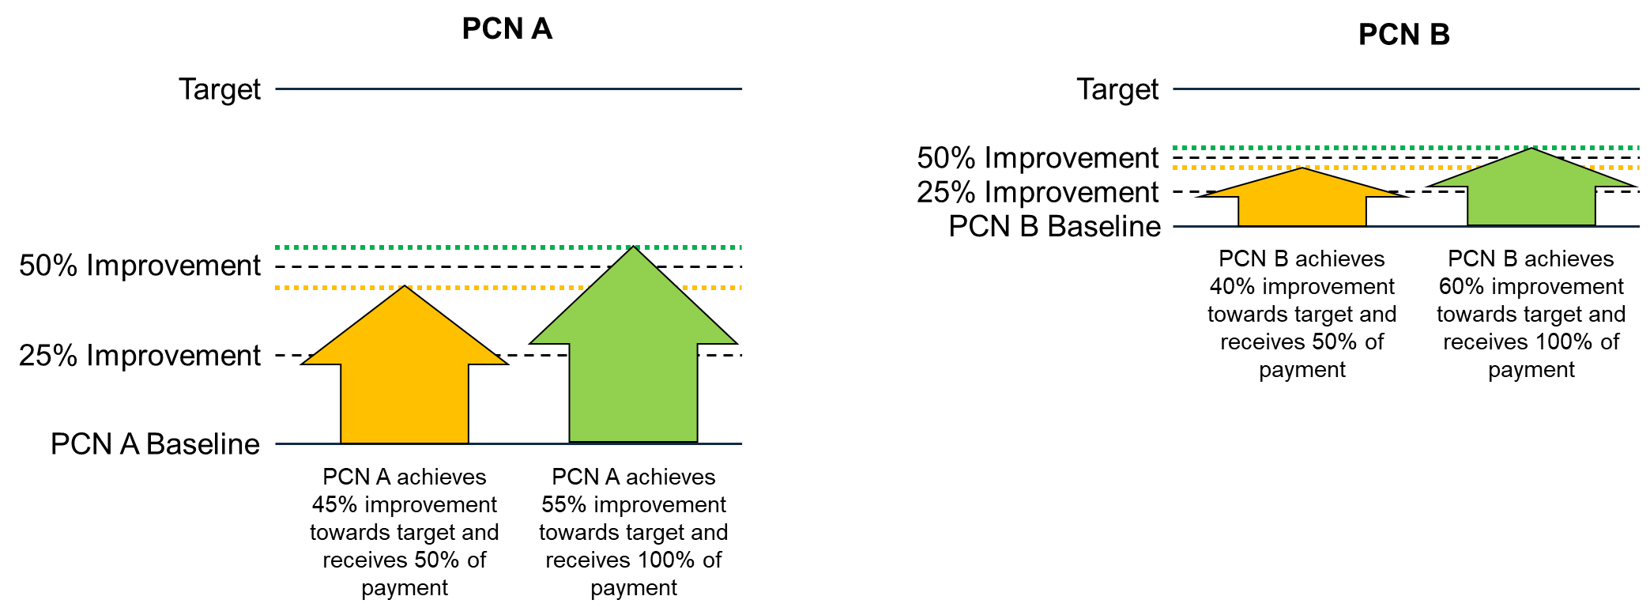  Achievements are banded as follows:  In view of the substantial changes from current specifications, this CRM specification will be reviewed by the ICB at quarterly intervals with input from the LMC. This will include both a review of the workload needed to deliver it and of the achievement thresholds.
  KPI | NWL Target Thresholds | Financial Achievement
  CRM01A: Identifying patients who likely have AF – screening (pulse rhythm or ECG). | 62.5% | 4%
  CRM01B: Identifying patients who likely have CKD - diagnose and code appropriately. | 86% | 4%
  CRM01C: Identifying patients who likely have DM - diagnose and code appropriately. | 80% | 4%
  CRM01D: Identifying patients who likely have HTN - diagnose and code appropriately. | 80% | 4%
  CRM01E: Identifying patients who likely have NDH - diagnose and code appropriately. | 80% | 4%
  CRM02: % Patients on PCN registers for AF, CKD, CVD (including CVA/TIA, CHD, PAD), HF, HTN, MASLD*, NDH with completion of key care processes (BMI, BP, HbA1c, Lipids, eGFR, uACR, smoking, waist circumference) in last 15 months and FIB-4 in MASLD in last 39 months  OR  % Patients on PCN register for diabetes with completion of key care processes as above plus foot check and mental health sc) in last 15 months and retinal screening in past 27 months and FIB-4 in T2DM in last 39 months | 50% | 20%
  CRM03: % people on PCN registers for CKD, DM, HTN with BP ≤ 130/80 (≤ 150/90 in moderate / severe frailty and those aged >80) | 52.5% | 5%
  CRM04: % on PCN register with A) CKD, CVD (including CVA/TIA, CHD, PAD), DM, HF OR B) AF, HTN, MASLD* , NDH and QRISK > 10%) on moderate/high intensity statins | 60% | 5%
  CRM05: % people on PCN CKD register with i) uACR ≥ 30 OR ii) diabetes and uACR ≥ 3 or eGFR < 60 on ACEI/ARB | 67% | 5%
  CRM06: % patients on PCN register with i) CKD and eGFR 20 to <45 OR ii) CKD and uACR ≥ 22.6 and eGFR 45-90 OR iii) T2DM on SGLT-2 OR iv) Heart Failure (excluding those with moderate/severe frailty or those aged >80) | 50% | 5%
  CRM07: % of Group 1 / Group 2 patients on PCN CRM register with codes for completion of holistic care plan (including six pillars of lifestyle medicine) | 50% | 30%
  CRM08: % of Group 1 / Group 2 patients on PCN CRM register with improvement in at least one of:  - exercise status from inactive/moderately inactive to a more active group  - BMI  - smoking status from any smoker status to non-smoker/ex-smoker status | 2.5% | 5%
  CRM09: % of Group 1 / Group 2 patients on PCN CRM register with pre- and post- care planning Health Confidence Score | 50% | 5%
Service Type | Package | No Pop-Up
Referral Criteria | Patients aged 17 years and above are Mandatory under this contract

CODING NECESSARY FOR INCLUSION IN REGISTER
Ref. | Description | SNOMED Code
CRM00A | Number of patients on the PCN CRM Register | AF QOF Register (AF001);  CHD QOF Register (CHD001);  CKD QOF Register (CKD005);  DM QOF Register (DM017);  NDH01: Age >= 17 AND NOT IN DM017 AND Has either 700449008 | Non-diabetic hyperglycaemia OR previous 11687002 | Gestational diabetes mellitus;  HF QOF Register (HF1);  HYP QOF Register (HYP001);  MDST01: 1197739005 | Fibrosis of liver due to metabolic dysfunction-associated steatotic liver OR 442685003 | Metabolic dysfunction-associated steatohepatitis OR <<1231824009 | Metabolic dysfunction-associated steatotic liver disease OR Non-alcoholic fatty liver (197315008)  PAD QOF Register (PAD001);  Stroke or TIA QOF Register (STIA001)

CODING USED FOR TRACKING CARE PLANNING
Ref. | Description | SNOMED Code
CRM00B | Coding used to track first and follow-up appointments | Personalised Care and Support Plan agreed (1187911000000105)  AND  Review of Personalised Care and Support Plan (1187921000000104)

APPENDIX II - DETECTION
Ref. | Description | SNOMED Code | Measurement |  | Target achievement | % of total payable for achieving target | Frequency of Monitoring
CRM01 | % Detection of uncoded PCN AF, CKD, diabetes and hypertension and NDH in the PCN | SNOMED codes in QOF cluster for: Atrial Fibrillation (AF001) | Numerator A: Number of patients on the PCN CRM register with no AF or PAF code AND pulse rhythm or ECG code | Denominator A: Number of patients on the PCN CRM register with no AF or PAF code | Individual per PCN (see Appendix XII) | 4% | Monthly – via the CRM Dashboard
CRM01 |  | Pulse rhythm:  Dropped beats - pulse (86890001)  Finding of pulse rhythm (301149000)  Heart irregularly irregular (248651005)  Heart regularly irregular (248652003)  Irregular heart beat (361137007)  O/E - irregular pulse (275954009)  O/E - no gallop rhythm (310597008)  O/E - pulse rhythm (268931003)  O/E - pulse rhythm regular (162999005)  O/E -pulse regularly irregular (163001005)  On examination - pulse irregularly irregular (163000006)  Pulse irregular (61086009)  Pulse irregularly irregular (271637005)  Pulse missed beats (248629002)  Pulse regular (271636001)  Pulse regularly irregular (271638000)  Pulse rhythm (364095004)  Regular intermission in pulse (248632004)  Sinus rhythm - pulse (248631006)
CRM01 |  | ECG:  Electrocardiogram, single lead (14431003)  Electrocardiographic monitoring (46825001)
CRM01 |  | CKD Diagnosis Codes:  CKD with GFR category G1 & albuminuria category A1 (949401000000103)  CKD with GFR category G1 & albuminuria category A2 (949421000000107)  CKD with GFR category G1 & albuminuria category A3 (949481000000108)  CKD with GFR category G2 & albuminuria category A1 (949521000000108)  CKD with GFR category G2 & albuminuria category A2 (949561000000100)  CKD with GFR category G2 & albuminuria category A3 (949621000000109)  CKD with GFR category G3a & albuminuria category A1 (949881000000106)  CKD with GFR category G3a & albuminuria category A2 (949901000000109)  CKD with GFR category G3a & albuminuria category A3 (949921000000100)  CKD with GFR category G3b & albuminuria category A1 (950061000000103)  CKD with GFR category G3b & albuminuria category A2 (950081000000107)  CKD with GFR category G3b & albuminuria category A3 (950101000000101)  CKD with GFR category G4 & albuminuria category A1 (950181000000106)  CKD with GFR category G4 & albuminuria category A2 (950211000000107)  CKD with GFR category G4 & albuminuria category A3 (950231000000104)  CKD with GFR category G5 & albuminuria category A1 (950251000000106)  CKD with GFR category G5 & albuminuria category A2 (950291000000103)  CKD with GFR category G5 & albuminuria category A3 (950311000000102 | Numerator B: Number of patients within the PCN with CKD code on the PCN CKD case finding report | Denominator B: Number of patients on the PCN CKD case finding report | Individual per PCN (see Appendix XII) | 4% | Monthly – via the CRM Dashboard
CRM01 |  | eGFR:  eGFR using CKD-Epi (Chronic Kidney Disease Epidemiology Collaboration) formula (857971000000104)  eGFR using creatinine Chronic Kidney Disease Epidemiology Collaboration equation per 1.73 square metres (1011481000000105)  eGFR using cystatin C Chronic Kidney Disease Epidemiology Collaboration equation per 1.73 square metres (1011491000000107)  GFR calculated by abbreviated Modification of Diet in Renal Disease Study Group calculation (1020291000000106)  GFR calculated by abbreviated Modification of Diet in Renal Disease Study Group calculation adjusted for African American origin (996231000000108)  GFR - glomerular filtration rate (80274001)
CRM01 |  | Urine ACR:  Urine albumin/creatinine ratio (1023491000000104)  Urine protein/creatinine ratio (1028731000000100)  Random Urine protein/creatinine ratio (1006631000000104)
CRM01 |  | SNOMED codes in QOF cluster for: Diabetes (DM017) | Numerator C: Number of patients within the PCN with DM code on the PCN DM case finding report | Denominator C: Number of patients on the PCN DM case finding report | Individual per PCN (see Appendix XII) | 4% | Monthly – via the CRM Dashboard
CRM01 |  | HbA1c:  HbA1c level - IFCC standardised (999791000000106)  HbA1c level (monitoring range) - IFCC standardised (1049321000000109)  HbA1c level (diagnostic range) - IFCC standardised (1049301000000100)
CRM01 |  | SNOMED codes in QOF cluster for: Hypertension (HYP001) | Numerator D: Number of patients within the PCN with Hypertension code on the PCN Hypertension case finding report | Denominator D: Number of patients on the PCN Hypertension case finding report | Individual per PCN (see Appendix XII) | 4% | Monthly – via the CRM Dashboard
CRM01 |  | Blood pressure (BP):  ONE OF:  O/E - Systolic BP reading (72313002)  Average night interval systolic blood pressure (314445006)  Average 24 hour systolic blood pressure (314449000)  Ambulatory systolic blood pressure (198081000000101)  Self reported systolic blood pressure (1162737008)  Lying systolic blood pressure (407556006)  Sitting systolic blood pressure (407554009)  Standing systolic blood pressure (400974009)  AND ONE OF:  O/E - Diastolic BP reading (1091811000000102)  Average night interval diastolic blood pressure (314460009)  Average 24 hour diastolic blood pressure (314462001)  Ambulatory diastolic blood pressure (198091000000104)  Self reported diastolic blood pressure (1162735000)  Lying diastolic blood pressure (407557002)  Sitting diastolic blood pressure (407555005)  Standing diastolic blood pressure (400975005)
CRM01 |  | Daytime average BP:  ONE OF:  Average systolic blood pressure (314440001)  Average day interval systolic blood pressure (314446007)  Average home systolic blood pressure (413606001)  AND ONE OF:  Average diastolic blood pressure (314453003)  Average day interval diastolic blood pressure (314461008)  Average home diastolic blood pressure (413605002)
CRM01 |  | Non-Diabetic Hyperglycaemia:  Non-diabetic hyperglycaemia (700449008)  Gestational diabetes mellitus (11687002) | Numerator E: Number of patients within the PCN with NDH code on the PCN NDH case finding report | Denominator D: Number of patients on the PCN NDH case finding report | Individual per PCN (see Appendix XII) | 4% | Monthly – via the CRM Dashboard
CRM01 |  | HbA1c:  HbA1c level - IFCC standardised (999791000000106)  HbA1c level (monitoring range) - IFCC standardised (1049321000000109)  HbA1c level (diagnostic range) - IFCC standardised (1049301000000100)

PAYMENT/KPI RULES:
To Achieve Payment for CRM01A:
- Patient must be Aged 55 or Over
AND
- On the PCN CRM Register before 1st Jan 2027
AND
- Has no previous diagnosis of Atrial Fibrillation (QOF AFIB) OR Paroxysmal Atrial Fibrillation (28285002) before the financial year
AND
- Has SNOMED code of ECG OR Pulse Rhythm code recorded in the financial year

To Achieve Payment for CRM01B:
- Patient must be Aged 17 and Over
AND
- First eGFR <60 event date before 1st Jan 2027 OR
- First urine ACR >3 (or urine protein/creatinine ratio >30) event date before 1st Jan 2027
AND
- Has NO QOF Cluster CKD (1-2) or QOF Cluster CKD (3-5) before the start of the financial year
AND
- Has NO Renal function tests within reference range (167179007) or Urine not examined (167219008) in the financial year
AND
- Patient has latest eGFR <60 recorded and a previous eGFR < 60 recorded between 3 months and 2 years before OR
- Has Urine ACR > 3 (or 30 if urine protein/creatinine ratio) recorded and a previous Urine ACR > 3 (or 30 if urine protein/creatinine
ratio) recorded between 1 week and 2 years before
AND
- Has CKD diagnosis recorded in financial year

To Achieve Payment for CRM01C:
- Patients aged 17 and over
- Has no previous diagnosis of Diabetes (QOF DM) before the financial year
AND
- First HbA1c >= 48 event date before 1st Jan 2027
AND
- Has HbA1c >= 48 AND has Diabetes diagnosis in the financial year

To Achieve Payment for CRM01D:
- Patients aged 17 and over
- Has no previous diagnosis of Hypertension (QOF HYP) before the financial year
AND
- First BP >= 140/90 event date before 1st Jan 2027 OR First daytime average BP >= 135/85 event date before 1st Jan 2027
AND
- Has BP >= 140/90 more than once AND has Hypertension diagnosis in the financial year OR
- Has BP <140/90 (or daytime average BP <135/85) recorded in the financial year after previous BP >= 140/90 OR
- Has daytime average BP >=135/85 AND has Hypertension diagnosis in the financial year

To Achieve Payment for CRM01E:
- Patients aged 17 and over
AND
- First HbA1c >= 42 and < 48 event date before 1st Jan 2027
AND
- Has HbA1c >= 42 and <= 47 AND has Non-diabetic hyperglycaemia (700449008) diagnosis in the financial year

APPENDIX III – COMPLETION OF KEY CARE PROCESSES
Ref. | Description | SNOMED Code |  | Measurement |  | Target  achievement | % of total payable for achieving target | Frequency of Monitoring
CRM02 | % of patients on PCN AF, CKD, CVD (including CVA/TIA, CHD, PAD), HF, HTN, MASLD*, NDH and NOT on DM registers receiving key care processes (HbA1c; BP; Cholesterol; serum creatinine/eGFR; urine albumin; BMI; waist circumference; smoking status in last 15m; foot check and mental health screening in last 15m in those with DM; retinal screening in last 27m in those with DM; FIB-4 in those with T2DM or MASLD in last 39m) | HbA1c | HbA1c level - IFCC standardised (999791000000106)  HbA1c level (monitoring range) - IFCC standardised (1049321000000109)  HbA1c level (diagnostic range) - IFCC standardised (1049301000000100) | Numerator A: Number of patients within the PCN CRM (except DM or MASLD) register receiving 8 key care processes within last 15m  Numerator B: Number of patients within the PCN MASLD register receiving all 8 key care processes within last 15m and FIB-4 within last 39m  Numerator C: Number of patients within the PCN Diabetes register receiving all 8 key care processes, mental health screening and foot check within last 15m, retinal screening within last 27m; FIB-4 within last 39m in those with T2DM | Denominator: Number of patients on the PCN CRM register | < 30%  30-50%  ≥ 50% | 0%  10%  20% | Monthly – via the CRM Dashboard
CRM02 |  | Blood Pressure | ONE OF:  O/E - Systolic BP reading (72313002)  Average systolic blood pressure (314440001)  Average night interval systolic blood pressure (314445006)  Average day interval systolic blood pressure (314446007)  Average 24 hour systolic blood pressure (314449000)  Average home systolic blood pressure (413606001)  Ambulatory systolic blood pressure (198081000000101)  Self reported systolic blood pressure (1162737008)  Lying systolic blood pressure (407556006)  Sitting systolic blood pressure (407554009)  Standing systolic blood pressure (400974009)  AND ONE OF:  O/E - Diastolic BP reading (1091811000000102)  Average diastolic blood pressure (314453003)  Average night interval diastolic blood pressure (314460009)  Average day interval diastolic blood pressure (314461008)  Average 24 hour diastolic blood pressure (314462001)  Average home diastolic blood pressure (413605002)  Ambulatory diastolic blood pressure (198091000000104)  Self reported diastolic blood pressure (1162735000)  Lying diastolic blood pressure (407557002)  Sitting diastolic blood pressure (407555005)  Standing diastolic blood pressure (400975005)
CRM02 |  | Lipids | Serum cholesterol level (1005671000000105)  Serum fasting total cholesterol (1083761000000106)  Serum total cholesterol level (994351000000103)  Total cholesterol measurement (121868005)  Fasting Cholesterol level (1083761000000106)  Cholesterol: HDL ratio  *Serum non high density lipoprotein cholesterol level (1006191000000106)  *Non high density lipoprotein cholesterol level (1030411000000101)  Serum cholesterol/high density lipoprotein ratio (1015681000000109)
CRM02 |  | Urine ACR | Urine albumin/creatinine ratio (1023491000000104)  Urine protein/creatinine ratio (1028731000000100)  Urine Microalbumin level (1010251000000109)  Urine Microalbumin Profile (994621000000103)  Urine protein/creatinine index (1030991000000102)  Random Urine protein/creatinine ratio (1006631000000104)
CRM02 |  | eGFR | *Glomerular filtration rate (80274001)  *GFR calculated abbreviated MDRD (1020291000000106)  *eGFR using creatinine (CKD-EPI) per 1.73 square metres (1011481000000105)  GFR (glomerular filtration rate) calculated by abbreviated Modification of Diet in Renal Disease Study Group calculation adjusted for African American origin (996231000000108)
CRM02 |  | BMI | Body Mass Index - observation (60621009)
CRM02 |  | Waist circumference | Waist circumference (276361009)  Waist circumference to body height ratio (1251557006)  Baseline waist circumference (846891000000106)
CRM02 |  | Smoking status | Smoking Status QOF cluster
CRM02 |  | Mental health screening | For patients on the diabetes register only:  One of:  - PHQ-4 (1104961000000104)  - PHQ AND GAD together -  - PHQ- 2 (1359723003) AND GAD-2 (836571000000106)  - PHQ- 2 (1359723003) AND GAD-7 (445455005)  - PHQ-9 (720433000) AND GAD-2 (836571000000106)  - PHQ-9 (720433000) AND GAD-7 (445455005)
CRM02 |  | Foot check (including testing for neuropathy and circulation) | For patients on the diabetes register only:  Any of:  O/E - Left diabetic foot at low risk (394675000)  O/E - Left diabetic foot at moderate risk (394681008)  O/E - Left diabetic foot at high risk (394676004)  O/E - left diabetic foot ulcerated (394674001)  O/E - Amputated left leg (308094003)  O/E - Amputated left above knee (308096001)  O/E - Amputated left below knee (308098000)  AND Any of:  O/E - Right diabetic foot at low risk (394671009)  O/E - Right diabetic foot at moderate risk (394682001)  O/E - Right diabetic foot at high risk (394672002)  O/E - Right diabetic foot - ulcerated (394673007)  O/E - Amputated right leg (308093009)  O/E - Amputated right above knee (308095002)  O/E - Amputated right below knee (308097005)
CRM02 |  | Record of Retinal Screening | For patients on the diabetes register only:  Digital retinal screening (390852004)  Retinal screening (390735007)  Seen by ophthalmologist (305721007)  Seen in ophthalmology clinic (185222001)  Diabetic retinopathy screening (134395001)  Slit lamp fundus examination (410455004)  O/E - no left diabetic retinopathy (390853009)  O/E - left eye background diabetic retinopathy (408410002)  O/E - left eye preproliferative diabetic retinopathy (408412005)  O/E - left eye proliferative diabetic retinopathy (408414006)  O/E - left eye stable treated proliferative diabetic retinopathy (414894003)  O/E - no right diabetic retinopathy (390850007)  O/E - right eye background diabetic retinopathy (408409007)  O/E - right eye preproliferative diabetic retinopathy (408411003)  O/E - right eye proliferative diabetic retinopathy (408413000)  O/E - right eye stable treated proliferative diabetic retinopathy (414910007)  O/E - left eye no maculopathy (414893009)  O/E - left eye diabetic maculopathy (408416008)  O/E - right eye no maculopathy (414909002)  O/E - right eye diabetic maculopathy (408415007)  Diabetic eye screening service (1874901000000100)
CRM02 |  | FIB-4 | For patients on the diabetes or MASLD registers only:  FIB-4 (719873005)

PAYMENT/KPI RULES:
To Achieve Payment for CRM02:
- Patient must be Aged 17 and Over
- AND EITHER:
- Has a SNOMED code of AF, CKD, CVD (including CVA/TIA, CHD, PAD), HF, HTN, MASLD*, NDH but NOT on DM without being resolved AND
- Has all of the Key care processes (CRM02A) recorded within the previous 15 months; 39 months for FIB-4 in MASLD
- OR:
- Has a SNOMED code of Diabetes QOF cluster without being resolved AND
- Has all of the Key care processes (CRM02B) recorded within the previous 15 months; 27 months for retinal screening; 39 months for FIB-4 in T2DM

APPENDIX IV – ACHIEVEMENT OF TARGET BLOOD PRESSURE
Ref. | Description | SNOMED Code | Measurement |  | Target achievement | % of total payable for achieving target | Frequency of Monitoring
CRM03 | % patients on PCN CKD, DM, HTN registers with latest BP ≤130/80 (≤150/90 in moderate/severe frailty or aged ≥ 80) | ONE OF:  O/E - Systolic BP reading (72313002)  Average systolic blood pressure (314440001)  Average night interval systolic blood pressure (314445006)  Average day interval systolic blood pressure (314446007)  Average 24 hour systolic blood pressure (314449000)  Average home systolic blood pressure (413606001)  Ambulatory systolic blood pressure (198081000000101)  Self reported systolic blood pressure (1162737008)  Lying systolic blood pressure (407556006)  Sitting systolic blood pressure (407554009)  Standing systolic blood pressure (400974009)  AND ONE OF:  O/E - Diastolic BP reading (1091811000000102)  Average diastolic blood pressure (314453003)  Average night interval diastolic blood pressure (314460009)  Average day interval diastolic blood pressure (314461008)  Average 24 hour diastolic blood pressure (314462001)  Average home diastolic blood pressure (413605002)  Ambulatory diastolic blood pressure (198091000000104)  Self reported diastolic blood pressure (1162735000)  Lying diastolic blood pressure (407557002)  Sitting diastolic blood pressure (407555005)  Standing diastolic blood pressure (400975005) | Numerator A:  Number of patients on the CKD, DM, HTN registers who have latest Blood Pressure ≤ 130/80 AND recorded within the previous 15 months and NO code for moderate or severe frailty AND aged < 80  Numerator B:  Number of patients on the CKD, DM, HTN registers who have latest Blood Pressure ≤ 150/90 AND recorded within the previous 15 months AND code for moderate or severe frailty or aged ≥ 80 | Denominator A:  Number of patients on the PCN CKD, DM, HTN registers with NO code for moderate or severe frailty AND aged < 80  Denominator B:  Number of patients on the PCN CKD, DM, HTN register WITH code for moderate or severe frailty or aged ≥ 80 | Individual per PCN (see Appendix XII) | 0%  2.5%  5% | Monthly – via the CRM Dashboard

PAYMENT/KPI RULES:
To Achieve Payment for CRM03:
- Patient must be between Age 17 AND
- Has a SNOMED code of CKD, DM, HTN cluster without being resolved
- AND EITHER:
- Has latest Blood Pressure ≤ 130/80 AND recorded within the previous 15 months AND NO code for moderate frailty (925831000000107) or severe frailty (925861000000102) AND aged < 80 OR
- Has latest Blood Pressure ≤ 150/90 AND recorded within the previous 15 months AND code for moderate frailty (925831000000107) or severe frailty (925861000000102) or aged ≥ 80

APPENDIX V – PRESCRIBING OF LIPID LOWERING THERAPY
Ref. | Description | SNOMED Code | Measurement |  | Target achievement | % of total payable for achieving target | Frequency of Monitoring
CRM04 | % on PCN register with  A) CKD, CVD (including CVA/TIA, CHD, PAD), DM, HF  OR  B) AF, HTN, MASLD*, NDH and QRISK > 10%)  prescribed moderate/high intensity statins | Moderate or High Intensity statin prescribed in last 6m:  - Atorvastatin 20mg, 40mg, 80mg  - Rosuvastatin 10mg, 20mg, 40mg  - Simvastatin 80mg | Numerator A:  Number of patients on the PCN CKD, CVD (including CVA/TIA, CHD, PAD), DM, HF registers with moderate or high dose statin prescription in last 6 months  Numerator B:  Number of patients on the PCN AF, HTN, MASLD*, NDH registers AND QRISK > 10% with moderate or high dose statin prescription in last 6 months | Denominator A:  Number of patients on the PCN CKD, CVD (including CVA/TIA, CHD, PAD), DM, HF registers  Denominator B:  Number of patients on the PCN AF, HTN, MASLD*, NDH registers AND latest QRISK > 10% | Individual per PCN (see Appendix XII) | 0%  2.5%  5% | Monthly – via the CRM Dashboard

PAYMENT/KPI RULES:
To Achieve Payment for CRM04:
- Patient must be Aged 17 and Over AND
- Has a SNOMED code of CKD, CVD (including CVA/TIA, CHD, PAD), DM, HF OR
- Has a SNOMED code of AF, HTN, MASLD*, NDH only and latest QRISK > 10%)
AND
- Has a moderate or high dose statin prescription in last 6 months

APPENDIX VI – PRESCRIBING OF ACEI / ARB MEDICATIONS
Ref. | Description | SNOMED Code | Measurement |  | Target achievement | % of total payable for achieving target | Frequency of Monitoring
CRM05 | % people on PCN register with  A) CKD AND uACR ≥ 30  OR  B) DM and uACR ≥ 3 or eGFR <60  who have been prescribed ACEI/ARB | ACE inhibitor or Angiotensin Receptor Blocker prescribed in last 6m | Numerator A:  Number of patients on the PCN CKD register with uACR ≥ 30 with ACE inhibitor or Angiotensin Receptor Blocker prescription in last 6m  Numerator B:  Number of patients on the PCN DM register with uACR ≥ 3 or eGFR <60 with ACE inhibitor or Angiotensin Receptor Blocker prescription in last 6m | Denominator A:  PCN register with CKD and uACR ≥ 30  Denominator B:  PCN register with diabetes and uACR ≥ 3 or eGFR < 60 | Individual per PCN (see Appendix XII) | 0%  2.5%  5% | Monthly – via the CRM Dashboard

PAYMENT/KPI RULES:
To Achieve Payment for CRM05:
- Patient must be Aged 17 and Over AND
- Has a SNOMED code of CKD without being resolved AND uACR (1023491000000104) ever ≥ 30 OR
Has a SNOMED code of diabetes cluster without being resolved and uACR (1023491000000104) ever ≥ 3 or eGFR ever < 60
- AND
- Has an Angiotensin Converting Enzyme Inhibitor or Angiotensin Receptor Blocker prescription in last 6 months

APPENDIX VII – PRESCRIBING OF SGLT2 INHIBITORS
Ref. | Description | SNOMED Code | Measurement |  | Target achievement | % of total payable for achieving target | Frequency of Monitoring
CRM06 | % patients on PCN register (excluding those with moderate/severe frailty or those aged >80) with  A) CKD and eGFR 20 to <45 OR  B) CKD and uACR ≥ 22.6 and eGFR 45-90 OR  C) T2DM  D) Heart Failure  on SGLT-2 | SGLT-2 inhibitor prescribed in last 6m | Numerator A:  Number of patients on the PCN CKD register AND eGFR 20 to <45 with SGLT-2 inhibitor prescription in last 6m (excluding those with moderate/severe frailty or those aged >80)  Numerator B:  Number of patients on the PCN CKD register AND uACR ≥ 22.6 AND eGFR 45-90 with SGLT-2 inhibitor prescription in last 6m (excluding those with moderate/severe frailty or those aged >80)  Numerator C:  Number of patients on the PCN T2DM register with SGLT-2 inhibitor prescription in last 6m (excluding those with moderate/severe frailty or those aged >80)  Numerator D:  Number of patients on the PCN HF register with SGLT-2 inhibitor prescription in last 6m (excluding those with moderate/severe frailty or those aged >80) | Denominator A:  PCN register with CKD AND eGFR 20 to <45 (excluding those with moderate/severe frailty or those aged >80)  Denominator B:  PCN register with CKD uACR ≥ 22.6 and eGFR 45-90 (excluding those with moderate/severe frailty or those aged >80)  Denominator C:  PCN register with T2DM (excluding those with moderate/severe frailty or those aged >80)  Denominator D:  PCN register with HF (excluding those with moderate/severe frailty or those aged >80) | Individual per PCN (see Appendix XII) | 0%  2.5%  5% | Monthly – via the CRM Dashboard

PAYMENT/KPI RULES:
To Achieve Payment for CRM06:
- Patient must be between Aged 17 and 79 AND
- Excludes those coded for for moderate frailty (925831000000107) or severe frailty (925861000000102) AND
- Has a SNOMED code of CKD without being resolved AND eGFR ever of 20 to <45 OR
- Has a SNOMED code of CKD without being resolved AND uACR ever ≥ 22.6 AND eGFR ever 45-90 OR
- Has a SNOMED code of diabetes cluster without being resolved AND latest Type 2 diabetes (<<44054006) without a more recent Type 1 diabetes (46635009) or diabetes resolved (315051004) AND
- Has an SGLT-2 inhibitor prescription in last 6 months

APPENDIX VIII – COMPLETION OF CARE PLAN
Ref. | Description | SNOMED Code |  | Measurement |  | Target achievement | % of total payable for achieving target | Frequency of Monitoring
CRM07 | % of Group 1 / Group 2 patients on PCN CRM register with codes for holistic care plan (including six pillars of lifestyle medicine) | Care Plan | Personalised Care and Support Plan agreed (1187911000000105) | Numerator:  Number of patients on the PCN CRM register and Group 1 / Group 2 classification and codes for holistic care plan (including six pillars of lifestyle medicine) | Denominator:  PCN CRM register with Group 1 / Group 2 classification | < 30%  30-50%  ≥ 50% | 0%  15%  30% | Monthly – via the CRM Dashboard
CRM07 |  | Eat | Diet poor (310502008)  Diet average (310503003)  Diet good (310500000)  Vegan diet (138045004)  Vegetarian diet (765021002)  Ovo-lacto-vegetarian (162538009)  High simple carbohydrate diet (226122007)  Carbohydrate restricted diet (66539004)  Low fat diet (16208003)  High fat diet (226097005)  Carbohydrate intake (788472008)  Fruit and vegetable intake (391129005)  Fruit juice intake (226389005)  Intake of fruit and vegetables at least 5 portions daily (301961000000107)  Intake of fruit and vegetables less than 5 portions daily (301991000000101)  Fat and oil intake (870372004)  Protein and/or protein derivative intake (874875003)  Water intake (226354008)  Milk intake (226404003)  Mineral intake (226352007)  Low salt diet education (183063000)  Low carbohydrate diet education (183065007)  Diet education (11816003)  Weight-reducing diet education (266724001)  Diet leaflet given (183101003)
CRM07 |  | Move | General practice physical activity questionnaire physical activity index: inactive (366121000000108)  General practice physical activity questionnaire physical activity index: moderately inactive (366171000000107)  General practice physical activity questionnaire physical activity index: moderately active (366211000000105)  General practice physical activity questionnaire physical activity index: active (366241000000106)  Aerobic exercise zero times a week (160636006)  Aerobic exercise once a week (160637002)  Aerobic exercise twice a week (160638007)  Aerobic exercise three or more times per week (160639004)
CRM07 |  | Sleep | Difficulty sleeping (301345002)  Poor sleep pattern (314938000)  Good sleep pattern (314939008)  Has regular bedtime (157851000146105)  Irregular sleep-wake pattern (271793004)  Good quality of sleep (11741000202105)  Middle insomnia (67233009)  Early morning waking (401236004)  Sleep apnoea (73430006)  Education about sleep hygiene behaviour (439035007)
CRM07 |  | Relax | Perceived Stress Scale score (720476003)  Feeling stressed (224974006)  High perceived stress (1193534004)  Low perceived stress (1359825002)  Absence of stress (13117000)  Stress at work (276074009)  Parenting stress (1236741000)  Counselling for stress (315600006)  Feeling calm (102894008)
CRM07 |  | Connect | Not socially isolated (817951000000100)  Social isolation (422650009)  Feeling lonely (267076002)  Feeling lonely occasionally (325611000000109)  Not feeling lonely (1230392000)  Lives alone (105529008)  Lives alone no help available (160726006)  Lives alone - help available (160725005)  Does voluntary work (224372004)
CRM07 |  | Avoid harmful substances | Alcohol:  Non - drinker (105542008)  Ex-drinker (82581004)  Current drinker (219006)  Alcohol units consumed per day (1082631000000102)  Alcohol units consumed per week (1082641000000106-)  Number of alcohol units consumed on heaviest drinking day (442547005)  AUDIT-C (Alcohol Use Disorders Identification Test - Consumption) score (763256006)  Alcohol intake within recommended sensible limits (160593006)  Alcohol intake above recommended sensible limits (160592001)  Harmful alcohol use (198431000000105)  Hazardous alcohol use (198421000000108)  Education about alcohol consumption (281078001)
CRM07 |  | Avoid harmful substances | Tobacco:  Never smoked tobacco (266919005)  Smoker (77176002)  Cigarette smoker (65568007)  Ex-smoker (8517006)  Waterpipe tobacco consumption (836001000000109)  Cigar smoker (59978006)  Electronic cigarette user (722499006)  Pipe smoker (82302008)  Occasional tobacco smoker (428041000124106)  Chain smoker (230065006)  Smoking cessation education (225323000)  Smoking cessation advice declined (527151000000107)
CRM07 |  | Avoid harmful substances | Drugs:  Misuse of prescription only drugs (191939002)  Injecting drug user (226034001)  Has never misused drugs (228368007)  Misused drugs in past (44870007)  Misuses drugs (361055000)  Self referral to substance misuse service (304301000000105)

PAYMENT/KPI RULES:
To Achieve Payment for CRM07:
- Patient must be Aged 17 and Over AND
- Has a SNOMED code of AF, CKD, CVD (including CVA/TIA, CHD, PAD), DM, HF, HTN, MASLD*, NDH without being resolved AND
- Has Group 1 / Group 2 classification AND
- Has one in each category of the Holistic Care Plan codes (CRM07) recorded within the previous 15 months

APPENDIX IX – IMPROVEMENT IN RISK FACTORS
Ref. | Description | SNOMED Code | Measurement |  | Target achievement | % of total payable for achieving target | Frequency of Monitoring
CRM08 | % of Group 1 / Group 2 patients on PCN CRM register with improvement in one of  A) GPPAQ Status from inactive/moderately inactive to a more active group  B) reduction in BMI  C) smoking status from any smoker status to non-smoker/ex-smoker status | General practice physical activity questionnaire physical activity index: inactive (366121000000108)  General practice physical activity questionnaire physical activity index: moderately inactive (366171000000107)  General practice physical activity questionnaire physical activity index: moderately active (366211000000105)  General practice physical activity questionnaire physical activity index: active (366241000000106)  Aerobic exercise zero times a week (160636006)  Aerobic exercise once a week (160637002)  Aerobic exercise twice a week (160638007)  Aerobic exercise three or more times per week (160639004) | Numerator A:  Number of patients on the PCN CRM register and Group 1 / Group 2 classification with latest GPPAQ code of moderately active or active OR Aerobic activity more than zero times a week  Numerator B:  Number of patients on the PCN CRM register and Group 1 / Group 2 classification with latest BMI less than first in-year BMI  Numerator C:  Number of patients on the PCN CRM register and Group 1 / Group 2 classification with latest smoking code of non-smoker or ex-smoker | Denominator A:  PCN CRM register with Group 1 / Group 2 classification with first in-year GPPAQ code of inactive / moderately inactive OR first in-year Aerobic exercise frequency of zero times a week  Denominator B:  PCN CRM register with Group 1 / Group 2 classification with BMI  Denominator C:  PCN CRM register with Group 1 / Group 2 classification with first in-year smoking code of current smoker | < 2%  2-2.5%  ≥ 2.5% | 0%  2.5%  5% | Monthly – via the CRM Dashboard
CRM08 |  | Body Mass Index - observation (60621009)
CRM08 |  | Smoker  PCD Ref ID: 999004211000230104  Ex-smoker  PCD Ref ID: 999005211000230103  Non-smoker  PCD Ref ID: 999006051000230100

PAYMENT/KPI RULES:
To Achieve Payment for CRM08:
- Patient must be Aged 17 and Over AND
- Has a SNOMED code of CKD, CVD (including CVA/TIA, CHD, PAD), HF, HTN, MASLD*, NDH without being resolved AND
- Has Group 1 / Group 2 classification AND
- Has all of Improvement in (CRM08) recorded within the previous 15 months

APPENDIX IX – COMPLETION OF HEALTH CONFIDENCE SCORE AND FOLLOW-UP
Ref. | Description | SNOMED Code | Measurement |  | Target achievement | % of total payable for achieving target | Frequency of Monitoring
CRM09 | % of Group 1 / Group 2 patients on PCN CRM register with completion of health confidence score and follow-up score | Health Confidence Score (1038101000000108) or Health Confidence summary score (1038201000000104), which is the sum of the following scores:  - Health Confidence score - I know enough about my health (1038141000000106)  - Health Confidence score - I am in control of my health (1038121000000104)  - Health Confidence score - I know how to get help if I need it (1038161000000107)  - Health Confidence score - I am involved in decisions about me (1038181000000103) | Numerator: Number of patients on the PCN CRM register and Group 1 / Group 2 classification with at least two codes for the Health Confidence Score at least one month apart | Denominator: Number of patients on the PCN CRM register and Group 1 / Group 2 classification | < 30%  30-50%  ≥ 50% | 0%  2.5%  5% | Monthly – via the CRM Dashboard

PAYMENT/KPI RULES:
To Achieve Payment for CRM09:
- Patient must be Aged 17 and Over AND
- Has a SNOMED code of CKD, CVD (including CVA/TIA, CHD, PAD), HF, HTN, MASLD*, NDH without being resolved AND
- Has Group 1 / Group 2 classification AND
- Has two records of Health Confidence Score codes (CRM09) recorded at least one month apart and within the previous 15 months

APPENDIX XI – Health Confidence Score
People who are more engaged in their own health tend to report better outcomes. Interventions that improve participants’ self-rated confidence in complying with prescriptions and maintaining lifestyle changes have been shown to be effective in diabetes, depression and heart disease.
A substantial proportion of the patient population (25%–50%) has low levels of health confidence, and this negatively impacts outcomes and experience, and increases use of emergency care. When health confidence is high, patients take more exercise, eat more healthily and avoid risks; people with diabetes report better blood sugar control. Health confidence is positively associated with patient’s knowledge (health literacy) and ability to access care they need.
The Health Confidence Score (HCS) is a simple, 4-question survey which measures 4 domains of patient confidence: health knowledge, capability to self-manage, access to help and shared decision-making.
The HCS design criteria were to be clear, short, with a low reading age, generic (applicable to people with any condition), suitable for frequent use, responsive and with good psychometric properties; also, to generate scores that are easy to understand and action, and comparable for benchmarking.
It is free, research-based and has associated SNOMED codes for use in clinical systems. https://bmjopenquality.bmj.com/content/8/2/e000411

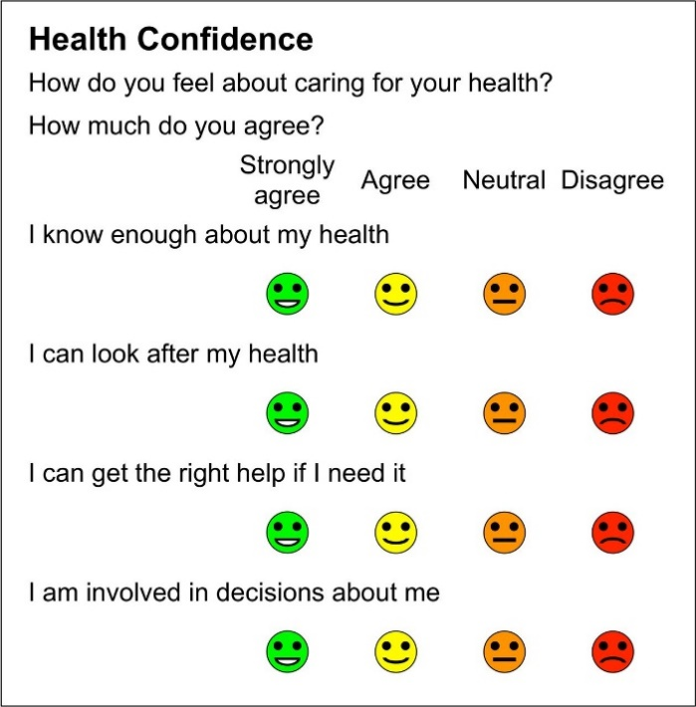

APPENDIX XII – Individualised PCN Targets
CRM01A: AF Coding

CRM01B: CKD Coding

CRM01C: Diabetes Coding

CRM01D: Hypertension Coding

CRM01E: NDH Coding
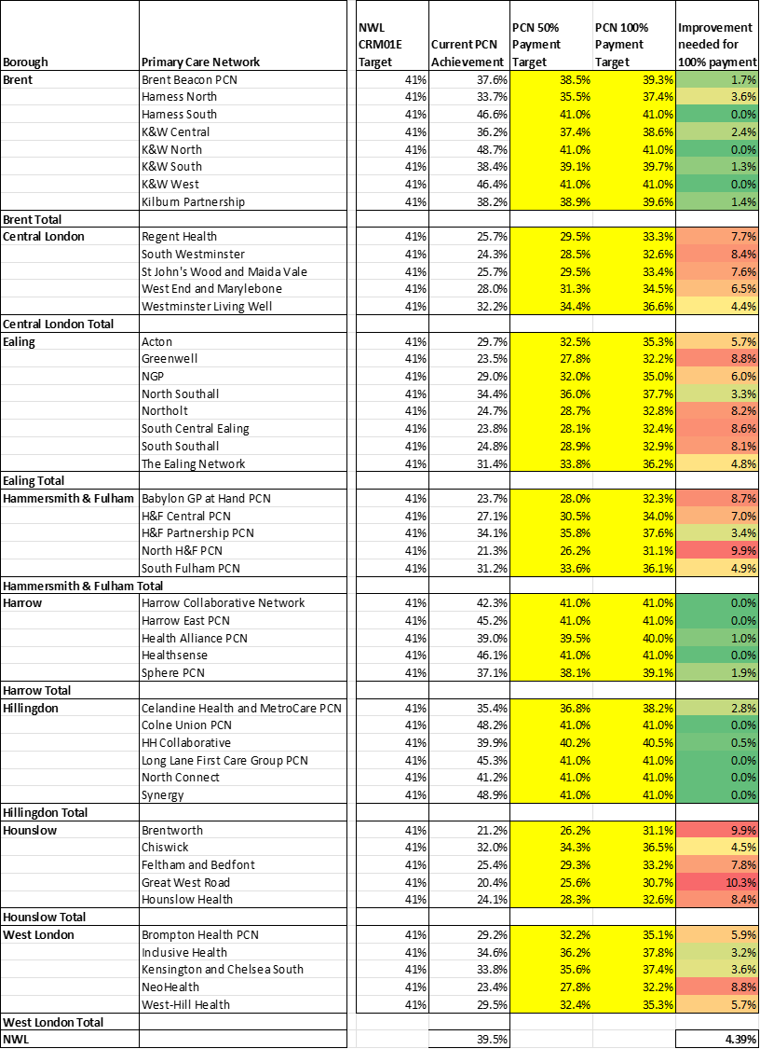

CRM03: BP ≤ 130/80 (≤ 150/90 in moderate / severe frailty or aged ≥ 80)

CRM04: Statin Prescribing
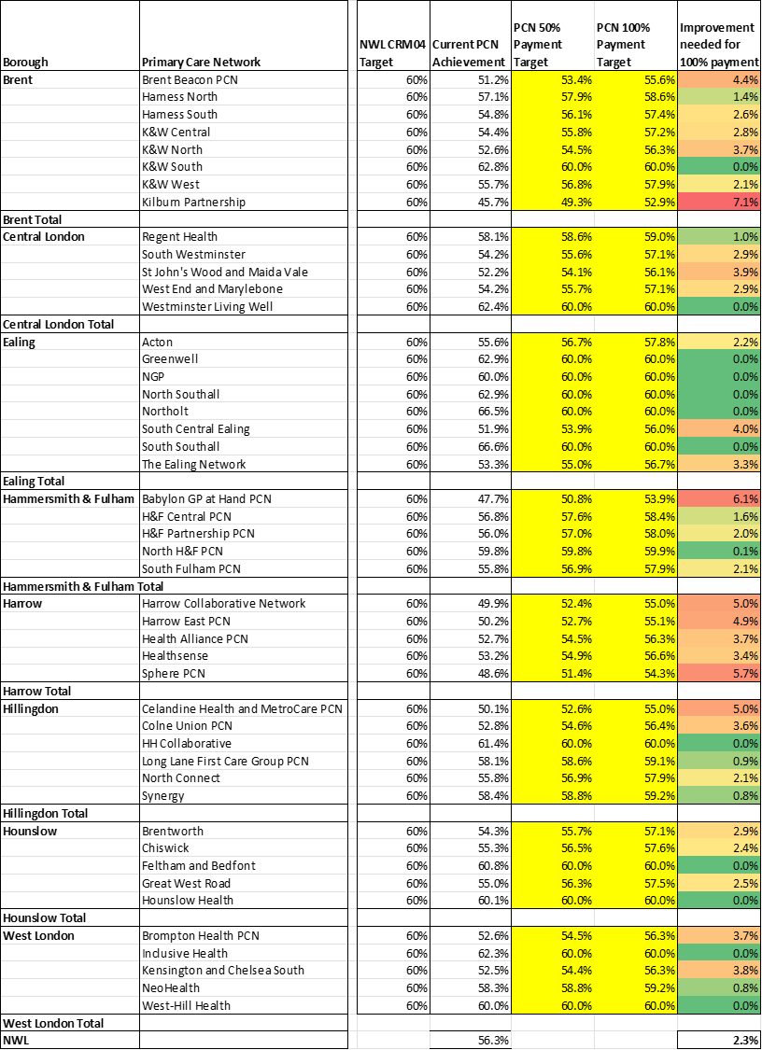

CRM05: ACEI/ARB prescribing

CRM06: SGLT2 Inhibitor Prescribing

APPENDIX XV: EVIDENCE BASE
Background:
Cardiovascular-Renal-Metabolic (CRM) conditions are a series of interwoven conditions including atrial fibrillation (AF), cardiovascular disease (CVD), chronic kidney disease (CKD), heart failure (HF), hyperlipidaemia, hypertension (HTN), metabolic dysfunction-associated steatotic liver disease (MASLD), non-diabetic hyperglycaemia (NDH) and type 2 diabetes (T2DM). These disorders are linked with central obesity, systemic inflammation and insulin resistance, with metabolically active fat as a key driver.

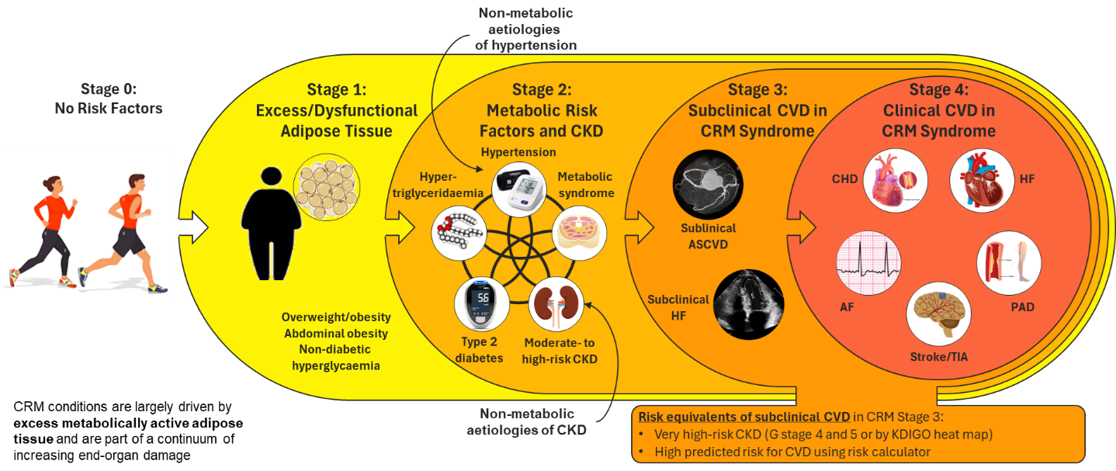

National Context:
In the UK, ischaemic heart disease (IHD) is the top cause of death for males and 2nd highest for females, whereas dementia (at least 15-30% of which is caused by vascular disease) is the top cause of death for females.
High blood pressure (hypertension) is described by NICE as ‘one of the most important treatable causes of premature morbidity and mortality in the world. It is a major risk factor for stroke, myocardial infarction, heart failure, chronic kidney disease, cognitive decline and premature death. Untreated hypertension is associated with a progressive rise in blood pressure.’
Hypertension continues to affect more than 1 in 4 adults in England and is the second largest single risk factor for premature death and disability in the country. A recent Public Health England (PHE) analysis suggests that there is now an opportunity to prevent more than 9,000 heart attacks and at least 14,000 strokes over the next 3 years if we work towards better detection and management of high blood pressure.
Diabetes remains a considerable health burden to the NHS, estimated to account for 6% of the UK health budget (around £14 billion). The majority of this is relating to excess costs of largely preventable complications, particularly heart disease, amputations and stroke, in addition to indirect costs from loss of productivity.
Metabolic-Associated Steatotic Liver Disease (MASLD, previously known as Non-Alcoholic Fatty Liver Disease) has a worldwide prevalence of approx 25% and is closely associated with T2DM, obesity and metabolic syndrome. Fatty liver infiltration can progress through stages of increasing fibrosis (scarring) to cirrhosis and is now the leading cause of liver failure in the UK. One recent study demonstrated that in people with T2DM those with MASLD and various stages of fibrosis / cirrhosis due to MASLD were 64% and 31% respectively. Screening for MASLD was calculated to be highly cost-effective (£2000-3000 per QALY).
Likewise, the leading causes of kidney failure in the UK are diabetes and hypertension, accounting for two-thirds of all cases of CKD.
Local Context:
For NWL ICB, the number of people with CRM conditions is rising steadily – for example, the number of people with diabetes (predominantly type 2) has risen from 160,079 to 184,847 in the last 4 years, while the number of people with non-diabetic hyperglycaemia (NDH) has risen from 175,322 to 235,379 over the same period. People with CRM conditions make up 20% of the population (approx 590,000 people affected) but 70% of hospital admissions.
Much of the focus to date with CRM conditions has been on the completion of care processes and optimisation of medication. There is very good evidence that early identification and optimisation of care has a very significant impact on the risk of progression and/or development of complications:
- Early optimisation of glucose levels in T2DM reduces risk of Cardiovascular Events by 62%
- SGLT-2 inhibitors provide substantial benefits in terms of CKD progression, cardiovascular events and mortality
- NWL data demonstrate ~66% fewer bed days in patients with CRM whose BP is on target and ~43% fewer bed days whose HbA1c is on target
However, a frequently quoted study estimated that good clinical care only contributes about 15-20% to outcomes. Social and economic factors, health behaviours and physical environment all play a very significant part.
Local data support this, demonstrating that social prescribing:
- Reduces GP appointments by 37%
- Reduces A/E admissions by 57%
- Reduces MED-3 issues by 53%
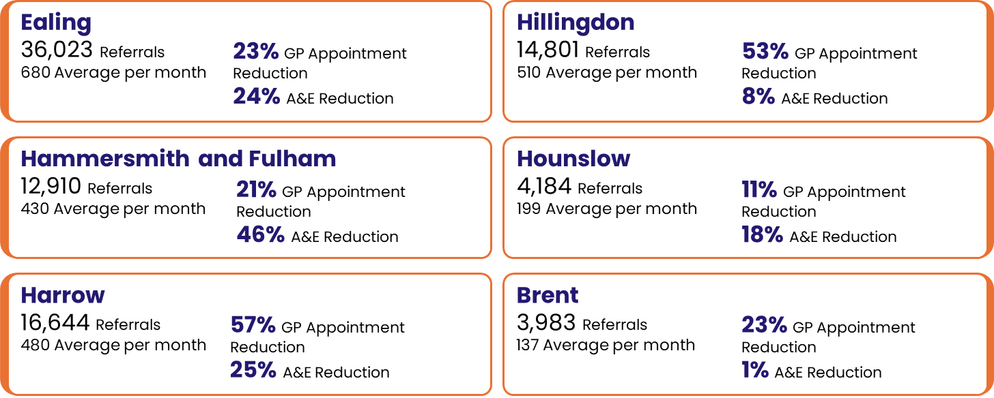

There is growing understanding of the value of collaborative care planning, lifestyle medicine and support for behavioural change. Therefore, a more holistic biopsychosocial approach involving motivational interviewing, personalised care and support planning, addressing the wider determinants of health (e.g. finances, employment and housing), behavioural change support and best clinical practice will result in a more significant impact on the development and progression of CRM conditions.

Health Equity:
CRM conditions are closely correlated with non-white ethnicity and deprivation. People with CRM conditions who live in deprived areas face a higher risk of adverse outcomes, including increased hospital admissions, progression to more severe disease states, and higher mortality rates. Specific domains of deprivation such as lower income, unemployment, and poor educational attainment are strongly associated with these poor outcomes.
Data demonstrate that 62% of the CRM population of NWL are living in the most deprived 50% of postcodes nationally (IMD1-5).

In England, there is a 19-year gap in healthy life expectancy between the most and least affluent areas of the country, with people in the most deprived neighbourhoods, certain ethnic minority and inclusion health groups getting multiple long-term health conditions 10 to 15 years earlier than the least deprived communities, spending more years in ill health and dying sooner.
Data from WSIC demonstrate similar patterns – earlier onset of multi-morbidity in more deprived groups and those from non-white ethnicities.
Potential mechanisms to explain the link between inequality and multiple conditions include:
- health-related behaviours such as diet, smoking or alcohol consumption.
- access to material resources such as finance and housing.
- psychological response to social inequality such as living in a sustained state of stress.
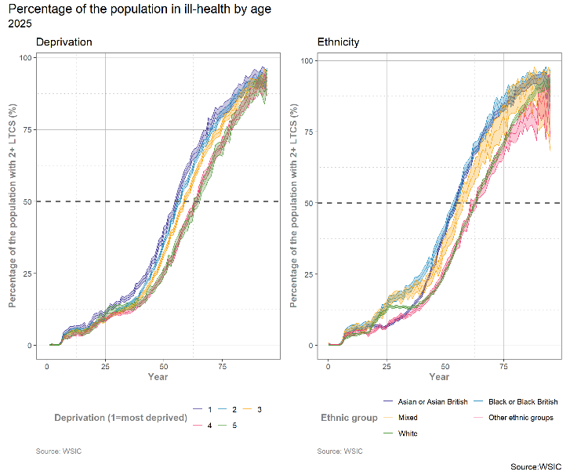
The NWL Shared Needs Assessment lists hypertension and diabetes as the LTCs with the highest prevalence. Hypertension, diabetes and obesity are among the top 5 with the greatest impact on hospital admissions. Taking recorded prevalence, unplanned bed days and inequality across deprivation groups into consideration, 4 of the top 5 LTCs which should be considered a priority are CRM conditions (hypertension, diabetes, obesity and heart failure).
LTC | Recorded prevalence (%) (WSIC) | Unplanned bed days (per 100K population) | Deprivation inequalities score | Worse than England
Diabetes | 8.6 | 135,900 | 0.21 | Yes
Hypertension | 16.0 | 125,800 | 0.11 | No
Obesity | 8.9 | 78,200 | 0.22 | No
COPD | 1.4 | 309,300 | 0.30 | No
Heart failure | 1.0 | 545,700 | 0.21 | No

Perversely, the level of funding provided to primary care to address need (calculated by the historical Carr-Hill formula) fails to rise proportionally as levels of deprivation rise:
- Average GP funding per patient ranges from approximately £130 per patient in the least deprived practice in NWL to £165 per patient in the most deprived.
- In contrast, the GP Need Index, the formula NHS England uses to estimate population healthcare need, rises more steeply (graph below). In the most deprived practices, the need is approximately double that in the practices serving the least deprived communities. A fair funding model would allocate ~£260 per patient to the practices serving the most deprived populations.
- This means that in our most deprived communities, need significantly outstrips funding, creating a widening gap.
- If we don’t explicitly invest based on deprivation and need, inequalities will persist or worsen, despite best efforts by frontline teams.
- Note that the Index of Multiple Deprivation data for 2025 has been released. The percentage of the NWL population living in a Core 20 area has increased from 12.7% to 17.4%. This creates an even greater imperative to tackle health inequalities.
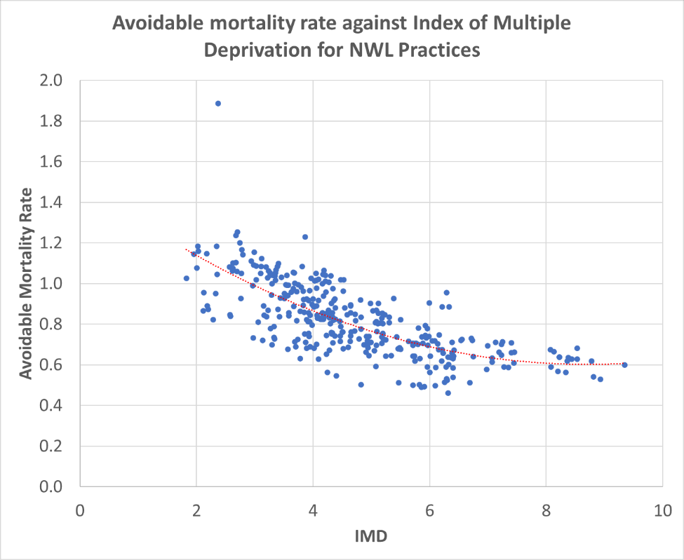

Aligning Resource to Need:
- Recent work on aligning resource to need demonstrates that the ratio of costs of crisis care versus neighbourhood / planned care is higher for the most deprived deciles than the least deprived. This CRM service specification seeks to address this by investing more in preventative care in order to reduce crisis care caused by CRM complications.
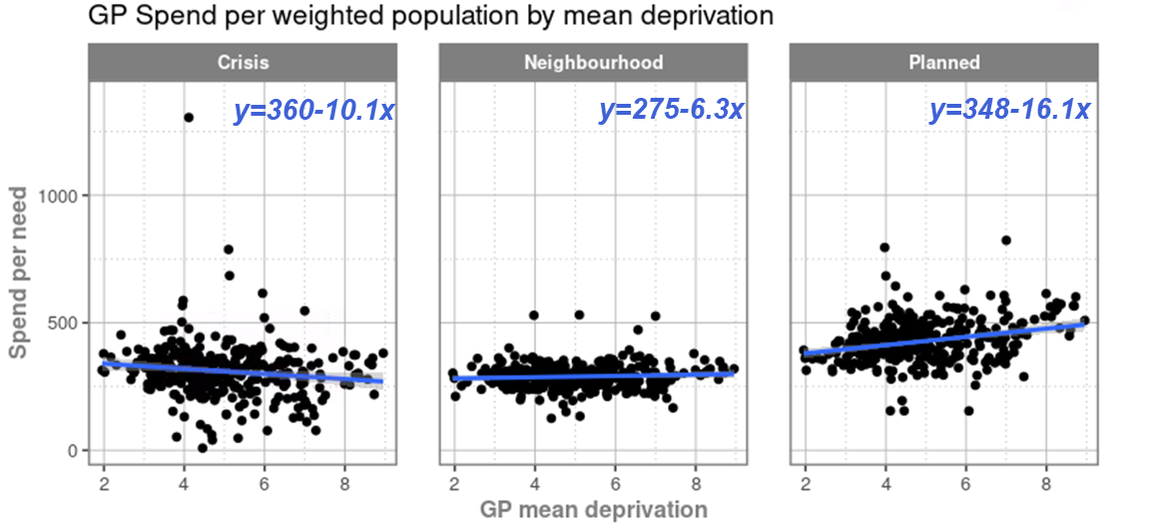

Importance of Physical Activity:
- Exercise has a major role to play in the development and progression of disease – in a study of over 120,000 people with a mean age of 53, people with a VO2max (a measure of cardiorespiratory fitness) in the bottom 25% had a 20% lower 10-year survival probability. Moving from low to above average fitness is equivalent to moving from End-Stage Renal Disease (ESRD) to normal health (65% relative mortality risk reduction).
- One in four people would become more active if advised by a healthcare professional to do so – this represents a clear opportunity to make every contact count.
- Government guidelines are clear about the beneficial effects of increasing moderate physical activity on a wide variety of conditions including various cancers, mental health conditions, MSK diagnoses as well as the risk of developing CRM conditions and adverse outcomes.
The benefits of supporting patients in becoming more physically active are very clear:
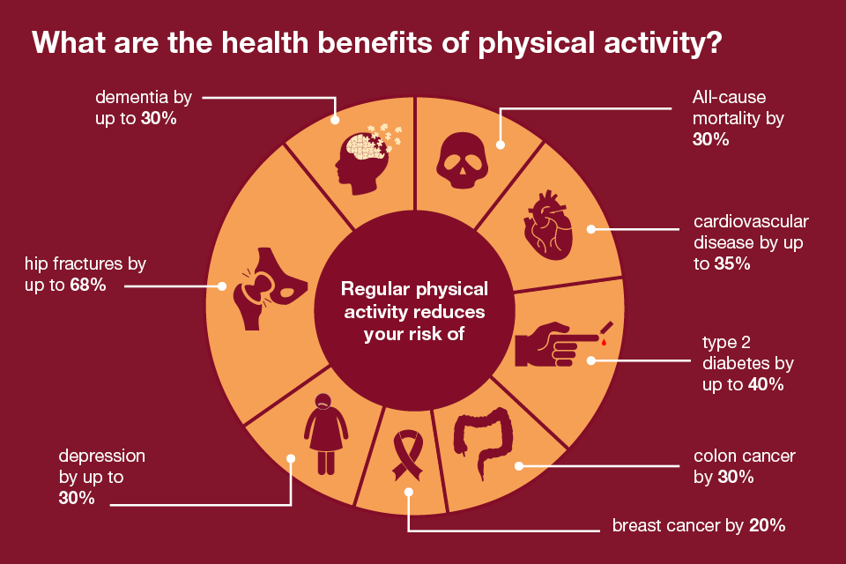

Importance of Healthy Weight:
- Tackling obesity positively provides substantial CRM benefits:
  - 0-5% weight loss can reverse hypertension and NDH.
  - 5-10% weight loss can prevent T2DM and reverse Metabolic-Associated Steatotic Liver Disease (MASLD, previously known as Non-Alcoholic Fatty Liver Disease) and dyslipidaemia.
  - 10-15% weight loss can reverse Non-Alcoholic Steato-Hepatitis (NASH) and prevent Cardiovascular Disease progression.
  - >15% weight loss can support remission from T2DM, reduce CVD mortality and reverse Heart Failure with preserved Ejection Fraction (HFpEF).
- Weight loss can also reduce proteinuria and support sustained improvements in eGFR (kidney function) for up to 5 years.
- People who adopt 5 or more weight loss strategies (especially “ate less food”, “exercised”, “lowered calories”, “drank a lot of water” and “ate less fat”) have a 45% lower risk of CVD mortality in one study of over 48,000 people.
- There are clear links between deprivation, food insecurity and obesity. A fifth of UK households (more in areas with higher deprivation) struggle to gain access to good quality food at reasonable prices, causing them to turn to unhealthy, high-calorie alternatives.
- Ultra-processed foods are closely linked with the development of obesity, hypertension, type 2 diabetes (T2DM), CVD, dementia and premature mortality (66% greater risk of heart disease mortality).
- There is good evidence that community Eatwell programmes (Recommendation 2.7 of the National Food Strategy, consisting of food prescriptions, a community shop/ food pantry and community kitchen) have a significant impact in people with LTCs (e.g. Off-target Type 2 Diabetes) who are living with food insecurity. For more info about the evidence base, see examples of Produce Prescriptions or Geisinger’s Fresh Food Farmacy: https://www.geisinger.org/freshfoodfarmacy/learn-more.
Importance of Smoking Cessation:
- Risk of heart attack halves within a year of stopping smoking.
- After 15 years, risk of heart disease is close to that of a non-smoker.

Building on the Success of the NWL Primary Care Enhanced Services:
Investment in the various CRM enhanced services to date has had clear, measurable clinical impact and positive patient outcomes:
- Diabetes: Over the last 10 years, since the introduction of the diabetes enhanced services in 5 of the boroughs, NWL has moved from the bottom quartile for achievement of treatment targets (blood pressure, blood glucose and cholesterol) to 1st position nationally. These metrics are key for reducing the risk of complications (e.g. heart attacks, strokes, kidney failure, vascular dementia), hospital admissions, disability and early death. Data from https://fingertips.phe.org.uk/profiles demonstrate significant improvements compared with the national average for various metrics (including CVD mortality) since the introduction of the original outcomes-based diabetes enhanced service in 5 of the boroughs in 2015, and subsequent expansion across all 8 boroughs (noting the dip in achievement during COVID).
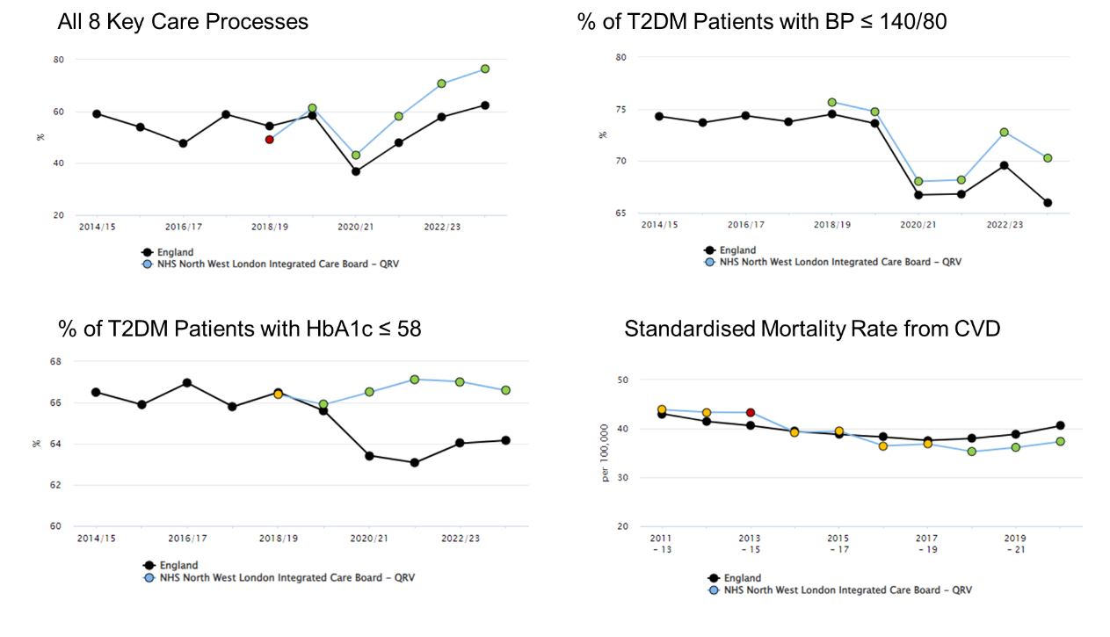
- Non-Diabetic Hyperglycaemia (NDH / prediabetes): As a result of the NDH enhanced service in NWL from 2015 onwards (including annual review and referral into the National Diabetes Prevention Programme), 2400 fewer patients in NWL with NDH progressed to a T2DM diagnosis, particularly those in younger age groups with most life years to gain.
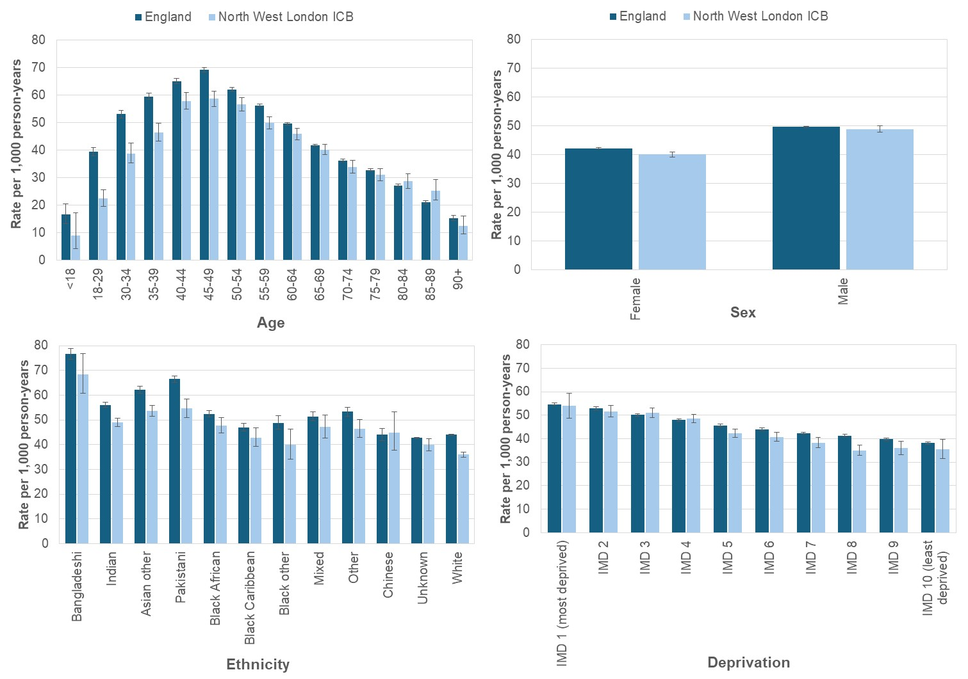 | 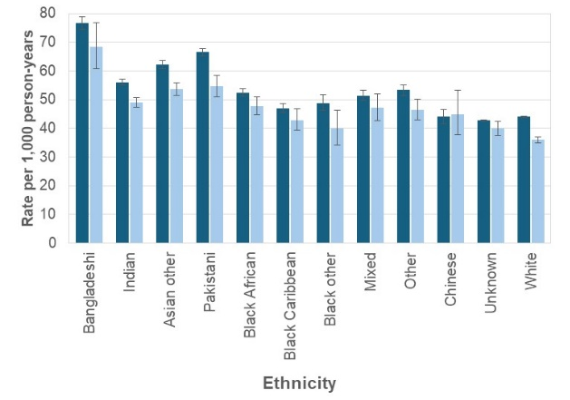

This is also demonstrated in the Public Health data showing a flattening off of diabetes prevalence compared to national data following the introduction of this service. NWL primary care data confirm this, with a reduction of 880 in annual new diabetes diagnoses from 2014/15 to 2024/25.
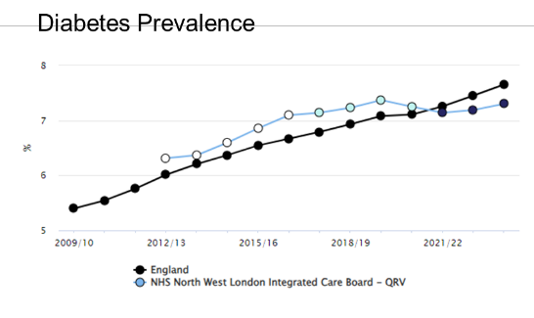
- Hypertension: As of 2025, NWL ranked top nationally in CVDPREVENT data for achievement of the target BP hypertension indicator. NWL has also shown a consistent increase since 2023, compared to London. This is likely to be due to a number of factors:
  - The diabetes enhanced service contract incentivised achievement of a target blood pressure of 140/80 since 2015 (NWL is in top position for achievement of 140/80 within the national diabetes audit).
  - Introduction of the hypertension enhanced service in 2023 including targets for measurement of BP and a specific KPI for achievement of target BP in black patients.
  - The input from the Clinical Effectiveness group and CVD champions – supporting clinical template improvements, clinical system searches and WSIC dashboards.
- Cholesterol: For the cholesterol indicator, NWL exceeded the England average, with an increasing trend since 2024.
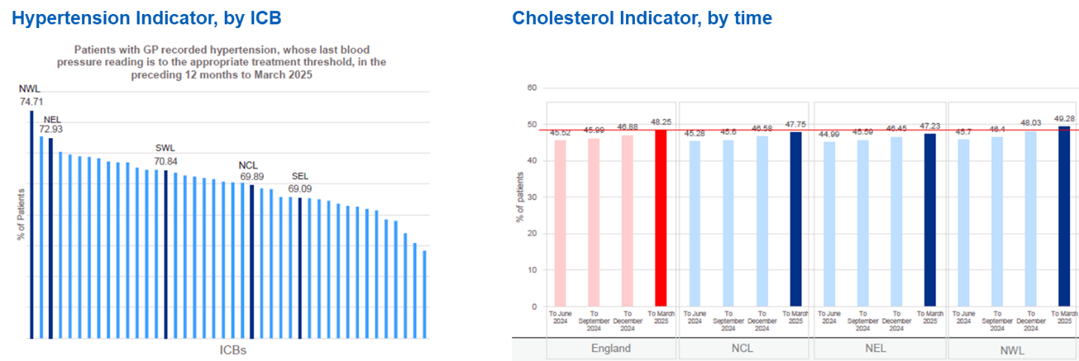

- Evidence from Published Research: The clinical and financial impact of these changes are significant. National and international studies demonstrate that optimisation of these factors will reduce CVD events, hospitalisation and mortality by 50%.
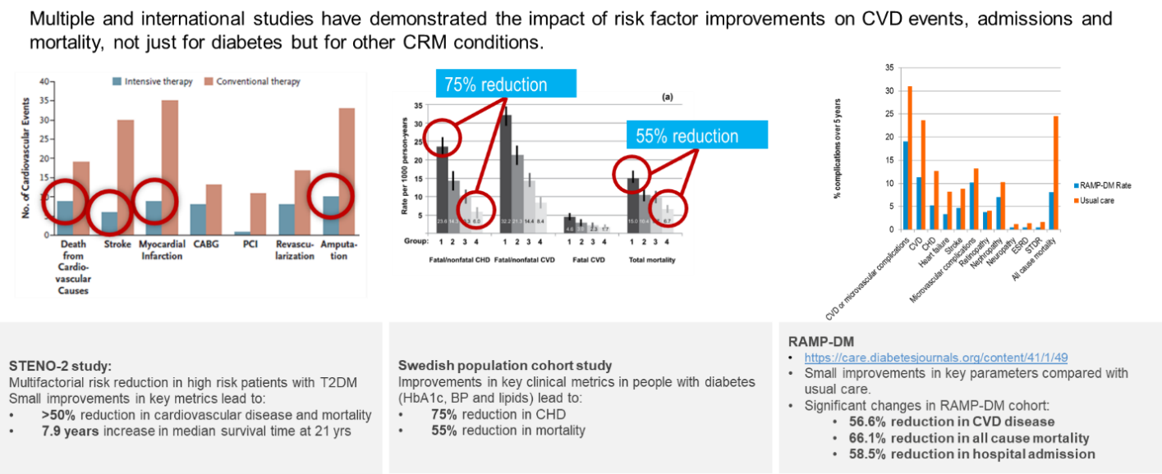

- Impact on NWL Bed Days: These findings are replicated locally, with data from WSIC demonstrating that for all patients with CRM conditions, mean non-elective bed days per patient are directly correlated with achievement of better blood pressure and blood glucose (HbA1c levels), independent of age, gender, ethnicity, deprivation or frailty status.
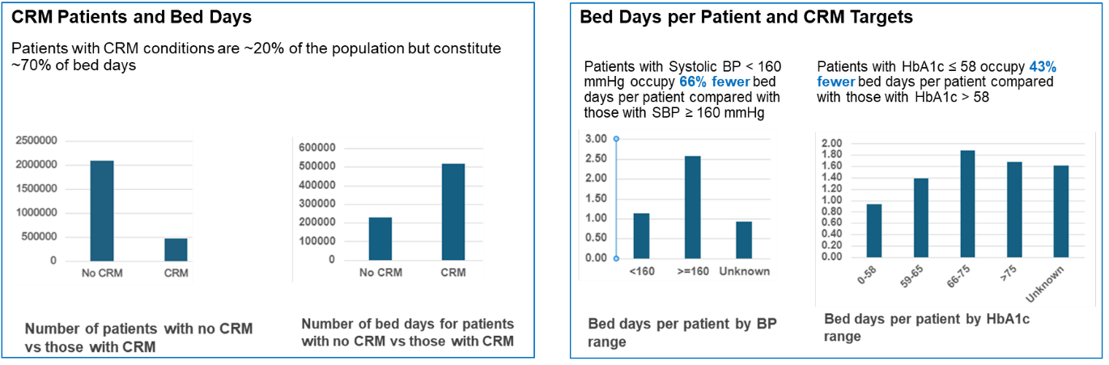

- Reduction in Non-Elective Diabetes Admissions: Data from WSIC also demonstrate a small reduction in non-elective admissions for people with diabetes complications (heart disease, strokes, renal failure, etc) since 2017/18. However, if we factor in the 28% growth in numbers of people diagnosed with diabetes since then (from 140,665 in 17/18 to 180,674 in 24/25), the data demonstrate a 23% reduction in numbers of non-elective admissions per patient.
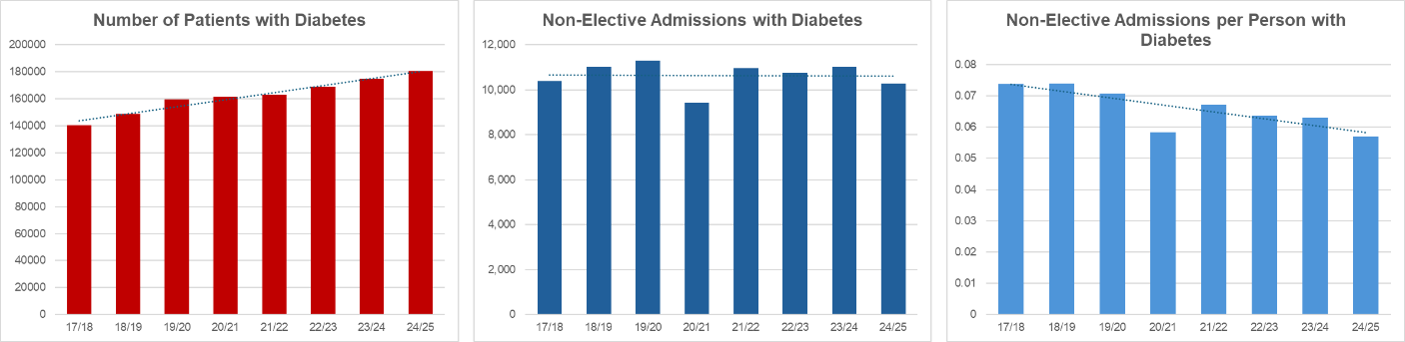
Note that these WSIC data underestimate any reduction in admissions due to the way that WSIC LTC registers are configured. WSIC LTC registers only include patients currently registered, so exclude those who have since deceased and transferred out. The result of this is that historical activity for patients now deceased or transferred out is not included, leading to an increasing underestimation of admissions activity the further back you look (and therefore an appearance of greater relative activity in more recent years). Register sizes used to show growth in numbers of people with LTCs and per person activity in these graphs are based on accurate historical primary care data, per person admissions graphs will still underestimate any reductions.
These data also do not include impact on out-patients or critical care activity (which is high for this group of patients).
- Impact of the NWL Diabetes Enhanced Service: The primary care enhanced service for diabetes started in 2014/15 in 5 NWL boroughs but was only implemented in 2021/22 Brent and Harrow. With that delayed start in population-level intervention (including screening and intervention for renal disease, which was removed from the national primary care Quality and Outcomes Framework), we might expect to see some differences in outcomes between NWL boroughs. Data from WSIC demonstrate a clear difference in outcomes for the two sets of boroughs: in Brent and Harrow, there was a 14% increase in renal failure admissions per person from 2017/18 to 2024/25, whereas in the 5 boroughs, there was a 33% decrease in per person admissions over the same period.

Renal failure Admissions for Brent and Harrow
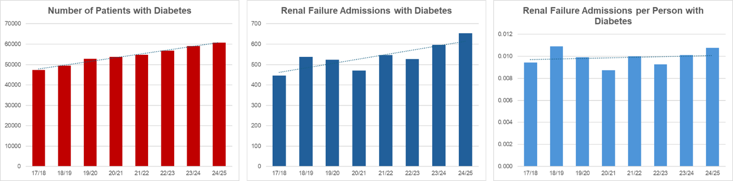

Renal failure Admissions for Central London, Ealing, Hammersmith and Fulham, Hounslow and West London
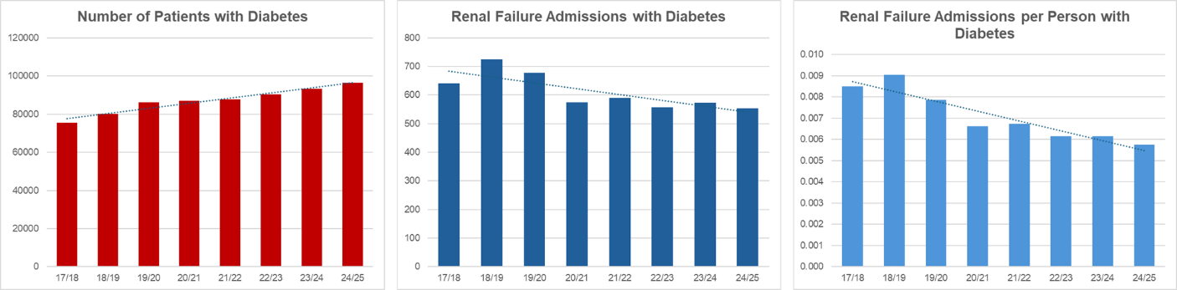

While it is not possible to prove causality, a causal impact would be consistent with the published evidence.

- Importance of Care Planning:
A component of the NWL Diabetes enhanced service has been a requirement to support collaborative care planning. Analysis of WSIC data from NWL demonstrates that patients for whom this is completed as part of the diabetes ES experience a 50% reduction in non-elective bed days independent of deprivation decile, demographic factors and medical complexity (see below).
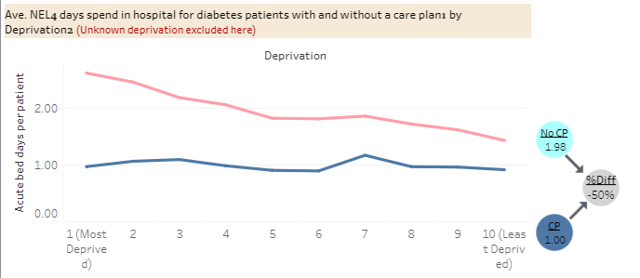
- Reduction in A/E Attendances for CVD Conditions:
Data from WSIC demonstrates that A&E attendances for people with CVD conditions on the CRM register have decreased by ~500 per month since 22/23 (saving approx. £250*500*12 = £1.5m annually).
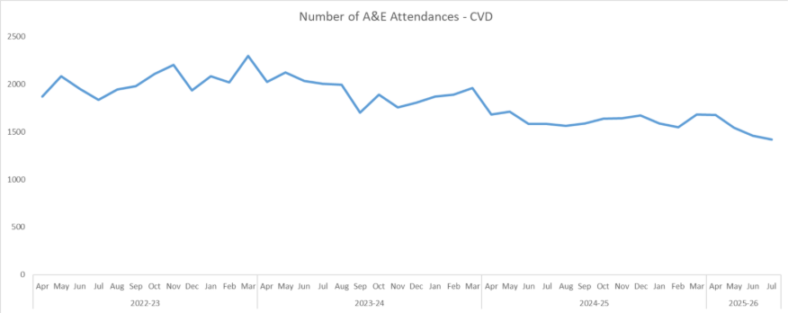

Learning and Evidence from the Harrow CRM Model:
- Borough-wide project delivered across 32 practices and 5 PCNs, involving a cohort of ~2,300 at-risk patients with CRM conditions/risk factors.
- Aims to shift care from reactive to preventative, improve early detection, and slow disease progression through holistic management.
- Aligns with the NWL Single Offer and the 10-Year Plan, focusing on lifestyle medicine, health coaching / motivational interviewing, and patient activation.
The key component of the Harrow CRM model is the 30-minute care planning discussion between a CRM prescribing clinician and the patient, which focuses on medicines optimisation and co-creation of a holistic health and wellbeing care plan.
- Quantitative and qualitative analysis so far demonstrates:
  - Significant improvement in some key clinical indicators which determine risk of progression and complications (BP, HbA1c and weight / waist circumference).
  - Improvements in patient experience and staff satisfaction.
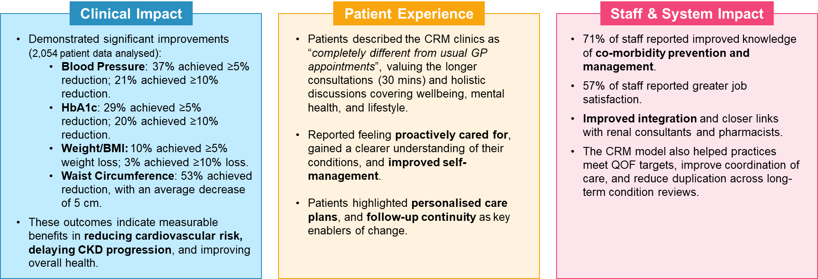

Health and Wellbeing Plan Using Motivational Interviewing – The Power to Unlock Change:
Motivational interviewing (MI) is a collaborative approach designed to help people find their own motivation and commitment to behavioural change. Systematic reviews and meta-analyses of MI,, have demonstrated that MI outperforms traditional advice giving with statistically significant impacts on key behaviours including physical activity, smoking cessation and weight loss as well as medication adherence, systolic blood pressure, HbA1c and lipid levels. One study of GPs trained in motivational interviewing demonstrated an increase in specific behavioural change information (including diet, physical activity, smoking cessation) received by people with T2DM.
In addition to body of evidence for the use of motivational interviewing in primary care, additional studies demonstrate:
- Physical activity: 1 in 4 people would become more active if a healthcare professional advised it. Recommendations from NHS England include signposting to digital tools such as ‘Couch to 5K’ and ‘Active 10’ as well as integrating physical activity into clinical pathways.
- Weight loss: Even brief, opportunistic interventions delivered in primary care can result in a five-fold increase in the proportion of patients engaging in weight management services (e.g. NHS DPP, T2DM Remission Programme, NHS Digital Weight Management Programme, local weight management services). Most people with obesity reported trying to lose weight but less than half recalled receiving advice on weight loss from their GP in the past year and few were referred to community weight-loss programmes. Those who recalled receiving GP advice on weight loss were substantially (OR=4.49) more likely to report taking action to lose weight. One study demonstrated that the language used during the discussion was important - “good news” that there is an opportunity to do something was more effective “than bad news”.
- Smoking Cessation: A meta-analysis demonstrated that communication of personalised risk resulted in an increase in smoking cessation rates. The Primary Care Respiratory Society has published a useful paper on the role of primary care in supporting patients quit.
From tracking over 9,000 people with long-term conditions across a health and care system, evidence has shown that people who are more confident and able to manage their health conditions (that is, people with higher levels of activation) have 18% fewer GP contacts and 38% fewer emergency admissions than people with the least confidence.
With both the Harrow CRM and NCL Long Term Conditions models, patients have confirmed the importance of the longer appointment time and collaborative care planning approach in addressing their real concerns and barriers to change. The ICB would ensure practice and their staff receive training in motivational interviewing in order to deliver effective interventions to their patients.
- “I felt listened to, and my concerns were addressed.” - Abernethy House Surgery
- “I feel much more involved in my care now. The clinician took the time to explain my treatment options and listened to my concerns.” - Abbey Medical Centre
- “It was the first time I felt like the pharmacist really listened to what matters to me, not just my blood pressure.” - Cheshire Road Surgery

Guidance for Transferring stable patients on depot antipsychotics to primary care, North West London 2021
Equally Well UK – Reducing physical health inequalities for people with mental health problems
For the latest version please email nhsnwl.mhlda@nhs.net
Health Care Assistant.
Recovery and Stay Well Plan – consisting of four items: 1) Patients Goals and Priorities; 2) Signs of becoming unwell; 3) Anticipatory Care Plan; 4) Health Action Plan.
The NWL Primary Care Wound Care Formulary aligns with the formularies used by the TVS across NWL. Therefore, we expect continuity of dressings being prescribed and used across both General Practice and Community Services. However, there may be occasions where specialist dressings outside the Formulary are clinically recommended by the TVS. In such cases, the prescribing clinician should use their clinical judgment and seek advice from the service.
NICE Guideline [NG136], Hypertension in Adults: Diagnosis and Management, August 2019
Public Health England, Tackling High Blood Pressure: An Update, January 2018 3 NHS Community Pharmacy Hypertension Case-Finding Advanced Service, version 1, November 2021
A small number of specialised services are commissioned nationally by NHS England directly as part of NHS England’s specialised commissioning role. These services include islet cell transplantation, pancreas transplantation, insulin-resistant diabetes, congenital hyperinsulinism, Alstrom Syndrome, Bardet-Biedl Syndromes and Wolfram Syndrome, and are delivered by tertiary centres that specialise in these specific conditions. Service specifications for these specialised services will not be covered here, but are included in the work streams of the Diabetes Specialised Commissioning Clinical Reference Group at NHS England.
Individualised HbA1c target may be as low as 48 for people with EOT2D
For completion of all 8 care processes - 22.8% of 19-25 year olds and 33.6% of 26-39 year olds compared to 46.6% and 58.5% of 40-59 and 60-79 year olds respectively; for HbA1c ≤ 58 mmol/mol - 51.6% of 19-25 year olds and 54.5% of 26-39 year olds compared to 57.1% and 68.4% of 40-59 and 60-79 year olds respectively - National Diabetes Audit, Young People with Type 2 Diabetes, 2019-20
Defined as achieving HbA1c target of < 48 mmol/mol, taking 5mg folic acid and avoiding potentially teratogenic medications.
National Pregnancy in Diabetes Audit Report 2020 - NDRS (digital.nhs.uk)
The specification and other supporting material uses the terms 'woman' or 'mother' throughout. These should be taken to include people who do not identify as women but who are pregnant.
A small number of specialised services are commissioned nationally by NHS England directly as part of NHS England’s specialised commissioning role. These services include islet cell transplantation, pancreas transplantation, insulin-resistant diabetes, congenital hyperinsulinism, Alstrom Syndrome, Bardet-Biedl Syndromes and Wolfram Syndrome, and are delivered by tertiary centres that specialise in these specific conditions. Service specifications for these specialised services will not be covered here, but are included in the work streams of the Diabetes Specialised Commissioning Clinical Reference Group at NHS England.
And any updates to the guidance during the lifetime of the service
For completion of all 8 care processes - 22.8% of 19–25-year-olds and 33.6% of 26–39-year-olds compared to 46.6% and 58.5% of 40-59- and 60–79-year-olds respectively; for HbA1c ≤ 58 mmol/mol - 51.6% of 19-25 year olds and 54.5% of 26-39 year olds compared to 57.1% and 68.4% of 40-59 and 60-79 year olds respectively - National Diabetes Audit, Young People with Type 2 Diabetes, 2019-20
Defined as achieving HbA1c target of < 48 mmol/mol, taking 5mg folic acid and avoiding potentially teratogenic medications.
Monitoring of other Coumarins: Patients are occasionally prescribed coumarins other than warfarin. This is unusual and such patients should be monitored in Secondary Care.
INR Star does also have a bridging component where clinically necessary and required for patient care.
It is important that TTR for each patient should be known because if <65% and there is no obvious reason for it then there an alternative anticoagulant should be used or dose adjustment. This is backed up by this 2018 audit that states if patient has TTR <65% should be classed as a ‘never’ event https://thrombosisuk.org/downloads/2018%20Anticoagulation%20UK%20-%20Audit%20of%20Anticoagulation%20management%20in%20secondary%20care%20in%20England.pdf)
Unstable in this context refers to patient having had at least 3 readings in range with none out of range before they can be taken on in primary care
Urinary incontinence and pelvic organ prolapse in women: www.nice.org.uk/guidance/ng123
The assessment and initial fitting may be carried out by the Primary Care (GP) under this service specification if the Service Provider feels competent to assess suitability as outlined above or alternatively refer the patient to the local PCN/Federation PCN Ring Pessary Clinic (Service points to be determined by each PCN in discussion with their borough team).
Urinary incontinence and pelvic organ prolapse in women: www.nice.org.uk/guidance/ng123
Royal College of Nursing - Genital examination in women: www.rcn.org.uk/professional-development/publications/rcn-genital-examination-in-women-pub007961
Royal College of Nursing - www.rcn.org.uk/clinical-topics/womens-health/urogynaecology
Monitoring recommendations are based on the national NHS England Shared Care Documents www.england.nhs.uk/medicines-2/regional-medicines-optimisation-committees-advice/shared-care-protocols
NHS England Shared Care Protocols www.england.nhs.uk/medicines-2/regional-medicines-optimisation-committees-advice/shared-care-protocols - Specialist Pharmacy Services, Drug Monitoring Guidance www.sps.nhs.uk/home/guidance/drug-monitoring
Women's Health Strategy for England August 2022 (publishing.service.gov.uk)
Beelen P, van den Brink MJ, Herman MC, et al Levonorgestrel-releasing intrauterine system versus endometrial ablation for heavy menstrual bleeding. Am J Obstet Gynaecol 2021;224:187 e1-187.e10
UK Medical Eligibility Criteria for Contraceptive Use (UKMEC) - Faculty of Sexual and Reproductive Healthcare (fsrh.org)
FSRH Guideline (March 2023) Intrauterine contraception | BMJ Sexual & Reproductive Health
https://www.londonsafeguardingchildrenprocedures.co.uk/index.html
http://londonsafeguardingchildrenprocedures.co.uk/info_sharing.html
Unless specifically noted within the service specification
Further information can be found at www.equalityhumanrights.com
https://www.kingsfund.org.uk/sites/default/files/field/field_publication_file/delivering-better-services-for-people-with-long-term-conditions.pdf
https://www.england.nhs.uk/personalised care/upc/
Note that Dapagliflozin is now off-patent and a cost-effective choice of SGLT2i
Current mean achievement across NWL for CRM01A is 49%, 75th centile 62.5%
Current mean achievement across NWL for CRM01B is 73%, 75th centile 86%
Current mean achievement across NWL for CRM01C is 57%, 75th centile 67%
Current mean achievement across NWL for CRM01D is 60%, 75th centile 79%
Current mean achievement across NWL for CRM01E is 40%, 75th centile 41%
Current mean achievement across NWL for CRM03 is 51%, 75th centile 54.5%
Current mean achievement across NWL for CRM04 is 56%, 75th centile 60%
Current mean achievement across NWL for CRM05 is 64%, 75th centile 67%
Current mean achievement across NWL for CRM05 is 36%, 75th centile 40%. There is a bigger jump on this target due to the new NICE guidelines for T2DM which recommend SGLT2 inhibitors as first line therapy for nearly all patients with T2DM.
At present, a number of codes are in use by different pathology services across North West London. There is ongoing work on unification of coding
Retinal screening codeset will be updated to incorporate additional codes.
https://doi.org/10.1111/liv.15730
https://evidence.nihr.ac.uk/collection/multiple-long-term-conditions-multimorbidity-and-inequality-addressing-the-challenge-insights-from-research/
https://doi.org/10.1007/s11606-016-3685-3
https://bjgp.org/content/bjgp/55/513/305.full.pdf
https://doi.org/10.1016/j.pec.2013.07.012
https://pmc.ncbi.nlm.nih.gov/articles/PMC3413190/
https://www.england.nhs.uk/ourwork/public-health/harnessing-the-benefits-of-physical-activity/
https://bmjopen.bmj.com/content/14/11/e086764
https://www.acpjournals.org/doi/10.7326/M22-2360
https://www.pcrs-uk.org/sites/default/files/OS_SmokingCessation.pdf

